Mumina Abdi   | Hillview | HS Teacher Assistant
Cassidy Adams  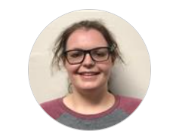 | College | EHS Teacher Assistant
Samantha Battey  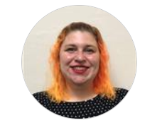 | College | EHS Teacher
Faye Bergeron   | Hillview | Food Service Specialist
Jessica Bradstreet  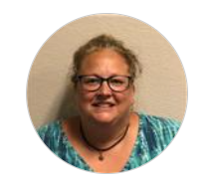 | College | HS Teacher
Oliver Brown   | All Sites | Permanent Rotating Substitute
Susan “Sue” Carver   | Coburn | Food Service Specialist
Destiny Chretien   | Webster & FDC | Site Supervisor
Lisa Coates   | Coburn | EHS Teacher  Site Coordinator
Bethany Corbin   | Connors | Family Advocate
Kassandra “Kassy” Creighton  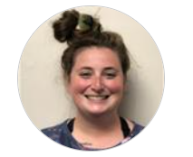 | Webster | HS Teacher
Denise Donaghy   | Hillview | HS Teacher Assistant
Abigail “Abby” Doyle   | ALL Sites | HS Teacher
Sarah Dudley-Taylor   | Connors | HS Teacher
Sophia Fogg  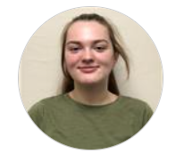 | Coburn | HS Teacher
Marie Fontaine   | Hillview & FDC | Family Advocate
Michele Gagnon   | College | EHS Teacher
Kaydence Gamblin   | Coburn | HS Teacher
Chelsey Garber   | Coburn | HS Teacher Assistant
Kristin Gibson   | Coburn | Human Resource Manager
Amy Goodie   | Coburn | Finance Coordinator
Neema Gracia   | Webster | EHS Teacher Assistant
April Gumprecht   | College | Family Advocate
Louise Hamner   | College | EHS Teacher
Kirsten Hart   | Connors | HS Teacher
Stephani Hebert   | Coburn & Hillview | Head Start Coach  Site Supervisor
Fatuma Hussein   | Connors | HS Teacher Assistant
Sahra Ibrahim   | College | HS Teacher Assistant
Nathan Imhoff   | Webster | HS Teacher Assistant
Jennifer Jackson  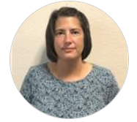 | Connors | HS Teacher Assistant
Halie Jipson   | Webster | Food Service Specialist
Rachael Jones   | Coburn | Early Interventionist  Supervisor
Crystal Kirk   | Hillview | HS Teacher & Site Coordinator
Kaitlyn Knight   | Coburn | EHS Teacher
Melissa Lane   | Coburn | CACFP Coordinator  Admin Coordinator  Nutrition
Norma Larocque   | Coburn | Health Coordinator  Nutrition Supervisor
Karen Longtin   | Coburn | EHS Teacher Assistant
Ardo Maalim   | Coburn | CACFP Coordinator
Isabelle “Izzy” MacFarlane   | Coburn | HS Teacher Assistant
Anneke MacIsaac   | Coburn | Curriculum Coach
Gwendolyn “Gwen” Malia   | Coburn | Finance Manager
Tatiana McCann   | College | EHS Teacher
Lisa McIntosh   | College | Site Supervisor
Heidi McKay   | F.D.C. | HS Teacher
Ntjantja “Lynette” Mfolozi  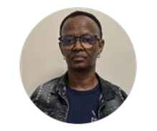 | Webster | HS Teacher Assistant
Jamie Michaud   | Hillview | HS Teacher
Violet Mikita   | Webster | EHS Teacher
Lori-Ann Milbert   | College | Food Service Specialist
Dianna Moore   | Webster | Cook
Betsy Norcross Plourde   | Coburn | Executive Director
Giovanna Olivier  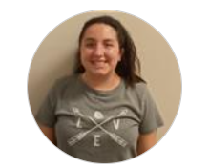 | College | EHS Teacher
Victoria “Vicky” Parks  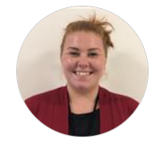 | Connors | Site Supervisor
Brook Pomerleau   | Webster | HS Teacher Assistant
Susan “Sue” Poulin   | Webster | EHS Teacher Assistant
Alyssa “Ally” Ratsavong   | Hillview | HS Teacher Assistant
Mary Ratsavong   | Coburn | Curriculum Coach
Monica Redlevske   | Coburn | Education/Child Development Manager
Molly Ridder   | Connors | HS Teacher
Erica Russell  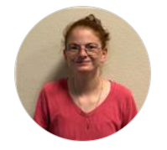 | College | EHS Teacher
John Salmon   | Coburn | Facilities Technician
Olivia Scott   | Coburn | Comprehensive Services Director
Mary-Elizabeth “Emmi” Silver   | F.D.C. | HS Teacher
Kaitlyn Socquet   | Connors | HS Teacher
Rebecca “Becky” Sosny   | Connors | HS Teacher
Barbara Stevens  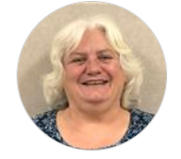 | Connors | HS Teacher Assistant
Angelina Thomas-Billings   | F.D.C. | HS Teacher Assistant  Food Service
Julie Tripp   | Webster | EHS Teacher
Margit Tripp  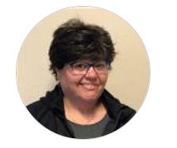 | Connors | Center Assistant
Marjorie “Marge” Turcotte   | All Sites | Permanent Rotating Substitute
Assunta “Susy” Villanueva   | Coburn | HS Teacher Assistant
Bahaya Wanyi   | College | HS Teacher Assistant
Kristeene Ward-Dulac   | Coburn | Family Services Manager  Family Advocate
Caitlyn Zitsch   | Coburn | HS Teacher Assistant

