Our Classroom Rules



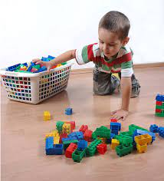

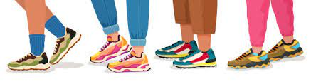

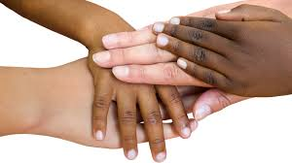

**Inside Voices**

**Clean Up After Yourself**

**Walking Feet**

**Gentle, Helping Hands**