Operations Manual
January 5, 2023

Table of Contents

Human Resources
Education
Health
Family Services
Special Services
Nutrition
ERSEA
Resource Links

Human Resources
- Time Off, Subbing and Scheduling
    - Work Schedules
    - Planned Time Off Approval Process
    - Requesting Planned PTO or Schedule Change Request
    - Subbing Procedures for Unplanned Absences
    - Summer On-Call Procedures for Laid- Off Staff
  - Payroll and Timecards
    - Logging on to iSolved (payroll system)
    - Accessing iSolved Mobile App
    - Viewing/Printing Pay Information in iSolved
    - Personal Information Updates in iSolved
    - Starting or Changing Health Savings Account or 403b Contributions
    - Logging in to AOD (timecard system)
    - Clocking in an out of AOD
    - Timecard Correction
    - Filing for Unemployment for Vacation Weeks (school year staff)
    - Benefit Premium Payments while on Leave
  - Operations
    - IT Work Order Process
    - Maintenance Work Order Process
    - Pest Control Process
    - Outlook Email
    - Outlook Calendar
    - Voicemail
  - Training
    - Maine Roads to Quality (MRTQ) Registry Annual Reviews

Education
2.1 Classroom
- Roles and Responsibilities
- Education Monitoring Plan
- Attendance Monitoring & Required Follow-up
- Classroom Environments
- Daily Classroom Cleaning Expectations
- 8 on 8 Health and Safety Check
- Cleaning and Sanitization Form
- Bulletin Board &Resource
- Classroom Schedules
- Arrival and Release of Children
- Rest Time Expectations
- Screen Time Guidance
- Substitute Teacher Roles & Responsibilities
- Classroom Nutrition Activities
- Classroom and Playground Rules
- Playground Expectations
- Infant-Toddler Communication Sheets
- Classroom inventory list
- Consumable orders
- Child’s Photos and Uploading Procedure
- Laminating Guidance
- End of Year Procedure
2.2 School Readiness
- Guidance of Young Children’s Behavior
- Home Language/Child Language Use Survey
- Developmental & Social-Emotional Screenings
- DLL Screening & preLAS
- DLL form for CDS
- DLL Teaching and Learning
- Transitions in Head Start
- PTCs and Home Visits
    - Setting Individual Child Goals
    - Talking Points Expectations
    - Language Line/Insight Guidance
    - Toileting Training Expectations
    - Toileting Plan
- Active Supervision of Children & Ratio Matters
2.4 Teacher Effectiveness
    - Program Monitoring
    - Curricula Implementation and Fidelity
    - Coaching
2.5 Teaching Strategies Gold Assessment System
    - TSG Observation Guidance
    - Classroom Profile Analysis (FALL/WINTER)
    - Teaching Strategies Quick “How to” Guide
    - Teaching Strategies FAQ
    - Closing out TSG files: observations, assessments, parent-teacher conference forms/report card

Health
2.1 Medical Emergencies

Emergency Backpacks
- Calling 911 in Emergency
- Emergency Procedures
- Dental Emergencies
- Child Incident Report
- Eye Wash Station Protocol
- Center Supply List- Order Form
- Health Supplies ordering procedure
2.2 Illness
- Daily Health Check
- Incident Report Protocol
- Sick/ Exclusion Guide
- Inclusion/Exclusion for Fever Procedure
- Health Communication Logs
- Individual Health Plans
- Health Information Form’s (Home Visit’s)
- Medication Administration
- Medication Forms Protocol
- Authorization to Dispense Prescription Medications
- Medication Incident Report
- Over the Counter (OTC) Medication Permission
- Red Folder List- Medications
- Allergy Plan
- Asthma Plan- No Medication
- Pandemic Response Policy
2.3
- Head Start Hand Washing Expectations
- Blood Borne Pathogens (BBP) Exposure Control Plan
- BBP Exposure Form
- BBP Clean Up and Spill Kit
- Human Bite Protocol
- Changing Soiled Clothing/Pullups
- Cleaning and Disinfecting Protocol
2.4
- Head/Neck/Spinal Injury protocol
- Helmet Safety Procedure
- Concussion (TBI) Symptoms
- Seizure Protocol
- Seizure Types and Symptoms and Protocol
- Seizure Log Form
2.5
- Health Screening and Exam Mandates
- EPSDT Screening Schedule
- Immunization Requirements
- Immunization Exemption Form
- Health Passport Protocol and Form
- Lead Screening Protocol and Authorization Form
2.6
- Head Lice Protocol and Kit/Combing
- Tick Removal Procedure
- Pest Protocol
- Pest Management Form
2.7
- Drinking Water
- Sun Safety
- Heat Stress
- Insect repellent
2.8
- Safe Sleep Practices
- Diapering Procedure
- EHS Hand Washing Procedure
- Edinburgh Postnatal Depression Scale
2.9
- Oral Health and Hygiene for Ages 3-5
- Oral Health and Hygiene for Ages 0-3

Health Resource Links

Nutrition:

Family Services
Family Services Monitoring
    - Family Services Monitoring Plan
    - Family Advocate/Teacher Meetings
    - Documentation
    - Family Referrals
    - Shared Families
    - PIR
Family Engagement
    - Framework
    - Confidentiality
    - Parent Group, Nurturing Parenting Program, Agency Wide Family Events, End of year Celebration, Agency Committees, In-Kind
    - Policy Council
    - Language Facilitator
    - Contracted Language Facilitator Log
Home Visits
    - Home Visit Roles and Responsibilities
    - Scheduling Home Visits
    - Home Visiting Safety
    - Family Services Initial Home Visit
    - Emergency Card
    - Extended Care
    - Parent Handbook
    - Unattended Child On a Home Visit
Family Partnership Agreement Process
    - Family Partnership Agreement
    - Family Wellness Profile
    - Family Circles Activity
    - Family Development Plan
    - Home Emergency and Safety Checklist
DHHS
    - DHHS Involvement/Interviews
    - DHHS Reporting

Special Services
- Behavior Incident Reports
- Requesting an Observation
- Referrals to CDS
- Behavior Safety Plan for Challenging Behaviors
- Referrals to Mental Health Provider- Community Based Services
- Referrals to Mental Health Provider- Classroom Based Services
- Help- Prompt-Wait- Using Behavior Management Techniques
- Special Education Process and Timeline

ERSEA

Age Eligibility

Income Eligibility and Verification

Categorical Eligibility and Verification

Enrollment Activity Sheets (EAS)

Transfer Request

Recruitment of Children and Families

ERSEA Training

ERSEA Definitions

Application Tracker

Application Status Definitions

Resource Links

Title of Procedure or Process: | Work Schedules
Program Area(s): | All Agency
Related Standards or Regulations: | ☒Head Start Program Performance Standards  ☒Maine State Licensing  - Developmentally Appropriate Practice/NAEYC  - Caring for Children  ☒Other
Person Responsible for  implementation: | Responsible Staff Person
Timeline for completion: | n/a
Submitted to: | n/a
ChildPlus Documentation: | n/a
Uploaded to ChildPlus: | n/a
Specific Directions: | n/a

Purpose: Regular schedules create consistency necessary to establish a foundation for good communication at all levels. In addition, regular schedules ensure that staff are available during times in which parents and customers are most likely to have needs; and also ensure staff are available to attend trainings and meetings that take place after child hours. The purpose of this procedure is to provide transparency in the way in which employee work scheduled is determined

Procedure:

- Administrative Staff: Normal business hours for the Agency are 8:00 am to 4:30 pm. Administrative personnel should work within a half hour of those start/end times to ensure availability to provide high levels of customer service to customers and staff members that may need support.
- Food Service Staff: Food Service staff schedules are based on a combination of estimated time needed to prep food, classroom mealtimes, and travel between sites. Schedules can change, based on change in classroom needs.
- Full Day Classroom Staff: Staffing patterns for each classroom have been established based on a wide variety of factors such as: age of children, licensing requirements, staffing patterns based on program option, child arrival and departure times, child behaviors, the ability to combine with other classrooms etc. Each staffing pattern has been considered carefully keeping in mind child safety, quality programming, and fiscal responsibility. Schedules can change based on classroom needs at any time and staff must be available to flex with those needs.
- Part Day Classroom Staff: Staffing patterns for each classroom have been established based on a wide variety of factors such as: age of children, licensing requirements, staffing patterns based on program option, child behaviors, the ability to combine with other classrooms etc. Each staffing pattern has been considered carefully keeping in mind child safety, quality programming, and fiscal responsibility. Part day classroom staff should work within a half hour of the start of their program option to ensure they are available for parents after children depart as well as trainings and meetings that are scheduled to take place.

Exceptions: There are always circumstances in which deviations may be deemed necessary in either the rules outlined in this procedure or the procedure itself. However, in order to ensure consistency across the Agency, any exception to this procedure must be pre-approved by the Program Supervisor (Education) or their direct Supervisor (all other staff members). Exceptions will only be considered for staff that are meeting or exceeding the requirements for their positions (current on home visits, TSG Observations, not on a performance improvement plan, etc.) and in the event they supervise staff their staff members must be meeting or exceeding the requirements for their positions. Staff members that are new to their role will not be considered for an exception to the standard scheduling protocol. If an exception is made, the follow stipulations apply:
- Must be productive work time
- Cannot cause over time
- Staff must be available for post-class meetings and trainings as needed (even if it means shifting schedule that day and flexing on another day)
- Flexing for schedule shifts must take place over the course of the week and be pre planned (it is not permissible to leave early every Friday afternoon)
- Earliest start time is 7:30 am
- In the event a staff member with an approved schedule exception supervises other staff members, they must provide specific tasks/expectations for staff to complete after they leave.

Title of Procedure or Process: | Planned Time Off Approval Process
Program Area(s): | All Agency
Related Standards or Regulations: | - Head Start Program Performance Standards  - Maine State Licensing  - Developmentally Appropriate Practice/NAEYC  - Caring for Children  ☒Other
Person Responsible for implementation: | Responsible Staff Person
Timeline for completion: | n/a
Submitted to: | Program Supervisor, Managers and/or Kitchen Supervisor
ChildPlus Documentation: | n/a
Uploaded to ChildPlus: | n/a
Specific Directions: | n/a

Purpose: The purpose of this procedure is to ensure a consistent process is used to approve or deny time off requests for employees in a timely manner while ensuring appropriate sub coverage is available.

Full Year Education Staff (Teachers, Teacher Assistants, Center Assistants, Perm Rotating Subs, Floats and Family Advocates):

- During the school year, no more than two FY Education staff will be approved per day Agency wide.
- During school year 22/23 no more than one classroom staff member per full day site will be approved for PTO.
- During summer 2022 (when PY classroom staff are off for summer break), no more than one staff member per classroom will be approved per day and no more than three total Agency wide.
- FY Employees will be granted no more than three weeks of vacation each summer unless staffing allows.
- Regardless of the time of year, if an employee has submitted a schedule change request that is at least a half day it will be counted as “day off” when approving other time off requests.
- Regardless of the time of year, no two lead teachers in the same FY classroom will be for approved PTO on the same day.
- PTO will not be approved for Agency In-Service Days.
- PTO requests will not be approved more than six months in advance.
- FY personnel requests for PTO must be submitted no later than April 30th…requests will be considered in order received.
Part Year Education Staff:
- PY employees will not be granted planned PTO outside of school vacations unless an extenuating circumstance exists (medical appointment, legal proceedings, etc). If an extenuating circumstance exists, the employee is encouraged to schedule appointments outside of child time and the Program Supervisor must be consulted before a decision is made.
- PTO will not be approved for Agency In-Service Days.

Procedure for Approving FY/PY Education Staff PTO Requests:

Your Supervisor receives time off request in AOD from the employee and within two business days reviews sub calendar to apply rules set out above (provided the time requested is within the next six months).

- If the time can be approved, they will approve the time in AOD with the following note on the approval: “Approved provided enough PTO is accrued at the time of the planned time off. At the same time the sub calendar will be updated so that and coverage can be obtained.
- If the time cannot be approved, the Program Supervisor will deny the PTO request in AOD and a note on the denial should be included as to why the request is being denied. The Supervisor will also be notified via email of the denial and the reason why the request was denied (too many people out already, co-worker in classroom already out etc).

If you would like to request time off that is more than six months in advance, please contact your Supervisor and Human Resources directly to discuss the circumstances before submitting the request.

On a monthly basis, Human Resources and Supervisors will review PTO balances for all staff members who have vacations scheduled in the coming month to ensure they have enough time accrued to take the vacation. If any staff members do not have enough PTO, their time off request will be denied. Site Supervisor will be notified and communicate to staff member.
- Sub coverage may not be found immediately, but staff should know that if their request has been approved, they will be able to take the time off even if a sub is not found immediately and on sub calendar.
- In general PTO requests are approved on a first come first served basis. However, the following weeks have been identified as highly desirable and as such will be handled differently:
    - Independence Day Week
    - Week of Thanksgiving
    - Days Around Christmas (if Agency is not closed)

At the beginning of the calendar year, the Human Resources Manager will send an email to all full year staff asking if they have an interest in taking the week of the 4th of July off requests must be submitted by email to HR between January 1 and January 31 of the year being requested. Raffle will occur in February. For the week of Thanksgiving and days around Christmas HR will send an email to all full year staff asking if they have an interest in time off requests must be submitted to HR via email between July 1 and July 31 of the year being requested. Raffle will be drawn in August. Requests will be approved based on the rules outlined above. If more people have requested the weeks than policy allows, individuals that had the same week the year prior will be removed from the grouping and rest of the employee names will be placed in a drawing and the first combination of employees that can take the time within policy will be approved for the time off for the following year. No requests for these weeks will be approved outside of this special process.
.
Rules for Non-Education Staff: (those that do not require a sub, non-classroom staff)

- Managers and Supervisors should ensure appropriate coverage is available in their department during staff vacations.
- No PTO will be approved for any Agency In-Service Days.

Non-Education Staff Procedures: (those that do not require a sub, non-classroom staff)

- Manager/Supervisor receives request in AOD and approves or denies based on rules outlined above.

Scheduled Change Requests
All Agency
- Head Start Program Performance Standards
- Maine State Licensing
- Developmentally Appropriate Practice/NAEYC
- Caring for Children
☒Other
Responsible Staff Person
n/a
Supervisor, Managers, Human Resources
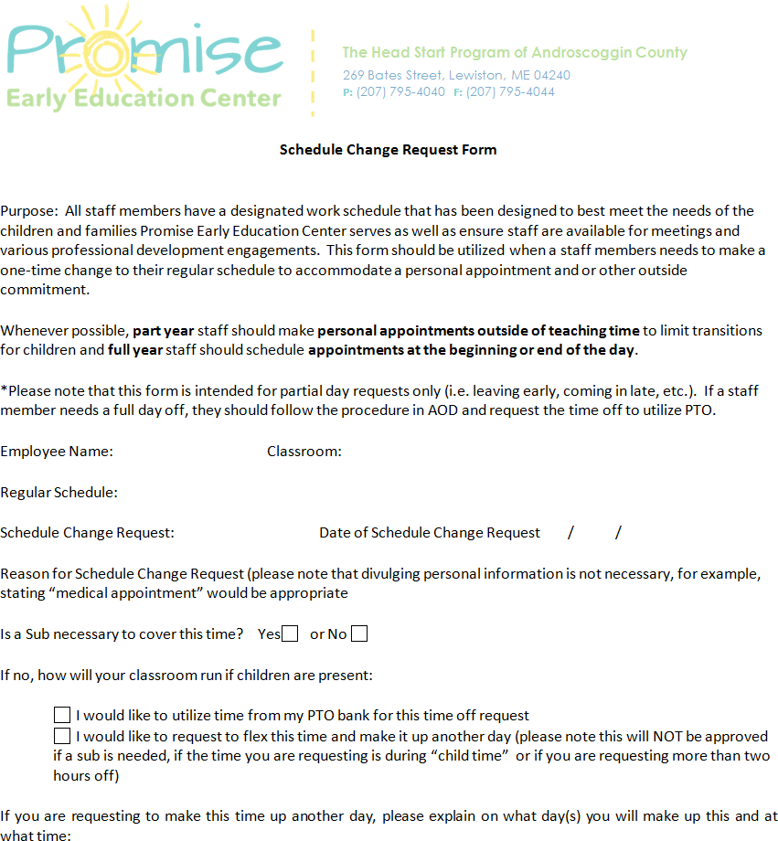

  - Approval /Denial will come via email and the Site Supervisor will be copied on the email.
  - The HR Manager will note schedule change on the Sub Calendar (and add the Site Supervisor as an “Attendee”) and will indicate on the meeting request if a sub is necessary or not.

- For Education staff, on a monthly basis, the Program Supervisor will look at the PTO balances of all time off requests for the following month to determine if each staff member has (or will have) enough PTO to cover their entire vacation. For all other staff their direct supervisor will be responsible for monitor PTO levels and communicating directly with staff.
o If there is an expectation that there will not be enough PTO, the Program Supervisor is to notify the Site Supervisor

Non-Education Staff Procedures: Full day requests should be submitted in AOD as outlined in Education Staff procedures. Partial day requests should be requested by emailing your direct Supervisor

Title of Procedure or Process: | Subbing Procedures for Unplanned Absences
Program Area(s): | Education
Related Standards or Regulations: | - Head Start Program Performance Standards  - Maine State Licensing  - Developmentally Appropriate Practice/NAEYC  - Caring for Children  - Other
Person Responsible for  implementation: | Identified Leadership Staff
ChildPlus Documentation: | n/a

Purpose: To communicate the process Site Supervisors will use in order to safety sub classrooms when unexpected absences occur.

Procedures for Sub Coordinator:

- When a sick call is received, the following staff members should be contacted in the following order:
  - Perm Rotating Sub should be utilized if available
  - Per Diem Sub should be utilized if available
  - Triage within the site if possible
  - Site Sup/Coach/Manager/FA – if you get to this point, the Operations Manager should be involved
    - In the summer, the Summer Subbing spreadsheet should be utilized to determine which part year staff to call in what order.
- Once a plan is established, the staff in the impacted classroom should be notified what the staffing plan for that day will be via text on the sub phone.

Title of Procedure or Process: | Subbing Procedures for Unplanned Absences
Program Area(s): | Education
Related Standards or Regulations: | - Head Start Program Performance Standards  - Maine State Licensing  - Developmentally Appropriate Practice/NAEYC  - Caring for Children  - Other
Person Responsible for  implementation: | Identified Leadership Staff
Timeline for completion:
Submitted to:
ChildPlus Documentation: | n/a
Uploaded to ChildPlus:
Specific Directions:

Purpose: To communicate the process Site Supervisors will use in order to safety sub classrooms when unexpected absences occur.

Procedures for Sub Coordinator:

- When a sick call is received, the following staff members should be contacted in the following order:
  - Perm Rotating Sub should be utilized if available
  - Per Diem Sub should be utilized if available
  - Triage within the site if possible
  - Site Sup/Coach/Manager/FA – if you get to this point, the Operations Manager should be involved
    - In the summer, the Summer Subbing spreadsheet should be utilized to determine which part year staff to call in what order.
- Once a plan is established, the staff in the impacted classroom should be notified what the staffing plan for that day will be via text on the sub phone.

Title of Procedure or Process: | Summer On-Call Procedures for Laid Off Staff
Program Area(s): | Education
Related Standards or Regulations: | - Head Start Program Performance Standards  - Maine State Licensing  - Developmentally Appropriate Practice/NAEYC  - Caring for Children  - Other
Person Responsible for  implementation: | Supervisor/Manager responsible for sub phone

Purpose: The purpose of this procedure is to ensure consistency in how part year staff members who are laid off during the summer will be utilized to support full year classrooms in both planned and unplanned absences so that the Agency is better able to fill open shifts and part year staff are better able to plan their summer.

Summary of Procedure: An on-call schedule will be created and communicated to staff by June 1st of each year. This on call rotation will include all classroom staff members that are laid off in the summer, are collecting unemployment, AND are not already scheduled to sub already. Two part-year staff will be assigned to each week in the summer and must be available to work during that week.
Creation of On Call Schedule:

- In May of each year, the HR Manager will ask that all full year classroom staff put in requests for summer vacations and will ask part year staff who is interested in subbing over the summer. Based on that information, the planned subbing schedule will be coordinated in the following way:
  - Permanent Rotating Subs are utilized to fill openings first.
  - Teacher Assistants who are collecting unemployment and WANT to work for the summer are utilized to fill openings next.
  - Per diem substitutes are utilized to fill openings next.
  - On call part year teaching staff will fill openings next.
- In May of each year, part year staff members will be asked if they are interested in working over the summer as well as provide input as to what weeks they would prefer to be “on call”. These preferences will be taken into consideration when possible, but each week in the summer must have two “on call” staff members, so preferences will not always be feasible.
- Once a plan is established to cover all planned absences, laid off staff members will be assigned one week where they will be “on call” during the summer. Rules associated with on call:
  - Staff must be available to work that week (ie not be away on vacation).
- If a full year staff member puts in a last minute planned vacation request (per policy staff must give two weeks notice for full week, or three days for a single day) one of the on call staff members will work. The on-call staff member will be notified of this immediately.
- If a sick call occurs and perm subs, part year staff that want to work and per diem subs are not available to work, the on-call staff will be called in to work.
- Staff will not be called and asked to work when it is not their on-call week.
- If an on-call staff member is not able to work during a day or week they are on call, the refusal of work will be reported to unemployment. In addition, they will be placed on call the following week and will be the first to be called in the event there is a subbing need.

itle of Form: | Logging on to iSolved
Related Policy: | n/a
Program Area(s): | All Agency
Related Standards or Regulations: | - Head Start Program Performance Standards  - Maine State Licensing  - Developmentally Appropriate Practice/NAEYC  - Caring for Children  ☒Other
Procedures
Form Completed By: | Responsible staff members
Timeline for completion: | Immediately
Specific Directions: | Access iSolved
Submitted to: | Human Resources
ChildPlus Documentation: | n/a
Uploaded to ChildPlus: | n.a

Purpose: iSolved is the Agency payroll system and is utilized for the following reasons: To view/print your paystub each pay period, to view/print historical pay stubs, to view/print W-2 forms, to update your personal information, to update your tax with holdings or to make updates to regular direct deposit accounts (all accounts with the exception of pre-tax health savings accounts).

Procedure:

- Log on to your Employee Self Service Account by using the following URL: https://payprosinc.myisolved.com/UserLogin
- Your username is your work email address: firstinitiallastname@promiseearlyeducation.org
- If you do no remember your password use the “forgot password” link and follow the instructions. Please note that a security code will be sent to your email address when you use this process. If you do not see the email, check your “junk” folder as it can go there.
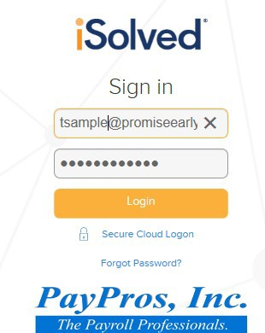

Title of Procedure or Process: | iSolved Go Mobile App User Configuration
Program Area(s): | All Agency
Related Standards or Regulations: | - Head Start Program Performance Standards  - Maine State Licensing  - Developmentally Appropriate Practice/NAEYC  - Caring for Children  ☒Other
Person Responsible for  implementation: | Responsible staff members
Timeline for completion: | n/a
Submitted to: | Human Resources
ChildPlus Documentation: | n/a
Uploaded to ChildPlus: | n/a
Specific Directions: | n/a

Purpose: The iSolved Go Mobile App can be used by employees to look at their paystubs, update your personal information (such as phone number and address), as well as change your state and federal tax withholdings!

Procedure:

- Download the free app in your Android or iPhone app store: iSolved Go
- Once iSolved Go has been downloaded, Open the app and follow the below instructions with regard to changing your app to function as a Network Partner.
  - Click on the Setup Wheel in the lower left corner.
  - Under Network Partner, type in “Payprosinc” and click the Save button.
  - Click the back arrow in the top left to get back to the main screen.
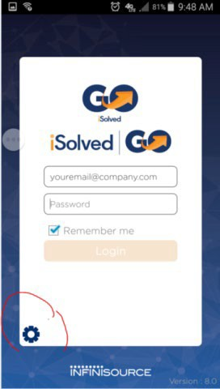
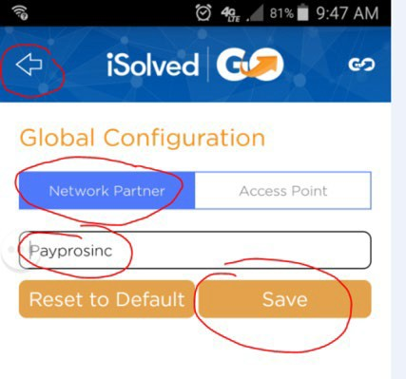

  - From the main screen Login using log in (your employee login is your entire email address) and your password.

Title of Form: | Viewing and Printing Pay Information in iSolved
Related Policy: | n/a
Program Area(s): | All Agency
Related Standards or Regulations: | - Head Start Program Performance Standards  - Maine State Licensing  - Developmentally Appropriate Practice/NAEYC  - Caring for Children  - Other
Procedures
Form Completed By: | Responsible staff members
Timeline for completion: | Immediately
Specific Directions: | Access iSolved
Submitted to: | Human Resources
ChildPlus Documentation: | n/a
Uploaded to ChildPlus: | n/a

Purpose: Paychecks are issued every other Thursday and will be for hours worked for the prior pay period. Pay weeks run Sunday is the first day of the pay week and Saturday is the last. Pay stubs (both current and historical) and other compensation information can be viewed and/or printed using iSolved.

Procedure:

- Log on to your Employee Self Service Account by using the following URL: https://payprosinc.myisolved.com/UserLogin
- On the left hand menu click “Pay History” and a list of all of your paystubs will appear that you can either view or print.
- You can also view historical W2 information by clicking on “W2/ACA/1099 forms
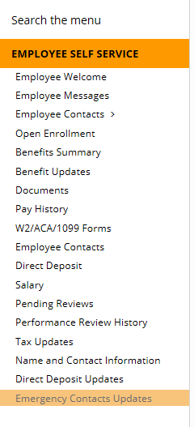

Title of Form: | Personal Information Updates in iSolved
Related Policy: | n/a
Program Area(s): | All Agency
Related Standards or Regulations: | - Head Start Program Performance Standards  - Maine State Licensing  - Developmentally Appropriate Practice/NAEYC  - Caring for Children  ☒Other
Procedures
Form Completed By: | Responsible staff members
Timeline for completion: | Immediately
Specific Directions: | Access iSolved
Submitted to: | Human Resources
ChildPlus Documentation: | n/a
Uploaded to ChildPlus: | n/a

Purpose: The following personal information should be up to date and current at all times in iSolved (Agency payroll system): Emergency Contacts, Direct Deposit Information (for all except pre-tax Health Savings Account direct deposits), Name, Address, Phone Number, and tax withholdings. If any of these items change staff are responsible for updating their information in iSolved.

Procedure:

- Log on to your Employee Self Service Account by using the following URL: https://payprosinc.myisolved.com/UserLogin
- On the left hand menu, you have the ability to make changes to all of the items that have the word “update” next to them.
- Click on the item you want to update and either click on “Add New” to enter a completely new entry or click on “Edit” to update an existing entry. Click save at the end.
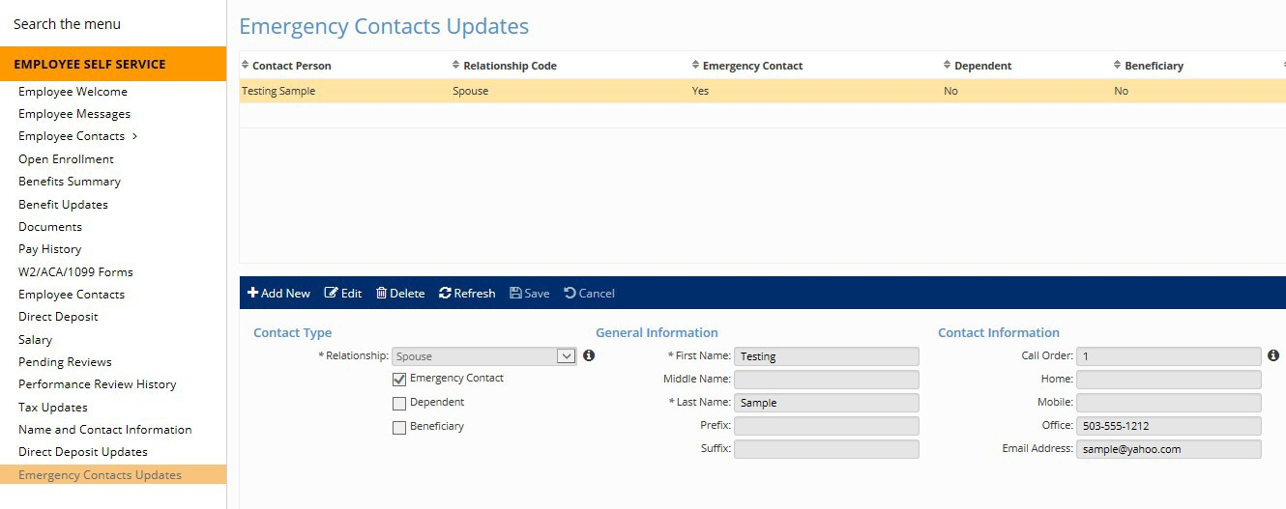
3
2

Title of Procedure or Process: | Health Savings Account and 403b Contribution Amount Changes
Program Area(s): | All Agency
Related Standards or Regulations: | - Head Start Program Performance Standards  - Maine State Licensing  - Developmentally Appropriate Practice/NAEYC  - Caring for Children  - Other
Person Responsible for  implementation: | Responsible staff members
Timeline for completion: | Upon need for change
Submitted to: | Human Resources
ChildPlus Documentation: | n/a
Uploaded to ChildPlus: | n/a
Specific Directions: | n/a

Procedure:

- The amount you contribute to your pre-tax Health Savings account can be changed at any time. In order to change it, complete section two of the Health Savings Account Direct Deposit form and submit to Human Resources.
- The amount you contribute to you 403b plan can be changed at any time. In order to change it, complete the 403b Contribution change form and submit to Human Resources. Please note that you can only select a percentage of your income and not a flat amount.

Title of Procedure or Process: | AOD – Logging In
Program Area(s): | All Agency
Related Standards or Regulations: | - Head Start Program Performance Standards  - Maine State Licensing  - Developmentally Appropriate Practice/NAEYC  - Caring for Children  ☒Other
Person Responsible for implementation: | Responsible Staff Members
Timeline for completion: | Weekly
Submitted to: | n/a
ChildPlus Documentation: | n/a
Uploaded to ChildPlus: | n/a
Specific Directions: | n/a

Purpose: AOD is the system staff members utilize to clock in and out, approve their time cards, view their PTO balances and request full days off.

Procedure for Logging In:

- Click on the following URL: https://androkids.attendanceondemand.com/ess/
- User Name: first initial last name
- Password: last for digits of your social

Title of Procedure or Process: | AOD – Clocking in and Out
Program Area(s): | All Agency
Related Standards or Regulations: | - Head Start Program Performance Standards  - Maine State Licensing  - Developmentally Appropriate Practice/NAEYC  - Caring for Children  ☒Other
Person Responsible for implementation: | Responsible Staff Members
Timeline for completion: | Daily
Submitted to: | Human Resources

Purpose: AOD is utilized by staff members for tracking their hours worked and hourly staff members must clock in at the beginning of their shift, clock in and out for a half hour lunch (if they are scheduled to work more than six hours per day) and out at the end of their shift.

Procedure for Clocking In and Out:

- Log in to AOD utilizing an Agency computer, laptop or iPad (please note that clocking in and out utilizing your phone is not permissible).
- Click on the “punch” button to clock in or out. Please note, you should only clock in when all of your personal business (taking off coat, using rest room, etc) is attended to and you are ready to work. At the end of the day, you should clock out before you attend to your personal business.
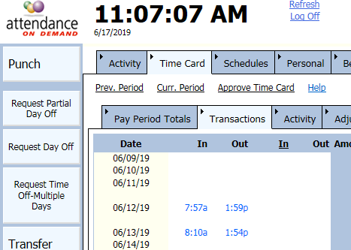

2
3
3

- To view your punches, click on the “Time Card” tab and then the “Transactions” Tab
- Please note that you should attempt to work the exact number of yours that you are scheduled to work each day and that the “Seven Minute” rule will apply. The seven minute rule rounds your punch to the nearest quarter hour. Every effort should be made to clock in and out utilizing this procedure. Missed punches create more room for error and more work in editing time cards.
  - Ex.: If you are scheduled to start at 8am and clock in at 7:54, the punch will round up to 8am. On the converse, if you clock in at 7:53, the punch will round to 7:45.
- Overtime must be pre-approved by your supervisor BEFORE you work i

    - Entering PTO for snow days (snow days cannot be made up, the amount of time you are scheduled to work is the amount of PTO that will be put in your time card). Part year staff have the choice of whether to take snow day time unpaid, if they want to take the time unpaid, that must be noted on the exception log, or PTO will automatically be entered.
    - Noting on the last day of the pay period any anomaly that occurred on the time card
    - Approving time cards
  - All employees should approve their time cards (in AOD) by Tuesday morning of a payroll week.
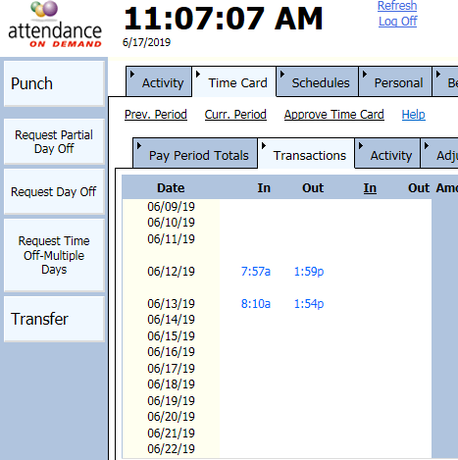
  - Site Supervisor should follow up on all unapproved or excessive “anomalies” each pay period.

All Non Education and FE’s

- Each Supervisor has an established procedure that they will discuss with you with regard to corrections.
- All employees should approve their time cards (in AOD) by Tuesday morning of a payroll week.

Title of Procedure or Process: | Timecard Correction and Approval Process
Program Area(s): | All Agency
Related Standards or Regulations: | - Head Start Program Performance Standards  - Maine State Licensing  - Developmentally Appropriate Practice/NAEYC  - Caring for Children  ☒Other
Person Responsible for  implementation: | Responsible staff members
Timeline for completion: | Weekly
Submitted to: | Human Resources and Finance

Purpose: To ensure proper payment of wages to all staff members as well as provide staff with the ability to review their timecards and approve of their hours.

Timecard Correction and Approval Process (Education and FA Staff):
Timecard Exception logs are electronic and are linked in the Staff Forms site, at https://promiseearlyeducation.org/staff-login/ There is one exception log per site, per program year (July 1- June 30)
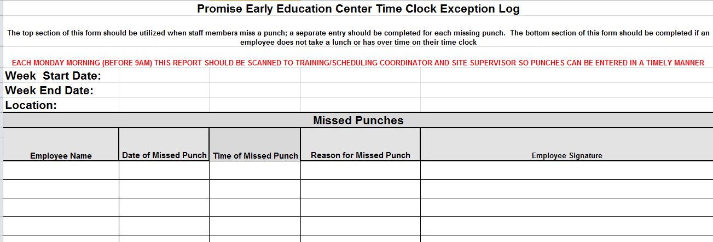
    - A separate entry for each missing punch
  - A note outlining any anomaly on the timecard (schedule change, long lunch, no lunch, over time etc)
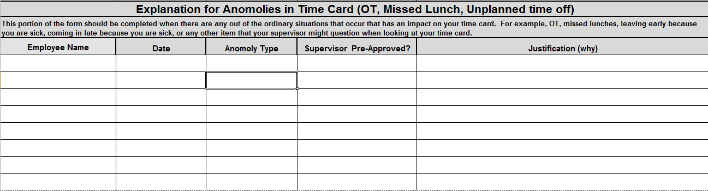
  - Employees are responsible for entering missed punches or other timecard adjustments on the electronic form no later than their next day of work after the punch anomaly date. All exception log entries for the previous pay period must be completed no later 8:00 am on Monday
  - Site Supervisors are responsible for the following items that should be completed by noon on each Monday:
    - Entering missed punches
    - Entering PTO to even out hours to budgeted amount
    - Entering UnpdAbs on AOD when no PTO is available for missed time
    - Entering PTO for unplanned absences (sick time cannot be made up, the amount of time you are scheduled to work that day is the amount of PTO that will be put in your timecard)

Title of Procedure or Process: | Unemployment Filing for Vacation Weeks
Program Area(s): | School Year Education Staff
Related Standards or Regulations: | - Head Start Program Performance Standards  - Maine State Licensing  - Developmentally Appropriate Practice/NAEYC  - Caring for Children  ☒Other
Person Responsible for implementation: | Responsible staff member
Timeline for completion: | Monday after returning from each vacation
Submitted to: | Human Resources

Purpose: To ensure you are utilizing all the benefits you are eligible for, the Human Resources Department will assist with filing for benefits over vacation weeks if you choose to participate If submitted correctly and approved by unemployment, you may be eligible for December, February and April vacation weeks. The benefit year is based upon when you first applied for unemployment and varies by person. If you applied for the first time for December vacation, December will be your “waiting” week and Feb and April vacations will be paid (less your “holiday hours”). You will need to apply/file online anytime you are filing for unemployment.
For your initial claim and to file weekly, please visit the Maine unemployment website: https://reemployme.maine.gov/
Please note that during the summer, you will need to file for unemployment each week either online or by calling unemployment directly.
FAQ’s

Q: If I have PTO does that mean I can’t file for unemployment?
A: You can still file! Unemployment does not take PTO into account when calculating benefits! You will have to report Holiday pay and that will lessen the benefit by a day…but any PTO you choose to use is “free”

Q: Will I have to do a work search?
A: It is likely if you have not already claimed 6 weeks in your benefit year you will not need to job search. Once you have filed 6 weeks of claims you are required to job search, regardless of when those claim weeks occurred

Title of Procedure or Process: | Benefit Premium Payments while on Leave
Program Area(s): | All Agency
Related Standards or Regulations: | - Head Start Program Performance Standards  - Maine State Licensing  - Developmentally Appropriate Practice/NAEYC  - Caring for Children  ☒Other
Person Responsible for  implementation: | Human Resources and Finance
Timeline for completion: | Within one week of approved Leave
Submitted to: | Human Resources
ChildPlus Documentation: | n/a
Uploaded to ChildPlus: | n/a
Specific Directions: | n/a

Purpose: While staff members are out on an approved leave of absence, the Agency continues to pay its portion of benefit premiums and staff remain responsible for continuing to pay their portion of the premium for any unpaid portion of their leave (payment through short term disability will NOT include benefit deductions).
Payment arrangements must be made for any unpaid portion of the leave in order to ensure benefits remain in effect.

Procedure:

- In order to request a Family Medical Leave or a Personal Leave, employees must submit a “Leave of Absence Request” form that is located on in the HR Folder of the staff forms website. School year staff that are going on “Summer Leave” are not required to submit a request and the HR Department will initiate the benefits payment process.
- HR will create a “Leave Benefits Agreement” form for employees to sign upon a leave of absence. The form will outline all benefit deductions and the total monthly employee cost.
  - Staff that have single coverage for medical insurance will be eligible to choose two payment options:
    - Finance will bill them and they will remit payment each month
    - When they return from leave, all owed premiums will be automatically deducted from their first paycheck
  - Staff that have family, employee and spouse, or employee and child coverage for medical insurance will be required to pay their portion of their premiums each month as to ensure continuing coverage for their family members.
- If staff fail to return to work after their leave and have not paid their portion of their insurance premiums they must pay the entire amount owed up to the recall date or their benefits will be terminated retroactively to the last month that was paid.

Title of Procedure or Process: | IT Work Order Process
Program Area(s): | All Agency
Related Standards or Regulations: | - Head Start Program Performance Standards  - Maine State Licensing  - Developmentally Appropriate Practice/NAEYC  - Caring for Children  ☒Other
Person Responsible for implementation: | Responsible staff member
Timeline for completion: | Immediately
Submitted to: | Supervisor
ChildPlus Documentation: | n/a
Uploaded to ChildPlus: | n/a
Specific Directions: | n/a

Purpose: To ensure that issues with equipment and systems are fixed in a timely manner and that staff are aware of the steps being taken to rectify said issues.

Procedure:
- Staff identifies issue and performs basic trouble shooting (reboot, unplug, etc)
- Staff completes IT Work Order form and forwards to Supervisor (located on the “Staff” tab of the staff forms website)
- Supervisor reviews IT Work Order to ensure accuracy and validity and assigns priority level
- Supervisor forwards IT Work Order to Executive Director
- In general, the following guidelines should be utilized to determine appropriate frequency of follow up:
  - Critical Priority: Should be in contact constantly until the issue is resolved
  - Normal Priority: Should be in contact every week
  - Low Priority: Should be in contact every two weeks
    - If ED is in contact with Tech and receives updates, they should be provided to Administrative Assistant ASAP
- Tech notifies staff on site and Executive Director when work order is completed.

Title of Form: | Maintenance Work Order
Related Policy: | All Agency
Program Area(s): | Health, Nutrition, Education, Special Services, Family Services, ERSEA, etc.
Related Standards or Regulations: | - Head Start Program Performance Standards  - Maine State Licensing  - Developmentally Appropriate Practice/NAEYC  - Caring for Children  ☒Other
Procedures
Form Completed By: | Responsible staff member
Timeline for completion: | Immediately
Specific Directions: | Maintenance and Executive Director
Submitted to:
ChildPlus Documentation:
Uploaded to ChildPlus:

Purpose: To ensure that issues with facilities and/or installations can be completed in a timely manner and that staff are aware of the steps that are being taken with regard to the work order.

Procedure:

- When work needs to be completed by Maintenance, a work order will be initiated by the Teacher, Family Educator, Site Supervisor or Manager (form is located on Maint. section of staff forms website). Verbal work order requests will not be assigned.
- The work order request will have no more than 3 items – it will have a requested date to be completed, who issued the work order with the center and today’s date. It also needs to specify whether it is a safety issue or not.
- The completed work order will be sent as an e-mail attachment and sent to the Facilities Tech, Site Supervisor and Executive Director
- Safety issues will take priority
- Minor work will attempt to be completed within two weeks.
- Larger jobs/projects will be estimated, and information sent back to the originator of the work order with a copy to Site Supervisor/Manager.

Title of Procedure or Process: | Pest Control Work Order
Program Area(s): | All Agency
Related Standards or Regulations: | - Head Start Program Performance Standards  - Maine State Licensing  - Developmentally Appropriate Practice/NAEYC  - Caring for Children  - Other
Person Responsible for  implementation: | Responsible Staff Member
Timeline for completion: | Immediately
Submitted to: | Maintenance
ChildPlus Documentation: | n/a
Uploaded to ChildPlus: | n/a

Purpose: To ensure the health and safety of children and staff in our facilities if you should discover a pest issue or infestation “Pest Control” form should be completed immediately (within the same day of the sighting).
Most common pests that can be found include ants, cockroaches, bees, wasps, bed bugs, mice, rats, and fleas, etc. If you are unsure when encountering a critter, please seek assistance from your supervisor.

Procedure:

- Complete “Pest Control” form (located under the Maintenance section of the staff forms website) and email to your Supervisor immediately (within the same day of the sighting)
- Site Supervisors will forward to appropriate personnel (Maintenance, Executive Director, and Health Manager.
- If pests are observed after action has been taken, another “Pest Control” form should be submitted to your supervisor until the problem is resolved.

Title of Procedure or Process: | Outlook Email
Program Area(s): | All Agency
Related Standards or Regulations: | - Head Start Program Performance Standards  - Maine State Licensing  - Developmentally Appropriate Practice/NAEYC  - Caring for Children  ☒Other
Person Responsible for  implementation: | Responsible Staff Person
Timeline for completion: | Daily
Submitted to: | n/a
ChildPlus Documentation: | n/a
Uploaded to ChildPlus: | n/a
Specific Directions: | n/a

Purpose: Outlook email and calendar accounts have been provided to all regular staff members. Email can be an appropriate and effective means of communication when you have brief straight forward pieces of information to share with coworkers, supervisors, or external parties (please review confidentiality information below when communicating with external parties via email) and can be a good way to recap a conversation to ensure clear communication has occurred. Emails should be brief in nature, be written professionally (i.e., using business writing skills, not text talk and abbreviations) and monitored on a daily.

Note on Confidentiality about email: Promise must protect the privacy of enrolled children and their families and email is not a secure means of communication. As such, the following expectations apply in all situations whether you have a release or not to speak with a provider. Providers include, but are not limited to case managers, mental health clinicians (TCMHS or other agency), or medical providers. Email to community providers cannot have any identifiable information on a child or family, i.e., name, date of birth, or address, included in the message.

The above expectations, though not required on email within our internal system, are best practice and following them will reinforce the method required when communicating with outside providers.

Procedure:

- Staff should access their email using the web application. Contact the Human Resources department if you have forgotten your username or password.
- Classroom staff should check their email at least daily, non-classroom staff should check their email multiple times a day.
- Hourly staff should only check their email when they are working (not from home or during breaks).
- To be consistent with the Promise brand, a signature should be created using the following template:
  - Log in to your email and click on “Settings Icon” in the upper right-hand corner. In the ‘Search” box start typing in “Signature” and click on the hyperlinked “Email Signature”

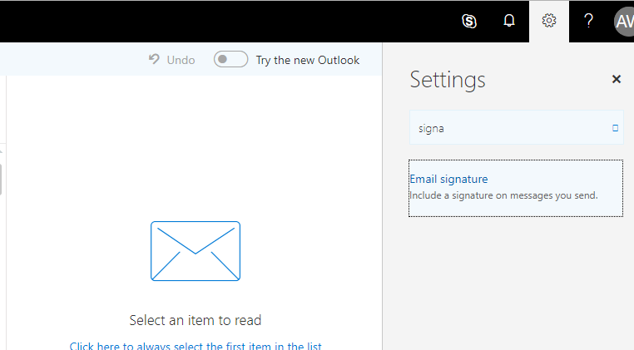
  - Copy and paste the signature below (It can be located electronically on the HR section of the
Staff Forms website entitled “Email Template”) and click “okay”
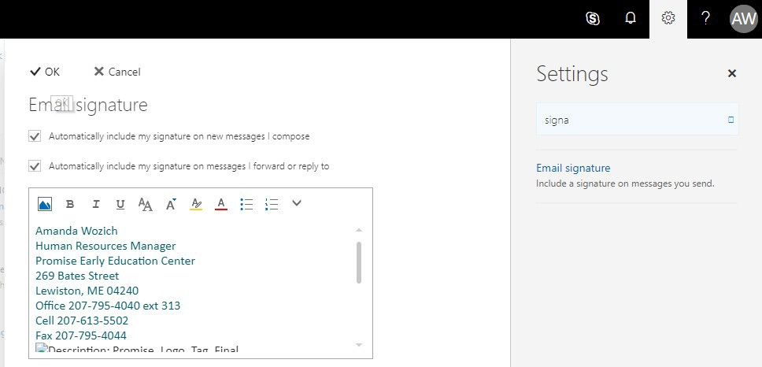

Employee Name Employee Job Title
Promise Early Education Center 269 Bates Street
Lewiston, ME 04240
207-795-4040 ext employee extension
Fax 207-795-4044 (update if you have your own fax number)

Confidentiality Notice:
This e-mail message, including any attachments, is for the sole use of the intended recipient(s) and may contain confidential and privileged information. Any unauthorized review, use, disclosure, or distribution is prohibited. If you are not the intended recipient, please contact the sender by reply e-mail and destroy/delete all copies of the original message. Thank you.

Title of Procedure or Process: | Outlook Calendar
Program Area(s): | All Agency
Related Standards or Regulations: | - Head Start Program Performance Standards  - Maine State Licensing  - Developmentally Appropriate Practice/NAEYC  - Caring for Children  ☒Other
Person Responsible for  implementation: | Responsible Staff Person
Timeline for completion: | Daily

Purpose: Outlook email and calendar accounts have been provided to all regular staff members. When calendars are updated appropriately, it is a tool that can assist with keeping track of work tasks and meetings, it allows your supervisor and administrative staff to schedule meetings when you are available, and provides a safety measure when staff are conducting home visits.

Procedure:

- All staff must use their Outlook Calendar to document home visits for safety purposes. Home visit information must include address of visit location and phone number of family in calendar detail (please refer to Home Visiting Safety Procedures and in the Family Services of this manual for complete instructions).
- Meetings to document in your calendar include parent meetings, parent-teacher conferences, home visits as previously noted, family advocate meetings, supervision, agency events, in-service days, communities of practice, trainings, feedback and consultations, IEPs/IFSPs, family team meetings, public pre-K meetings if appropriate, center/parent meetings, time off and other appointments, events, or deadlines.
- Staff should share their calendar so that their supervisors can view all details. Instructions for sharing is as follows:
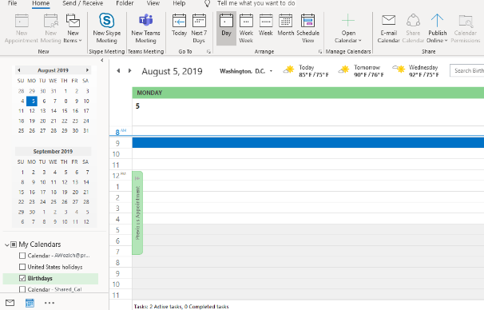
  - Log in to your email account and click on the “Calendar” tab in the bottom left-hand corner of the screen and then click on the “Share” tab.

  - Once you click on the “Share Calendar, click on “Calendar” and “Add” and select the name of the person you want to share your calendar with. On the bottom of the box in the “Permissions” section click the “Can Edit” box and then hit apply.
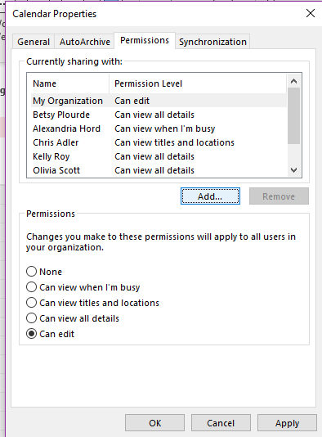

Title of Procedure or Process: | Voicemail
Program Area(s): | All Agency
Related Standards or Regulations: | - Head Start Program Performance Standards  - Maine State Licensing  - Developmentally Appropriate Practice/NAEYC  - Caring for Children  ☒Other
Person Responsible for implementation: | Responsible Staff Person
Timeline for completion: | Daily
Purpose: A Voicemail account is provided to each classroom as well as administrative staff so that parents and customers have a means of leaving a message when staff are not available to answer the phone. In order to ensure customers and parents know what to expect and have all pertinent information when leaving a message, voicemail greetings should contain a consistent greeting regardless of the classroom or person customers and parents are attempting to reach.

Procedure:

- To update your voicemail greeting take the following steps:
  - Dial 500
  - Enter your password (your extension)
  - Press 3 “Manage Your Mailbox”
  - Press 1 “To Change your Greeting”
  - Select Greeting “1”
  - Press 2 to “Re-record”
  - Record your greeting using the following script “You have reached location/classroom or name/title, for example Coburn Room 2 or FDC…. John Smith, Administrative Assistant. We are or I am currently unavailable to take your call. Please leave your name and number and we/I will return your call. If this is an emergency, please hang up and call back at 795-4040 and press 0. Thank you”
  - Press 9 to save your greeting
- To update your voicemail name (classroom, personal name or department name) take the following steps:
  - Dial 500
  - Enter your password (your extension)
  - Press 3 “Manage your Mailbox”
  - Press 2 “User Options”
  - Press 6 to “record name”
  - Say name and press #
- Voicemail should be checked on an ongoing basis (at least three times over the course of the day). To check your messages, take the following steps:
  - Dial 500 or press the blinking voicemail button
  - Enter your security code
  - Press 1 to play your messages

Title of Procedure or Process: | Maine Roads to Quality (MRTQ) Registry-Annual Review
Program Area(s): | Education, Management, Supervisor, and Family Advocate Staff
Related Standards or Regulations: | - Head Start Program Performance Standards  - Maine State Licensing  - Developmentally Appropriate Practice/NAEYC  - Caring for Children  ☒Other
Person Responsible for implementation: | Responsible staff member
Timeline for completion: | Once Yearly on Anniversary of Enrollment.
Submitted to: | Human Resources
ChildPlus Documentation: | n/a
Uploaded to ChildPlus: | n.a

Purpose: To ensure up to date training and employment documentation is provided to an annual basis so that the Agency can continue to maintain four star quality ratings. Once on the Registry as member, you are expected to maintain the accuracy of the information within your Professional Development Profile.

Procedure:

- You will receive an annual reminder email from iSolved to update your account based on the yearly anniversary you registered with Maine Roads to Quality.
- The following information should be updated
  - Email address
  - Home address
  - Workplace
  - Current level of Education
  - Certifications
- Enter any non- Maine Roads to Quality trainings under the “My Education” tab. They should be entered as “Elective Trainings”. Only trainings that you were awarded a certificate should be uploaded, as only these will be considered verified once Maine Roads receives the certificate(s). Certificates can be emailed or scanned and emailed to: mrtq.registry@maine.edu.
- If you need a copy of your training certificates, please contact Human Resources.

Title of Procedure or Process: | Roles and Responsibilities Form & Zoning and Staffing Grid
Program Area(s): | Health, Nutrition, Education, Special Services, Family Services, ERSEA, etc.
Related Standards or Regulations: | ☒Head Start Program Performance Standards  - Maine State Licensing  ☒Developmentally Appropriate Practice/NAEYC  - Caring for Children  - Other
Person Responsible for implementation: | Lead Teachers and Supervisors
Timeline for completion: | Within 1 week of a new staff person starting in a classroom
Submitted to: | NA
ChildPlus Documentation: | NA
Uploaded to ChildPlus: | NA
Specific Directions: | See Below

Procedure:

- Lead teacher and/or supervisor reviews roles and responsibilities form and assigns tasks to individuals within 1 week of new staff starting full time in the classroom.
- If needed, team will also update the zoning and staffing grids to reflect new staff or staffing pattern.

Title of Procedure or Process: | Educational Monitoring Tool
Program Area(s): | Health, Nutrition, Education, Special Services, Family Services, ERSEA, etc.
Related Standards or Regulations: | ☒Head Start Program Performance Standards  - Maine State Licensing  ☐Developmentally Appropriate Practice/NAEYC  - Caring for Children  - Other
Person Responsible for implementation: | Lead Teachers, Site Supervisors and Coaches
Timeline for completion: | Review monthly
Submitted to: | NA
ChildPlus Documentation: | NA
Uploaded to ChildPlus: | NA
Specific Directions: | See Below

Procedure:

- Teachers, coaches and supervisors will use the Educational Monitoring Tool monthly to ensure timelines and mandates are met.

 | Attendance Monitoring and Required Follow-up
Program Area(s): | Health, Nutrition, Education, Special Services, Family Services, ERSEA, etc.
Related Standards or Regulations: | ☒Head Start Program Performance Standards  - Maine State Licensing  ☒Developmentally Appropriate Practice/NAEYC  - Caring for Children  - Other
Person Responsible for implementation: | Lead Teachers and Family Advocate
Timeline for completion: | Daily
Submitted to: | Full Day attendance records are sent to Fiscal and Part Year attendance records  are given to Site Supervisors
ChildPlus Documentation: | Entry Express-Attendance on tablet or laptop by 9am (or within ½ hour of your start time)
Uploaded to ChildPlus: | NA
Specific Directions: | See Below

Procedure:

Teachers will build a positive expectation for attending school and building a relationship with the parent, child and school by communicating directly with families, especially those children who have a history of at- risk or chronic absenteeism.
Every day:
      - Say hello to each and every child when they arrive.
      - If a child arrives after an absence, make sure to make a 1:1 connection to say how glad you are to see them back at school.
      - Remind children that “School is your first and most important job.”
Recording Attendance
- The teacher assistant will print the most current attendance sheet each Friday for use the following week.
- Parents sign children when arriving in the classroom or if arriving by bus, teaching staff will document attendance on the attendance sheet in the classroom as children arrive.
Attendance will be entered in ChildPlus by 9:30am every day.
- If parent has made contact that their child will be absent, write the reason for a child’s absence in the “Absence Reasons” area of ChildPlus.
- If the absence is due to child illness, also document in the Health Communication Log the symptoms (cough, runny nose, rash, fever, etc.) or diagnosis.
- When staff is made aware of reasons for absence after attendance has been recorded in the system, TA will update the absence reason in attendance. This step is critical in ensuring that we are able to conduct an effective analysis of the class’ absence reasons.
- When a child arrives late, or leaves early, document the child as Tardy or Left Early in ChildPlus.

Child Absences and required follow up:
- Phone Call for “no call/no show”:
If the parent has made no contact (“no call/no show”) regarding the child’s absence that day the family is texted as soon as possible that day- within an hour of class time using a Family Advocate if feasible. The first call is to establish the reasons for absence, offer support, explain the benefits of regular preschool

attendance, and problem-solve any attendance barriers. Note the results of the call under Absentee Reasons in ChildPlus.
If the parent is not reached, log in CP+ that a call was made / message was left.
- Follow-up call made if needed:
HS teacher/Family Advocate will call/text all families that were not reached by “First Call”.
The educator will establish the reason for the absence, offer support, explain the benefits of regular preschool attendance, and problem-solve any attendance barriers. Note the results of the call on the attendance in ChildPlus.
- We missed your child here at school
- We care about your child
- Mention a positive comment about the child
- Inquire about their health--- Is she/ he feeling OK??
- Some of the activities/ work your child missed involved….(using a preferred communication method)
- Home Visit after two consecutive days of NO CALL/NO SHOW:
If a child has been absent for two consecutive days with No call/No show Family Advocates MUST conduct a home visit no later than the morning of the third day. Document the outcome of the home visit in an attendance follow up case note.

ATTENDANCE MONITORING:
Use ChildPlus Report: #2305

  - Attendance Conversation:
The first month a child falls below 90% (missing 2 or more days) staff enter as event in Family Services as Attendance Conversation with summary of absence reasons and supports offered.
  - Initial Attendance Goal:
Goal is set with family upon enrollment on the initial home visit.
  - Attendance Goal for Moderate/Chronic Attendance MUST be established and documented under Family Services:
The second consecutive month where the child falls below 90%, staff will engage the family in a conversation regarding the importance of attendance; determine the reasons for absences and brainstorm with parents how to improve attendance will be documented as an Initial Attendance Goal under Family Services.

*If chronic absence for two consecutive months is the result of illness, consult Health Services staff.

*If the child is on an IFSP, notify both the CDS Case Manager and the Special Services Coordinator, and consult with them while addressing chronic poor attendance.

Title of Procedure or Process: | Classroom Environments
Program Area(s): | Education
Related Standards or Regulations: | ☒Head Start Program Performance Standards  - Maine State Licensing  ☒Developmentally Appropriate Practice/NAEYC  - Caring for Children  - Other
Person Responsible for implementation: | Lead Teachers
Timeline for completion: | NA
Submitted to: | NA
ChildPlus Documentation: | NA
Uploaded to ChildPlus: | NA
Specific Directions: | See Below

PROCEDURE:
    - Ensure indoor and outdoor spaces are safe, clean, spacious and attractive at all times.
    - Classroom doors are locked for both safety and the social-emotional health of children.
    - Teaching related materials such as staplers, teacher scissors, etc. must be stored out of child reach and not on a teacher desk or cubby top.
    - Teacher personal belongings are stored in closet or teacher room. All teacher beverages must be stored in an opaque container and out of reach of children.
    - Cell phones and electronic devices are not allowed in the classroom. Phones and devices must only be accessed when on break or at end of day.
    - Activity areas are clearly defined while allowing children to work individually or together in small or large groups and are clearly labeled as dramatic play, blocks, etc.
    - Space is arranged to provide clear pathways for children to move from one area to another and to minimize distractions.
    - Developmentally appropriate materials and equipment are displayed on low, open shelves to promote accessibility and independent use by children. Sufficient quantity of durable materials and equipment is available.
    - Materials on shelves should be stored in an orderly fashion and shelving should not be left bare or sparse. Materials are displayed in such a way that it is clear to children “how much” material is needed for one person to play successfully.
    - Certain centers such as blocks, dramatic play, sensory tables or libraries will have limits posted in individual centers to indicate the number of children who can play there # of children will be determined based on center size and quantity of materials available for all to play.
    - Classroom labels are affixed to shelving using contact paper or small amounts of Velcro. Do not use clear tape.
    - Classroom labels and displays included the home languages of children in the classroom.
    - No tape of any kind should be placed on rugs or floors.
    - Posters and signs should be hung on bulletin boards. Do not use any type of tape or Velcro to attach posters to walls. If necessary to hang something on a wall, use 3M hooks or hangers only.
    - Napping mats/cots are stored in a sanitary manner with napping surfaces not touching and blankets stored in plastic totes.
    - As needed, classrooms will adapt and modify space for special needs (wheelchairs, other individual adaptive equipment/materials).
    - Classrooms will utilize Turns Lists daily in all areas where children may be waiting for a turn (see Turns List Guidance for more guidance).
    - Classroom environmental changes need to involve a coach.
    - Learning centers should be set up in the following manner:
Block Area
      - The block area should be one of the two biggest centers in the room

      - Should be enclosed on 3 sides so that there is only one way into the center in order to minimize outside interruptions and foot traffic
      - The block area should have a flat, solid surface for building while also giving the children a comfortable place to sit on the floor such as a thin rug
      - There must be enough wooden unit blocks for at least 3-4 children to build independent structures
      - There should be different kinds of blocks in the center
      - Should have some accessories (people, road signs, cars, animals, small buildings, etc.) that can be used to enhance block play as related to curriculum. “Extra” block props that are not tied to theme or curriculum are stored outside of the block area and not on the shelf.
      - Blocks must be separated by type (wooden vs foam) and stored in an organized manner.
      - Writing materials should be available for labeling, sign making, etc.
Art Area
      - There should be an art easel, open art shelf and table within the area
      - Should be located close to the water supply to ease with clean up.
      - The center must provide a variety of materials to children such as crayons, markers, paint, play dough, yarn, scissors (as appropriate), glue, beautiful junk from the Share Center, etc.
      - Materials should be arranged so that children can use them with minimal assistance from adults
      - Smocks should be available for children to wear while they are creating, especially when using paint. There should be at least as many smocks as there are children allowed to play in the center at the same time
Fine Motor/Manipulatives Area
      - Should be several different types of fine motor materials in this center including those that snap, connect, stack, etc.
      - The materials should vary in difficulty to address the needs of all children. Some examples are regular and knobbed puzzles, larger and smaller interlocking blocks, smaller and larger stringing beads, etc.
      - Most fine motor materials should be stored in bins (without lids) and should be labeled with pictures and words to help the children with organizational skills, clean-up, and literacy skills. Materials can also be displayed on trays in appropriate amounts for one child to use and tray can be used to help define play space
      - A table should be in or near the fine motor area so children can play with the materials comfortably
Math Materials
      - A variety of math related manipulatives such as counters, unifix cubes, pattern blocks, numbered manipulatives, # or shape puzzles, magnetic numerals, sorting containers, scale, etc.
      - Counting games
      - Building Blocks activities
      - Math related literature to be located/displayed in the center or incorporated in the classroom library.
Library Area
      - Must be enclosed on 3 sides so that there is only one way into the center in order to minimize outside interruptions and foot traffic
      - Should be a quiet, comfortable area with soft furnishings for children to relax. Soft furnishings should include a couch and or chair, small carpet
      - The library area should have at least 35 books in a variety of genres (wordless, fiction, non-fiction, board, etc.) accessible for children with many of them facing forward so the cover can be seen
      - Books in the library area should be age appropriate, in good condition, and cover a variety of topics such as differing abilities, cultures, health, jobs/work, math, people, nature/science, etc.
      - There should be at least 5 books displayed in the room (doesn’t have to be in the library area) that relate to current classroom activities or themes
      - The library is not used as a “break space” or alone space (cube).
Dramatic Play Area
      - The dramatic play area should be one of the two biggest centers in the room along with the block area
      - There should be a variety of dramatic play materials accessible such as dolls, child-sized furniture, play foods, cooking utensils, and dress-up clothes for boys and girls. Additional dramatic play props such as a mailbox, restaurant menus, doctor tools, or play money, etc. are added as it relates to the

unit of study and removed when the theme changes i.e. restaurant materials are replaced with doctor tools…
      - The dramatic play area can be altered to address the interests of the children and does not have to just be a “kitchen” area
      - There should be at least 4 examples to represent diversity in the dramatic play area such as dolls of different races, foods of different cultures, equipment used by people with disabilities, etc. and include examples of home language in signs, labels or displays.
Sensory Table
      - A sand/water table must be accessible for children every day.
      - Number of tools and toys added still allows space to use sensory materials and do not crowd the table.
      - Sand substitutes can be used in the table but cannot include food products such as rice or beans.
Science Area
There should be a variety of science materials accessible from 4 specific categories:
      - Living Things: plants, window bird feeder, butterflies, etc.
        - It is encouraged, but not required, that each classroom have a living thing such as a plant so the children have the opportunity to help take care of it. If there is a plant in the classroom, it must be labeled with the name of the plant and must be found on the Safe Plants list
      - Natural Objects: seeds, leaves, pine cones, rocks, seashells, etc.
      - Science related literature: fiction and non-fiction texts.
      - Nature exploration/Science Tools: color paddles, magnets, magnifying glasses, prisms, mirrors, tornado tubes, etc.
Writing Area
      - This area should be a permanent interest area in the classroom with a writing table and shelf with writing materials
      - There should be various types of writing materials in this area such as markers, crayons, pencils, lined paper, blank paper, construction paper, journals, envelopes, etc.
      - The area should contain items that encourage the child’s interest in learning to write alphabet letters such as a book with names of the children, alphabet strip/poster in plain view, Picture Dictionary/ABC book, etc.
    - Classroom space should include soft elements such as rugs, cushions, or soft seating.
    - Classroom will have a cozy/safe area created with the wooden cube that will allow children to COMPLETELY escape the business of the room where a child can be mad, sad or just alone. This should not be in your Library/Reading area to ensure that upset children do not cause a disruption to the reading in the library.
    - Check that the environment reflects non-stereotyping and cultural diversity and reflects the backgrounds and interests of families and children. Cultural diversity is represented in the classroom in pictures, photographs and materials displayed and used in activities.
    - The “Required Classroom Display” document identifies several items that must be posted inside or outside the classroom. In addition to those required items, the display should be used to enhance the child’s environment and promote learning such as literacy and math skills.
    - The weekly theme/topic should be evident in the classroom display and materials offered in the classroom.
    - Photos and names of the enrolled children should be found in multiple places throughout the room. Examples would be: Their cubbies, tables, charts, child identifiers for center selection (i.e. pictures on ice cream sticks), bulletin boards, birthday displays, writing center, etc).
    - Classroom displays should be limited to bulletin boards and about 1/3 of the display materials should be children’s individualized artwork.
    - Arrange a parent bulletin board/message center that is regularly updated with attractive displays, interesting articles and announcements of activities and events of the program, center and community. Refer to “Required Classroom Display” document for guidance.
    - Use signs/labels and pictures in each interest area of the classroom to help everyone where materials belong.
    - Add Language Facilitation Guides to centers to help teachers, practicum students or volunteers know what skills children can learn and how to facilitate activities or language interactions in each area.

    - Separate the location of the learning centers that are “quiet” from the ones that are “noisy” and separate wet/messy play from dry play areas. This can be done by having them on opposite sides of the classroom or by placing a “buffer” center between them. Centers should be viewed as quiet, noisy, messy or a buffer based on the information below:
Quiet Centers: Library, Writing, Puzzles, Buffer Centers: Manipulatives, Science, Math,
Messy Centers: Art, Sensory table(s), Noisy Centers: Dramatic Play, Blocks,
    - There are individual spaces provided for children to hang their clothing and store their personal belongings. Children’s belongings should not be touching while stored in their individual areas. Spare clothes are stored in Ziploc bags in a cubby or kept in a child’s backpack.

Title of Form: | Daily Classroom Cleaning Expectations
Related Policy: | Health Safety Practices
Program Area(s): | Education
Related Standards or Regulations: | ☒Head Start Program Performance Standards  ☒Maine State Licensing  - Developmentally Appropriate Practice/NAEYC  ☒Caring for Children  - Other
Procedures
Form Completed By: | Teacher Assistant/Ed Tech
Timeline for completion: | Daily
Specific Directions: | Complete cleaning & sanitization tasks as described within the form
Submitted to: | NA  Daily Cleaning form laminated and re-used daily
ChildPlus Documentation: | NA
Uploaded to ChildPlus: | NA

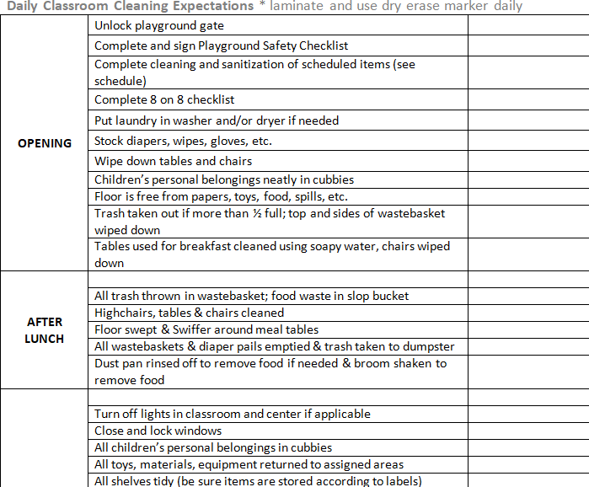

Title of Form: | 8 on 8 Health and Safety Check
Related Policy: | Health Safety Practices
Program Area(s): | Education
Related Standards or Regulations: | ☒Head Start Program Performance Standards  ☒Maine State Licensing  - Developmentally Appropriate Practice/NAEYC  ☒Caring for Children  - Other
Form Completed By: | Teacher Assistant/Ed Tech
Timeline for completion: | Daily
Specific Directions: | Complete tasks as described within the form
Submitted to: | NA
ChildPlus Documentation: | NA
Uploaded to ChildPlus: | NA

Procedure:
- Lead teachers will assign 8 on 8 tasks to classroom staff and develop a system for ensuring completion when responsible staff are absent.

Title of Form: | Cleaning and Sanitization Form
Related Policy: | Health Safety Practices
Program Area(s): | Education
Related Standards or Regulations: | ☒Head Start Program Performance Standards  ☒Maine State Licensing  - Developmentally Appropriate Practice/NAEYC  ☒Caring for Children  - Other
Procedures
Form Completed By: | Teacher Assistant/Ed Tech
Timeline for completion: | Daily
Specific Directions: | Complete cleaning & sanitization tasks as described within the form
Submitted to: | NA  Cleaning and Sanitization form-place completed form in Yellow Book
ChildPlus Documentation: | NA
Uploaded to ChildPlus: | NA

Procedure:
- Lead teachers will assign cleaning and sanitization tasks to classroom staff and develop a system for ensuring completion when responsible staff are absent.

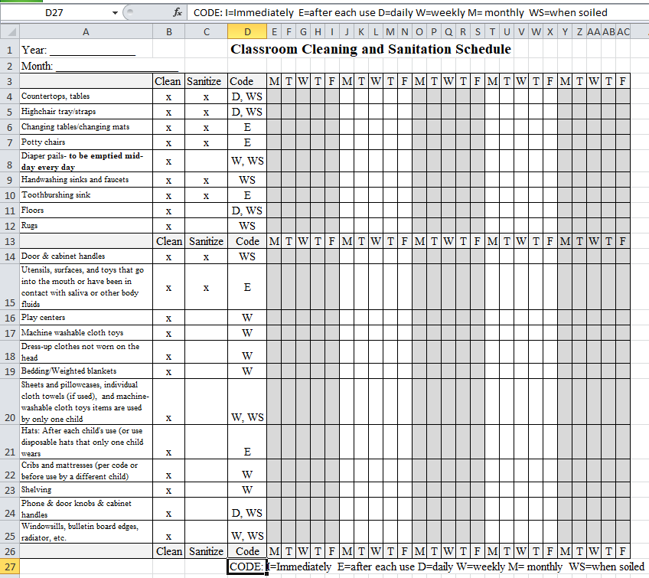

Title of Procedure or Process: | Bulletin Board & Resource Shelf Guidance
Program Area(s): | Education, Health, Nutrition & Family Services
Related Standards or Regulations: | ☒Head Start Program Performance Standards  ☒Maine State Licensing  - Developmentally Appropriate Practice/NAEYC  - Caring for Children  - Other
Person Responsible for implementation: | Teacher Assistants or Ed Techs
Timeline for completion: | Updated as needed
Submitted to: | NA
ChildPlus Documentation: | NA
Uploaded to ChildPlus: | NA
Specific Directions: | See below

Required Classroom Displays:

Title of Sign/Poster/Display |  | Item Description | Required Location |  | Where to find information
Program Information
Child Care License |  |  |  | Promise: At center entrance  Public School Partnerships:  Spruce- in classroom  LPS- in FA office |  | Agency Provided
5210 Certificate |  |  |  |  |  | Agency Provided
Maine Roads to Quality Certificate |  |  |  |  |  | Agency Provided
Nutrition
“And Justice for All” | USDA document |  |  | Must be visible to parents |  | Agency/School Provided
Building for the Future | CACFP document |  |  |  |  | Agency/School Provided
Menus |  |  |  |  |  | Agency/School Provided
Health & Safety
First Aid Kit | A sign/”Red Cross” that shows location of first aid kit |  |  | On door or cabinet containing First Aid Kit |  | Teacher Created
Emergency Board | Medication & Allergy information, Emergency #’s, fire drill procedure, poison control, dental emergencies, emergency resources posted on red bulletin board paper |  |  | Wall closest to door and phone |  | Agency/School Provided
Fire/Evacuation Route(s) | A diagram of building that clearly shows a marked path that will be used to exit the building in case of emergency |  |  | Wall closest to door and phone |  | Agency/School Provided
CPR/Choking Procedures | Pictorial diagrams of emergency procedures |  |  | Next to/near Emergency Bd |  | Agency Provided
Diapering Procedure EHS | Steps of diapering process |  |  | Near changing table |  | Staff forms website
Handwashing Procedure | Visual showing steps in handwashing |  |  | Above all sinks in the classroom |  | Dropbox
Visitor Access | A document that describes who can be given access to classrooms |  |  | Near security system “buzzer” |  | Agency Provided
8 on 8 Checklist | 8 safety tasks completed every am |  |  | Posted in classroom |  | Staff Forms Website
Cleaning and Sanitization Schedule | Form used to record daily/weekly cleaning tasks |  |  | Posted in classroom |  | Staff Forms Website
Agency Contact List | All staff phone directory and including center addresses |  |  | Next to phone |  | Staff Forms Website
Ratios Matter Wipe-off poster | Form used to document # or children and adults present in the classroom |  |  | On/next to classroom door |  | Staff Forms Website
Education
Weekly Lesson Plan | A printed lesson plan from CC3 or OWL/BB |  |  | Must be posted |  | Teacher Created
Classroom Schedule for Adults | A typed, detailed schedule of the day with times listed |  |  | Near teacher area |  | Agency Provided
Picture Schedule for Children | Pictures and text on a large chart |  |  | Displayed at child height |  | Teacher Created
Cubby Labels | Include first name only (and photo at beginning of year) |  |  | Located on cubbies |  | Teacher Created
CHILD / CLASSROOM DISPLAYS | Allow displays to show the wide range of activities occurring in your room  Label displays with child’s first name  Use rolled paper or fabric on your bulletin boards- DO NOT use construction paper Any board using fabric needs to be flame retarded  Staple use on bulletin boards:  Cover exposed staples with piece of tape  Remove “old” staples from board when swapping-out child work. No thumb tacks ANYWHERE
Title of Sign/Poster/Display | Item Description | Required Location | Where to find information

Helpers/Job Chart (HS) | A chart that identifies responsibilities for a small number of children during the day |  |  | Near large group area |  | Teacher Created
Classroom Rules | A short list of rules (that includes visuals) for children written to tell them what they “can do” not what they “can’t” |  |  | At child level in classroom |  | Staff Forms Website
Center Labels | A label or sign that identifies each center |  |  | On center shelf/bulletin bd |  | Dropbox
Limit Signs (HS) | Signs that indicate the # of children who can play in a center using numerals and visuals |  |  | Center areas/shelves |  | Dropbox
Language Guides or Instructional Support Guides (HS) | A document that prompts language interactions between children and adults |  |  |  |  | Dropbox
Alphabet or Number Charts/Signs |  |  |  | Posted at child’s eye level |  | Agency provided or teacher created
“Welcome” Sign in multiple languages |  |  |  | On front door |  | Agency provided or teacher created
5210 Poster |  |  |  | Within the classroom |  | Agency provided
Family Services Community Board
WIC |  |  |  |  |  | Agency provided
Internal Job Postings |  |  |  |  |  | Agency provided
Area Parenting Resources/Activities |  |  |  |  |  | Agency provided
Curriculum Information |  |  |  |  |  | Agency provided
Licensing Manual ( Up To Date |  |  |  |  |  | Agency provided
Parent Handbook (Up To Date) |  |  |  |  |  | Agency Provided
Monthly Average Attendance |  |  |  |  |  | Agency Provided

RESOURCE SHELF
OWL/Building Blocks/Creative Curriculum teacher manuals | Licensing book | Agency teacher resource books
Parent handbook  Personnel Policies | Purple (health) book | Asthma resources
Color me healthy curriculum 5210 resources | Personal safety curriculum  I am Moving I am Learning resources | Hanen: Learning Language & Loving It book
Second Step SE  Kind Mind | SIOP texts if applicable | MELDS  HSELOF
HS Performance Standards

Title of Procedure or Process: | Classroom Schedules
Program Area(s): | Education
Related Standards or Regulations: | ☒Head Start Program Performance Standards  ☒Maine State Licensing  ☒Developmentally Appropriate Practice/NAEYC  - Caring for Children  - Other
Person Responsible for implementation: | All classroom staff
Timeline for completion: | Daily in classrooms
Submitted to: | NA
ChildPlus Documentation: | NA
Uploaded to ChildPlus: | NA
Specific Directions: | See below

Procedure:
- Teachers will implement a classroom schedule that will provide a balanced program and guide children and adults into a consistent and orderly day. Classroom schedules will be followed with fidelity.
- Teachers will post both a picture schedule for children at child height and an 8x11 copy of a daily schedule for adults with times attached to the components of the day
- The daily schedule provides for alternating periods of quiet and active play.
- Indoor free choice periods allow the children to choose the materials they play with and which learning centers they want to spend time in. Children are allowed to play in a center or with classroom materials until they are finished or it is time for the next transition. Children waiting for a turn should use the Turns List (See Turns List guidance for more information).
- Outdoor/gross motor play should be scheduled as follows:
  - All full-day and part-day programs (6 hours or more) must have 60 minutes of outdoor/gross motor play daily.
  - If classrooms are unable to go outside, physical activity is provided in the classroom for 30 minutes.
- A 60-90 minute rest/quiet period is scheduled for classes in session for 4 hours or more each day (See Nap Guidance for more information).
- Routine tasks are integrated into the program as a means of furthering children’s learning, self-help and social skills. Routines such as toileting, hand washing, and tooth brushing should be relaxed, reassuring, and individualized based on developmental needs.
- Changes to planned or routine activities (according to the needs or interests of the children, and/or to cope with changes in weather or other situations that affect routines) are conducted without unduly alarming or unsettling the children.
- Transitions are conducted smoothly between activities.
  - Children should not always be required to move from one activity to another as a group. Use transitions as a vehicle for learning. Wait time/down time should be less than 3 minutes.
- A copy of the daily schedule is provided by Education department or Coaches at the start of every school year. Coaches are always involved in changes to classroom schedules after the start of the year.

Title of Procedure or Process: | Arrival and Release of children
Program Area(s): | Education
Related Standards or Regulations: | ☒Head Start Program Performance Standards  ☒Maine State Licensing  ☒Developmentally Appropriate Practice/NAEYC  - Caring for Children  - Other
Person Responsible for implementation: | All classroom staff
Timeline for completion: | Daily in classrooms
Submitted to: | NA
ChildPlus Documentation: | NA
Uploaded to ChildPlus: | NA
Specific Directions: | See below

Procedure:
All necessary precautions are taken to ensure that children arrive safely to their classroom before class and are released from the classroom or bus only to an authorized parent/guardian after class. For this reason, we will only release a child to his/her parent or legal guardian, or to an adult or responsible person (14 years of age or older) authorized in writing by the parents or legal guardian to receive the child on the Emergency Card.
Arrival:
- Upon arrival, the person bringing the child to the center shall:
  - Sign the child into the center and note arrival time.
  - Participate in child’s daily health check and hand washing.
  - EHS: Change the child’s diapers according to the posted diapering procedure.
  - Remain with the child until the child is accepted by staff.
  - Say good-bye to the child prior to departure.
- Upon arrival, the teacher will:
  - Greet each and every parent/caregiver and child.
  - Ensure sign in is complete.
  - Complete a quick visual health check.
  - Encourage adult to assist with hand washing.
Departure:

- The parent/guardian picking up the child shall:
  - Check their child’s cubby for clothes/papers that need to go home.
  - Sign the child out (See Release of a Child below).
  - Discuss with staff member about how the child’s day went before leaving.
  - In EHS classroom Infant/Toddler Communication sheets are provided to parents.
  - If a person other than the parent/guardian picks up the child, information cannot be shared concerning the child’s day unless the parent/guardian has given written permission. Refer to Confidentiality Guidelines for Sharing Information.
- Upon dismissal the teacher will:
  - ID the adult picking child up if unknown or within the first 4 weeks of school and compare with e-card information.
  - Briefly share with parent/guardian about child’s day. Use “Oreo Cookie” approach if needed.
  - EHS provide copy of I/T Communication Sheet.

Release of Child

For the safety of the children, an authorized individual must accompany a child to and from school each day. Parents/Guardians will be required to provide names of individuals who are authorized to pick up their child from the center to be listed on the emergency card. Individuals authorized to pick up children must be at least 14 years of age and have a photo I.D or be willing to allow PEEC staff to create a photo I.D. card. These procedures will be followed in each classroom.

- Parents/Guardians or designated individuals are expected to drop off and pick up their child at the designated time
- In the event of an emergency that will cause parents/guardians to be delayed, they are to contact the center staff immediately. Contact information is included in the handbook.

- If the dismissal time passes with no contact from parents/guardians, staff will follow these procedures:
  - Efforts will be made to contact parents/guardians
  - If unsuccessful, individuals listed on the emergency card will be contacted.
  - If unsuccessful, Head Start Staff will contact law enforcement.
- If a staff member determines that the adult picking up the child is unable to safely provide care for the child, the procedure is as follows:
  - The staff member calmly approaches the individual and asks to speak with them privately.
  - The staff member states their concern for the safety of the child.
  - The staff member offers to contact another person to pick up the child.
  - The staff member will notify local authorities if unable to contact an authorized individual.

- In addition, Promise has established a safeguard to the children enrolled in the program. If anyone who comes to pick up a child seems to be under the influence of drugs or alcohol, the child will not be released to that individual/parent and another individual from the emergency card will be contacted. Promise will contact law enforcement and DHHS.
- Staff member will notify supervisor if these instances occur.
- Child custody issues will be handled according to the regulations set forth by the State of Maine. If you have a court order that limits the rights of one parent in the matters such as custody or visitation, please bring that order to your Family Advocate or your child’s teacher, so that a copy can be placed in your file.

All parents and guardians will be asked for identification for the first 4-6 weeks of school to ensure the safety of children. Head Start and Early Head Start staff shall always verify the identification of any person, other than the parent or legal guardian who picks up the child.

Title of Procedure or Process: | Rest Time Expectations
Program Area(s): | Education
Related Standards or Regulations: | ☒Head Start Program Performance Standards  ☒Maine State Licensing  ☒Developmentally Appropriate Practice/NAEYC  ☒Caring for Children  - Other
Person Responsible for implementation: | All classroom staff
Timeline for completion: | Daily in classrooms with rest time
Submitted to: | NA
ChildPlus Documentation: | NA
Uploaded to ChildPlus: | NA
Specific Directions: | See below

Procedure:

Agency Guidelines:
- All classroom schedules will allow for a daily rest period of at least 60-90 minutes within their daily routines if operating for four or more hours.
- Naptime should not exceed 2 hours in HS and ALL children will be up from rest by 2:30 pm everyday regardless of when they fell asleep.
- Staff will inform children of the daily schedule and will prepare children for the rest period by setting boundaries around the expectations and why rest time is important.
- Staff will implement a system for routines-i.e.: bath rooming, hand washing, etc. to be completed before children settle down for their rest period.
- Staff will be consistent with expectations and support one another around the implementation of rest time.
- Staff will establish a classroom climate that encourages children to rest with dim lighting (not dark), soft music, etc.
- Staff will zone appropriately during rest time to ensure adequate supervision of all children and will maintain enough light in a classroom during rest to ensure adequate visual supervision of all children (example: teachers need to be able to see if a child’s lips turn blue during sleep).
  - Every 15 minutes, a staff person physically walks around the classroom and checks on resting children.
- Children in our classrooms shall be provided with an individual space in which to rest. All cots or mats will be spaced at least 2ft. apart.
- Children will be provided with quiet materials to explore while rest time is occurring (books, puzzles, paper and pencil, small manipulatives).
- Children will be actively supported by staff to maintain their individual space.
- Children who choose not to sleep will be offered quiet activities at a table monitored by staff.
- All children will be provided with a arms-free wearable blanket (in a crib) or blanket (on a cot) during rest time.
- EHS staff will refer to Safe Sleep Practices when napping infants and toddlers.

Title of Procedure or Process: | Screen Time
Program Area(s): | Education
Related Standards or Regulations: | - Head Start Program Performance Standards  - Maine State Licensing  ☒Developmentally Appropriate Practice/NAEYC  ☒Caring for Children  ☒Other: American Academy of Pediatrics
Person Responsible for implementation: | All classroom staff
Timeline for completion: | Daily in classrooms
Submitted to: | NA
ChildPlus Documentation: | NA
Uploaded to ChildPlus: | NA
Specific Directions: | See below

Procedure:
INSTRUCTIONAL APPROACH:
Promise follows the NAEYC and the Fred Rogers Center recommendations for Screen Time in Early Childhood Programs which supports the selection of technology that is developmentally appropriate, has quality content and has opportunities for co-engagement.

Any use of technology tools in Promise classrooms will related to instructional goals, integrated into projects and used intentionally with children to extend and support active, hands-on, creative, and authentic engagement.

Assistive technology is used to support children as indicated on their IFSP/IEP. Technology and media should be used to support learning, not an isolated activity, and to expand young children’s access to new content by complementing and supplementing current activities such as creative play, physical activity, outdoor experiences, conversation, or social interactions.

Technology tools can be effective for dual language learners by providing access to a family’s home language and culture while supporting English language learning.

Passive and non-interactive use of technology or screen media is an inappropriate replacement for active play, engagement with other children, and interactions with adults.

MANAGEMENT
- Use agency created username & password for logging on tablets. DO NOT create your own login.
- Tablets and laptops should not be available during drop-off or pick-up times
- Tablets and laptops should only be used in the classroom and should not be used outside or during playground time.
- Tablets or laptops should not be set up and used as a third teacher i.e. children watching/moving with a movement video while teacher does something else unrelated to activity
- Screen time is limited to no more 20 minutes/day (total time spent in front of any screen) for preschoolers and no screen time for children under 2 years old.

Title of Procedure or Process: | Substitute Teacher Roles and Responsibilities
Program Area(s): | Health, Nutrition, Education, Special Services, Family Services, ERSEA, etc.
Related Standards or Regulations: | - Head Start Program Performance Standards  - Maine State Licensing  ☒Developmentally Appropriate Practice/NAEYC  ☒Caring for Children  - Other
Person Responsible for implementation: | Classroom staff
Timeline for completion: | NA
Submitted to: | NA
ChildPlus Documentation: | NA
Uploaded to ChildPlus: | NA
Specific Directions: | NA

Expectations:

When the Lead Teacher is absent, the Teacher Assistant or Ed Tech is expected to fulfill the lead teacher role and the substitute will fulfill the TA role.

When a substitute is present, the classroom lead (Classroom Lead Teacher or TA/Ed Tech) is responsible for:
  - Ensuring the substitute has reviewed daily schedule, emergency information including evacuation map, allergies and any other important information about children or programming.
  - All caretaking tasks such as diapering and bottle-feeding babies or medication administration and delegates other classroom or custodial tasks to the substitute teacher.
  - Taking the lead in handling all behavior management concerns in the classroom and will step in for the substitute teacher regarding behavior management issues
  - Releasing children to authorized adults and engaging with parents at drop off or pick up, phone calls, etc.

*If a substitute will be in one classroom for an extended period of time such as covering a leave of absence, classroom staff will work with their supervisor to determine additional roles and responsibilities appropriate for the substitute to take on.

Title of Procedure or Process: | Classroom Nutrition Activities
Program Area(s): | Health, Nutrition, Education
Related Standards or Regulations: | ☒Head Start Program Performance Standards  - Maine State Licensing  ☒Developmentally Appropriate Practice/NAEYC  - Caring for Children  ☒Other 5210
Person Responsible for implementation: | Lead Teacher
Timeline for completion: | Monthly
Submitted to: | NA
ChildPlus Documentation: | NA
Uploaded to ChildPlus: | NA
Specific Directions: | See below

Procedure:

Nutrition Activities are opportunities for learning about nutrition and are present every day in the preschool classroom. In fact, every time a meal is served in the classroom an opportunity exists for learning. Taking advantage of these incidental learning opportunities is vital because our children need to learn early what foods are good for them and, if given a choice, they should eat food that will keep them healthy. This is a lesson that will serve them well beyond their preschool years. Additionally, staff will follow the nutrition activity guidance provided by the nutrition department including the introduction of *new foods found on the menu (see Nutrition Activity calendar below).

Below are some additional ways to integrate these activities into your curriculum.
  - Talk, talk, and talk about the food children are eating during mealtimes. Ask questions to stimulate awareness of color, texture, size and quality.
  - Read books about food.
  - Sing songs and do finger-plays about foods.
  - Display posters of different foods from a variety of cultures.
  - Display My Plate or 5210 chart. Introduce it during a group activity and reinforce the concepts during small group times. Refer to it frequently during mealtimes.
  - Have children cut pictures of food from magazines to create their own My Plate chart.
  - Do graphing/charting activities that involve favorite foods and the various attributes of food.
  - Conduct taste comparison activities.
  - Provide food props in the playhouse areas, including foods from various cultures.
  - Have parents send in empty cans, cartons, and bottles for children to play with in the playhouse.
  - Read the ingredient label on empty cans, cartons, and bottles to the children. Talk about the merits of the various ingredients.
  - Set up a grocery store, farmers market or restaurant in the classroom.
  - Invite Eat Smart, Play Hard, Healthy Androscoggin or Cooperative Extension to your classroom for a nutrition activity with children. See your site supervisor for contact information.

Title of Procedure or Process: | Classroom/Playground Rules
Program Area(s): | Education
Related Standards or Regulations: | - Head Start Program Performance Standards  ☒Maine State Licensing  ☒Developmentally Appropriate Practice/NAEYC  - Caring for Children  - Other
Person Responsible for implementation: | All teaching staff
Timeline for completion: | Introduce at start of year and ongoing at least once a month
Submitted to: | NA
ChildPlus Documentation: | NA
Uploaded to ChildPlus: | NA
Specific Directions: | Classroom rules must:  - include visuals for each part of the day  - be accessible to children in the classroom  - be short (# of words in a statement is appropriate to the age of child) and manageable (number of rules i.e. 3-5)  - Rules are clear (describes the behavior you want to see)  - Rules are stated in positive terms

Procedure:

Post classroom rules in the classroom and ensure that on agency playgrounds rules are posted. Share classroom and playground rules with families at initial home visit.
At the start of the program year (and with newly enrolled children) all classroom rules and playground rules are reviewed daily and at least once a month or as needed.

Playground rules should be reviewed in context, on the playground.

Title of Procedure or Process: | Playground Expectations
Program Area(s): | Health, Education, Special Services
Related Standards or Regulations: | ☒Head Start Program Performance Standards  ☒Maine State Licensing  ☒Developmentally Appropriate Practice/NAEYC  ☒Caring for Children  - Other
Person Responsible for implementation: | Classroom staff
Timeline for completion: | NA
Submitted to: | NA
ChildPlus Documentation: | NA
Uploaded to ChildPlus: | NA
Specific Directions: | NA
Expectations:

- All EHS and HS children shall play outside every day.
- Playground Safety Checks are completed prior to children having access to the playground.
- Playground rules should be reviewed every day at the start of the school year and revisited frequently thereafter.
- Staff must use a walking rope to transition children from classroom to playground and back from playground.
- Outdoor/gross motor play should be scheduled as follows:
  - Full day programs (6 hours or more) must have 60 minutes of outdoor/gross motor play daily
  - If classrooms are unable to go outside, physical activity is provided in the classroom for 30 minutes.
- Classroom staff will engage in Active Supervision and Zoning while on the playground (see Active Supervision guidance). Ratios must be always maintained on the playground.
- Each classroom should bring their First Aid, Emergency Card information, Emergency cell phone (fully charged), necessary medications, and laminated class list (see below):
Wipe off boards/laminated class list on the playground:
The daily count of children is written on the classroom wipe off board/list each day in the classroom. If a child leaves early or arrives late, the number is changed to reflect the total number of children in attendance upon arrival or dismissal. The total number of children present for class that day must always be on the board/list.
The wipe off board/list must reflect the number of children in attendance for the day and must also account for children present but not on the playground. To account for children who leave playground for a short period of time (such as for the bathroom, screening, or therapy) this must be reflected at the bottom of the wipe off board (below the total count). If a single child, or multiple children leave the playground (such as when one staff takes a group to the bathroom) this must be reflected on the wipe off board/list; classroom staff members must also communicate with each other that they are taking children off the playground. Once the child or group returns, the wipe off board/list must be updated immediately to reflect the number of children on the playground.
- Gates will be locked while children are on the playground.
- During the warmer season, children will wear sunscreen- See Sun Safety for more information.
- Drinking water will be available to children every day on the playground.
- No play activities should be located in fall zones of playground structures and equipment.
- Limit the number of children on climbing or play equipment where having too many children could increase risk of pushing and falling.
- All wheeled toys powered by pedaling require a helmet to be ridden by child- See Bike Helmet Guidance.

Title of Procedure or Process: | Infant Toddler Communication Sheets
Program Area(s): | Health, Education, Special Services, Family Services
Related Standards or Regulations: | ☒Head Start Program Performance Standards  ☒Maine State Licensing  ☒Developmentally Appropriate Practice/NAEYC  ☒Caring for Children  - Other
Person Responsible for implementation: | Classroom staff
Timeline for completion: | Daily
Submitted to: | Parents and Caregivers
ChildPlus Documentation: | NA
Uploaded to ChildPlus: | NA
Specific Directions: | See below
Expectations:

- All infants (up to 12 months) and toddlers (12-24 months) should receive a daily sheet.
- Parents should be asked if they want a sheet on toddlers 24 months-30 months.
- Children 30-36 months should move to verbal reports only to families as they prepare for transition to 3-5 programming unless parent requests to continue receiving communication sheets.
- Any newly enrolled families of an older toddler should be given a communication sheet for the first 4-6 weeks and then transition to verbal reports unless requested otherwise.
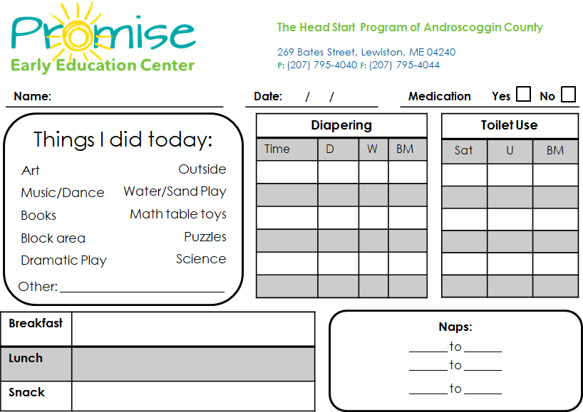

Title of Procedure or Process: | Classroom Materials Inventory- EHS/HS
Program Area(s): | Education
Related Standards or Regulations: | - Head Start Program Performance Standards  - Maine State Licensing  - Developmentally Appropriate Practice/NAEYC  - Caring for Children  - Other
Person Responsible for implementation: | Teacher with assistance from Coach
Timeline for completion: | May/June
Submitted to: | Education Manager
ChildPlus Documentation: | NA
Uploaded to ChildPlus: | NA
Specific Directions: | See below

Procedure:

At year-end each classroom teacher will work with his/her Coach to complete an inventory of classroom materials and equipment (NOT consumables). Inventory information will be used to inform purchasing for following school year.

Title of Procedure or Process: | Classroom Consumable Orders- EHS/HS
Program Area(s): | Education
Related Standards or Regulations: | - Head Start Program Performance Standards  - Maine State Licensing  ☒Developmentally Appropriate Practice/NAEYC  - Caring for Children  - Other
Person Responsible for implementation: | Teacher with assistance from Coach
Timeline for completion: | June submission for Fall, December submission for Spring
Submitted to: | Education Manager & Program Specialist
ChildPlus Documentation: | NA
Uploaded to ChildPlus: | NA
Specific Directions: | See below

Procedure:

At year-end each classroom teacher will work with his/her Coach to complete an inventory of classroom consumables.

Title of Procedure or Process: | Child’s Photo’s and Uploading
Program Area(s): | Education, Family Services
Related Standards or Regulations: | - Head Start Program Performance Standards  ☒Maine State Licensing  ☒Developmentally Appropriate Practice/NAEYC  - Caring for Children  - Other
Person Responsible for implementation: | Lead Teacher or Teacher Assistant/Ed Tech
Timeline for completion: | See below
Submitted to: | Within 2 weeks of enrollment or July 1 (for extended day programs)  Child photos for emergency cards emailed to Administrative Asst. for printing
ChildPlus Documentation: | NA
Uploaded to ChildPlus: | Child photo uploaded to child file in CP+ within 1 week of enrollment or July 1 (for extended day programs)
Specific Directions: | See below

Procedure:
Child’s Photo for Classroom Use
- Each class may send 40 pictures 4x a year to Site Supervisor
  - Photos need to be sent by:
    - September 30th
      - Child photo should be uploaded to ChildPlus (see instruction below)
    - November 30th
    - February 15th
    - May 15th
*Please send the photos in one email, in a zip file
Child’s Photo for Emergency Card
  - Take photo of child within first week of enrollment
  - Upload photo from tablet to desktop
  - Copy photo onto blank word document (photo should be ~wallet-sized)
  - Email document to Site Supervisor and photo(s) will be printed on color printer
  - Printed photos will be placed in mailboxes for pick-up
*This process is ONLY for emergency cards photos *
Uploading a Child’s Photo to ChildPlus
Photo should be uploaded to CP+ within first week of enrollment or July 1 (for extended day programs).
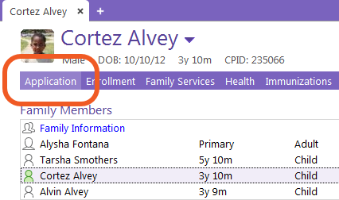
- Open the Application module.
- Choose enrolled child
- Click Photo (in blue text)
- Click Add Picture.
- Select the picture that you want
- Click Open.

Title of Procedure or Process: | Laminating
Program Area(s): | Education
Related Standards or Regulations: | - Head Start Program Performance Standards  - Maine State Licensing  - Developmentally Appropriate Practice/NAEYC  - Caring for Children  ☒Other
Person Responsible for implementation: | All classroom staff
Timeline for completion: | NA
Submitted to: | NA
ChildPlus Documentation: | NA
Uploaded to ChildPlus: | NA
Specific Directions: | See below

Procedure:

Each classroom will receive 150 sheets of laminating film for the entire school year. Laminating film will not be re- ordered mid-year. Please plan according by minimizing the use of laminating film and using contact paper whenever possible. Lamination film should only be used for items/projects that will require wipe-off capability, longevity or curricula specific materials as directed by coaches.

Laminate | Do Not Laminate- Use Contact Paper or  Sheet Protectors if necessary
- Lunch tags  - Cubby tags if used all year  - Parent board/curriculum board labels  - Writing center alphabet strips  - Name cards for writing center  - Classroom labels or signs to be used all year  - Teacher created materials that support OWL, CC3, Building Blocks or Second Step only (to be kept and used year to year) | - Child art for displays or bulletin boards  - Cubby tags that are changed frequently  - One time use items  - Activities for children  - Attendance wipe-off list

Title of Procedure or Process: | End of Year Procedures
Program Area(s): | Education
Related Standards or Regulations: | - ☒Head Start Program Performance Standards  - Maine State Licensing  - Developmentally Appropriate Practice/NAEYC  - Caring for Children  ☒Other
Person Responsible for implementation: | All classroom staff
Timeline for completion: | NA
Submitted to: | NA
ChildPlus Documentation: | NA
Uploaded to ChildPlus: | NA
Specific Directions: | See below

Protocol for Closing Child Files

Directions for Children Transitioning to Kindergarten or Moving internally from one classroom to another classroom at a different center:
- Remove the entire contents of the file from the binder and place it in a manila file folder. Save the binders and file dividers!

- On the tab of the file folder clearly label the child’s information with
Last name, First name DOB
Site/Teacher or HV Program year

- Attach an Enrollment Activity Sheet on the front of the file with a rubber band indicating the last class day. Please make sure to e-mail a copy of the EAS to all addresses listed on form.

Directions for Returning Children
- Leave the file intact in the binder for those children who will be returning to your classroom. Keep them in the locked file cabinet at your site. Make sure the Administrative Assistant has a copy of your file cabinet key at Coburn and notify your supervisor where your file cabinet key is stored in case she/he needs to get to it during the summer.
- If a family is requesting a transfer to another room return the child’s file to Enrollment with a transfer request attached.
- Fill out an Enrollment Activity Sheet for all children stating if they are repeating or requesting a transfer and e-mail a copy to all e-mail addresses listed on the form.

Please dispose of binders that are broken and worn. If additional blue binders and/or colored file dividers are needed, contact Administrative Assistant with the number needed and they will be available when files are distributed in the fall.

Other End of Year Procedures
- Answering Machine: Please change the answering machine message to include the following information: your classroom is closed for the summer and that if they are interested in enrolling their child for the fall they need to contact the Enrollment Department at 795-4040 ext. 325. Please clarify that messages left at your site for enrollment will not be received due to no staff being on site during the summer.
- Closed for Summer sign: Please post a sign (located on staff website) that states center is closed and who they can call for information or questions.
- Child Plus Reporting and PIR: Information should all be up to date and accurate in CHILDPLUS in the areas of Health, Family Services, and Disabilities. Over the summer, all information will be “rolled over” and you will not be able to change it. *Enrollment Coordinator will visit each site to ensure CHILDPLUS reporting is accurate.
- Health EPSDT:
- Closing out Child’s CP+ Health Files
  - If past due or needs to be scheduled during the summer:
    - SCHEDULE THE APPOINTMENT NOW OR DOCUMENT “THE WHY” IT WON’T BE COMPLETED IN ADD ACTIONS.
  - Close out all Health Communication Logs. Add closed date and change status to COMPLETED.
- Completing Health Passport for Parent/Guardian before last day of school.
  - If past due or needs to be scheduled during the summer:
    - SCHEDULE THE APPOINTMENT NOW and write in the appointments date. If parent has barriers to scheduling the appointment, please write “appointment needed”.
  - Present health passport at/before last day of school and make the outreach positive. Add smiley faces or prize for what parent was successful in completing.
- WCC
- Immunizations
- Hearing
- Vision
- Lead
- Dental Home
- Dental Exam
- Dental Treatment
- Health Specialist/Chronic Health Condition

Guidelines for packing and closing classrooms

For all classrooms:
- Clean all surfaces, tables, cubbies, shelving, toys, and clothing
- Discard left over food items such as birdseed, flour, etc. No food items are to be stored for next year.
- Clean and organize cabinets and storage areas.
- Do not pack up shelves and materials unless requested.
- Discard items in disrepair; Send list of discarded items to Supervisor. Please check with supervisor if you are unsure if item should/not be discarded
- Ensure all outdoor toys and equipment is stored properly.

Health:
- Return all OPEN health supplies to Health Coordinator this Includes:
  - Gloves
  - Toothpaste
  - Lice Kits (only if broken)
  - All medications that were not returned to parents.
  - Cleaning Products
  - Sunscreen
  - Steam Cleaner (only if broken)
- Return Emergency Backpacks to Health dept.
  - First Aid Supply
  - Fanny Pack(s)
  - Spill Kit
  - Medication bags
- Complete Health Supply List; write Center/Classroom.
  - Document all unopened supplies and email the form to Health Coordinator.
  - Do not return unopened supplies to Health.
  - Include in email, items you will need at startup (i.e., lice comb supplies, steam cleaner supplies)
  - Close out all Health Communication Logs. Add closed date and change status to COMPLETED.
Technology:
- Laptops returned should be labeled and returned to Main Office.
- Tablets should be clearly labeled with the Site and returned to Main Office
Please “Bag-up” and return all tablet items:
  - Tablet- Teachers’ and Students
  - Protective covers/keyboards
  - Chargers and cords
  - Wireless speaker and charger cords
  - Headsets
  - Tablet will be cleaned, updated, and unnecessary photos and videos removed! Be sure to save photos to the clprint off any items you wish to keep.
  - Other items will be tested and examined for wear and tear and updated where possible.
  - If there have been issues of ANY kind, please attach a sticky note describing the issue and I will try to resolve them.
- Please unplug all power strips. Phones should remain plugged in.
- Desktop computers should be unplugged and stored on a desk (NOT the floor) and covered with a trash bag to protect from dust.

Art Materials:
- Discard broken crayons & materials.
- Consumable supplies will be restocked as classrooms reopen in the fall. Education will send consumable and material lists to classrooms to complete prior to leaving in June.
- Left over paint and glue from Part Year classrooms should be sent to Full Day classrooms. Talk to your supervisor about which center will receive your art supplies.

Bulletin Boards:
- Do not take down Emergency boards unless materials are worn and need replacement. If replacement is needed, please contact health department.
- Leave bulletins boards if materials in good shape or re-paper boards before leaving for the year.

MISC
- Take home personal all items
- Ask another classroom to take care of plants for summer
- Stack chairs in corners with no more than 6 high
- Return all Adaptive Equipment to Education Dept. at Coburn
- Keys- Turn in ALL building and classroom keys to Supervisor. Add filing cabinet key to key-ring with building and classroom keys. Please label ‘filing cabinet’.

Title of Procedure or Process: | Guidance of Young Children's Behavior
Program Area(s): | Education
Related Standards or Regulations: | ☒Head Start Program Performance Standards  ☒Maine State Licensing  ☒Developmentally Appropriate Practice/NAEYC  - Caring for Children  ☒Other Safety Care
Person Responsible for implementation: | All classroom staff
Timeline for completion: | Daily in classrooms
Submitted to: | NA
ChildPlus Documentation: | NA
Uploaded to ChildPlus: | NA
Specific Directions: | See below

Procedure:

Promise Early Education Center is committed to the social-emotional well-being of individual children and their families. Supporting children’s social-emotional development is an ongoing partnership between program staff and families. The Child Guidance Procedures outlines our commitment to provide and promote positive guidance and supportive interactions, and to create a social-emotional environment in which children gain the skills to control their own behaviors, resolve conflicts with others, and understand the impact of their choices. Promise uses the Pyramid Model and Head Start’s Early Learning Outcomes Framework (HSELOF) to guide teachers.
Site staff working with children will use positive guidance techniques. These include:

- Building, nurturing, and maintaining positive relationships with children
- Adapting the environment, routine, and activities to the needs of individual children
- Establishing consistent, reasonable expectations
- Involving children in defining simple, clear classroom limits
- Observing, facilitating and actively supervising children’s activities
- Establishing a predictable classroom schedule
- Reminding children with environmental and verbal cues what will happen next and allowing time for transitions
- Modeling and teaching social skills, such as turn-taking, cooperation, waiting, treating others respectfully, and conflict resolution;
- Acknowledge children’s feelings.
- Modeling and teaching emotional skills, such as identifying and recognizing feelings.
- Giving directions and instructions and offering replacement behaviors that tell children what they can do;
- Anticipating problems and developing plans to avoid them
- Remembering that behavior that gets noticed is repeated
- Staff is expected to use positive guidance techniques to support classroom limits and maintain safety, such as:
  - Recognizing and respecting each child’s energy level; learning style, temperament, developmental ability including stage of play and capacity
  - Redirecting children to appropriate activities that match the child’s needs and preferences
  - Assisting children to solve interpersonal difficulties through peaceful negotiation
  - Looking for causes and patterns in behaviors
- Communicating and working with parents to better understand and resolve challenges with the early outreach and involvement of parents when a concern arises in the classroom. Outreach should be done by phone or in person at a parent-teacher conference or home visit.

Title of Procedure or Process: | Developmental & Social-Emotional Screenings
Program Area(s): | Health, Nutrition, Education, Special Services, Family Services
Related Standards or Regulations: | ☒Head Start Program Performance Standards  - Maine State Licensing  ☒Developmentally Appropriate Practice/NAEYC  - Caring for Children  - Other
Person Responsible for implementation: | Lead Teacher/Family Educator
Timeline for completion: | - Within 45 days of enrollment (30 days for Public PreK)  - Screening data to be entered in online management system within 1 week of screening
Submitted to: | https://asqonline.com/home http://oms.brigance.com/Login.aspx
ChildPlus Documentation: | Education Event: ASQ or ASQ SE/ Brigance or Brigance SE
Uploaded to ChildPlus: | Upload copies of digital reports from online management system  - ASQ /ASQ SE Reports  - Brigance Data Sheet, Brigance SE Scale Report and Summary report
Specific Directions: | See below
Procedure:
- Parents will provide consent to screen their child by signing Permission for Services form in enrollment.
- Lead Teachers/Family Educators will screen within 45 days of first classroom day or initial home visit:
  - All newly enrolled EHS/HS children.
  - All children transitioning from EHS to HS.
  - Any repeating Head Start child for whom we have new or emerging developmental concerns.
  - Dual Language Learners: See DLL Screening process for guidance on administering preLAS
- Staff will complete ASQ or Brigance screenings using tablet or paper screening form. All paper screenings need to be entered into online management system and summary sheets from screening uploaded.
  - ASQ-3/ASQ SE-2 should be completed in conjunction with parents whenever possible. ASQ screenings are ongoing and will be completed as prescribed by the tool.
  - Brigance SE Parent report MUST be completed by parent at initial home-visit and Brigance SE Teacher report should be completed by teacher if there is a SE concern. Only the parent reported SE screening is logged in the online management system.
- Parents will receive written notification of screening results using Summary reports from online management systems and any recommendations.
- Required actions based on child’s overall screening score:
  - Pass - no further action is required. Share results with parent.
  - Rescreen - Child will be rescreened within 90 days. Enter Rescreen date in Child Plus and Outlook calendar. If the child has an IEP, no rescreen is needed.
    - Any child determined to have a result of Below Average, Fail or Cannot Test on the initial screening will be rescreened within 30 calendar days.
    - If screening was done during summer screening, then 2nd attempt will take place as soon as the child feels comfortable in the classroom and no longer than 30 days after enrollment. If child is still scored Below Average, Fail, or CNT, Head Start staff will follow agency referral procedures. (See Referral procedure in Special Services)
  - Refer – Contact Special Services for guidance before initiating a referral. Obtain CDS Release of Information for permission to have the program facilitate a CDS Referral for further evaluation.
    - The Lead Teacher will complete and submit a “CDS Child Referral Form” with the required information to Special Services.
    - If child is DLL, CDS DLL form is also completed with language facilitator and preLAS if age eligible.

Title of Procedure or Process: | Home Language Survey or Child Language Use Survey
Program Area(s): | Education, Special Services, Family Services
Related Standards or Regulations: | ☒Head Start Program Performance Standards  - Maine State Licensing  ☒Developmentally Appropriate Practice/NAEYC  - Caring for Children  ☒DOE
Person Responsible for implementation: | Lead Teacher/Family Educator Language Facilitator
Timeline for completion: | Complete within first 45 days or enrollment
Submitted to:
ChildPlus Documentation: | Education Event: Home Language Survey/Child Language Use Survey
Uploaded to ChildPlus: | Upload copies of language survey under Education Attachments. Use Home Language Survey for form used from TSG and Child Language Use Survey for Lewiston public PreK children.
Specific Directions: | This form is administered to ALL children at initial home visit.

Process:

- Complete Home Language Use Survey or Child Language Use Survey (PreK) on the initial home visit.
- Enter completion under Education as an event and upload a copy of the completed form as an education attachment.
- Use score from language form to enter DLL status in TSG child profile.
- Use score from language form to double check language information under Application for the child. Adjust if necessary.

Title of Procedure or Process: | Dual Language Learners: Developmental, Social-Emotional & preLAS Screenings
Program Area(s): | Health, Nutrition, Education, Special Services, Family Services
Related Standards or Regulations: | ☒Head Start Program Performance Standards  - Maine State Licensing  ☒Developmentally Appropriate Practice/NAEYC  - Caring for Children  ☒DOE
Person Responsible for implementation: | Lead Teacher/Family Educator Language Facilitator
Timeline for completion: | - Brigance/ASQ- Within 45 days of enrollment (30 days for Public PreK)  - preLAS- completed for public PreK students within 5 days of enrollment  - Screening data to be entered in online management system within 1 week of screening
Submitted to: | https://asqonline.com/home http://oms.brigance.com/Login.aspx
ChildPlus Documentation: | Education Event: ASQ or ASQ SE/ Brigance or Brigance SE including score information  Education Event: preLAS including score and proficiency level
Uploaded to ChildPlus: | Upload copies of digital reports from online management system  - ASQ /ASQ SE Reports  - Brigance Data Sheet, Brigance SE Scale Report and Summary report
Specific Directions: | The Office of Head Start defines English Language Learners as children who:  -acquire two or more languages simultaneously (i.e., from birth)  -or learn a second language while continuing to develop their first language

Procedure:
- Decide whether the child’s language experiences require language facilitator to jointly administer screening:
  - Use information documented on Home Language Survey in Head Start OR Language Use Survey in public school PreK classrooms.
  - Use parent information/interview to gather information about the child’s exposure to languages in the home as well as the child’s knowledge, skills, and abilities.
- A child who has grown up hearing equal amounts of two or more languages every day since birth should be screened in both languages.
- For children who have had brief or sporadic experiences with English as a second language, a language facilitator (or Language Line/Insight) will be utilized throughout the developmental screening process.
- Prior to jointly administering the screening, we ensure that language facilitators/interpreters understand the purpose of the screening process and are familiar with the screening tool, especially the terms and concepts used in the tool.
- DLL screening process:
Brigance:
  - Lead teacher or Family Educator will sit with child and language facilitator at the same table.
  - During screening, the language facilitators will speak one language at a time and only use levels of prompting allowed by the screening tool.
  - Language facilitators will collaborate with the trained staff person to accurately report the child’s responses to each item and will note the child’s non-verbal behaviors and unusual responses, vocalizations, and verbalizations including errors in sounds, word order, and word choice in the home language.
preLAS:
  - Lead teacher or ELL staff person will administer the preLAS screening in English. No language facilitator is used in this screening.
- When a screening indicates a referral is needed and parents agree to the referral, the Language Facilitator will spend at least one hour with the child in the classroom to establish native language proficiency and complete the DLL form for CDS to be sent with initial CDS referral paperwork.

Title of Form: | DLL form for CDS
Related Policy: | Education &Special Services
Program Area(s): | Education
Related Standards or Regulations: | ☒Head Start Program Performance Standards  - Maine State Licensing  ☒Developmentally Appropriate Practice/NAEYC  - Caring for Children  - Other
Procedures
Form Completed By: | Lead Teacher
Timeline for completion: | At time of referral
Specific Directions: | Contact language facilitator to come and spend at least 1 hour in the classroom with DLL child to answer the questions listed on the form. Language Facilitator completes form and gives to classroom teacher. Classroom teacher send the form to special services to be sent with referral.
Submitted to: | Sent with CDS referral to Special Services
ChildPlus Documentation: | If child failed screening, indicate referral as the result of screening under Education tab and in the notes state DLL form for CDS was completed.
Uploaded to ChildPlus: | Special Services will upload DLL form for CDS with initial referral paperwork.

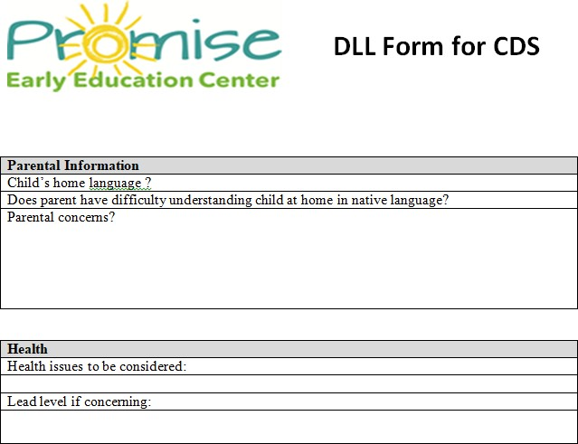

Title of Procedure or Process: | Dual Language Learners: Teaching and the Learning Environment
Program Area(s): | Health, Nutrition, Education, Special Services, Family Services, ERSEA, etc.
Related Standards or Regulations: | ☒Head Start Program Performance Standards  - Maine State Licensing  ☒Developmentally Appropriate Practice/NAEYC  - Caring for Children  - Other  ☒DOE
Person Responsible for implementation: | All teaching staff
Timeline for completion: | NA
Submitted to: | NA
ChildPlus Documentation: | NA
Uploaded to ChildPlus: | NA
Specific Directions: | NA
Expectations:

- Ensure learning experiences such as music, math, science reflect the cultures and languages of the children in the class.
- Include reading to children in English and in their home languages whenever possible.
- Incorporate key words and phrases in the home languages of the children in learning experiences and everyday routines. Learn basic greetings in the languages represented in your classroom.
- Promote children’s positive self-correct by using the correct pronunciation of children’s names.
- Promote, when possible, pairing of English-speaking children with children whose home language is not English to encourage child-child interactions in English.
- Accept code-switching/translanguaging as a natural communication strategy for children who are DLLs.
- Plan and use dialogic reading and oral language strategies in order to promote English language development.
- Use a range of verbal and non-verbal methods to promote adult-child interactions with DLL children.
- Reflect an understanding of the stages of first and second language acquisition. Use information from the preLAS to determine English language proficiency (4’s only).
- Use intentional strategies to help children who are DLLs comprehend what is happening in the learning environment, including demonstrations, videos, visuals, gestures, and props.
- Build children’s vocabulary by making explicit the connections between familiar words in a child’s home language and new words in English.
- Coordinate with language facilitators who visit your classroom about activities, themes and ideas for their support of language with DLLs.
- Display photographs of our children who are DLLs and their families that teachers refer to as part of planned teaching strategies.
- Use materials, visuals, and other items that reflect the families’ cultures that teachers and home visitors include as part of planned teaching strategies
- Include environmental print in children’s home languages, including labels, posters, and signs, which help the children make connections between their home language and English.
- Share screening (Brigance, ASQ or preLAS) and assessment results with our families in culturally and linguistically sensitive ways and in their preferred language, if possible.
- Share strategies and activities with our families that promote the child’s use of the home language
- Work with our families to adopt a long-term commitment to supporting their child’s home language development.
- Help our families feel welcome by greeting them in their home languages and displaying images and items from their home cultures.
- Support children’s transition into and within our program by discussing classroom materials, the daily schedule, and basic rules of the classroom so that families may communicate this information with their child in their home language.

Title of Procedure or Process: | Transitions in Head Start
Program Area(s): | Health, Nutrition, Education, Special Services, Family Services, ERSEA, etc.
Related Standards or Regulations: | ☒Head Start Program Performance Standards  - Maine State Licensing  ☒Developmentally Appropriate Practice/NAEYC  - Caring for Children  - Other
Person Responsible for implementation: | Lead Teachers and Family Advocate
Timeline for completion: | May/June
Submitted to:
ChildPlus Documentation: | Education Tab:  K Readiness Activities (visit to K classroom, by a K teacher, etc.) entered as event  K Readiness form completion is entered as an event.
Uploaded to ChildPlus: | K Readiness form is attached under Education
Specific Directions: | See Below

Procedure:
A) Annual Staff Training:
- EHS and HS education staff will be trained annually in supporting healthy transitions for children and families.
- EHS and HS education staff will visit each other’s programs to support staff communication and a shared understanding of our 0-5 program services. Staff visits will take place in February/March each year.

B) Child and Family Transitions- Home or Childcare into EHS:
- Enrollment will gather information on formula choice, bottle & nipple preference, and diaper size.
- EHS Teachers will plan individualized supportive transitions in partnership with parents at the initial home visit.
- For children on IFSPs, the IFSP goals will be reviewed and incorporated in the transition process.
- Parents will be offered the opportunity to visit the center/classroom or view a video created by classroom teachers before child’s first day to support a healthy transition.

C) Child and Family Transitions- EHS to HS:
- Every EHS child will have a transition plan in place by age 30 months developed in partnership with parents.
Sixth Month:
- Primary Caregiver and parent discuss transition process.
- Primary Caregiver / FE informs parent that updated income verification will be required before the child transitions to Head Start.
- For children in a childcare slot Family Advocate and parent will discuss transition with FA supporting parent in accessing referrals to outside programs. Before communicating with parent FA will outreach to ERSEA Supervisor regarding possible CC slot availability in Promise full day rooms. Please note that the small number of CC slots available in a HS full day room are prioritized for EHS-eligible children who when transitioning to HS are found non-eligible due to increased family income. (Income is not needed verified for CC slot families.)

Within the First Three Months of the transition process:
- Site is determined by Selection Committee.
- Early Head Start Primary Caregiver / FE will offer the parent the opportunity to visit the selected Head Start site(s)
- Primary Caregiver/ FE notifies Special Service Coordinator, if needed, of targeted transition date and notifies the case manager at Child Development Services.
Two Months prior to transition:
- Transfer Request completed and sent to Site Supervisor with updated family income. Site Supervisor will sign and forward to Enrollment Coordinator. EC will verify that the child is still eligible based on new income.
Month Prior to transition:
- EHS staff /FE will contact Head Start family service staff in person or by phone to plan smooth transition of child to new program and document contact in case notes.
- Primary Caregiver FE will arrange for meeting with staff, Health & Nutrition staff and parents to discuss any medical needs or plans of care - when applicable.
- EHS Primary Caregiver/ FE will make arrangements for the Head Start teacher to come to EHS to visit the child's classroom and observe the child. The Primary Caregiver/FE and Head Teacher will meet to discuss the observation.
Transition Month:
- EHS primary caregiver will offer to meet the parent and the child at the placement site. The number and frequency of the visits will be decided individually for each family. Whenever possible visits will take place at various times of the day to give the child a better idea of the routines of the new site.
- Head Start family service staff will contact the parent to arrange a home visit to complete enrollment paperwork. EHS Primary Caregiver/ FE may attend this home visit at the parent's request.
- If needed, a new Food Allergy and Dietary Needs report will be filled out and distributed by the receiving site
- EHS Primary Caregiver will provide placement site with their own original copy of the child's emergency card to be kept at the placement site.
Transition Day:
- After the child's last day at EHS Primary Caregiver will pass along the child's main file to the placement site teacher.
- Head Start Family Service FE staff at each site will complete and distribute an Enrollment Activity Sheet (EAS).

- If parents are interested in their child applying to Head Start, staff will facilitate scheduling of the enrollment interview. All EHS children must be re-determined income eligible at the time of application to HS.
- Income eligibility will be determined by HS and EHS applicants selected according to the Selection Criteria Policy.
- The transitioning children selected into HS will participate in class visits to the HS center they will attend. EHS centers will coordinate class visits for children who will be transitioning, and the HS center will arrange for both a teacher and family advocate to be present to speak to parents whenever possible.
- EHS transitioning children with diagnosed disabilities will have placement determined at their scheduled IFSP team meeting. The EHS Specialist will accompany the parent whenever possible to this meeting. EHS staff will support parents in advocating for their child’s needs.
- EHS staff will assist with transition as indicated on the IFSP Family Outcomes and Transition from Early Intervention section of the child’s IFSP. HS staff will attend the meetings whenever possible.

Title of Procedure or Process: | Individual Goal Setting for Children
Program Area(s): | Health, Nutrition, Education, Special Services, Family Services, ERSEA, etc.
Related Standards or Regulations: | ☒Head Start Program Performance Standards  - Maine State Licensing  ☒Developmentally Appropriate Practice/NAEYC  - Caring for Children  - Other
Person Responsible for implementation: | Lead Teacher
Timeline for completion: | Fall PTC and Winter PTC
Submitted to: | NA
ChildPlus Documentation: | Education Tab:  Add Event: Fall or Winter Child Educational Child and type a brief description of the goal in Event Notes.
Uploaded to ChildPlus: | NA
Specific Directions: | See Below

Goals for children's development and learning provide a structure for framing observations. Goals are set with family input and serve as the starting points for more formal, observation-based assessment. Teachers and home visitors will take steps to link their observations to the goals to track children's progress over time through documentation and Teaching Strategies Gold assessments.

Procedure:
- At first parent teacher conference, ask families if they have a goal they would like their child to work toward or they have been working toward at home. Teachers can use TSG objectives to help guide conversation if needed.
  - Observations should be simple, clear, and free of interpretations or judgments.
- Child educational goals should be measurable and developmentally appropriate.
  - Measurable learning goals focus on skills, behaviors, and knowledge that are observable; developmentally appropriate educational goals are consistent with well-established developmental progressions.
- Share progress or completion of child educational goal at winter PTC/HV then again at spring PTC/HV.
- The child goal can stay the same for the winter if a child is continuing to work toward completing the goal set in the fall.

ADD EVENT (Child Educational Goal)-
- Choose appropriate event from Event drop-down box, i.e. Fall Child Educational Goal or Winter Child Educational Goal
- Enter date of PTC or HV in Event Date.
- Choose Status drop-down.
  - Complete (goal setting is complete). Goal progress will be monitored through TSG.
- Type brief goal information into Event Notes.

Title of Procedure or Process: | Home Visits and Parent Teacher Conference Guidance for Teachers
Program Area(s): | Health, Education, Special Services, Family Services
Related Standards or Regulations: | ☒Head Start Program Performance Standards  - Maine State Licensing  ☒Developmentally Appropriate Practice/NAEYC  - Caring for Children  - Other
Person Responsible for implementation: | Lead Teacher
Timeline for completion: | See below
Submitted to: | NA
ChildPlus Documentation: | Education Tab- Add event: Educational Home Visits and Parent Teacher Conferences, Child Education Goal
Uploaded to ChildPlus: | Parent Teacher Conference Forms for each PTC
Specific Directions: | Teachers MUST complete 2 Home Visits and 2 Parent Teacher Conferences each year for each child.
Procedure:
Use of Language Facilitator or Insight required for ELL families.
Initial Home Visit/ 1st Home Visit (following initial enrollment or re-enrollment/roll-over)
Full Day- July 1 is the start of a new school year and starts the clock over for visits and conferences.
- Initial Home Visit for newly enrolled children should occur prior to child starting in the classroom. If HV is not completed prior to starting, it should be completed within 2 weeks of starting in the classroom.
- 1st Home Visit should be completed between July and August 31st for children “rolling over” in full- day programming. An educational child goal should be set with parental input.
- 2nd Home Visit should be completed in February/March and should also include a PTC for Winter TSG checkpoint using TSG Child Report Card. An educational child goal should be set or continued with parental input.
*For children who enroll mid-year, try to move to July/August & Feb/March schedule
Part Year- August start-up is the beginning of the new school year
- Initial/1st Home Visit should be completed during August start-up and 100% complete by the first day of school. An educational child goal should be set with parental input.
o Children who enroll after the first day of school should receive their initial/1st home- visit prior to starting in the classroom. If HV is not completed prior to starting, it should be completed within 2 weeks of starting in the classroom.
- 2nd Home Visit should be completed in January & February as a Parent Teacher Conference. An educational child goal should be set or continued with parental input.

Parent-Teacher Conferences
- 1st PTC should be completed in October/November after TSG closes for Fall TSG checkpoint using TSG Child Report Card (See TSG Quick Guide for more information on printing Report Card).
- 2nd PTC should happen at 2nd Home visit following Winter TSG checkpoint using TSG Child Report Card.
- 3rd PTC: using TSG Child Report Card

Full Year:
  - For children leaving by June 30th PTC should be complete by the end of May/beginning of June children
  - For children “rolling over” PTC should be complete by July 30th- combine with 1st HV Part Year: PTC should be completed by the end of May/beginning of June following the 3rd TSG checkpoint

Visit Type/When | What to do
Initial Home Visit/1st Home Visits Visits must be done in the family’s home before a child can start. If there is a barrier to doing the initial home visit please contact the Family Services Manager to review options. | Complete initial paperwork (see Initial Home Visit Checklist)- FA Review Parent Handbook- FA  Discuss the importance of attendance- FA Review classroom schedule- Teacher Discuss classroom expectations- Teacher Drop off/pick-up expectations-Teacher  Health Passport- Teacher
1st Parent Teacher Conference  November- December | Review TSG Report Card- Teacher  Set educational goal for child- Teacher Attendance- Teacher  Health Passport- Teacher  Children going to K: Transition Discussion & search for child care- FA
2nd Parent Teacher Conference/ 2nd Home Visit  February- March | Review TSG Report Card- Teacher  Review, update and/or change educational goal set for child- Teacher Attendance-Teacher  Health Passport-Teacher
Parent Teacher Conference- Late May-June | Review TSG Report Card- Teacher Health Passport-Teacher

Title of Procedure or Process: | TalkingPoints Expectations
Program Area(s): | Education, Family Services
Related Standards or Regulations: | ☒Head Start Program Performance Standards  - Maine State Licensing  ☒Developmentally Appropriate Practice/NAEYC  - Caring for Children  - Other
Person Responsible for implementation: | Lead Teacher/FA
Timeline for completion: | Families are enrolled within the first 2 days of a teacher receiving a file
Specific Directions: | See below
Expectations:
  - Every week the Lead Teacher will send classroom information to families in digital using TalkingPoints. All messages sent to families are limited to 600 characters.
  - Teachers are expected to use the TalkingPoints classroom assigned by Education and may not create their own class within TalkingPoints or create a TalkingPoints account outside of Promise.
  - At Enrollment, when families are asked for their cell phone number they are told we will use TalkingPoints to communicate and they should expect the classroom teacher to communicate using this program.
  - Teachers notify Education within the first 2 days of receiving a file with the information required to enter them in TalkingPoints.
  - At the first center visit or home visit, teachers will ensure that families are successfully receiving TalkingPoints messages and announcements.
Content to be shared through TalkingPoints:
Classroom information- weekly information sent through TalkingPoints replaces a monthly newsletter and should include:
    - Attendance data
    - Upcoming Events: Policy council meeting date and time, Parent Committee info, community activities like Touch a Truck, etc.
    - Classroom news/what children are learning: books read, concepts taught (sink/float, shadows or reflections), science experiments, nutrition activities, songs sang- including lyrics, new classroom areas (grocery store in dramatic play) or materials that can be collected by parents for the classroom
    - Reminders: extra clothes, outdoor gear, book orders, closures/holidays/in-service days
- Photos- only send de-identified photos of classroom activities or experiences to the whole class
- Individual child photos can be shared with student families only.
Parent contact- as needed
- To communicate about home visits, parent-teacher conferences, parent meetings, special events
- To communicate about a child.
Announcements are best for whole class information
- Only de-identified photos should be sent
- Send announcements with the same flyers you print/post (make sure your attachment is a PDF). Attachments are not translated.
- Be aware of frequency & message length
One on one texting conversations are best for individualized reminders & 2-way communication
- Should be more frequent and sent as needed
Use voice calls to reach out about sensitive information

Title of Procedure or Process: | Insight- Video Translation
Program Area(s): | Education
Related Standards or Regulations: | ☐Head Start Program Performance Standards  ☐Maine State Licensing  ☐Developmentally Appropriate Practice/NAEYC  ☐Caring for Children  ☒Other
Person Responsible for implementation: | NA
Submitted to: | NA- system tracks user and usage information
Specific Purpose: | Insight is a video based remote interpreting app that is available on identified promise tablets. Insight can also be used for audio only calls with families.

Procedure:
Each Family Advocate, Family Educator, and Center will have access to an ‘Insight’ tablet. Insight is a video conference platform that will allow you to access translation services with families at a touch of a button.

Language Line/Insight Expectations
It is an expectation that all staff are utilizing this resource to translate for families on a phone call, when sharing sensitive or complicated information, Zoom meetings, in person at pick-up or drop-off or at a parent teacher conference to ensure equitable access to information for all families. All tablets should be fully charged each day- please identify someone at your site who will ensure that the tablet is charged.
Language Line/Insight vs Talking Points
Language Line is appropriate for quick phone calls and notifications for families. Use of Insight is preferred for in-depth calls and conversations at pick up/drop off in person when interpreters are unavailable. Please use Talking Points texting only for quick information sharing or classroom news- Talking Points is not meant to be used for lengthy back and forth conversations or conversations related to health and safety, COVID, or child concerns. You must use Language Line/Insight for these conversations with families.
Language Line/Insight Tracking
We will be tracking use by classroom each month using the call details provided by Language Line/Insight and we will be following up with classrooms with little to no usage.
RESOURCES
Insight- Video Conferencing Translation Services
- Each center and family advocate has an identified Video Conferencing tablet.
Adding Interpreter to Zoom meeting:
- To add an interpreter to a zoom meeting, you first will call insight on your tablet and indicate that you need them for a Zoom Meeting and they will either set up a meeting for you to send to the family or will supply you an email to send the information of your pre-scheduled meeting.
Tutorial Language Line- Insight ( Video Conferencing) https://www.youtube.com/watch?v=VMrWEB9zg30
Tutorial Language Line- Phone https://www.youtube.com/watch?v=n8VfCJbN_7s
Language Line- Check your cards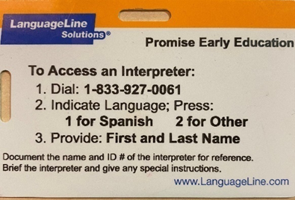

Title of Procedure or Process: | TOILETING EXPECTATIONS
Related Policy: | Toilet Training Procedure
Program Area(s): | Health, Education or Special Services
Related Standards or Regulations: | ☒Head Start Program Performance Standards  - Maine State Licensing  ☒Developmentally Appropriate Practice/NAEYC  ☒Caring for Children  - Other
Person Responsible for implementation: | - Lead Teacher
Submitted to: | NA
Specific Purpose: | Learning to use the toilet is an important step in a child’s development. When children are enrolled in Head Start, they will transition from diapers to pull-ups if not toilet trained, and a toileting plan will be developed at the initial home visit. Children with developmental concerns should be reviewed with Education to determine appropriateness of developing a plan.
Process:
Children (ages 2+) are most likely to begin toilet training when:
- They show a preference for a clean diaper and when soiled asks to be changed.
- They stay dry for at least 2 hours at a time during the day or are dry after naps.
- Their bowel movements become regular and predictable.
- Facial expressions, posture or words reveal they are about to urinate or have a bowel movement.
- They can walk to and from the bathroom and can pull-down/up pants and underwear with minimal assistance.
- They ask to use the toilet or ask for underwear.
Parent Responsibility:
- Provides 2-4 changes of clothes and underwear during school.
- Dresses the child in clothing that is easy to remove in a hurry.
- Agrees to provide regular toilet breaks at home.
- Encourages toilet-training when child demonstrates toileting readiness at home.
- Will inform teachers of toileting progress so that the teacher will plan classroom experiences that will support home toilet‐ training efforts.
Staff Responsibility:
- Encourages toilet-training when child demonstrates toileting readiness in EHS (age 2+).
- Will change the child, or assign other staff to change the child, when wet or soiled.
- Will change the child in a location that allows for privacy.
- Will provide plastic bags to send home soiled clothing.
- Will schedule regularly planned visits to the bathroom, if the child demonstrates toileting readiness.
- Will use positive reinforcement techniques to encourage independent toilet use.
- The teacher will keep the parent/guardian informed of the child’s toileting progress.
- Will share updates with the parents via notes, phone calls, texts and home visits to reinforce positive outcomes.
Challenging Situations:
    - If no progress in toilet training is noted after four weeks of using the Individualized Toilet Training Plan, Education must be notified and a staff meeting or parent meeting will be held to determine the next steps.
    - There are times when difficult situations may arise with families. Based on the circumstances involved, Promise may adjust or modify these procedures to best meet the needs of individual child and family.
*Each site has varying bathroom accommodations. The parent/guardian is encouraged to visit the site and discuss the site accommodations with the classroom teacher. All teachers follow diapering and toilet‐training guidelines that have been approved by the program and meet health standards.

Title of Procedure or Process: | Active Supervision & Ratio Matters documentation
Program Area(s): | Education
Related Standards or Regulations: | ☒Head Start Program Performance Standards  ☒Maine State Licensing  ☒Developmentally Appropriate Practice/NAEYC  - Caring for Children  - Other
Person Responsible for implementation: | All classroom staff
Timeline for completion: | Daily in classrooms
Specific Directions: | See below
What is Active Supervision?
Active supervision always requires focused attention and intentional observation. Educators (all Head Start staff who care for children) position themselves so that they can observe all the children: watching, counting, and always listening.
  - General requirements:
      - Staff to child ratios: A minimum ratio of 1 staff per 10 children for Head Start and 1 staff per 4 children for Early Head Start will be always maintained as required by both Head Start and Child Care Licensing.
      - As a team, direct management staff and center staff, will review active supervision roles and ensure that procedures are followed for their center.
      - Classroom staff will teach and review classroom rules with children.
      - Personal cell phones and other electronic devices (i.e. smart watch) must not be accessible to staff while children are present.
  - Procedures for transitions:
      - Arrival and Departure Procedure. Refer to this (separate) specific procedure for children’s arrival to and departure from the center.
      - Redundant Checks. These are completed to ensure that no child remains alone in any setting (such as a classroom, bathroom, playground, etc). Redundant checks will be used when the group leaves one area to go to another (such as transitioning from the classroom to the playground.) All children transitioning from classroom to another part of the building or playground must use a walking rope.
          - 1st check- one staff member counts the children and roll call from sign-in/sign-out sheet before leaving classroom.
          - 2nd check- one staff does a final sweep of the space the group is leaving and scans to ensure no child is left behind (including checking in the bathroom) and confirms verbally with other staff that the check is complete.
          - 3rd check- recount children once on the playground or the space the group is arriving to.
    - Wipe off Ratio Matters list in the classrooms and on the playground:
Classroom Staff:
      - The daily count of children is written on the classroom wipe off board/list each day. If a child leaves early or arrives late, the number is changed to reflect the total number of children in

attendance upon arrival or dismissal. The total number of children present for class that day must always be on the board.
      - Names and number of staff present in the classroom are also noted on wipe off board and are adjusted as staff enter or exit classroom.
      - The wipe off board/list must reflect the number of children in attendance for the day and must also account for children present but not in the classroom. To account for children who leave the class for a short period of time (such as for the bathroom, screening, or therapy) this must be reflected at the bottom of the wipe off board (below the total count). If a single child, or multiple children leave the classroom (such as when one staff takes a group to the bathroom) this must be reflected on the wipe off board/list; classroom staff members must also communicate with each other that they are taking children out of the classroom. Once the child or group returns the wipe off board/list must be updated immediately to reflect the number of children in the classroom. The classroom staff shall count the children when they re-enter the classroom, playground or space.
Non-classroom staff:
      - When a non-classroom staff person removes a child from the classroom (such as a health screener or therapist) that person will write the child’s name and their name on the wipe off board/list. They must also communicate directly with classroom staff that they are removing a child. Once the child is returned to the classroom the non-classroom staff will update the wipe off board/list and directly communicate to classroom staff that the child has been returned. The classroom staff shall count the children when they re-enter the classroom, playground or space.
  - Zone Supervision
Zoning Supervision must be used in the classroom, on the playground, during nap time, during transitions or during toileting/bathroom activities. Staff must supervise the outdoor and indoor play areas in such a way that children’s safety can be easily monitored and ensured. One or more staff are assigned a specific area – a “zone” – for which each are responsible for maintaining line-of-sight supervision of each child within his/her assigned zone while that supervision strategy is being used.
Set Up the Environment
Educators set up the environment so that they can supervise children at all times. Small spaces are kept clutter free and big spaces are set up so that children have clear play spaces that educators can observe. Teachers sit with backs to walls not with back to children.
Create a chart
Specify which teacher is in charge of which area/activity, as well as what individual duties are during the transitions before and after the activity. Zoning allows every staff to be accountable and informed.
Position/Zone Staff
Educators carefully plan where they will position themselves in the environment to prevent children from harm. They place themselves so that they can see and hear all of the children in their care. Educators stay close to children who may need additional support.
Scan and Count
Educators are always able to account for the children in their care. They continually scan the entire environment to know where everyone is and what they are doing. They count the children frequently. This is especially important during transitions in the classroom or on the playground. During a transition staff use redundant systems: roll call from attendance list and count children.
Listen
Educators who are listening closely to children immediately identify signs of potential danger. For example, bells added to doors help alert educators when a child leaves or enters the room.
Anticipate Children's Behavior
Educators use what they know about each child's individual interests and skills to predict what he/she will do, they anticipate children's behavior. Educators who know what to expect are better able to protect children from harm.

Talk to the other staff members
Talk to one another in the classroom throughout the day. Be sure to highlight positive behaviors you see the children engaging in, “Wow, look at these children trading toys so nicely,” as well as address any issues that may arise, “Miss Teri, I need to help Oscar wash his hands, can you cover my area?” or to share information or expectations such as “Semir is going to hang up his smock before joining you at the art table Miss Monica” or “Jabril is going to put away the sand toys before he comes to the swings.”

Title of Procedure or Process: | Program Monitoring: Formal and Informal Observations
Program Area(s): | Education, Health & Nutrition, Family Services, Special Services
Related Standards or Regulations: | ☒Head Start Program Performance Standards  ☒Maine State Licensing  ☒Developmentally Appropriate Practice/NAEYC  ☒Caring for Children  - Other
Person Responsible for implementation: | All classroom staff
Timeline for completion: | NA
Submitted to: | NA
ChildPlus Documentation: | NA
Uploaded to ChildPlus: | NA
Specific Directions: | See below

Procedure:

Head Start and Early Head Start programs use ongoing monitoring to continually assess progress toward meeting program goals and objectives, as well as compliance with regulatory requirements.

The following practices and processes will be part of ongoing monitoring:
    - Classroom environments/organization/materials display
    - Inclusive and equitable practices
    - Teacher effectiveness- CLASS, TPITOS/TPOT
    - Arrival and departure of children
    - Active supervision
    - Teacher talk: teacher to teacher communication in the classroom
    - Daily health check
    - Transitions in the classroom and to other areas such as the playground
    - Behavior management and Pyramid practices
    - Safety Care practices
    - Curriculum fidelity
    - Curriculum implementation
    - Group times
    - Small groups
    - Playground
    - Tooth brushing
    - Diapering and toileting
    - Nap Time
    - Annually: home visit and parent-teacher conference
    - Supervision between Teachers and TA’s
    - Meetings with Family Advocate
    - Parent Groups
    - Use of Language Line & Insight for ELL families
    - Child Plus Documentation and attachments
    - TSG documentation
    - Monthly safety checks
    - Medication management
    - Administering medication
    - Cleaning and sanitization practices
    - Fire drills and lockdown drills
    - Use of Outlook calendar
    - Use of time clock & exception logs

Title of Procedure or Process: | Curriculum Implementation & Fidelity
Program Area(s): | Education
Related Standards or Regulations: | ☒Head Start Program Performance Standards  - Maine State Licensing  ☒Developmentally Appropriate Practice/NAEYC  - Caring for Children  - Other
Person Responsible for implementation: | All EHS/HS teaching staff
Timeline for completion: | - Daily for core curriculum (OWL, BB, CC3, etc.)  - Pedestrian Safety within 30 days of enrollment  - Flu prevention in first week of October  - Personal Safety (Second Step) starts in November and continues for 6 weeks (HS only)  - Personal Body Safety is covered during the month of April and revisited when necessary
Submitted to: | NA
ChildPlus Documentation: | Pedestrian and Personal Safety entered under Entry Express within 1 week of  teaching
Uploaded to ChildPlus: | NA
Specific Directions: | See below
Procedure:
- Education is responsible for ensuring that staff training and professional development takes place to ensure the curriculum is implemented with fidelity program-wide for children from birth to age 5.
- All instructional staff will receive necessary training for the adopted curriculum with regard to implementation and fidelity within one year of employment.

EHS

- The instructional staff will utilize the evidence-based, age appropriate Creative Curriculum 3rd ed. &
Toddler Units of Study as the core curriculum in EHS.
- Each EHS teacher develops individualized daily lesson plans based on the curriculum guidebook. The plans are developmentally appropriate, align with HSELOF and ME’s I/T Early Learning and Development Standards, and meet developmental needs in all domains of development. The teacher plans for children’s individual levels according to the recommended accommodations suggested in the curriculum guidebook.
- The instructional staff takes anecdotal records throughout the day based on student level of performance. The anecdotal records are recorded in the TSG Assessment system on a weekly basis and monitored by the education management staff.
- The EHS staff include parents/guardians, as the child’s first teacher, in the learning process by utilizing the Learning Games component of the curriculum. The family activities correlate to the learning content and the activities are geared to enhance both child and family outcomes.
- Coaching staff will support instructional staff to effectively implement curriculum. Curriculum fidelity will be monitored using the CC3 fidelity tool, formal and informal observation, and review of the weekly lesson plans. Support, feedback and coaching for continuous improvement will be provided for instructional staff as needed. Professional development opportunities will be offered in areas of need.
- Supplemental Curriculum: I am Moving, I am Learning (IMIL) is a proactive approach for addressing childhood obesity. The teaching staff will implement curriculum to increase daily moderate to vigorous physical activity, improve the quality of movement activities intentionally planned and facilitated by adults, and promote healthy food choices every day.
- Staff can support appropriate hand washing, coughing/sneezing etiquette with toddlers on an ongoing basis as the precursor to Flu Prevention lessons in HS.
HS

  - The teaching staff will utilize the evidence-based, age appropriate Opening the World of Learning (OWL)
and Building Blocks Mathematics (BB) as the core curricula in HS.
  - Each HS teacher uses the OWL/BB daily lesson plans based on the implementation schedule determined by Coaches. The plans are developmentally appropriate, align with HSELOF and ME Early Learning and Development Standards, and meet developmental needs in all domains of development.
  - All components of the OWL/BB curricula are implemented with fidelity including: Morning Meeting/Introduction to Centers, Centers, Multiple Story Readings, Let’s Find Out About It (LFOAI) , Small Groups and Songs, Word Play and Letters (SWPL)
  - The HS staff take anecdotal records and collect work samples throughout the day and observations, child work, video or photos are recorded/uploaded in the TSG Assessment system on a weekly basis and monitored by the education management staff.
  - The HS staff include parents/guardians, as the child’s first teacher, in the learning process by utilizing the Take Home Activities from Building Blocks or from OWL newsletters. The activities correlate to the learning content and the activities are geared to enhance both child and family outcomes.
  - Coaching staff will support instructional staff to effectively implement curriculum. Curriculum fidelity will be monitored using OWL fidelity tool, formal and informal observation, Sibme video submission and review of the weekly lesson plans. Support, feedback and coaching for continuous improvement will be provided for instructional staff as needed. Professional development opportunities will be offered in areas of need.
  - Staff will write-in Second Step lessons, gross motor activities, and health or nutritional activities on printed roll out grids.
  - Supplemental Curricula:
    - I am Moving, I am Learning (IMIL) is a proactive approach for addressing childhood obesity. The teaching staff will implement curriculum to increase daily moderate to vigorous physical activity, improve the quality of movement activities intentionally planned and facilitated by adults, and promote healthy food choices every day.
    - Flu Prevention contains two lessons for children to learn about the flu, hand washing and coughing/sneezing etiquette. This is taught right before flu season in the first week of October.
    - Kind Mind social-emotional curricula promotes resiliency and compassion and teaches children mindfulness and regulation strategies. This curricula is used in public PreK classrooms.
    - Second Step:
      - Social Emotional Curricula is a program that promotes self-regulation and executive- function skills that help children pay attention, remember directions, and control their behavior. Teaching staff will implement Second Step: Social and Emotional Skills with children daily for the first 4-6 weeks of school and within Let’s Talk About It throughout the school year and as skills need to be readdressed.
      - Child Protective Unit gives teachers the tools to recognize and respond to abuse and the confidence to comfortably teach students about this sensitive subject.
        - Pedestrian Safety is taught in the first 30 days of school or enrollment.
        - Personal Safety should start in November and continue with a lesson a week for 6 weeks of content.
        - Personal Body Safety will be covered during April and revisited whenever appropriate.

Title of Procedure or Process: | Coaching
Program Area(s): | Education
Related Standards or Regulations: | ☒Head Start Program Performance Standards  - Maine State Licensing  ☒Developmentally Appropriate Practice/NAEYC  - Caring for Children  - Other
Person Responsible for implementation: | Instructional Coaches
Submitted to: | Coaches: joint plans sent to Site Supervisor
Practice Based Coaching (PBC) Overview
In Promise Early Education Center’s program, ongoing professional development is an individualized expectation and is supported for each education staff member to promote growth and effective teaching practices. Coaching promotes continuous self-assessment through a cycle of planning, observing, taking action, and reflecting.
What is Coaching?
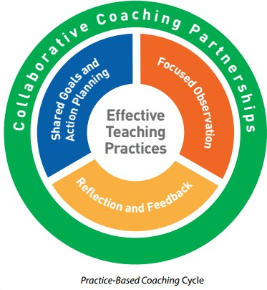
Coaching is a relationship based process designed to build capacity for specific professional dispositions, skills, and evidence based practices. It is focused on goal setting and achievement for an individual or group. Coaching support will be determined by Education staff considering many factors including longevity, new initiatives, CLASS scores, child outcomes, classroom demographics and teacher self-assessment. Head Start’s Practice-Based Coaching guides the coaching strategy.

“Coaching promotes learner use of desired practices, including, but not limited to, the adoption of new instructional innovations, increased use of effective teaching practices and decreased use of ineffective practices, and promotion of sustained behavioral change.”
Expectations in a Coaching Relationship
A Coachee will…
  - Embrace reflective practice.
  - Commit to co-creating meaningful Joint Plans that are relevant in the practice setting.
  - Participate in ongoing discussions with coach and colleagues.
  - Use a variety of tools and strategies to support practice development, including: submitting videos, watching your own videotaped work and coach feedback, watching exemplars, and 1:1 or group coaching.
A Coach will…
  - Embrace reflective practice and support the reflective practices of the practitioner.
  - Commit to co-creating Joint Plans that are meaningful and align with effective teaching practices.
  - Maximize the use of tools to offer reflective opportunities and offer meaningful feedback.
  - Engage in support for their own professional development.
Assure content expertise to best support each Coachee.
Title of Form: | TOILET TRAINING PLAN FORM
Related Policy: | Toilet Training Procedure
Program Area(s): | Health, Education or Special Services
Related Standards or Regulations: | ☒Head Start Program Performance Standards  - Maine State Licensing  ☒Developmentally Appropriate Practice/NAEYC  ☒Caring for Children  - Other
Procedures | - Retrieve form from Promise website.  - Read & follow the Toileting Expectations before completing the form.  - Review with parent and assist in filling out the plan before child’s first day.  - Discuss with parent that the plan will help their child be more successful with toilet training when both Home and School agree upon and have the same plan.  - When the written plan is completed, send it to the Education Manager for review and approval.  - Upload approved toilet plan in Child Plus under Education Events and mark Status as In Progress.  - If child has toilet training in IEP, the IEP can be used in place of plan.  - When child no longer needs plan in place update Child Plus, change event status to Completed.
Form Completed By: | Staff with Family Service Responsibility or Lead Teacher
Timeline for completion: | Before child first day of school/childcare
Specific Directions: | Complete at first Home Visit
Submitted to: | Education
ChildPlus Documentation: | Yes, in the Education Tab-Add Event-Toilet Plan Developed Event
Uploaded to ChildPlus: | Yes, in the Education Tab-Attachments
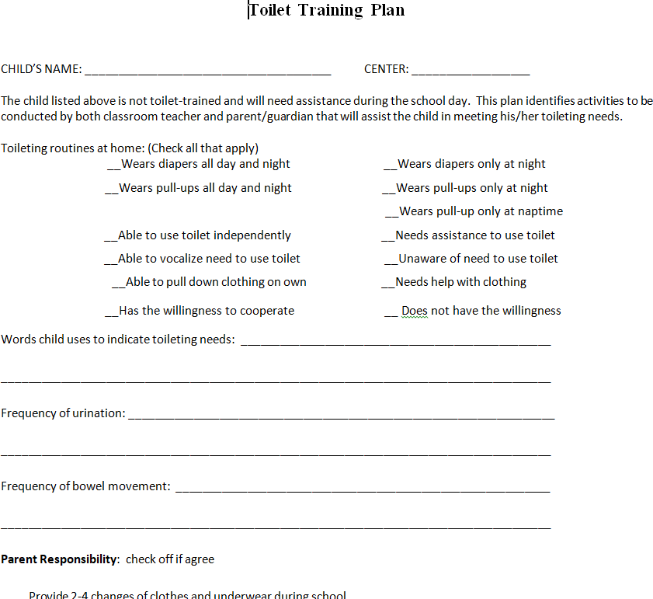

Title of Procedure or Process: | TSG Observation Guidance
Program Area(s): | Education
Related Standards or Regulations: | ☒Head Start Program Performance Standards  - Maine State Licensing  ☒Developmentally Appropriate Practice/NAEYC  - Caring for Children  ☒Other
Person Responsible for implementation: | All Teaching staff
Timeline for completion: | Observations are entered weekly.
Observation Quantity, Content and Quality:
  - There must be a minimum of 1 observation per indicator per child per Checkpoint. Your goal should be to meet 85% of the observations required.
  - Any group observations will need to be individualized by child.
  - Observations can include photos and samples of the child and the child’s work.
    - Photos and samples do not need to be annotated.
  - Use of the On-the-Spot observation tools for literacy, math and physical development is encouraged
  - Notes should be short and to the point- try to keep to one sentence.
    - Just right: IC identified square and triangle only.
    - Too much: R. demonstrated his ability to identify shapes by visual representation during center time with a teacher. R. was able to identify and name the shapes, square, and triangle. He was unable to name circle, rectangle, or oval.
TSG Observations should:
Provide a snapshot in time which allows the reader to envision exactly what happened at that specific moment
  - This should dictate for you how much to include in one observation. It should be of a specific moment or activity.
  - This also supports clarity of which dimensions to tag, setting preliminary, and finalizing your levels.
Be Clear, Concise, Complete, and Correct
Clear: Child’s Name, What Happened, Where and When
Concise: Only write what is relevant to the observation
Complete: Provide enough detail to ensure the reader can understand what happened and how it relates to a learning goal
Correct: Only write what you see or hear. Avoid assumptions, generalizations, or assigning emotion or meaning
Be objective and factual.
Objective and factual notes are:
    - Descriptions of an action (J. caught ball 3 out of 4 times)
    - Quotations of language ("Me like lunch.")
    - Descriptions of a gesture (shrugged, nodded)
    - Descriptions of a facial expression (smiled, frowned)
    - Descriptions of a creation (best to use a photo here)
Objective and factual notes are not:
    - Labels (shy, mad, sad)
    - Intentions (wants to, needs to, doesn’t want to)
    - Evaluations and judgments (good job, beautiful, sloppy, didn’t try)
    - Negative (didn’t, can’t, won’t)
Monitoring your documentation:
Use documentation status report to help you determine areas that you need to gather more information on.
  - Click on Report
  - Select Documentation Status
  - Review per child/ per objective

Title of Form: | Classroom Profile Analysis
Related Policy: | Teaching Strategies Gold Assessment
Program Area(s): | Education
Related Standards or Regulations: | ☒Head Start Program Performance Standards  - Maine State Licensing  ☒Developmentally Appropriate Practice/NAEYC  - Caring for Children  - Other
Procedures
Form Completed By: | Lead Teacher
Timeline for completion: | Within 2 weeks of Fall and Winter checkpoints. Classroom profile reviewed with Education staff prior to PTC’s
Specific Directions: | Complete form using TSG Classroom Profile Analysis
Submitted to: | Google Form- link provided by Education
ChildPlus  Documentation: | NA
Uploaded to ChildPlus: | NA

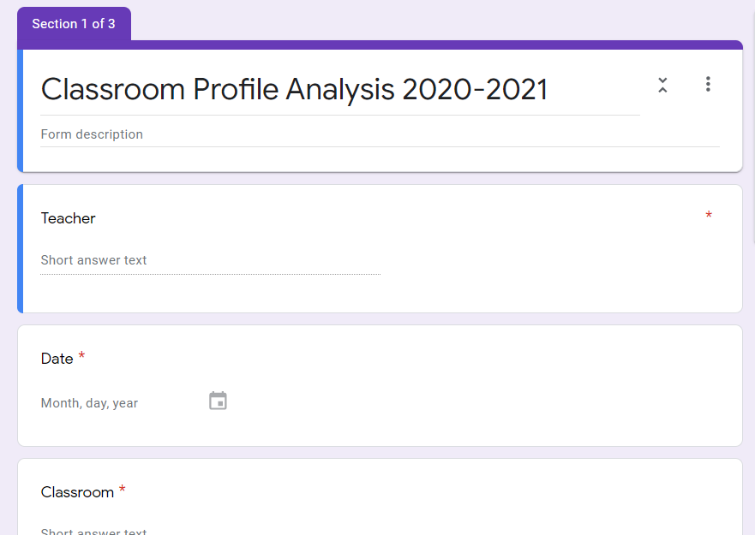
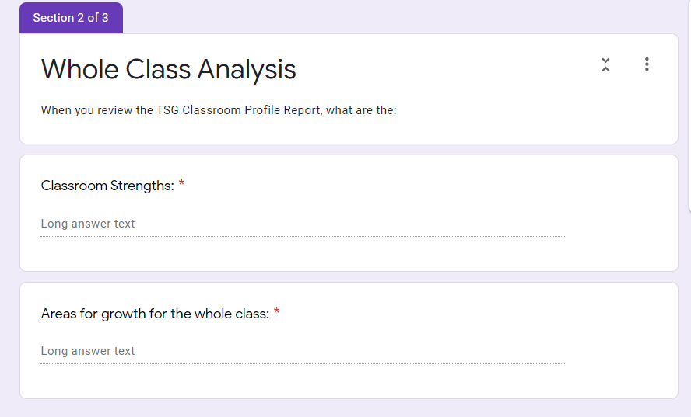

Title of Procedure or Process: | TSG Quick Guide
Program Area(s): | Education
Related Standards or Regulations: | ☒Head Start Program Performance Standards  ☐Maine State Licensing  ☒Developmentally Appropriate Practice/NAEYC  ☐Caring for Children  ☒Other
Person Responsible for implementation: | All Teaching staff
Timeline for completion: | NA
Submitted to: | NA
ChildPlus Documentation: | NA
Uploaded to ChildPlus: | NA
Specific Directions: | See below

Procedure:
Adding Children (only add NEWLY enrolled children, NOT children who transfer between classroom)
- Click Children drop down menu
- Click Manage Children
- Click Add New Child
  - Complete name
  - Do not complete identifier
  - Complete class, gender, DOB
  - Complete first day in program, Primary language, Ethnicity, & Race
  - For age/class grade, for a child 3-4 click Preschool 3
  - For a child 4-5 click Pre-K 4
*The child will remain in this age grade for the program year
- Under funding sources select Head Start or Head Start and Child Care
- Click Yes/No to indicate if a child has an IEP
- Skip free and reduced lunch
- Click Yes/No if child speaks Spanish

How to Change Age Class / Grade in TSG
*Note: Age Class/Grade is the Childs PIR age (The child’s age at October 15th of that year). This age grade should remain the same for the entire program year. Returning/Full Day children are updated at the beginning of the program year.
- Click on your class name in the upper right hand corner
- Select “Manage Class” from the drop down menu
- Click on child’s name
- Under Class Details, select appropriate Age / Class Grade
- Scroll down to the bottom of the screen and click checkpoint settings

- Click update next to the checkpoint you wish to change age/grade for

- Change age or Class/Grade and click save

Home Language Survey or Child Language Use Survey
- Complete at the home visit for all children. When the child is entered into TSG you will be prompted to enter the form online. Use the information gathered from the home visit to complete the form. *Not applicable for children under three years old.

Checkpoints by Multiple Children
- How to enter checkpoints by multiple children
  - Click Checkpoints tab
  - Click by Multiple Children then click Domain
  - Click Objective- this allows you to see all your children on one screen for this objective. Information entered here is considered preliminary until it is finalized.
  - Once complete, click Next Dimension or Save and close at bottom of the screen

How to Finalize TSG Assessments
- Go to Checkpoint tab
- Click by area -Developmental (1-14)
- Once all areas of the assessment are complete, click finalize
- Go back to checkpoint tab
- Click by area, Content
- Once all areas of the assessment are complete, click finalize
- Go back to checkpoint tab
- Click by area, English Language Acquisition
- Once all areas of the assessment are complete, click finalize.
- **Checkpoints are to be finalized F / W / S in accordance to dates set on agency calendar.

Assessment Status Report
- Make sure all assessments are complete.
- Click Checkpoint
- Click Assessment Status Report
- Click your Class Name
- Click Period you are checking on
- Click Show Finalized Checkpoints
- Click PDF
- Click Generate Report
- If areas are listed under 100% go back and see if you missed a question or area.

Class Profile Report
- Click on the Reports tab, then click Class Profile
- Select your Class Name
- Click your Class
- Under Age/Class/Grade, click all
- Click Current Last Checkpoint complete and include all levels
- Click PDF and Color
- Click Generate Report

How to Read Class Profile Report
- On the classroom profile report you will see a grid with each dimension on the left. The number progressions of each indicator are listed along the top. The colored blocks indicate the range of skill where a typically developing child should be placing for that objective/dimension by the end of the program year.
- Scroll down through the list and note the number of the children in the colored areas, as well as to the left and right of the boxes. Look for trends in the data.

Child TSG Report Card
- Go to Reports
- Go to Report Card
- Under Checkpoint Period, click Fall, Winter or Spring box.
- Click Child’s Name
- Select ALL objectives and dimensions
- Click English
- Click Generate Report
- Scroll to bottom of Report Card and enter in any Teacher Comments for the checkpoint and click SAVE Comments
- Print
- To save: click Print and choose PDF
  - In upper right-hand corner choose the arrow for download and save to your desktop
  - Upload saved Report Card to CP+

Child Profile Report
- Go to Reports
- Go to Individual Child and click Child’s Name
- Under Period, click all boxes.
- Click each Domain and check all. (*Note: English Language Acquisition only applies to DLL students, Spanish Literacy and Spanish Language only applies to children who speak Spanish),
- Click Include All Levels
- Click English
- Click PDF
- Click Generate Report and Print

Individualization
- TSG assessment data must inform the make-up of individual and small group activities and material selection for the classroom.
- TSG documentation must include observations related to goals set with parents and areas of learning below age-grade expectations.
- IEP goals should be referenced in the ‘child’s plan for development’ portion on the family conference form or ‘teacher comments’ on report card (customize then add (IEP-speech) (IEP-OT)

Title of Procedure or Process: | TSG Frequently Asked Questions
Program Area(s): | Education
Related Standards or Regulations: | ☐Head Start Program Performance Standards  ☐Maine State Licensing  ☒Other
Person Responsible for implementation: | Lead Teachers
Procedure:
TSG Training & Certification
- All teaching staff are required to complete the Teaching Strategies Professional Development Course titled Introducing My Teaching Strategies.
- Lead teachers are required to complete/maintain Teaching Strategies Interrater Reliability Certification prior to 1st checkpoint closing. This certification is valid for three years.
Entering/Exiting Children from TSG
- Teachers will enter children into TSG
- Previously enrolled children: alert Education staff to assist with the transfer of information and help avoid duplication of files. A new file should not be created for a transferred child.
- Children’s age/grade should reflect child’s PIR age (child's age on Oct. 15th). Age grades need to be updated yearly.
- When a child transfers or leaves the program attach TSG Assessment & Portfolio to ChildPlus prior to sending an EAS.
- Other assessments, such as Brigance and ASQ, can also be used as observational data
Home Language Survey*
- The Home Language Survey needs to be completed and entered into TSG for all HS children before the first checkpoint. Complete at the home visit for all children. When the child is entered into TSG you will be prompted to enter the form online. Use the information gathered from the home visit to complete the form. *Not applicable for children under three years old.
- Public PreK must use Child Language Use Survey to determine DLL status.
Child with IFSP/IEP
- Child’s IFSP/IEP status (box checked / unchecked) can be updated throughout the year as needed.
Assessments
- Assessments are completed 3 times per year (fall, winter, spring) for all children, regardless of start dates. Finalized data will be collected at F/W/S checkpoints.
Individualization
- TSG assessment data must inform the make-up of individual and small group activities and material selection for the classroom.
- TSG documentation must include observations related to individualized activities, goals set with parents and areas of learning below age-grade expectations and tagged as “Goal related observation”.
- IEP goals should be referenced in the ‘child’s plan for development’ portion on the family conference form or ‘teacher comments’ on child report card (customize then add (IEP-speech) (IEP-OT)
Family Conference Form/Child Report Card
- Completed 3 times per year
- Must show parent participation in goal setting (identify as child goal)
- Uploaded to ChildPlus in Education Attachment
Child Arrives after Checkpoint Closes
- If a child is enrolled after a checkpoint closes. Their first assessment may show as due or past due, even if they were not enrolled at the time the assessment was due. In this case,
  - Click the assessment Date for the child. In the upper right drop down box click N/A, late enrollment
  - In the lower left, click Mark All and N/A, late enrollment
  - Enter the Date assessments were due to be finalized
  - Click Complete
*Please do not delete/ transfer any children from TSG!
Passwords
- If you enter the wrong password three times, TSG will lock your account. Education staff can assist with unlocking accounts.
Title of Procedure or Process: | Closing out Teaching Strategies Gold (TSG) Files: Child Assessments, Child Observations and Parent Teacher Conference Form/Child Report Card
Program Area(s): | Education
Related Standards or Regulations: | ☒Head Start Program Performance Standards  ☐Maine State Licensing  ☐Developmentally Appropriate Practice/NAEYC  ☐Caring for Children  ☐Other
Person Responsible for implementation: | Lead Teachers
Timeline for completion: | By June 30th or at the same time as EAS
Submitted to: | NA
ChildPlus Documentation: | Education Tab
Uploaded to ChildPlus: | Education Attachment
Specific Directions: | See below

Procedure:
Produce and save Child Assessment to your desktop
- Go to Reports Individual Child
- Select child
- Select boxes fall, winter and spring checkpoints for current year
- Click generate report, then click print.
- Choose PDF
- In the upper right click on the download arrow. Save the file to your desktop using the child’s name (first initial, last name) and assessment
Produce and save the Documentation Report to your desktop
*Note: Before producing Documentation Report, all documentation must be individualized. If two or more children are included on the same documentation item, click ellipsis in upper right corner of documentation item Individualize then click Individualize by Child on right side of screen.
- Go to the Assess tab view documentation
- Go to Filter Documentation on right side. Select Child, Time Frame and Author (Select All). Click Apply after each selection.
- Select checkbox on a documentation item then Select All on Page that appears above documentation. Complete for each page.
- Click Print to PDF above documentation on right then click Print.
- Select the “Gold” button in the upper right and scroll down to click Manage my Files
- Select the blue PDF to pull up document
- Download, rename the file with the Child’s name (first initial, last name) and documentation, save to desktop
Produce and save Family Conference Forms to your desktop
- Click family tab, then Family Conference Form
- Click view print PDF
- Click download arrow in upper right, save file with child’s name and FCF to your desktop
Produce and save Report Cards to your desktop
- Go to Reports Report Card
- Under Checkpoint Period, click Fall, Winter or Spring box.
- Click Child’s Name
- Select ALL objectives and dimensions
- Click English
- Click Generate Report, then click print and choose PDF
- Click download arrow in upper right, save file with child’s name (first initial, last name) and RC to your desktop

Upload all files to Child Plus under Education / Teaching Strategies Gold Assessment, TSG Child Observations or TSG Family Conference Form. TSG Child Report Card can be used in place of TSG Family Conference Form.

Delete children’s files off your desktop after uploading
Title of Form: | Emergency Playground Backpack and Emergency Evacuation Backpack
Related Policy: | Emergency Preparedness
Program Area(s): | HEALTH
Related Standards or Regulations: | ☒Head Start Program Performance Standards  ☒Maine State Licensing  ☐Developmentally Appropriate Practice/NAEYC  ☒Caring for Children  ☐Other
Procedures
Form Completed By: | Classroom Staff

Promise Early Education Center is committed to Emergency Preparedness to ensure children are safe while off site of our physical locations.
Emergency Playground/ Secondary Evacuation Backpack: Red Kidney Bag
- Emergency Playground Backpacks are utilized during outdoor play times
- Back Packs Include
  - First Aid Kit (See Full List in First Aid Kit Procedure)
  - Emergency Relief Medication for Emergency Medical Plan children only. IE:
    - Epi Pens
    - Asthma Inhalers
    - Benadryl
  - Gloves (Must contain sizes for all staff present)
  - Site Cellphone
Emergency Evacuation Backpacks are intended to be used in the case of an all-building evacuation off site. These Backpacks are equipped with Emergency Preparedness items for a long-term evacuation plan.
  - Melier Blankets
  - Formula/Water (EHS Students Only)
  - Spill Kits

Title of Form: | Calling 911 in Emergency Situations
Related Policy:
Program Area(s): | Health, Nutrition, Education, Special Services, Family Services, ERSEA, etc.
Related Standards or Regulations: | ☐Head Start Program Performance Standards  ☒Maine State Licensing  ☐Developmentally Appropriate Practice/NAEYC  ☐Caring for Children  ☐Other
Procedures
Form Completed By: | Responsible staff
ChildPlus Documentation: | Document as Incident Report in Child Plus as soon as possible.
Uploaded to ChildPlus:

Promise Early Educations foremost goal is the safety and wellbeing of students, staff, providers and families. In the case of emergency situations that require emergency medical attention. Staff will immediately call 911 and relay the following information.
- Address
- Your Name, Organization and Contact Number
- Explain Emergency in Detail
- Notify Hospital Preference and Answer questions regarding allergies if necessary
- Stay with the child to watch for worsening symptoms relay to EMS when they arrive
Emergency Situations to Call 911 For:
- Child is unconscious, or acting confused after head trauma
- Child is choking/airway is blocked
- Child is not breathing and or experiencing breathing issues
- Child has ingested an unknown substance
- Child has a seizure for the first time, or the seizure lasts more than three minutes
- Child is vomiting or coughing up blood
- Child has a Head, Neck, or Spinal injury
- Child has sudden severe pain anywhere in the body. IE: Severe Cramping and Abdominal Pain
- Child has sustained a cut that causes limb threatening
- Child has uncontrolled bleeding
- Child has ingested allergen and has a allergy action plan that outlines EMS intervention.
Once EMS have arrived, Ensure communication with Site Supervisor and Family and Document situation as soon as possible. Ensure when documentation is submitted an email to the Health and Nutrition Manager, Executive Director and Site Supervisor is sent to notify Maine State Licensing if necessary.

Title of Procedure or Process: | EMERGENCY PROCEDURES FOR SERIOUS INJURY OR ILLNESS
Program Area(s): | Health & Human Resource
Related Standards or Regulations: | ☒Head Start Program Performance Standards  - Maine State Licensing  - Developmentally Appropriate Practice/NAEYC  ☒Caring for Children  - Other
Person Responsible for implementation: | Classroom Staff i.e. Lead teacher, TA, Substitute, Health staff
Timeline for completion: | Immediately, as needed
Submitted to: | Health Manager and Site Supervisor / Human Resource if BBP to staff
ChildPlus Documentation: | Incident Report
Uploaded to ChildPlus: | Medical Records to return to school
Specific Directions: | Use your CPR & First Aid Training and always call 911, if needed
Procedure:
- Survey the scene: Remain calm and assess the situation. Is the area safe for you to approach? Are the other children safe? How many children are injured? Who is available to help? The following dangers will require caution: live electrical wires, gas leaks, building damage, fire or smoke, traffic, or violence.
- Do a primary survey for life-threatening conditions: Is the child conscious and responsive? Is the airway open (A-B-C)? Is the child breathing? Is the blood circulation normal? If not breathing or no pulse, start CPR and call 911.
- Do a secondary survey for specific injuries: Do a head-to-toe check. Ask them to stay as still as possible and tell you where it hurts. Provide comfort and warmth. Phone 911: If the child has a life-threatening condition, or the injury appears serious (broken bone, severe head injury, breathing issue, bleeding, or pain).
- DO NOT move a severely injured or ill student unless necessary for immediate safety. If moving is necessary, follow guidelines in NECK AND BACK PAIN section.
- Provide first aid as needed: Stop bleeding, immobilize injured limbs, clean & bandage wounds. A caregiver/teacher, trained in Pediatric First Aid, should stay with the child and administer first aid until emergency medical personnel arrives (EMS).
- Do NOT give medications unless there has been prior approval by the student’s parent or legal guardian and doctor according to the Individual Health Care Plan.
- Call the parent/guardian: or the parent/legal guardian emergency contact substitute if the parent/legal guardian cannot be reached as soon as possible. Explain what happened, what first aid was given, and the child’s present condition. Explain whether the parent will need to pick up the child and take to the doctor or meet the ambulance at the hospital.
- A caregiver/teacher must accompany a child to the hospital or other urgent care facility and remain with the child until the parent/guardian arrives and assumes the responsibility for the child.
- Talk with the other children present: Have another adult supervise the other children while you care for the injured child. Reassure the children that the injured child is being cared for by staff and that emergency services are on the way. Later, answer children’s questions about what happened and discuss how future injuries may be prevented.
- Notify the Site Supervisor and Health Manager as soon as possible. Complete an INCIDENT REPORT the day of the injury. The report must be reviewed by the parent/guardian and site supervisor. A copy of the report is given to the parent/guardian, a copy is kept in the child’s file, and a copy is sent to the Health Manager within 24 hours.

Title of Form: | Dental Emergencies
Program Area(s): | Health,
Related Standards or Regulations: | ☐Head Start Program Performance Standards  ☐Maine State Licensing  ☐Developmentally Appropriate Practice/NAEYC  ☒Caring for Children  ☒Other
Procedures
Form Completed By: | All Staff
Timeline for completion:
Specific Directions:
Submitted to:
ChildPlus Documentation: | Incident Report and Health Communication Log
Uploaded to ChildPlus:
Procedure:
In the case of a dental emergency staff will access the situation depending on the severity of dental issue. Any dental issue that causes pain, agitation or change of behavior for the child should result in a visit to the Pediatric Dentist. Unless there is trauma to the mouth area IE: Uncontrolled Bleeding, Swelling with Redness and Discomfort the child can remain in care.

Toothache: If a child is complaining of a tooth ache, look at the potential affected area for any chis/cracks and or clear indicator of dental emergency. Have the child swish warm water, and if tolerable brush the area to attempt to clean the area gently. If pain still persists, call Health and Nutrition Manager for further guidance. Document pain in Child Plus under Health Comm Log.
Tooth Cracked/Broken: If a child has lost/cracked a tooth due to a fall, trip, trauma to the mouth area access the area. If you can see/ capture the missing tooth place it in a sealed ziplock baggie. Notify Health and Nutrition Manager and Family if bleeding is controlled. If Bleeding is not controlled by applying consistent pressure for five minutes call 911 and notify site supervisor and family. (Follow protocol for calling 911) Document in Child Plus Incident Report and Health Comm Log
Baby Tooth Fallen Out: If a child has lost a ‘wiggly’ baby tooth, collect the tooth if possible in a plastic bag, Monitor for any bleeding of the area. Have the child swish warm water and save tooth to give to family when they arrive at Pick Up. Document in Child Plus in Health Comm Log ( IE: Lost Tooth- No-Trauma)
Tooth Decay: If a child has visible tooth decay, notify Health and Nutrition Manager via Email or Phone at observation. Monitor the child for issues chewing/swallowing or sensitivity to eating/drinking. Begin the process of communicating to the family in regard to Dental Outreach if there has not been an established plan thus far. Monitor Dental Progress through Family Advocates, Health Passport and Health and Nutrition Department Document in Child Plus under Health Comm Log ( IE: Tooth Decay)

Title of Procedure or Process: | INCIDENT REPORT PROTOCOL
Program Area(s): | Health
Related Standards or Regulations: | - Head Start Program Performance Standards  ☒Maine State Licensing  - Developmentally Appropriate Practice/NAEYC  ☒Caring for Children  - Other
Person Responsible for implementation: | Lead Teacher or Site Supervisor
Timeline for completion: | Before End of the Day; If Emergency-Immediately
Submitted to: | Health Manager
ChildPlus Documentation: | Under Health Tab; Incident Report tab
Uploaded to ChildPlus: | Within 24 hours of the incident
Specific Directions: | For the purpose of this protocol, a reportable child incident is anything that happens to a child that causes harm to their body while they are on site i.e., injury, accident  or medical emergency.
Procedure:
Staff Responsibility is:
- To ensure that incidents/accidents are managed in accordance with American Red Cross Pediatric First Aid & CPR guidelines.
- That Health Checks are done at arrival and throughout the day (i.e., looking for any new marks on a child’s body that wasn’t there when he/she came in).
- That the child’s incident/accident report is completed in Child Plus (CP+).
- Parent is informed of the report made on the day of the incident.
- To inform Health Manager by email within 24 hours when an incident occurs.
- EHS staffs are responsible to discuss with parents that they may not receive an incident report for every fall if it did not results in bodily injury or first aid as children between 15 months and 2 years old are learning to achieve skills, strength, balance and rhythm of a secure walker.
Health Manager Responsibility is:
- To monitor incident/accident reports and perform accident prevention planning with the safety committee monthly.
- Assure all direct service staff will have current certification for American Red Cross Pediatric CPR & First Aid.
Incident involving First Aid-
- Any incident requiring first aid will need an Incident Report
  - Staff will use their first aid training and assist the child and give TLC.
  - Staff completes Incident Report in Child Plus the day of the incident.
  - Notify parent at pickup or by phone.
  - If parent wants a copy, please print report from CP+ and give to the parent.
- Even if you did not observe the incident that left a mark or swelling on a child an incident report is needed.
  - If a child reports aches and pains that happened during children’s school hours.
  - If an incident happened that could have resulted in injury, and may be relayed to parents, i.e., “I fell off the slide today”; “I hurt my arm when Johnny pushed me down today”, etc. (Use your judgment).
Incident involving a Serious Injury-
- Requires medical attention (i.e., burns, tooth loss/break, falls, ingestion of non-food substances and head or spine trauma).
- Also, any serious injury (i.e., broken bones, severe bleeding and loss of consciousness) that requires calling 911. If the 911 dispatcher does not feel the injury warrants EMS involvement, staff will follow recommendations of 911 dispatcher and notify Health Manager as soon as feasible. Refer to OM; pg. 1 - When to Call 911.
  - Verbally notify the parent and Site Supervisor immediately if medical attention is needed.
  - Site Supervisor will contact Health Manager to report the injury.
  - Complete the form immediately following the occurrence of any injury that is severe enough to cause the loss of one-half day or more of school or warranted medical attention and treatment (i.e., School Nurse, ER and MD).
  - A staff member will go with child to the ER, if a parent is not onsit

Title of Procedure or Process: | Eye Wash Station Procedure
Program Area(s): | Health
Related Standards or Regulations: | - Head Start Program Performance Standards  - Maine State Licensing  - Developmentally Appropriate Practice/NAEYC  ☒Caring for Children  - Other
Person Responsible for implementation: | Teacher, Site Supervisor or Health Staff.
Timeline for completion: | Treat Eye Immediately; Compete IR by days end
Submitted to: | Notify Health Manager and Parent
ChildPlus Documentation: | Under Health Tab; Incident Report tab
Uploaded to ChildPlus: | Within 24 hours of the incident
Specific Directions: | If child does not tolerate the eye wash, child must seek medical attention.
How to use the eye wash bottle:
- Remove cover.
- Assist child with opening their eye lid and put eye down onto the eye cup.
- Squeeze bottle until solution comes out of the straw. If inside, you can put a cup under the straw to capture the dirty solution.
- Ask child to open eye wide and roll eye around while washing the eye.
- Flush for 5 minutes, or until child no longer tolerates it.
- Repeat flushing as needed.

After I use an eye wash bottle:
- Empty it completely.
- Wash hands
- Wash the Eye Wash Bottle and all accessory parts: cap, tubes, etc. in mild detergent solution.
- Rinse well to remove all traces of detergent.
- Replace top, close cap and return to emergency station.
- Complete a WO by days end, for maintenance to refill the bottle.
- After using an eye wash bottle, the injured child may need to see a physician for examination and treatment.
- Complete an Incident Repot in CP+ and notify Health Manager.
- Inform parent of these warnings sign, and when to seek medical attention for their child.
  - swelling,
  - redness, or
  - pain in your eye

How-to video: https://www.youtube.com/watch?v=5ArFXTChdgM
Reorder Honeywell Eyesaline

Title of Form: | CENTER SUPPLIES LIST
Related Policy: | Health Supplies Ordering Procedure
Program Area(s): | Health
Related Standards or Regulations: | ☒Head Start Program Performance Standards  ☒Maine State Licensing  - Developmentally Appropriate Practice/NAEYC  ☒Caring for Children  ☒Other; Emergency First Aid & CPR
Procedure: | - Retrieve form from Promise Website  - Complete the form for the whole Center  - Send form to Health Assistant and cc your Supervisor  - When supplies arrive by UPS/FedEx return packing slip to Denise Garant.  - Return any supplies that were not on your supply list or items arrived damaged to  Administrative Office.
Form Completed By: | Center Staff (designate one person)
Timeline for completion: | 2 weeks prior to running out, or First Aid supplies same day used
Specific Directions: | Follow the procedure in the Operations Manual
Submitted to: | Health Assistant
ChildPlus Documentation: | N/A
Uploaded to ChildPlus: | N/A
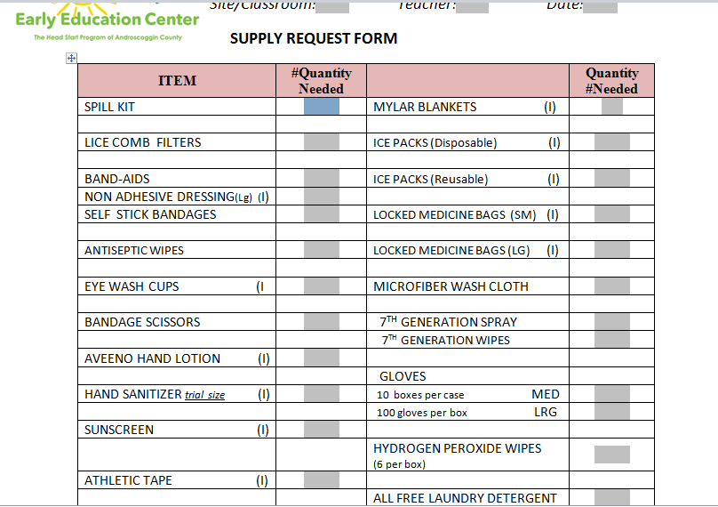

Title of Procedure or Process: | HEALTH SUPPLIES ORDERING PROCEDURE
Program Area(s): | Health
Related Standards or Regulations: | - Head Start Program Performance Standards  - Maine State Licensing  - Developmentally Appropriate Practice/NAEYC  ☒Caring for Children  ☒Other
Person Responsible for implementation: | Classroom Staff and Site Supervisor
Timeline for completion: | November, February and June-by end of the month
Submitted to: | Darcy Morgan, Health Assistant
ChildPlus Documentation: | N/A
Uploaded to ChildPlus: | N/A
Specific Directions: | The Health Department retrieves the PO and completes the form, upon receiving requests from centers; the secretary then orders supplies, and finance completes the order by receiving verbal/electronic confirmation and/or packing slip to confirm  shipment was received.

PROCEDURE:

  - Obtain the form from the Promise website- Staff forms- under Health & Safety- Health Supply Request Form.
  - The expectation is that orders are completed for the whole center, to reduce PO’s and shipping cost.
  - Send the digital copy of the form to the Health and Nutrition Manager, Health and Nutrition Coordinator and Site Supervisor November 1st, February 1st and June 1st .
  - Reminder, the full order may arrive in multiple packages and on multiple days, depending on the vendor.
  - If supplies are damaged, inform and return to Health, to allow the agency to get reimbursed.
  - Return all packing slips to Denise in Finance office by inner office mail. If there is no packing slip, please inform Denise of this. Note-electronic receipts may be sent to Roberta whom placed the order.
  - The Health Department will order all start-up Health supplies needed to get a classroom set-up for the first day of school in August.

Title of Procedure or Process: | DAILY HEALTH CHECK
Program Area(s): | Health, Education
Related Standards or Regulations: | ☒Head Start Program Performance Standards  ☒Maine State Licensing  - Developmentally Appropriate Practice/NAEYC  ☒Caring for Children  - Other
Person Responsible for implementation: | Classroom Staff and Site Supervisor
Timeline for completion: | Before parent leaves the classroom or when child enters the classroom
Submitted to: | Health Department, if temporarily excludable
ChildPlus Documentation: | Health communication Log and Attendance Tab, Absence Reason
Uploaded to ChildPlus: | Physicians note, if required by the Health Manager
PHILOSOPHY:
Promise provides opportunities for healthy growth and development including establishing daily routines for each child served. Children will have a daily health check, wash their hands at required times, and brush their teeth daily according to established procedures and with the guidance and support of trained staff
PROCEDURE:
Prior to the start of each class, the designated staff member will perform a health check on each child as they enter the classroom. Staff should objectively determine if the child is ill or well. Staff should determine which children with mild illnesses can remain in care and which need to be excluded. The Site Supervisor will monitor this and ensure staff are following the protocol daily.

- The health check will begin with questions for the parent (if present) and the child:

  - Ask Parent – “How has your child been in the last 24 hours?” (Sleeping/eating habits, medications, illness concerns, accidents, ER visit or other concerns)

  - Ask Child – “How do you feel today?”
- The staff member will continue the health check by looking at the child’s:
  - Overall appearance
  - Color/condition of skin, face and arms (pale or flushed appearance, rash or injuries)
  - Eyes (redness, drainage, injuries, swelling or itching)
  - Nose (drainage or discharge)
  - Mouth (dry/cracked lips, rash/lesions on or around lips, drooling)
  - Movement (unusual walk, limp, or overly protecting any area of the body)
Most illnesses do not require exclusion (temporarily “excluded” from school). Lead Teacher or Supervisor should determine if the illness:
- Prevents the child from participating comfortably in all activities;
- Results in a need for care that is greater than the staff can provide without compromising the health and safety of other children;
- Poses a risk of spread of harmful diseases to others.
- When staff has completed the health check, they will decide if there is a suspected contagious condition or another concern that would prevent the child from safely attending class.Staff will refer to the Caring for Children’s Exclusion Chart in the Operations Manual to advise the parent as to when the child may return to class.
- If any of the above criteria are met, the child should be excluded, regardless of the type of illness.
- Staff will document in two areas for any child sent home with a suspected contagious condition or excludable conditions in Child Plus.
- Health Tab, Health Communication Log
- Attendance Tab, Absence Reason
- Most conditions that require exclusion do not require a primary health care provider visit before reentering care.
- If parent/guardian and teacher disagree with the health check results, the teacher should not accept responsibility for the care of the child.
- Contact the Health Manager and your Site Supervisor if there are parent questions or concerns.

Title of Procedure or Process: | INCIDENT REPORT PROTOCOL
Program Area(s): | Health
Related Standards or Regulations: | - Head Start Program Performance Standards  ☒Maine State Licensing  - Developmentally Appropriate Practice/NAEYC  ☒Caring for Children  - Other
Person Responsible for implementation: | Lead Teacher or Site Supervisor
Timeline for completion: | Before End of the Day; If Emergency-Immediately
Submitted to: | Health Manager
ChildPlus Documentation: | Under Health Tab; Incident Report tab
Uploaded to ChildPlus: | Within 24 hours of the incident
Specific Directions: | For the purpose of this protocol, a reportable child incident is anything that happens to a child that causes harm to their body while they are on site i.e., injury, accident  or medical emergency.
Procedure:
Staff Responsibility is:
- To ensure that incidents/accidents are managed in accordance with American Red Cross Pediatric First Aid & CPR guidelines.
- That Health Checks are done at arrival and throughout the day (i.e., looking for any new marks on a child’s body that wasn’t there when he/she came in).
- That the child’s incident/accident report is completed in Child Plus (CP+).
- Parent is informed of the report made on the day of the incident.
- To inform Health Manager by email within 24 hours when an incident occurs.
- EHS staffs are responsible to discuss with parents that they may not receive an incident report for every fall if it did not results in bodily injury or first aid as children between 15 months and 2 years old are learning to achieve skills, strength, balance and rhythm of a secure walker.
Health Manager Responsibility is:
- To monitor incident/accident reports and perform accident prevention planning with the safety committee monthly.
- Assure all direct service staff will have current certification for American Red Cross Pediatric CPR & First Aid.
Incident involving First Aid-
- Any incident requiring first aid will need an Incident Report
  - Staff will use their first aid training and assist the child and give TLC.
  - Staff completes Incident Report in Child Plus the day of the incident.
  - Notify parent by phone if mark is visible unable to reach send message through Talking Points.
  - If parent wants a copy, please print report from CP+ and give to the parent.
- Even if you did not observe the incident that left a mark or swelling on a child an incident report is needed.
  - If a child reports aches and pains that happened during children’s school hours.
  - If an incident happened that could have resulted in injury, and may be relayed to parents, i.e., “I fell off the slide today”; “I hurt my arm when Johnny pushed me down today”, etc. (Use your judgment).
Incident involving a Serious Injury-
- Requires medical attention (i.e., burns, tooth loss/break, falls, ingestion of non-food substances and head or spine trauma).
- Also, any serious injury (i.e., broken bones, severe bleeding, and loss of consciousness) that requires calling 911. If the 911 dispatcher does not feel the injury warrants EMS involvement, staff will follow recommendations of 911 dispatcher and notify Health Manager as soon as feasible. Refer to OM; pg. 1 - When to Call 911.
  - Verbally notify the parent and Site Supervisor immediately if medical attention is needed.
  - Site Supervisor will contact Health Manager to report the injury.
  - Complete the form immediately following the occurrence of any injury that is severe enough to cause the loss of one-half day or more of school or warranted medical attention and treatment (i.e., School Nurse, ER and MD).
  - A staff member will go with child to the ER, if a parent is not onsite

Promise Early Education Center

Sick/Exclusion Plan-Short Term
Policy: Androscoggin Head Start & Child Care is committed to maintaining a healthy, safe environment for enrolled children, their families, and staff. Temporarily excluding a child from program participation protects the health of the affected child, other children and staff.
Purpose: To provide guidelines for family and staff to clearly identify when a child should be excluded from attending our program, including Home Based socializations, and our Family Child Care program.
Symptom | Child Must be at home?
Cold Symptoms | No, unless  - Fever and behavior change •  - Child looks or acts very ill •  - Difficulty breathing •  - Blood red or purple rash not linked to an injury •
Cough | No, unless  - Severe cough •  - Rapid and/or difficult breathing •  - Wheezing if not previously evaluated and treated •  - Cyanosis (blue color of skin and mucous membranes) •  - Tuberculosis until treated **☺  - Pertussis until 5 days after antibiotic treatment **☺
Diaper Rash | No, unless  □ Oozing sores that leak body fluids outside the diaper •
Diarrhea  In Caring for Our Children, the excluding criteria states “children may remain in care as long as the stool is contained in the diaper or underwear.” | No, unless  - Watery stools, increased two or more stools above the normal•  - Diarrhea not contained in toilet until resolves •  - Blood/mucus in stool (unless from medication or hard stools) •  - Abnormal color of stool for child • (i.e. all black or very pale)  - No urine output in 8 hours •  - Jaundice (i.e. yellow skin/eyes) •☺  - Fever with behavior changes •  - Looks or acts very ill •  (Shiga-toxin producing E. coli (STEC) also known as enterohemorrhagic E.coli (EHEC),  Shigella and Salmonella typhi (typhoid) require clearance by health department prior to return  to school) **☺
Difficult or Noisy Breathing | Yes, if  - Hard, fast, difficult breathing that does not improve with any medication the program has been instructed to use for child’s difficult breathing •  - Barking cough with fever or behavior changes •  - Chest retractions •  - Breathing problem that makes feeding very difficult •  - Looks or acts very ill •
Earache | No, unless  - Unable to participate • 19  - Fever with behavior changes •
Eye Irritation, Pinkeye |  | Yes, if  □ Purulent (pink or red conjunctiva (whites of eyes) with white or yellow mucus), or diagnosed with bacterial conjunctivitis, until treated **  If more than 1 or 2 children in group have watery red eyes without chemical irritant exposure, exclusion may be required and health authorities should be notified **☺
Fever  - 100°F axillary – infants •  - 101°F orally (not reliable under 4 years of age) •  - 102°F rectally •  Ear measurements may not be reliable but are similar to rectal temperatures. |  | No, unless  - Behavior change •  - Child cannot comfortably participate in school activities, as determined by staff •  - Staff attention to the illness must not overwhelm delivery of care/education to other children •  Temperatures considered elevated above normal, leading to concern of possible disease (children older than 4 months) •  ✓Infants younger than four months (4) with an unexplained fever should be evaluated by medical professional.
Headache |  | No, unless  □ Child is unable to participate in school activities, as determined by staff •
Itching |  | Yes, if  ✓See under “Rash” for chickenpox, shingles, scabies, impetigo, ringworm.  No, unless appears infected  ✓Head lice (at end of day until first treatment; no exclusion for nits or live lice) •  - Pinworm •  - See under “Rash” for eczema, contact or allergic dermatitis.
Mouth Sores |  | No, unless  - Inability to swallow •  - Excessive drooling with breathing difficulty •  - Fever with behavior changes •
Rash |  | Yes, if  - Rash with behavior change or fever •  - Oozing/open wound •  - Bruising not associated with injury •  - Joint pain and rash •  - Unable to participate in school activities •  - Measles until 4 days after start of rash **☺  - Rubella until 6 days after onset of rash**☺  - Chickenpox (Varicella) until all lesions have dried (usually 6 days) **  - Scabies until treated **  - Impetigo until treated for 24 hours **  - Ringworm (at end of day until treatment started) •  No, unless appears infected  - Allergic or irritant reactions •  - Eczema •  - Shingles (must be able to keep lesions covered with clothes and/or dressing). •
Sore Throat (pharyngitis) |  | No, unless  - Inability to swallow •  - Excessive drooling with breathing difficulty •  - Fever with behavior change •
Stomachache |  | No, unless  - Severe pain causing child to double over or scream •  - Abdominal pain that continues after two hours •  - Abdominal pain after injury •  - Bloody/black stools •  - No urine output for 8 hours •  - Diarrhea •  - Vomiting •  - Yellow skin/eyes **  - Fever with behavior change •  Looks or acts very ill •
Swollen Glands (Lymph Nodes) |  | No, unless  - Difficulty breathing or swallowing •  - Red, tender, warm glands •  - Fever with behavior change •  - Mumps, until 9 days after swelling of parotid glands •☺
Vomiting |  | Yes, if  - Vomiting 2 or more times in prior 24 hours •  - Fever •  - Vomit that appears green/bloody •  - No urine output in 8 hours •  - Recent history of head injury •  - Looks or acts very ill •
Other |  | As per Health Dept. during outbreak  Yes, if  - Hepatitis A until 1 week after onset of illness or jaundice **☺  - Child is irritable, lethargic, continuously crying, or requires more attention than staff can provide without compromising the health and safety of the other children.  ✓Pandemic Plan: Maine CDC may initiate different guidelines for exclusion during a pandemic influenza outbreak.
No set of recommendation can cover all situations. Consult with a pediatrician, the health department, or individual pre- school district policies when in doubt.

Additional Information: When a child has suffered from a serious respiratory illness (RSV, pneumonia), been hospitalized or been seen in a hospital emergency room, we require a note from the physician (an ER note will not be excepted) stating that the child’s condition is not contagious, and that the child can participate in regular activities. If there are any restrictions in activities or dietary needs, an Individualized Health Plan will be developed by the Health Manager, and we will make reasonable accommodations to meet the restrictions prior to the child returning to AHSCC.

A note from the physician is only required for health reasons that are listed on the Exclusion List, stating that the child’s condition is not contagious, and that the child can participate in regular activities.

Sick/Exclusion Plan-Short Term

Purpose: To provide guidelines for family and staff to clearly identify when a child should be excluded from attending our program, including Home Based socializations, and our Family Preschool & Child Care program.

Policy: Promise Early Education Center is committed to maintaining a healthy, safe environment for enrolled children, their families, and staff. Temporarily excluding a child from program participation protects the health of the affected child, other children, and staff.

Protocol: Is for the teacher to review Signs and Symptoms Chart attached and the Purple Book (Managing Infectious Diseases in Child Care and Schools). Teachers are then required to call there SS first (if can’t be reached) the Health Manager/School Nurse for guidance before calling a parent to come and pick up their child. A note from the physician is required for health reasons that are listed on the Exclusion List and if the child has been out for three or more days and has been seen by a physician, stating that the child’s condition is not contagious, and that the child can participate in regular activities

Sick/Exclusion Plan-Short Term
Additional Information: When a child has suffered from a serious respiratory illness
(RSV, pneumonia), been hospitalized or been seen in a hospital emergency room, suffered a fractured bone, concussion, seizure, contagious illness, etc., we REQUIRE a note from a health professional stating that the child’s condition is not contagious, and that the child can participate in regular activities. If there are any restrictions in activities, we will try to make reasonable accommodations to meet the restrictions prior to the child returning to Promise. Only the Health Manager/School Nurse can determine and approve those accommodations can be met while in our care. You are required to outreach to the Health Manager before promising a parent their child can return to school.
Procedure:
- Upon enrollment, each family will receive a copy and explanation of this policy and questions will be answered.
- The overall health of each child shall be observed daily at the time of arrival. Unusual symptoms or change in health and/or behavior of the child shall be discussed with the parents or guardians and documented.
- A child shall not remain in our care if the child is not well enough to participate in usual activities or is showing signs and symptoms as described in our Sick/Exclusion Plan.
- Children will continue to be observed throughout the day. Observations of mild symptoms or change in behavior will be recorded and discussed with parents or guardians when the child is returned to their care.
- The child’s Teacher, Family Service Advocate, Site Supervisor, or the Health/Nutrition Manager will be available to support and consult with staff and families during the onset of a child’s illness.
- In the event of a sudden illness such as vomiting, diarrhea, elevated temperature of 101° or higher, etc., the parent will be notified as soon as possible and asked to come for the child. Caregiver/teacher will document the episode in Child Plus.
- If a child has a fever of 101° or higher with symptoms of illness or two or more episodes of vomiting or diarrhea in the previous 24 hours, the child needs to remain at home until the symptoms are no longer present (without medications such as Tylenol) and the child feels well enough to participate in the normal routine and activities at Head Start.
- Emergency cards, with at least two contacts who can respond to an emergency, will be on hand and updated on a regular basis.
- Every effort will be made to keep children with symptoms of illness separated from other children (at least 6 feet away) and kept as comfortable as possible until their parents or a designated person is able to come for them.
- Notes/Documentation for Return: A student may return to school with physicians, nurse practitioners, or licensed health care professional medical note for return to school following an excludable condition.
- If a child is diagnosed with a contagious illness or condition, notices will be sent to all parents and guardians of children who may have been exposed

Title of Procedure or Process: | INCLUSION/EXCLUSION FOR FEVER
Program Area(s): | Health, Education
Related Standards or Regulations: | ☒Head Start Program Performance Standards  ☒Maine State Licensing  - Developmentally Appropriate Practice/NAEYC  ☒Caring for Children  ☒Other American Academy of Pediatrics
Person Responsible for implementation: | Lead Teacher, Site Supervisor and Health Manager
Timeline for completion: | Every day i.e. morning health check and monitor throughout the day
Submitted to: | Health Manager or Health Department
ChildPlus Documentation: | Health Communication Log
Uploaded to ChildPlus: | Medical Notes. If applicable
Specific Directions: | Inform parents of policy/procedure and assure they understand them. Provide  guidance at pick up, drop-off, home visit and through remind, when needed.
Procedure:
Fever is defined as a temperature above 101° F (38.3 degrees C) by any method. These temperature readings do not require adjustment for the location where they are made. Report the temperature and the location (e.g. 101° F in the axilla (armpit) or temporal (forehead scan). If an infant 2 months or younger has a temperature of 100.4 or higher the parent should immediately call their doctor or go to the emergency room.

Fever without signs or symptoms of illness (sore throat, earache, stomach pain, persistent cough, rash, vomiting, diarrhea) or a fever without acute behavior change (lethargy, irritability, persistent crying, difficulty breathing) that prevents the child from participating comfortably in normal daily activities DOES NOT require exclusion from the classroom.

- Exclusion is not needed for fever alone.
  - An unexplained fever (as defined above) without any signs/symptoms of illness or behavior changes staff will:
    - Notify parent/guardian of unexplained fever and staff will monitor the child for any changes in behavior or symptoms of illness.
    - Staff should recommend the parent/guardian follow-up with their child’s physician for guidance.

- Exclusion is recommended when:
  - Fever occurs in an infant, who is younger than 2 months old; a temperature above 100.4°F by any method and behavior change or other signs and symptoms.
  - Fever is associated with behavior change or other signs of illness or other condition that requires exclusion (see sick/exclusion Protocol). The signs of illness are anything (other than fever) that indicates the child’s condition is different from what is usual when the child is healthy.
  - The child is unable to participate in normal daily activities and requires more care than the classroom staff can provide without compromising the health and safety of the other children.
  - The child has not completed the recommended vaccine series; until it is clear the child does not have a vaccine- preventable illness and does not pose a risk of spread of harmful disease to others.

*Behavior is a much more reliable indicator of the significance of illness, than the presence and height of a fever.

TITLE OF FORM: | HEALTH COMMUNICATION LOG
Related Protocol: | Daily Health Check Protocol
Program Area(s): | Health,
Related Standards or Regulations: | - Head Start Program Performance Standards  ☒Maine State Licensing  - Developmentally Appropriate Practice/NAEYC  ☒Caring for Children  - Other
Procedures | - When a child has a short-term health concern, or a concern was observed on the Daily Health Check, you must create a Health Communication Log to track the treatment or parent support of.  - Enter daily follow-ups with feedback from parent until the child’s health improves. Review Child Plus Training in OP’s manual to learn required documentation needed.  - If a concern improves you must add close out date and change the status to completed. If same concern arises again, change the status and remove close out date and continue adding new updates for ongoing concern. Do Not create multiple logs for the same health concern.  - Outreach to Health Manger for guidance and questions.
Form Completed By: | Lead Teacher or Family Advocate
Timeline for completion: | By end of the end of the day
Specific Directions: | Do not create multiple logs for the same concern, you must keep adding updates into the health communication log area.
Submitted to: | N/A
ChildPlus Documentation: | Yes, under Health Tab, Health Events, Add Event, Health Communication Log
Uploaded to ChildPlus: | Medical notes, if applicable
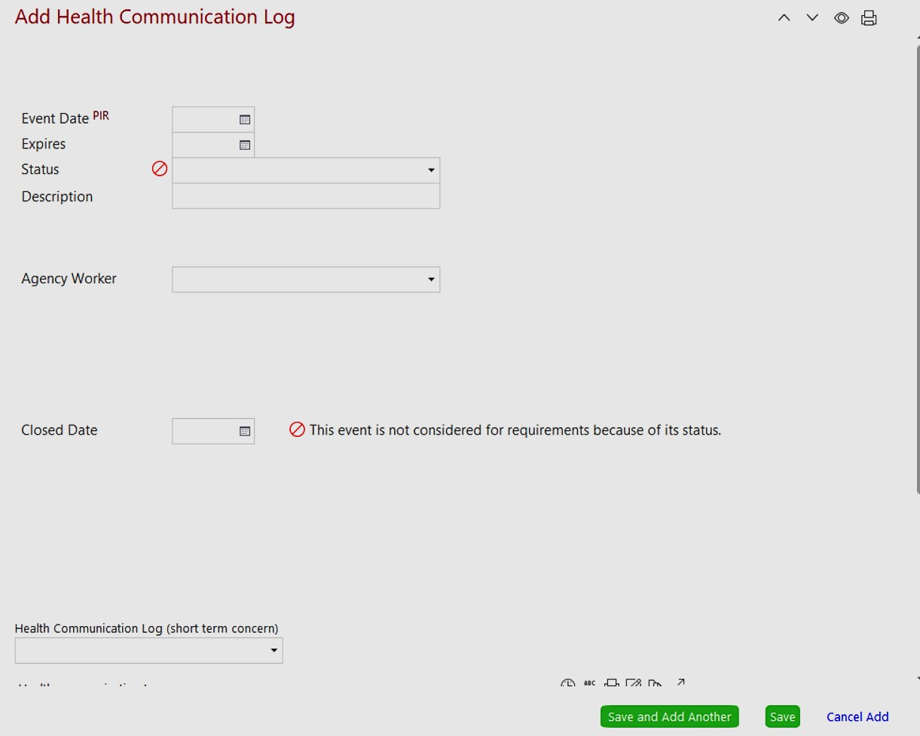

Title of Procedure or Process: | INDIVIDUAL HEALTH PLAN
Program Area(s): | Health, Nutrition, Education, Special Services, Family Services, ERSEA, etc.
Related Standards or Regulations: | ☒Head Start Program Performance Standards  ☒Maine State Licensing  - Developmentally Appropriate Practice/NAEYC  ☒Caring for Children  - Other
Person Responsible for implementation: | Health Manager
Timeline for completion: | Within 48 hours after receiving PCP Health Plan
Submitted to: | Lead Teacher
ChildPlus Documentation: | Chronic Health Condition under Health Tab-Health Event
Uploaded to ChildPlus: | All Medical Notes and Signed IHP
Specific Directions: | The IHP serves to document that a proper plan and safeguards were put into place to ensure the child’s educational progress and/or health and safety while  at school. It is used to communicate a student’s specific health care information to classroom staff and parents.
Procedure:

A Copy of All Doctor’s Notes must go to the Health Manager.
The original doctor’s note is downloaded in Child Plus under attachment under the Health Tab and goes in the child’s file.

IHP-WHEN IT IS NOT NEEDED - Medical
If the condition is short term (1-14 days) and no medication or classroom modifications are needed, a health care plan other than the doctor’s note is not necessary.

IHP: WHEN IT IS NEEDED-Medical
Anytime a child needs modifications or restrictions to their diet, activities or the classroom environment and/or requires medication to be kept at school, a health plan needs to be developed.

When a child returns after a surgery, accident or injury that requires any classroom accommodation, restriction or modification of daily activities, a meeting with the Health Manager, the classroom staff, site supervisor and parents should be scheduled before the child returns. An IHP should be completed with the details of the accommodation(s) and/or modifications that are required according to the doctors’ orders. The plan should include safety plans for fire drills and emergency evacuations or lockdowns.
Example: If the condition is temporary but long term, such as a leg fracture requiring the use of crutches or wheelchair that will require activity and classroom modifications, than a health plan should be developed and implemented.

Title of Form: | Health Information Form (paper form) –> Electronically in Child Plus
Related Policy: | No Policy, Best Practice based on HS standard
Program Area(s): | Health, Nutrition, Education, Special Services, Family Services, ERSEA, etc.
Related Standards or Regulations: | ☒Head Start Program Performance Standards  - Maine State Licensing  - Developmentally Appropriate Practice/NAEYC  ☒Caring for Children  - Other
Procedures | - Retrieve form from Promise Website if you will not have access to Wi-Fi/computer  - Required to assure on the child’s first day of school, they are medically cleared to be in school by the health manager.  - Fill out for parent, to keep it legible.  - Complete at Enrollment, Health Screen Day or 1st initial home visit.  - Has to be uploaded into CP+ within one week of child’ first day of school.  - Contact Health Manger on the day of completing the form if there is health concerns, IHP needed, mealtime restrictions, etc.  - Health Manager reviews all questionnaire’s and oversees children Health, Nutrition & Safety.
Form Completed By: | Staff with Family Service Responsibility.
Timeline for completion: | Before child enrolls in the program and uploaded into CP+ one week after enrolled.
Specific Directions: | Head Start Standard, §1302.42 Child health status and care  (4) A program must identify each child’s nutritional health needs, taking into account available health information, including the child’s health records, and family and staff concerns, including  special dietary requirements, food allergies, and community nutrition issues as identified through the community assessment or by the Health Services Advisory Committee.
Submitted to: | Inform Health Manager when it is uploaded for review
ChildPlus  Documentation: | Electronically input information from paper form into—Under Application Tab—Health Nutrition  Questionnaire Tab
Uploaded to ChildPlus: | N/A shred paper form was uploaded.

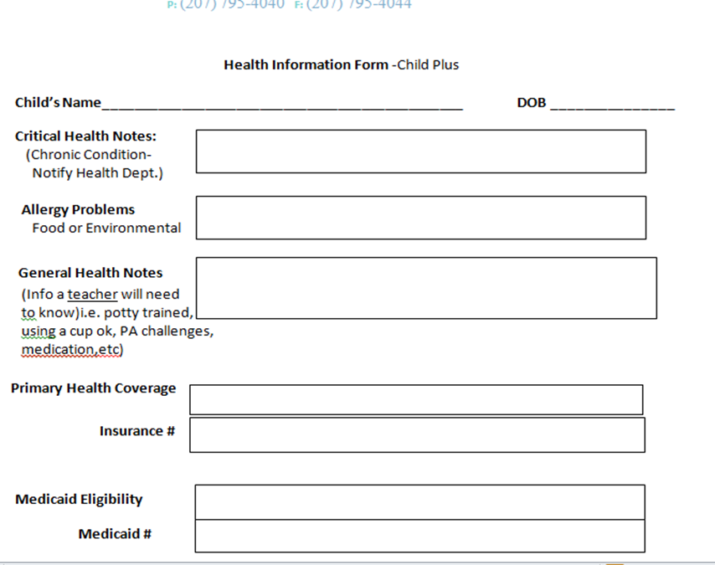

Title of Procedure or Process: | MEDICATION ADMINISTRATION
Program Area(s): | Health
Related Standards or Regulations: | ☒Head Start Program Performance Standards  ☒Maine State Licensing  - Developmentally Appropriate Practice/NAEYC  ☒Caring for Children  ☒Other
Person Responsible for implementation: | Staff Med 101 Trained only
Timeline for completion: | Before Medication is left at school
Submitted to: | Health Manager; Contractual Nurse will review
ChildPlus Documentation: | Create a Flag-Medication onsite
Uploaded to ChildPlus: | All PCP notes, AAP, Seizure Plans; Food Allergy Plan,
Specific Directions: | Prescribed Medication cannot be kept on site without a doctor approved note, Health Manager approval, Med Authorization form is completed, and medication bag is available. Promise staff cannot transport medication i.e. classroom-to-classroom, parent-to-another parent or center-to-center.
Procedure: Medication will be administered to a child enrolled in our program only in accordance with the regulations set forth in the State of Maine Rules for the Licensing of Child Care Facilities 10-148 CMR Chapter 32, Head Start Performance Standards, and recommendations from Promise Early Education Center Health Advisory Committee.
Philosophy: Promise requests that medication(s) be administered at home and encourages parents, in collaboration with their physician, to schedule doses of a medication to be given during the times when the child is not attending Promise.
The Health Manager may authorize a medication to be administered when a child has a medical condition e.g., asthma, serious allergy that may require urgent administration of a medication or when refusal to do so would pose a significant hardship to the family or require the absence of a child in the recovery phase of an illness that is otherwise well enough to attends.

Prescription Medication:

- Staff must inform and review with the parent/guardian the Promise Medication Policy prior to the child entering our program.
- A child needing Emergency Medication (Epi-pen, asthma inhaler, etc.) will be excluded from attending class until the parent provides the medication and attends a Health Plan meeting with the Health Manager and teachers.
- Promise also recommends the parent provides information on other medications the child is taking at home, to observe the child for possible side effects while attending our program.
- Center staff will notify Health Manager before the end of the day when they discover that a child is required to take a prescribed medication while attending class/center activities.
- Classroom staff/Supervisor will inform the parent that medication cannot be left at the center or administered to a child until:
  - Written authorization from child’s physician (guidance in bullet 8.) is received
  - Verbal approval by Promise Health Manager, Head Start Nurse, or other contractual health professional,
  - Authorization Medication Form is completed and signed, by parent, teacher and Health Manager,
  - Medication is in required packaging (see bullet 8.)
- Promise requires that the first dose of any medication be given at home. When any medication is Prescribed for the first time, children need to remain at home until 24 hours after the first dose has been given.
- Lead teacher must review and become familiar with all information in the child’s health record for children on their caseload, to become familiar with the child’s possible symptoms, to clearly understand if/when medication is needed.
- A physician’s note, needs to have the following information:
  - Authorization to administer medication
  - Reason for the medication to be given
  - Name of the medication
  - Dosage, route, and duration of medication required
  - Administration schedule
  - Possible side effects of the medication – pharmacy informational printout
  - Special instructions or precautions
  - Health Care Provider Signature.
- The parent must bring the medication to the Lead Teacher ( Med 101 Trained), it must be in the original pharmacy-labeled container that is labeled with:
  - The childs first and last name
  - The name and strength of the medication
  - Specific, legible instructions for administration ( Dose, Route, Frequency) storage and if application disposal
  - Date the prescription was filled
  - The name of the health care provider who wrote the prescription
  - Medication Expiration Date
- The authorization to administer medication form MUST be completed by the Lead Teacher and Health Manager and reviewed with the parent/guardian. A plan may be created that includes specific directions for childcare staff. The completed form must have the following:
- Child’s Name
- Name of Medication
- Dosage
- Date and Time of Administration
- Three authorized signatures, The Health Manager, Classroom Staff and Parent/Guardian.
- Signature of the person Trained and Administering the Medication.
- Each time medication is administered it MUST be recorded on the child’s record of Medication Log
- Staff will Administer Medication according to the following protocol
  - Wash hands with soap and water before giving and after administering medications
  - Assemble Supplies- Ensuring the “5 R’s”
    - Right Child
    - Right Medication
    - Right Time
    - Right Dose
    - Right Route
  - Always address the child by name to let them know it is time for there medication
  - When administering, make sure the entire dose is given
  - Document in the Records of Medication Log including the following information
      - Name of the Child
      - Name of the Medication
      - Dosage
      - Route
  - When complete ensure storage of the medication returns to the Emergency Backpack, and is double locked up and out of reach.
- Staff will observe the child for any adverse reactions to the medication, signs of allergy, changes in behavior, etc.
- Adverse reactions are reported to the parent immediately
- A Medication Incident Report is completed and downloaded into Child Plus under Health Attachments
- Teachers will contact Health Manager if he/she is unclear regarding medication instructions or have concerns regarding the administering on any medication prior to.
Before such a medication will be allowed to be administered at the center there will be a health team meeting consisting of the supervising classroom teacher, parent and family service worker and the health manager, contracted nurse, or health coordinator. This meeting takes place so the family and team are all specifically trained on what the medication is, why it might or might not be necessary to provide at the center, to answer any questions by the family and/or center staff and to be sure all paperwork and physician signatures are in place.

Title of Procedure or Process: |  | MEDICATION FORM PROTOCOL
Program Area(s): |  | Health
Related Standards or Regulations: |  | - Head Start Program Performance Standards  ☒Maine State Licensing  ☒Developmentally Appropriate Practice/NAEYC  - Caring for Children  ☒Other
Person Responsible for implementation: |  | Health Manager Oversees and Lead Teacher is responsible for oversight of
Timeline for completion: |  | Before Medication is left on sight and monthly
Submitted to: |  | Health Manager
ChildPlus Documentation: |  | Flag, Chronic Condition Event, Food Allergy Event and Health Comm Log
Uploaded to ChildPlus: |  | Under Health Attachments
Specific Directions: |  | Promise protocol on what to do with all the Medication Authorization Forms & Record of Medication Log - Doctors Notes – Physicians Health Plan--Individualized Health Plans - Medication List – Medication Incident Report- Controlled Medication Daily Log- Medication Release Authorization Letter in the classrooms.
Procedure:
 | Medication Authorization Form  (found on Promise website | 1. Needs to be kept in medication bag with IC medication.  Why? For Licensing, that parent has signed and approved med to be administered. Also, anyone administering the medication and/or reviewers can see that all safety protocols are in place to administer medication(s). Attached is the Record of Medication Log; when full, please send to the Health Manager for signature. HM will  upload into CP+ in child’s file.
 | Doctor’s Note | Need to be in IC electronic file and a copy sent to the Health Manager and Public School Nurse (if applicable).
 | Physicians Health Plans  (Receive from IC PCP) | 2.Need to be kept in the medication bag with IC medication and in IC electronic file. For Licensing, a physician has approved this med to be administered.
 | Individualized Health Plans  (Receive from Health Manager) | Should be kept in the medication bag (lock box) with IC medication and in IC electronic file. OR kept in Red Folder on Emergency Board.
 | Medication List (Monthly Inventory Log) (found on the Promise website) | To be kept in the medication folder hanging on your Emergency Board beside the medication class list. This provides name of medication, health condition, date med was accepted, expiration date, IHP expiration date, staff accepted med and inventory date.  Why? Anyone assisting in the classroom can be prepared to assist a child (only staff who has Medication 101 training can assist) View the oversight of medication and the expiration dates of IHP, Medical note and Medication at the same time. When completed, send to the Health Manager for review and to keep on file.
 | Medication Incident Report  (found on the Promise website) | Will be kept in the child’s electronic file and a copy given to the parent and a copy sent to the Health Manager and Site Supervisor.
 | Controlled Medication Daily Log  (Must contact Health Manager) | Will be kept in the medication lock box with the controlled medication.
 | Medication Release Authorization Letter  (found on the Promise website) | The signed copy will be kept in the child’s electronic file. This is only for medication that Promise has permission to administer and that the parent/caregiver has given permission to be offsite and in someone else’s possession. A child’s Emergency  Card is not a substitute or allowable authorization.

Title of Form: | AUTHORIZATION TO DISPENSE PRESCRIPTION MEDICATION
Related Policy: | Medication Administration
Program Area(s): | Health
Related Standards or Regulations: | ☒Head Start Program Performance Standards  ☒Maine State Licensing  - Developmentally Appropriate Practice/NAEYC  ☒Caring for Children  - Other
Procedures | - Print the form off of the Promise Website,  - Complete the form when the medication in its original packaging has been received;  - Three signatures are needed, Parent, Staff and Health Manager;  - Form goes in the medication bag and stays with the child’s medication.  - Record of Medication Form (backside) must be completed each time a medication has been administered-ONLY staff Med 101 trained can administer.
Form Completed By: | Responsible staff
Timeline for completion: | Before or when medication is brought to a Center
Specific Directions: | No medication can stay on site without a physicians note.
Submitted to: | Health Manager
ChildPlus Documentation: | Add under Chronic Condition and Food Allergy Health Event or Health Comm Log
Uploaded to ChildPlus: | Doctors note, with permission to administer the medication, Asthma Action Plan, Seizure Plan. The Mediation Authorization Form

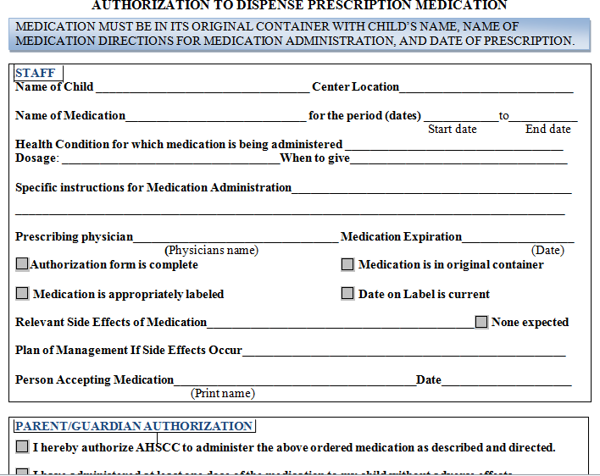

Title of Form: | MEDICATION INCIDENT REPORT
Related Policy: | Medication Procedure
Program Area(s): | Health,
Related Standards or Regulations: | ☒Head Start Program Performance Standards  ☒Maine State Licensing  - Developmentally Appropriate Practice/NAEYC  ☒Caring for Children  - Other
Procedures | - Retrieve form for Promise Website, complete and print.  - Contact Health Manager immediately or child’s PCP for guidance.  - Contact parent and inform them of the incident.  - Upload into Child Plus.
Form Completed By: | Staff involved in the incident
Timeline for completion: | At the time of the incident, same day
Specific Directions: | Incident Report is completed when *a MEDICATION ERROR is defined as failure to administer the prescribed medication to the  right student, at the right time, the right medication, the right dose or the right route.  Poison Control should be called:  - You give the wrong medication to a child  - You give a medication to the wrong child
Submitted to: | Health Manager
ChildPlus Documentation: | Under Health Tab—Event Tab—Add Event--Chronic Condition or Health Communication Log Event depending on medical condition for medication prescribed.
Uploaded to ChildPlus: | Completed form—under Health Tab--Attachments

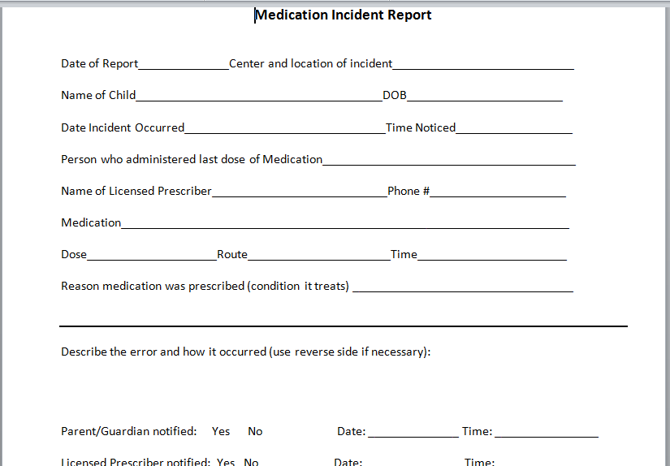

Title of Form: | PARENTAL PERMISSION TO ADMINISTER OTC PRODUCT
Related Policy: | Medication Policy
Program Area(s): | Health,
Related Standards or Regulations: | - Head Start Program Performance Standards  ☒Maine State Licensing  - Developmentally Appropriate Practice/NAEYC  - Caring for Children  - Other
Procedures | - Print form from Promise Website  - Complete form and have parent sign  - Keep with OTC medication
Form Completed By: | Classroom Staff or Health Manager
Timeline for completion: | Before preventative medication is administered
Specific Directions: | Call Health Manager to complete and review OTC instructions, if needed. Otherwise can be completed by Lead Teacher or Family Advocate.
Submitted to: | N/A
ChildPlus Documentation: | If relevant to a Health Communication Log (short-term health concern)
Uploaded to ChildPlus: | Yes, under Health Tab--Attachments

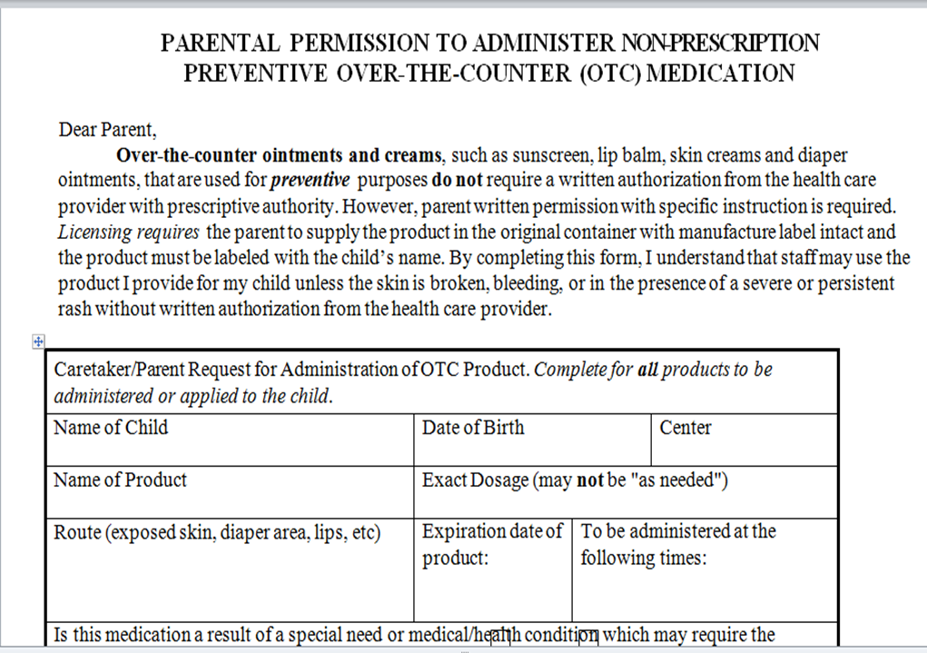

Title of Form: | MEDICATION RED FOLDER LIST
Related Policy: | Medication Policy
Program Area(s): | Health
Related Standards or Regulations: | - Head Start Program Performance Standards  ☒Maine State Licensing  - Developmentally Appropriate Practice/NAEYC  ☒Caring for Children  - Other
Procedures: | - Print off of the Promise Website  - Place into the Red Folder that hangs on the Emergency Board  - Designated classroom staff must do monthly medication inventory checks on this form.  - If designated staff will be out for extend time, you must designate another staff to complete *must do for Licensing requirement.  - Maintain current information at all times: How?  - Add children who are prescribed medication to be administered at school.  - Cross-off children who no longer need medication or have left the program.  - Contact Health Department one month prior to an IHP expiring-to renew.  - Inform parent one month prior, when medication is expiring.  - Authorization Medication form dates can be altered if medication expired, and parent is bringing in the same but renewed medication (white out and add new  medication expiration date). NO other data can be altered on the form.
Form Completed By: | Lead Teacher and SS
Timeline for completion: | At start-up and inputted as medication comes in.
Specific Directions: | This Form tracks Expiration Dates for: Child Care Licensing requirement  - Individualized Health Plan (IHP)  - Medication  - Med Authorization From  All three could expire at different times and needs to be monitored closely.
Submitted to: | N/A
ChildPlus Documentation: | Document outreach to parent and Health Depart. regarding expired forms or medication under child’s Health Event it relates to e.g., Chronic Health Condition, Food Allergy, etc.
Uploaded to ChildPlus: | N/A
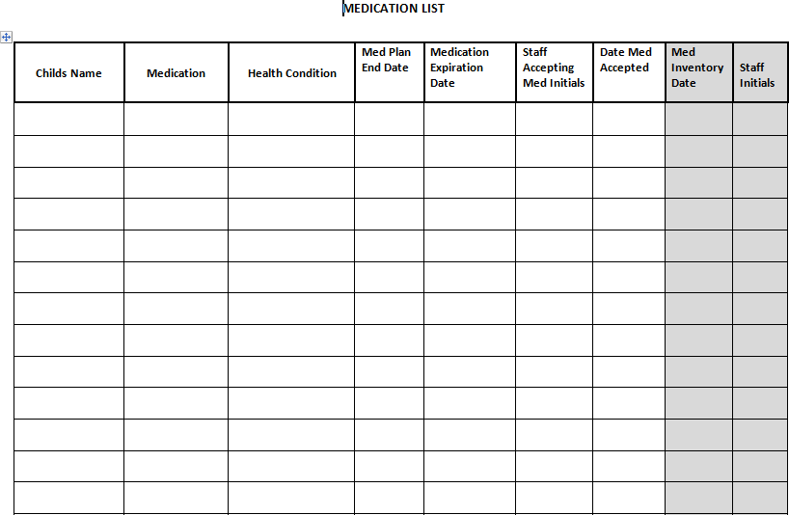

Title of Form: | ASTHMA PLAN-NO MEDICATION
Related Policy: | Individualized Health Plan
Program Area(s): | Health
Related Standards or Regulations: | - Head Start Program Performance Standards  - Maine State Licensing  - Developmentally Appropriate Practice/NAEYC  ☒Caring for Children  - Other
Procedures | ^ Print the Asthma Plan form from the Staff Website-Under the Health Section.  ^ Staff must have parent sign this form and return to the Health Department  ^ Form must be uploaded to Child Plus
Form Completed By: | Lead Teacher or FA
Timeline for completion: | As soon as you know parent will not be wanting medication at school
Specific Directions: | With a confirmed physician diagnosis or Asthma or Reactive Airway Disease and the child was prescribed medication, this form must be completed if the parent does not want  medication administered at school.
Submitted to: | Health Manager
ChildPlus Documentation: | Under Health Tab- Health Event-Chronic Condition Event-Add Action documentation
Uploaded to ChildPlus: | No Medication Asthma Plan Form (below) Physicians note (if applicable)
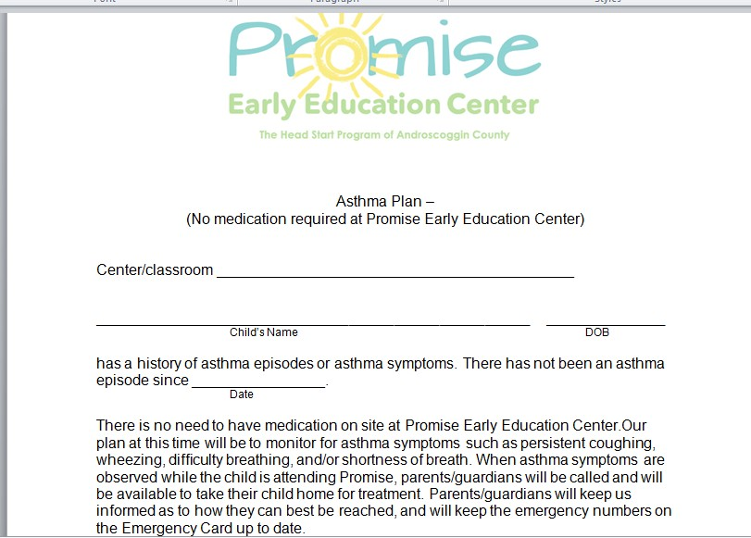

* note -In most cases, if the child has an asthma diagnosis and has not needed to use the prescribed medication for the past year; then use the Asthma Plan-No Medication Promise’s Form. Because, sometimes the asthma is well controlled with medication, such as singular for asthma that is triggered by allergies, that the rescue inhaler is not needed except in rare instances.

IHP: WHEN IT IS NEEDED-Asthma
In the case of an asthma diagnosis (chronic and not episodic with an upper respiratory infection) that requires a rescue medication, such as an albuterol inhaler, and the parent wants medication kept at school, a health plan should be in place, even if the asthma is well controlled with other medication given at home.
Title of Procedure or Process: | PANDEMIC INFECTIOUS DISEASE PROTOCOL
Program Area(s): | Health, Human Resource.
Related Standards or Regulations: | - Head Start Program Performance Standards  ☒Maine State Licensing  - Developmentally Appropriate Practice/NAEYC  ☒Caring for Children  - Other
Person Responsible for implementation: | All Staff are responsible and are to be committed to maintaining a healthy, safe environment for enrolled children, their families and staff.
Timeline for completion: | Immediately upon confirmed diagnosis
Submitted to: | Health Manager
ChildPlus Documentation: | Health Communication Log-Illness category
Uploaded to ChildPlus: | Doctors Notes-confirmed Influenza diagnosis
Specific Directions: | Promise follows recommendations of Maine Center for Disease Control (CDC) and American Academy of Pediatrics (AAP).  Licensing 17.4.2.3 When a child care facility is aware of a notifiable condition, the Health Manager must notify the Maine CDC immediately for category 1 conditions  and within 48 hours for category 2 conditions.
Purpose: To provide guidelines for families and staff and to clearly define Pandemic Influenza.

Definition of Pandemic: A pandemic is a global disease outbreak. A Infectious Disease pandemic occurs when a new virus emerges that people have little or no immunity to and for which there is no vaccine available. The disease spreads easily from person to person and causes serious illness. It can sweep across the country and around the world very quickly
Procedure-Infectious Control Guidelines for Promise Staff:
- Teach staff, children and parents how to stop the spread of infectious viruses.
- Utilize good hand washing by washing hands for at least 20 seconds when hands are soiled.
- Use alcohol-based hand sanitizer when soap and water are not available, and hands are not visibly soiled. This will be supplied for staff, but it must be kept in a safe place out of the reach of children. Hand washing with soap and water remains the preferred method for cleaning of hands.
- Cover mouth and nose when coughing or sneezing. Cover mouth with a tissue and dispose of it in an appropriate container, or cough and sneeze into sleeve.
- Clean frequently touched surfaces, toys and community shared items at least daily and more frequently when soiled.
- Keep enough supplies on hand to control the spread of infection, such as hand sanitizer in areas without a sink and running water i.e., playground. (Hand sanitizer needs to be kept out of the reach of children.)
- Utilize paper towels and hand-free wastebaskets throughout the facility.
- Utilize tissues for coughing, sneezing and runny noses.
- Keep all supplies in easy to locate places.
- Keep at least two extra weeks of supplies on hand.
- Encourage families to talk with their provider about getting the Seasonal and H1N1 Flu vaccine for children (6 months and
- older), parents and staff. Also, the SARS-CoV-2 vaccine for approved children and adults.
- Help all to understand the top priority groups for each of these immunizations. Immunizations will first be distributed to those in the top priority groups.
- All children and staff who have been ill are required to stay home until they have been fever free for 24 hours without taking fever reducing medications such as Tylenol and may require a doctor’s note to return to school.

Additional Guidelines for Direct Line Staff:
- Staff will do daily health checks on children exhibiting symptom of current Pandemic listed by CDC, such as: Fever of 101 ° (38.3 degrees C) by any method. The temperature readings do not require adjustment for the location where they are made, simply report the temperature and the location (example- 101° in the armpit/axilla), Headache, Tiredness, Cough, Sore Throat, Runny/Stuffy Nose, Muscle Aches, and particularly in young children - Nausea, Vomiting and Diarrhea. Children will be excluded if they present with flu like symptoms

Title of Procedure or Process: | HAND WASHING PROCEDURE-HS CLASSROOM
Program Area(s): | Health, Nutrition, Education
Related Standards or Regulations: | ☒Head Start Program Performance Standards  ☒Maine State Licensing  - Developmentally Appropriate Practice/NAEYC  ☒Caring for Children  - Other
Person Responsible for implementation: | All Promise staff
Timeline for completion: | Upon entering a classroom and as listed below
Submitted to: | N/A
ChildPlus Documentation: | N/A
Uploaded to ChildPlus: | N/A
Specific Directions: | Promise Early Education Center promotes good hygiene through hand washing to reduce to prevent the transmission of infectious diseases and the spread of germs. Hand washing is required of all staff, volunteers, parents and children.  Adherence to good hand-hygiene technique has consistently demonstrated a reduction in disease transmission in child care and school settings.

Procedure:
Staff/Volunteers:
- Upon arrival to the childcare facility and before going home
- Immediately before handling food and preparing bottles; before & after feeding children
- After using the toilet, assisting a child using the toilet; before & after changing diapers
- After contact with any body fluids (e.g. nasal drainage, vomit, saliva, feces)
- Whenever hands are visibly dirty or after cleaning up a child, i.e. bathroom/classroom, playground, wounds or trash
- After removing gloves used for any purpose*
- Before & after giving or applying medication or ointment to a child or self (wear gloves for open wounds)
- Staff assists children who are developmentally ready with hand-washing to ensure proper technique. Staff should wash their own hands after assisting.

Children:
- Upon arrival at the childcare facility
- Immediately before and after eating
- Immediately before and after toothbrushing
- After using the toilet or having their diapers changed
- Before using water and sand tables
- After playing on the playground
- After handling pets, pet cages, or other pet objects
- Whenever hands are visibly dirty
- Before going home

Proper Hand-Washing Procedure for adults and children:
- Dispense paper towel first to avoid touching handle after hand washing
- Liquid soap and running water is required
- Vigorously rub hands for at least 20 seconds, including backs of hands, between fingers, under nails, and under and around any jewelry.
- Rinse hands under running water until free of soap and dirt
- Dry hands with a single use paper towel Avoid touching surfaces i.e. turn off water with paper towel

Title of Procedure or Process: | BLOOD BORNE PATHOGENS- EXPOSURE CONTROL PLAN
Program Area(s): | Health and Human Resource.
Related Standards or Regulations: | ☒Head Start Program Performance Standards  ☒Maine State Licensing  - Developmentally Appropriate Practice/NAEYC  ☒Caring for Children  - Other
Person Responsible for implementation: | All Promise Staff
Timeline for completion: | Training within 90 days of hire; Implement at all times
Submitted to: | Staff IR- Human Resource; Child IR-Health Manager
ChildPlus Documentation: | Child Incident Report
Uploaded to ChildPlus: | N/A
Specific Directions: | Complete Staff Accident Incident Report from Staff Website-Human Resource
Procedure:
Promise Early Education Center is aware that accidents and injuries involving blood and body fluids may occur in the classroom/child care setting. Lacerations, abrasions, and bloody noses are common occurrences and have the potential to transmit infectious disease. The body fluids of all persons must be considered potentially hazardous.

All employees who work directly with children are required to participate in training provided by Promise on Blood Borne Pathogens and Universal Precautions. All new employees receive training on Blood Borne Pathogens, Universal Precautions, OSHA regulations and preventing infectious disease transmission within the first three months of employment.

Promise Early Education Center developed an Exposure Control Plan to protect staff that may be at risk of exposure to bacteria and viruses present in human blood and body fluids that can cause disease in humans. These pathogens include Hepatitis B Virus (HBV), Hepatitis C virus (HCV), and Human Immunodeficiency Virus (HIV), which causes Acquired Immune Deficiency Syndrome (AIDS).

Employees can reduce and/or remove BBP hazards from the workplace by using a combination of work practice controls, personal protection clothing and equipment, training, medical surveillance, Hepatitis B Vaccination, signs and labels, and other provisions.

Who is covered by this Regulation? (Exposure Determination)
All Promise employees who work directly with children and are expected to respond to First Aid situations and/or there is a reasonable expectation of exposure to blood or other materials that could cause infections while performing their job.

Procedure for a Blood Incident/Possible Exposure
The employee who responds to a First Aid incident must complete an injury/incident report form. If there has been a possible blood exposure, the employee needs to call Human Resources as soon as possible and within 24 hours after the incident and complete a Possible Exposure Report Form.

Any employee who has experienced the possibility of a blood/bodily fluid exposure does have the option to be evaluated by Concentra. An employee may refuse to be evaluated in writing (please see Possible Exposure Report Form on PROMISE website). During normal business hours, the Human Resource Manager can make arrangements for the visit. An employee is free to go to Concentra without the Human Resource Managers consent. If an employee needs to be seen after Concentra’s office hours, Central Maine Medical Center will provide the evaluation for Concentra. ANY POSSIBLE BLOOD BORNE PATHOGEN EXPOSURE NEEDS TO BE EVALUATED WITHIN 24 HOURS.

Universal Precautions- Protective Equipment:
All employees are provided with personal protection equipment: non-latex gloves, gowns, face shields, masks, eye protection, and spill kits. All classrooms that have Epi- pens or other sharps will be provided with an OSHA approved container for sharps disposal. Hand washing and gloves: All employees are to wear non-latex, non-porous gloves whenever there is body fluids/blood present and wash their hands immediately after removing their gloves. Employees are taught proper technique for hand washing and
glove removal.

Title of Form: | Possible BBP Exposure Report Form
Related Policy:
Program Area(s): | Health
Related Standards or Regulations: | - Head Start Program Performance Standards  - Maine State Licensing  - Developmentally Appropriate Practice/NAEYC  - Caring for Children  - Other
Procedures
Form Completed By: | Responsible staff
Timeline for completion: | ASAP from Exposure, Submitted to the Health Manager, Human Resources and Site Supervisor within 12 hours of incident

If you are exposed or believe you were exposed to BBP, You must complete the exposure report form as soon as possible, No later than 12 hours after incident. Please notify your supervisor immediately to ensure adequate care is provided to you.

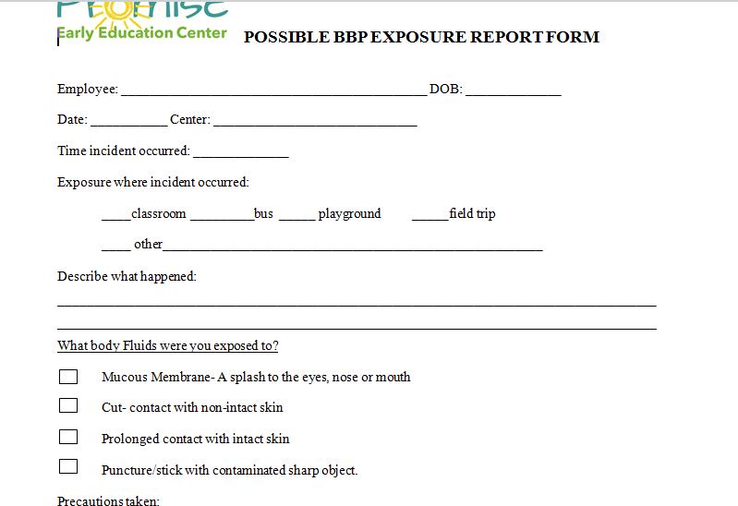

Title of Procedure or Process: | BLOOD AND BODILY FLUIDS CLEANUP AND CONTAINMENT & SPILL KIT INSTRUCTIONS
Program Area(s): | Health
Related Standards or Regulations: | ☒Head Start Program Performance Standards  ☒Maine State Licensing  - Developmentally Appropriate Practice/NAEYC  ☒Caring for Children  - Other
Person Responsible for implementation: | All Staff
Timeline for completion: | Immediately after a hazardous waste spill/leak
Submitted to: | Health Manager and Site Supervisor
ChildPlus Documentation: | Child Illness bodily fluid leak will require a Health Communication Log- Illness
Uploaded to ChildPlus: | Medical Record to return to school, if needed.
Specific Directions: | Promise Early Education Center promotes health and safety by maintaining a clean environment for children and staff. The use of non-latex non- porous gloves by staff is required when in contact with blood and bodily fluids. Gloves are required during diapering, assisting with toileting & toothbrushing, administering first aid, and when vomiting occurs. Proper technique is to be used in cleaning and disinfecting all bodily fluid spills immediately after it occurs. The use of gloves is not a substitute for hand washing and staff will wash hands immediately after the gloves are removed.
Procedure:
- Staff will notify Health Manager of a hazardous waste spill/leak if they need guidance or training.
- Secure/block off the spill area from children.
- A BBP trained staff person wearing PPE’s (personal protective equipment) secures, cleans, and disinfects the soiled area according to the Spill Kit instructions. Spill Kits are in the classroom First Aid/Emergency Response backpack (contained in a labeled clear plastic zipper pouch).
- Pour an absorbent material over the spill (packet of loose absorbent on porous surface or VoBan-hard non- porous surface only).
- Completely saturate the spill area with the disinfectant and let it set for the recommended time for BBP’s (approximately 10 minutes).
- Use the enclosed scoop to pick up the semi-solid gel using the flat tear off piece as a back stop for the scoop.
- To clean the soiled area:
Hard porous surface i.e. table top, linoleum floor, etc.
  - Wipe up area with white absorbent paper towels and double bag the paper towels. Remove the bag from the area and dispose of immediately out of the reach of children.
  - Then spray the contaminated area with hydrogen peroxide spray and let sit for 1 minute and wipe up with paper towels or Swiffer mop.
Non-porous surface i.e. rug
- Wipe up area with a micro-fiber cloth and double bag cloths. Remove the bag from the classroom and bring
to the laundry room. Handle contaminated laundry with gloves.
- Steam-clean the non-porous contaminated surface, according to the training/directions provided.
- Cleaning equipment used to clean spills of bodily fluids (swifter mop, vacuum, steam-cleaner, etc.) must be cleaned and disinfected immediately after use or bagged and tagged for removal and disinfecting.
  - Cleaning equipment used to clean up body fluids need to be:
Cleaned with detergent and rinse with hot water, use bathroom/janitorial sink and sanitize the sink after;

Title of Procedure or Process: | HUMAN BITE PROTOCOL
Program Area(s): | Health, Education.
Related Standards or Regulations: | - Head Start Program Performance Standards  ☒Maine State Licensing  ☒Developmentally Appropriate Practice/NAEYC  ☒Caring for Children  - Other
Person Responsible for implementation: | Lead Teacher or Site Supervisor
Timeline for completion: | IR is done for child bitten/BIR is done for the child who bit
Submitted to: | Health Manager or Education Manger-BIR
ChildPlus Documentation: | IR or BIR
Uploaded to ChildPlus: | IR-Health Tab; BIR-Education
Specific Directions: | To provide a safe environment for children and adults while at school to protect against the transmission of infection, especially with blood-borne viruses. Bites from young children very rarely lead to bacterial infections. Those that do break the skin  don’t usually go deep enough to draw blood.
Procedure:
Philosophy: All staff will follow these required safety practices as recommended by American Academy of Pediatrics when a biting incident occurs. Common reasons why children start biting is teething, excitement and over-stimulation, impulsiveness and lack of self-control, and feeling frustrated (i.e. language barrier).

Procedure: The following steps will be taken if a biting incident occurs at our center.
- The biting will be interrupted with eye contact and a firm “STOP! You bit him with your teeth. He doesn’t like it. It is not OK to bite people.”
- Staff will stay calm and will not overreact.
- The bitten child will be comforted.
- Staff will remove the biter from the situation. The biter will be redirected to another activity and separated from the bitten child for an appropriate amount of time.
- The wound of the bitten child shall be assessed and cleaned with soap and water. Apply a cold compress. If it is determined that there was a blood exposure further steps need to be taken under our procedure for ‘Incident Involving Blood Exposure’.
- Staff and parents of both children will be notified of the biting incident. Appropriate form will be filled out (IR and BIR).
- The bitten area should continue to be observed by parent and staff for signs of infection.

When a bite or injury occurring in the school setting involves a break in the skin and potential blood exposure, the Center will follow the guideline set forth by the Promise Health Department. The following steps should be taken:
- PPE is required before assessing the bitten area.
- Let the wound bleed gently; do not squeeze it. Carefully clean with soap and water.
- Check both children’s immunization records and determine if they are up to date on their tetanus (DtaP), and Hepatitis B vaccines.
- Notify the parent of both children immediately.
- File an incident report as outlined above.
- Both children (and parties involved, e.g. teacher) involved in the biting incident are recommended to be tested for Hepatitis B, C, and HIV by their private physicians. The staff bitten should follow the Exposure Control Plan-Blood Borne Pathogens in the Operations Manual and proceed with Promise’s procedure.

If this behavior persist, parents/guardians, caregivers/teachers, the child care Health Manager and the Behavioral Health Manager should be involved to create a plan targeting this behavior. A caregiver/teacher intervention protects children and encourages children to exhibit more acceptable behavior.

Title of Procedure or Process: | HS CHANGING SOILED UNDERWEAR/PULL-UPS AND CLOTHING PROTOCOL
Program Area(s): | Health, Education
Related Standards or Regulations: | ☒Head Start Program Performance Standards  ☒Maine State Licensing  ☒Developmentally Appropriate Practice/NAEYC  ☒Caring for Children  - Other
Person Responsible for implementation: | Lead Teacher and Site Supervisor
Timeline for completion: | When child is developmentally ready
Submitted to: | Education Manager
ChildPlus Documentation: | Health Communication Log (IC reverts backwards) of Toileting Plan
Uploaded to ChildPlus: | Under Health Tab-Health Comm. Log or Under Education-Toileting Plan Tab
Specific Directions: | Required to track a child based on trauma or Health condition that results in a child reverting back to soiling their underwear.  Toileting Plan required for all children not completely Toilet Trained.
Procedure:
- Prepare Area. Prior to bringing the child to the bathroom changing area staff will: Perform hand hygiene, gather & bring supplies to the changing area i.e. disposable gloves, disposable paper liner, wipes, new pull-up or clean underwear, clean clothes, and a plastic bag for soiled underwear/clothing.
- Prepare the Child. Place child on the paper liner, large enough to cover the changing surface from the child’s shoulders to beyond the child’s feet. Remove child’s shoes & socks before changing. If possible, have the child hold their shirt, sweater, etc. up above their waist during the change. This keeps their hands occupied and away from the soiled area during clean-up.
- Pull-ups. Pull down bottom clothing and pull open sides rather than sliding down the child’s legs. Put soiled pull-up directly into a hands-free, plastic lined waste can.
- Soiled Clothing. If needed, remove soiled clothing, doing your best to avoid contamination of surfaces and place in a plastic bag immediately. If disposable paper mat was soiled fold in half or dispose of and get a new paper mat.
- Underwear. Remove soiled underwear and soiled clothing, doing your best to avoid contamination of surfaces and place in a plastic bag immediately. Do not rinse soiled underwear/clothing/shoes in the sink or toilet. Place all soiled garments/shoes in a securely tied plastic bag to be sent home. *If you see the child wearing these shoes the next day, please ask the parent if the shoes were sanitized and washed, to assure there will be no contamination to the childcare center. It is best to have extra garments, and a pair of footwear & socks kept at the facility.
- Clean the Child. Remove feces & urine from front to back using a fresh wipe for each swipe. Put the soiled wipes directly into a designated plastic-lined, hands-free waste can.
- Clean Up. When cleaning is complete, remove gloves & put in designated covered hands-free plastic lined waste can. Wash your hands, or use disposable antibacterial hand wipes only, if soap & water is not available.
- Washing Hands. Assist the child, if developmentally needed, in washing their hands. Use disposable antibacterial hand wipes, only if soap & water is not available.
- Assist the child, as needed, to put on a clean pull-up or underwear and clothing.
- Clean & disinfect any surfaces contaminated during the changing process according to the agency cleaning & sanitization procedure.
- Wash hands record only health concerns in Child Plus, if you have referred a parent to call IC physician i.e. severe skin irritation or open wounds/markings.

You should never wash underwear or clothes/shoes soiled with fecal matter in the childcare setting. Because of the risk of splashing, and gross contamination of hands, sinks and bathroom surfaces, rinsing increases the risk that you, other providers, and the children would be exposed to germs that cause infection.

All soiled clothing/shoes should be bagged and sent home with the child without rinsing. (You may dump feces into a toilet). Parents are to be informed about the procedure and why it is important.

Title of Form: | CLASSROOM CLEANING AND DISINFECTING SCHEDULE FORM
Related Policy: | Clean, Sanitize and Disinfect Procedure
Program Area(s): | Health, Education
Related Standards or Regulations: | ☒Head Start Program Performance Standards  ☒Maine State Licensing  - Developmentally Appropriate Practice/NAEYC  ☒Caring for Children  ☒Other, Promise’s Best Practices
Form Completed By: | Classroom staff
Timeline for completion: | Everyday
Classroom Cleaning and Disinfecting includes the following forms:
- Classroom Cleaning and Sanitation Schedule Form: Located on Staff Forms
  - To be completed daily by assigned staff.
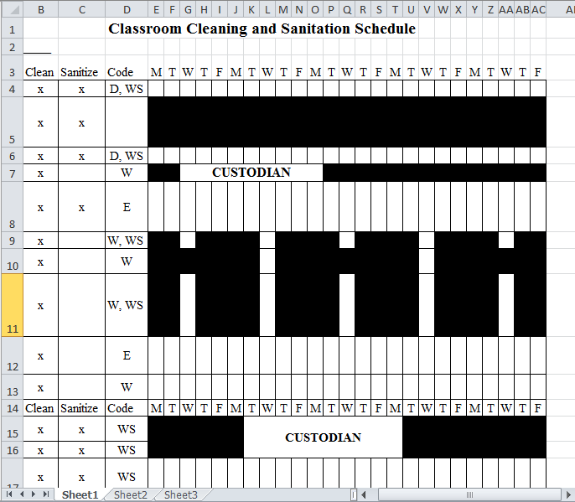
- Daily Classroom Cleaning Expectations: Located on Staff Forms
  - To be completed and Checked off Daily by Assigned Staff
  - Must be completed by white board daily and initials

Title of Procedure or Process: | HEAD INJURY PROTOCOL
Program Area(s): | Health
Related Standards or Regulations: | - Head Start Program Performance Standards  ☒Maine State Licensing  - Developmentally Appropriate Practice/NAEYC  ☒Caring for Children  ☒Other
Person Responsible for implementation: | Classroom Staff, Site Supervisor & Health Staff
Timeline for completion: | If emergency-Immediately or IR within 24 hrs.
Submitted to: | Health Manager
ChildPlus Documentation: | IR
Uploaded to ChildPlus: | Under Health Tab-Incident Report Tab
Specific Directions: | If 911 is called contact school nurse, parent and Health Manger immediately.
Procedure:
Closed head wound with bruising/swelling - No bleeding
- Apply a cold compress (ice or an instant ice pack wrapped in cloth) for 20-30 minutes to control swelling.
- Remove child from activity and rest while applying ice.
- Observe the child for signs of a concussion (see attached list).
- Notify parent/guardian of injury. Parent/Guardian should monitor the child for 24 hours after head injury for
- new or worsening symptoms of a concussion.
- Recommend parent/guardian follow up with their physician even if emergency care is not needed.

Open head wound with bleeding
- Press a clean cloth to the area and apply pressure to stop the bleeding.
- Once bleeding has stopped, cleanse the area with soap and water. Apply bandage, if needed.
- Apply a cold compress for 20-30 minutes and have the child rest.
- Observe for signs of a concussion (see TBI form).
- Notify parent/guardian of injury.
- Wounds that are deep or gaping may require immediate attention by the physician.
- Recommend parent/guardian follow up with their physician, even if emergency care is not needed.

Prevent further injury
- Do not move, pick up, or shake a child that has lost consciousness.
- If child is vomiting, turn on side and support the head.
- Do not leave an injured child unattended. Call for assistance.
- Call your SS or Health manager immediately for guidance

CALL- 911 if the child is unconscious, semi-conscious or unusually confused, the child has bleeding that won’t stop i.e. there is a known bleeding disorder or the child has injury to the neck or spine.

Title of Procedure or Process: | HELMET PROCEDURE
Program Area(s): | Health, Education
Related Standards or Regulations: | ☒Head Start Program Performance Standards  ☒Maine State Licensing  - Developmentally Appropriate Practice/NAEYC  ☒Caring for Children  - Other
Person Responsible for implementation: | Promise staff supervising and assisting children on riding equipment
Timeline for completion: | Regular use of helmets during program hours is required to promote an important safety habit. Teaching staff please utilize helmet use with children as a safety teaching  moment.
Specific Directions: | All children one year of age and over should wear properly fitted and approved helmets while riding toys with wheels (tricycles, bicycles, etc.) that are propelled by pedaling. It is not recommended that infants (children under the age of one year) wear helmets or ride  as a passenger on wheeled equipment.
1. Wearing helmets when children are learning to use riding toys or wheeled equipment teaches children the practice of wearing helmets while using any riding toy or wheeled equipment.
Preschool children must wear a helmet whenever they are on bikes or any other propelled by pedaling riding equipment whether indoors or out.
2. Helmets should be removed as soon as children stop riding the wheeled toys or using wheeled equipment. Helmets can be a potential strangulation hazard if they are worn for activities other than when using riding toys or wheeled equipment and/or when worn incorrectly. A wheeled vehicle that relies on children pushing with their feet moves slowest and is lower to the ground and does not require a helmet.
3. Center Staff supervising child play activities will ensure children are properly wearing child bike helmets when riding on or in any wheeled play equipment (tricycles, two-wheeled bicycles, etc.); propelled by pedaling or that use gears that can be used at greater speeds.

- The helmet should be level on the child’s head.
- The smallest size that fits over the head is best.
- Helmet pads should not be used to make a helmet that is too big fit the head.
- 1-2 finger widths should be visible between eyebrows and the front of the helmet.
- Straps should be even and form a Y under each earlobe.
- The buckled chin strap should have enough room to insert a finger between the buckle and the chin, but should be tight enough that when the child opens their mouth you can feel the helmet pull down on top.
- The helmet should not move up and back to reveal the forehead.
4. Health Manager and Site Supervisors will ensure that each center they supervise has enough appropriately sized bicycle
safety helmets for each child riding on or in any wheeled, play equipment (tricycles, two-wheeled bicycles, wagons, etc.).
5. Clean helmets used by another child with a damp paper towel/cloth with mild soap and water. Allow to air dry in designated area. Helmets should never be sprayed with any type of liquid or product.
Concern regarding the spreading of head lice when sharing helmets should not override the practice of using helmets. The prevention of a potential brain injury heavily outweighs a possible case of head lice.
If a child has head lice, there is no need to isolate the bike helmet from other helmets or place it in a plastic bag. Lice cannot stick to a helmet or helmet padding and will just fall off. Without hair to cling on to, they will die.
6. Storing of helmets at the end of the day, will be placed in a mesh bag and hung on a wall designated in each
center/classroom.

Title of Procedure or Process: |  |  | TBI (TRAUMATIC BRAIN INJURY) - Concussion
Program Area(s): |  |  | Health, Special Services.
Related Standards or Regulations: |  |  | - Head Start Program Performance Standards  - Maine State Licensing  - Developmentally Appropriate Practice/NAEYC  ☒Caring for Children  - Other
Person Responsible for implementation: |  |  | All staff First Aid trained
Timeline for completion: |  |  | Observe after a known head injury
Submitted to: |  |  | Health Manager and Site Supervisor
ChildPlus Documentation: |  |  | Incident Report always and Health Communication Log, if needed
Uploaded to ChildPlus: |  |  | Medical Records under Health Attachments
Specific Directions: |  |  | Print off symptoms off for parents, if child is being sent home from our care after an injury. Call Health Manager if you have immediate concerns, while waiting for parent  to pick up.
Procedure:

Mild TBI Symptoms
Mental/Thinking Physical/Sensory Emotional/Mood Consciousness/Sleep
-Loss of memory before or -Headache -Mood changes or mood -No loss of consciousness or --loss after the injury -Dizziness/loss of balance swings of consciousness for a few seconds
-Difficulty concentrating -Blurry vision -Irritability or a few minutes
Slow processing thoughts -Ears ringing -Sadness -Sleeping more or less than usual
-Difficulty remembering new -Bad taste in mouth -Depression -Difficulty falling asleep information -Sensitivity to light or -Anxiety
Confused/disoriented sound -Nervousness
-Nausea/vomiting Fatigue/drowsy

Moderate to Severe TBI Symptoms
Mental/Thinking Physical/Sensory Emotional/Mood Consciousness/Sleep
-Profound confusion -Persistent or worsening -Agitation -Loss of consciousness for a few headache -Combativeness or minutes to a few hours
-Disoriented -Prolonged nausea or unusual behaviors -Unable to awaken from sleep vomiting
-Loss of memory -Slurred speech
-Loss of coordination
-Unable to process -Dilation of one or both eye
information or answer pupils
questions -Convulsion/ seizure

Symptoms in Infants and Young Children unable to report a headache, confusion, or other sensory problems
 | Mental/Thinking | Physical/Sensory |  | Emotional/Mood | Consciousness/Sleep
 | -Change in ability to pay attention | -Persistent crying  -Unable to be consoled  -Change in nursing or eating habits |  | -Unusual or increased irritability  -Change in mood or personality  -Loss of interest in  favorite toy or activities | -Change in sleep habits  -Unable to awaken

 |  | EPILEPSY SEIZURE TYPES AND SYMPTOMS
Program Area(s): |  | Health
Related Standards or Regulations: |  | - Head Start Program Performance Standards  - Maine State Licensing  - Developmentally AppropriatePractice/NAEYC  ☒Caring for Children  ☒Other References: Epilepsy Foundation; CDC and Maine School Health Manual
Person Responsible for  implementation: |  | All Classroom staff, Site Supervisors and Health & Special  Services Staff
Timeline for completion: |  | N/A
Submitted to: |  | N/A
ChildPlus Documentation: |  | Health tab- Add Event-Seizure event
Uploaded to ChildPlus: |  | Medical Records
Specific Directions: |  | The first line of response when a person has a seizure is to provide general care and comfort and keep the person safe. The information here relates to all types of seizures. What to do in specific situations or for different seizure types is listed in the following pages. Remember that for  the majority of seizures, basic seizure first aid is all that may be needed.
Procedure:
 | Generalized Seizures | Symptoms
 | Grand Mal  (generalized tonic-clonic) | Sudden cry, fall, unconsciousness, convulsions, rigid muscles
 | Absence | Blank stare, rapid eye blinking, chewing,  unaware of surroundings
 | Myclonic | Sudden brief, massive muscle jerks,  collapse or fall
 | Clonic | Repetitive jerking movements on  both sides of the body
 | Tonic | Muscle stiffness, rigidity
 | Atonic | Loss of muscle tone, sudden collapse, fall
Generalized tonic clonic seizures are the type of seizure that the person experiences convulsions that usually last from 2 to 5 minutes with complete loss of consciousness and muscle spasms.

Absence seizures take the form of a blank stare lasting only a few seconds. The person is aware but unresponsive and experiences a loss of time

Partial seizures produce involuntary movements of arm or leg, distorted sensations,
or a period of automatic movement in which awareness is blurred or completely absent
 | Partial Seizures  - Simple- Partial  - Simple- Motor  - Simple- Sensory  - Simple- Psychological |  | Symptoms  Awake and Aware, Jerking Movements in one are of body that can’t be stopped, Aura’s, Change in Vision, Hearing, Smell, Tase or Touch Sensations. Feelings of anxiety, drastic change in behavior and memory/emotional disturbances
 | - Complex |  | Unaware, Appears Dazed, Mumble, Repetitive Movements, lip smacking, chewing, convulsing that is uncontrolled

Title of Procedure or Process: |  |  |  | FIRST AID SEIZURE PROTOCOL
Program Area(s): |  |  |  | Health
Related Standards or Regulations: |  |  |  | ☒Head Start Program Performance Standards  - Maine State Licensing  - Developmentally Appropriate Practice/NAEYC  ☒Caring for Children  - Other
Person Responsible for implementation: |  |  |  | All staff MED 101 trained, Nurse Consultant
Timeline for completion: |  |  |  | Immediately with onset of seizure
Submitted to: |  |  |  | Health Manager
ChildPlus Documentation: |  |  |  | Health tab-Add Event-Seizure
Uploaded to ChildPlus: |  |  |  | Within 24 hours of seizure
Specific Directions: |  |  |  | If 911 was called contact the Parents, Site Supervisor and Health Manager  immediately.
Procedure:
There are many different types of seizures which may temporarily affect awareness, movement or sensation. Sometimes, seizures that have subtle symptoms, like unusual movements or staring spells, may not be noticed by others.

- Recognize Common Symptoms:
  - Blank stare, rapid eye blinking, chewing
  - Clumsy, wandering, dazed, confused
  - Shaking, muscle jerks, rigid limbs
  - Confused speech, mumbling
  - Sudden outcry, fall
  - Full body shaking (convulsion)

- Follow first aid steps:
For all seizures:
  - Stay calm and track the time (look at the clock)
  - Have other adult call the School Nurse or Health Manager immediately
  - Block hazards (move objects away from individual)
  - Speak calmly, give reassurance
  - Don’t restrain (grab or hold) or attempt to put anything in mouth
  - Allow child to rest after the seizure

- For tonic-clonic (full body convulsion) seizures also:
  - Lower child to the floor if they are in a chair
  - Turn on side if possible
  - Cradle or support head, loosen tie or collar to avoid injury
  - Explain to others briefly (say “ is having a seizure”) and you may remove other children from the classroom or area to provide privacy
  - Monitor breathing pattern
  - Remain with child until fully conscious and alert
  - Notify parent as soon as possible. Parent and staff will determine whether emergency transport will be necessary.
  - Allow child to rest after the seizure
3.A seizure is considered an emergency when:
Convulsive (tonic-clonic) seizure lasts longer than 5 minutes Child has repeated seizures without regaining consciousness Child is injured or diabetic
Child has a first time seizure
 | Title of Form: |  | SEIZURE LOG
 |  | Related Policy: | First Aid Seizure Protocol
 |  | Program Area(s): | Health,
 |  | Related Standards or Regulations: | - Head Start Program Performance Standards  - Maine State Licensing  - Developmentally Appropriate Practice/NAEYC  ☒Caring for Children  - Other
 |  | Procedures | - Contact Health Manager for guidance  - Print form off of Promise website  - Keep in Red Folder on Emergency Board  - Document on form when symptoms of seizure occur  - Contact Health Manager when a seizure occurs
 |  | Form Completed By: | Lead Teacher, Site Supervisor
 |  | Timeline for completion: | Daily, when seizure occurs
 |  | Specific Directions: | Constant contact with Health Manager is required when this form is being used.
 |  | Submitted to: | Health Manager and Childs Neurologist/Specialist
 |  | ChildPlus Documentation: | Yes, under Health Tab--Health Event—Seizure Event
 |  | Uploaded to ChildPlus: | Completed logs

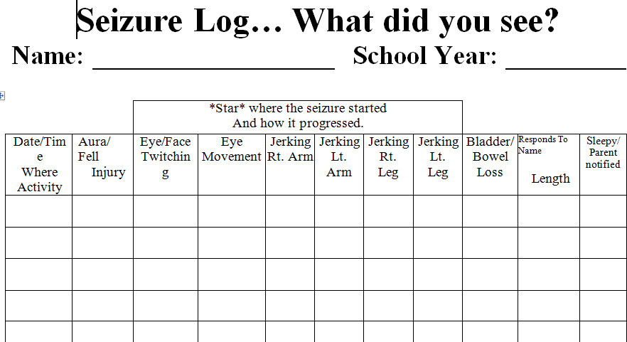

Title of Procedure or Process: | EARLY PERIODIC SCREENING DIAGNOSIS & TREATMENT --SCREENING SCHEDULE
Program Area(s): | Health
Related Standards or Regulations: | ☒Head Start Program Performance Standards  - Maine State Licensing  - Developmentally Appropriate Practice/NAEYC  ☒Caring for Children  - Other
Person Responsible for implementation: | Health Staff and staff with Family Service Responsibility
Timeline for completion: | Complete within Head Start Standard Guidelines
Submitted to: | N/A
ChildPlus Documentation: | Yes, under each PIR Health Event add parent follow up conversations
Uploaded to ChildPlus: | Medical Records and Screening Results
Specific Directions: | Connect with Health Department with scheduling screenings and medical appointment questions or barriers.

Procedure:
Any child, who is NOT up to date with the EPSDT schedule upon enrollment, should be brought up to date within 90 days or documentation of a plan to bring the child up-to-date is documented in Child Plus under health event.

Physical Examinations: One week; then One, Two, Four, Six, Nine, Twelve, Fifteen, Eighteen Months and thirty months; then Two, Three, Four, and Five years of age. Performed by a Health Professional and documentation is provided and recorded in the enrolled child’s health file. Children are required to be up to date with EPSDT guidelines within 90 days of enrollment or documentation of a plan in place to bring the child up to date in Child Plus under health event.

Height/Weight/BMI/Blood Pressure: Same as physical exams based on the EPSDT schedule. Height, weight and blood pressure is obtained at the initial health screenings for pre-enrollment or with-in 90 days of enrollment.

Hearing & Vision Screenings: Children are screened at three, four and five years of age at pre-enrollment or within 45 days of enrollment by Promise staff. Hearing is checked by a health professional at well child exams at age 3, 4 and 5 years. Otoacoustic Emission (OAE) screenings are recommended at birth and six months of age than annual screening with a pass result. Subjective paper screenings are completed based on parent and staff observations at Birth to 3 months; 3 to 6 months; 10 to 15 months; and 18 to 24 months.

Oral Health Screenings and Examinations: The first clinical oral examination is recommended at the eruption of the first tooth and no later than 12 months of age and repeat every six months or as indicated by the child’s oral health risk assessment. Oral health screenings are completed by the primary health care provider at age 1, 15months, 18 months, and two year well child visits.

At the age 3, Head Start requires a child to have a dental exam by a dentist. After the exam a cleaning is recommended every 6 months and an exam yearly.

Lead Screenings: EPSDT requires blood lead level screenings at age one and two. Written documentation is obtained of test results and recorded in the child’s health file. If Promise does not receive documentation that a child received lead screening by two years of age, Head Start Standards require that lead screening be done up to 72 months of age. Promise encourages the parent request lead screening by the PCP, if this is not possible Promise will schedule on-site Lead Screening Clinics within 90 days of the beginning of the program year to ensure children

are up to date with the EPSDT requirements. A blood lead level of 5 or below is considered normal. Maine CDC Lead result recommendations are:

- Lead level: 5 – 9 mcg/dl - State lab recommends venous blood draw and contacting family to provide prevention material and a home lead dust kit.
- Lead level: 10-14mcg/dl – recommend venous blood draw, contact family to provide prevention/education material & lead dust kit. Recommended a home visit from public health nurse.
- Lead level: 15-19mcg/dl and above – venous blood draw, contact family and owner of rental property for a complete screen of the environment.
- Lead level: 20-44mcg/dl or above – immediate contact of family for venous blood draw and possible hospitalization for chelation, complete screen of the environment

Anemia – Hemoglobin or Hematocrit (Hgb or Hct): A blood screening for anemia is required by age one. Test results are obtained from WIC or other health professional and recorded in the child’s health file. A Hgb of 11 or above and a Hct of 34 or above are considered within normal limits, however, some labs or physicians may consider a slightly lower count to be within normal limits.

Immunizations: The State of Maine requires that a child’s immunization record be on file within 30 days of enrollment and updated annually. Children must be up-to-date on all immunizations appropriate for their age according to the Maine immunization requirements developed by the Maine CDC. After 30 days of enrollment, the Health Manager may exclude children if documentation of immunization is not obtained. Exemptions of proof of immunity for a religious, philosophical, or medical reason must be signed by the parent/guardian and include written documentation for the stated exemption request.

Partnership with Parents: Staff works in collaboration with families and their health care providers to ensure that all enrolled children are up-to-date on their EPSDT schedule. When a child is not up-to-date, staff will assist families in overcoming any barriers and making the necessary arrangements to bring the child up-to-date.

Parent/Guardian Refusal: At enrollment staff will discuss with families the different types of health and developmental screenings and examinations that Head Start programs require and obtain consent during the initial Health Interview and/or home visit. All efforts by staff to arrange screening, evaluation, or treatment with families must be documented in Child Plus. A family may choose not to consent to their child receiving a specific health screening, evaluation, or treatment after being given information about the specific service and understand the purpose of the screening in early detection, treatment, and prevention of sensory, developmental, and behavioral concerns. Classroom staff must consult with their Site Supervisor and the Health Manager if a parent/guardian refuses a health screening, evaluation, or follow-up treatment to decide if the refusal warrants a report to the Department of Health and Human Services as a child ‘at risk’. A Health Services Refusal Form may be completed and signed by the parent/guardian for a sincere religious, philosophical, or medical objection to a specific screening, evaluation or treatment.

Title of Form: | Immunization Requirements
Related Policy:
Program Area(s): | Health, Nutrition, Education, Special Services, Family Services, ERSEA, etc.
Related Standards or Regulations: | ☒Head Start Program Performance Standards  ☒Maine State Licensing  ☒Developmentally Appropriate Practice/NAEYC  ☐Caring for Children  ☐Other
Procedures

Children are required the following Immunizations unless deemed medically unnecessary.
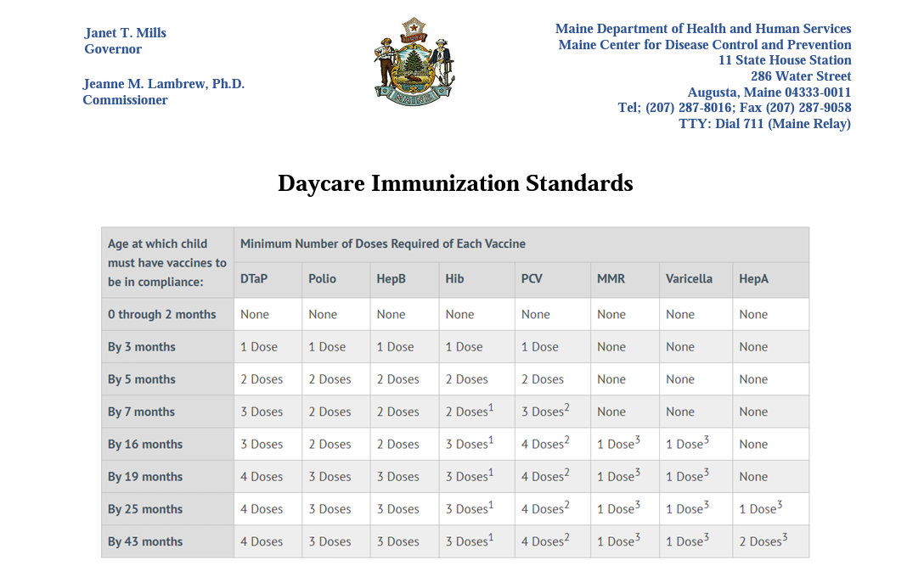
Families out of compliance, will receive their first outreach from Family Services to check in on the status of an appointment. If Families have not established appointments, Family Services will support the outreach to set up appointment.
If a family is refusing immunization or has missed their appointments without reasonable cause, outreach to Health Department will occur for next steps.

Title of Form: | IMMUNIZATION EXEMPTION FORM (Medical reason ONLY)
Related Policy: | Health Screening & Exam Requirements-EPSDT
Program Area(s): | Health
Related Standards or Regulations: | ☒Head Start Program Performance Standards  ☒Maine State Licensing  - Developmentally Appropriate Practice/NAEYC  ☒Caring for Children  ☒Other, LD 798 Maine Law
Procedures | - Retrieve off of Promise Website  - To be completed if parent has a medical waiver exempting child out of immunizations.  - To be completed if child has aged out of immunization.  - Remind parent that Maine Law LD 798 an Act To Protect Maine Children and Students from Preventable Diseases by Repealing Certain Exemptions from the Laws Governing  Immunization Requirements, will take effect in Sept. 1, 2021.
Form Completed By: | Staff with Family Service Responsibility
Timeline for completion: | At enrollment or within 30 days of child enrolled in the program
Specific Directions: | *Child Care Licensing requires records or exemption form is on file within 30 days of child enrolled.
Submitted to: | Health Department (health coordinator or health assistant)
ChildPlus Documentation: | Under Immunization Tab—Immunization notes (time stamp and document parent conversation/action).
Uploaded to ChildPlus: | Completed exemption form

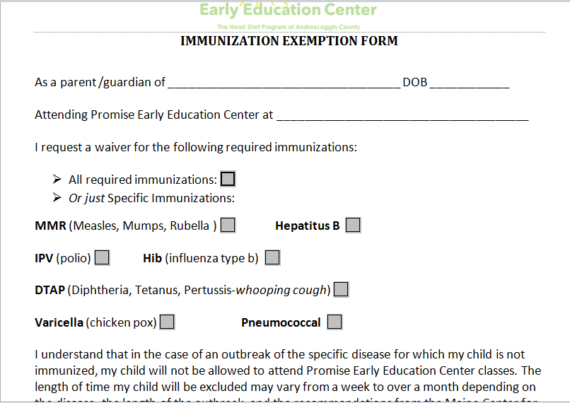

Title of Procedure or Process: | HEALTH SCREENING & EXAM REQUIREMENTS-EPSDT
Program Area(s): | Health
Related Standards or Regulations: | ☒Head Start Program Performance Standards  ☒Maine State Licensing  - Developmentally Appropriate Practice/NAEYC  - Caring for Children  ☒Other- Maine CDC
Person Responsible for implementation: | All staff with Family Service Responsibility and Health Staff
Timeline for completion: | Follow HS standards and Maine CDC recommendations
Submitted to: | Health Department
ChildPlus Documentation: | Health Event Tabs
Uploaded to ChildPlus: | All medical reports/labs/documentation and scheduled appointments; family barriers if can’t complete.
Specific Directions: |  | Family Service staff must communicate with Health why a parent/guardian is struggling/refusing to meet EPSDT Health requirements
Procedure:
Family Service personnel are required to read their child’s file for health information upon receiving. Health Department staff will communicate with Family Service personnel when child has missing health data or treatment needed. Staff with Family Service responsibilities is responsible for tracking their own children and collaboration with the Health Department, when barriers prevent a parent/guardian in meeting EPSDT requirements. At first home visit conversations need to begin regarding the creation of plans to complete health mandates and continue through the child’s enrollment in parent conferences, home visits, REMIND and parent conversation at drop-off and pick-up.

Dental – it is mandated that we assist families in establishing a DENTAL HOME.
- Completed Dental Applications; send to Health Coordinator with signed Release of Information for submission by Coordinator to dental provider.
  - Application must include the child’s MaineCare number.
  - Dental provider will contact the parent/family to schedule an appointment…staff follow-up to support family access.
  - Dental Homes should be established within 30 calendar days from enrollment.

- Dental Exams by a Dentist mandated- *Tooth fairies does not meet this requirement
  - Cleaning/fluoride by hygienist is not a dental exam…if child has not previously been seen by a dentist, an initial exam is required to be scheduled within 90 calendar days of enrollment.
  - If a child had a dental exam within the last year…follow EPSDT schedule for oral exams to keep up-to-date.
  - If family is not able to complete a dental exam within the recommended time-frame, there must be a documented plan in Child Plus Health event of steps taken to meet the dental exam mandate i.e. conversations, meetings, phone calls, appointment date scheduled, missed appointments and rescheduled date.
  - Children must be up-to-date on preventative oral care according to EPSDT schedule.

- Dental Documentation – Scheduled appointments, completed visits and treatment to be documented in Child Plus health event follow-up notes.

Well-Child Exams (MEDICAL HOME) – Family Service personnel must ensure children are up-to-date according to the state EPSDT schedule or have a scheduled appointment within 90 calendar days of enrollment.

Health Screenings
- Vision and Hearing screenings must be conducted within 45 days of enrollment by Health Department.
  - Children absent from screening require follow-up plan by Family Service staff documented in Child Plus health event follow-up notes to bring the child up-to-date and schedule a re-screen date.

- Lead Screenings – children must be up-to-date according to EPSDT schedule for lead screenings at 12 and 24 months of age.
  - Head Start requires children, who did not receive a lead screening at 24 months of age or later, to receive a lead screening up to 72 months of age.
  - Must have a plan in place to bring up-to-date within 90 calendar days of enrollment.

- Hemoglobin Testing for Anemia - required by EPSDT schedule at age one.

If you have any questions regarding working with families in the area of health please contact the Health Coordinator (ext. 312), Health Assistant (ext. 354) or Health Manager (ext. 319).

Child’s Educational Health Plan: Parent Discussion Guide
 | EPSDT Plan
 | Health Topic |  |  | To Be Completed  in | Discussion | If Child is not up to date in this area, add  written plan to the Case Note Health Section. Here are sample sentences you  can use.
 | Immunizations on file |  |  | 30 days/re- quired by state law | We don’t have a copy of your child’s shot record. Let’s make a  plan. | (Parent’s name) signs a permission form so Promise can get (child’s name) shot record from the doctor’s office.
 | Immunizations up- to-date according to State EPSDT  schedule |  |  | Plan in place to bring up-to-date or exclude after  90 days. | Is your child up to date on their shots? | Call doctor at (number) on (date) and ask for an appointment to get shots.  Tell (staff name) the date of the appointment.
 | Medical Home |  |  | Must be established within 30 days | Does your child have a doctor? If not, let’s make a plan. | Provide the family with a list of pediatricians in their area. Assist family with paperwork and scheduling an appointment. Also assist with transportation, if needed.
 | Well Child Exam up- to-date with EPSDT schedule |  |  | 90 days or plan in place to bring up- to-date | When was your child’s last physical? | Call doctor at (number) and ask for the date of your child’s last physical. Ask if your child is due for a physical. If your child is due for a physical, ask for an appointment and  tell (staff name) the date of the appointment.  Discuss barriers to getting to this apt.
 | Lead Screening up-to-date  according to EPSDT schedule  Follow-Up care |  |  | 90 days or plan in place to bring up- to-date  Must facilitate follow-up treatment, testing and plans for abnormal test results | Did your child get a test for lead at age 1 (for EHS/EHB) or age 2 (for HS/HB)?  Lead screens are performed at school too.  If your child did not have a lead screening at age 2 or later, or if there are known environmental or dietary risks, Head Start requires a lead screening up to 72 months of age. | Call doctor at (number) on (date) and ask if your child had a lead screening. If your child  had a lead screening, tell (staff name) by (date). If your child didn’t have a lead screening, ask the doctor to make arrangements for a lead screening.  Tell (staff name) the date you took your child for a lead screening.  Please sign the permission form and  I will notify you when the screening will take place in your child’s classroom and provide you with your child’s results.  Long-term exposure to lead can cause serious health problem which can lead to a wide range of symptoms,  from headaches and stomach pain to behavioral problems an anemia (not enough healthy red blood cells).  Lead also can affect a child's developing brain.
 | Dental Plan
 | Topic |  |  | To Be Completed  In | Discussion | If Child is not up to date in this area, make a  written plan in the Dental Section.  Here are sample sentences you can use:
 | Dental Home |  |  | Should be established  within 30 days | Does your child have a dentist? If not, let’s  make a plan. | Fill out Dental Application. Dentist office will call you to make an appointment. Tell  (staff name) the date of the appointment

 |  |  |  |  |  | by (date).
 | Dental Exam by a Dentist (hygienist visit only does not qualify) |  | 90 days or plan in place to bring up-to-date with EPSDT schedule |  | When was the last time your child was seen by the dentist? | Call dentist at (number) by (date) and  ask for an appointment for a dental exam. Tell (staff name) the date of the appointment.
 | Hearing and Vision Plan
 | Topic | Completed In |  |  | Discussion | Sample Sentence for Form
 | Hearing and Vision Screening | Must be conducted within 45 Days |  |  | We will test your child’s vision and hearing. | (Staff name) will tell you the results of the hearing and vision screenings by (date).  If your child needs a follow up visit, please call a physician to schedule this.

Title of Form: | AUTHORIZATION TO DISPENSE PRESCRIPTION MEDICATION
Related Policy: | Medication Administration
Program Area(s): | Health
Related Standards or Regulations: | ☒Head Start Program Performance Standards  ☒Maine State Licensing  - Developmentally Appropriate Practice/NAEYC  ☒Caring for Children  - Other
Procedures | - Print the form off of the Promise Website,  - Complete the form when the medication in its original packaging has been received;  - Three signatures are needed, Parent, Staff and Health Manager;  - Form goes in the medication bag and stays with the child’s medication.  - Record of Medication Form (backside) must be completed each time a medication has been administered-ONLY staff Med 101 trained can administer.
Form Completed By: | Responsible staff
Timeline for completion: | Before or when medication is brought to a Center
Specific Directions: | No medication can stay on site without a physicians note.
Submitted to: | Health Manager
ChildPlus Documentation: | Add under Chronic Condition and Food Allergy Health Event or Health Comm Log
Uploaded to ChildPlus: | Doctors note, with permission to administer the medication, Asthma Action Plan, Seizure Plan. The Mediation Authorization Form

Title of Procedure or Process: | ‘Promise Health Passport’ Procedure
Program Area(s): | Health
Related Standards or Regulations: | ☒Head Start Program Performance Standards  - Maine State Licensing  - Developmentally Appropriate Practice/NAEYC  - Caring for Children  ☒Other; Maine EPSDT
Person Responsible for implementation: | Lead Teacher, FA, FE
Timeline for completion: | Before every Parent Conference or sooner if child has health needs that is preventing them from receiving their education or nutrition
Submitted to: | Parent/Guardian
ChildPlus Documentation: | Any details related to a health event that was discussed over the review of  the health pamphlet.
Uploaded to ChildPlus: | N/A
Specific Directions: | To present to parents that All aspects of their child’s health affects a child’s learning and school readiness.
Procedure:

Part Year and Full Year Child | Will present at:  - Health Screening Day  - Home Visits  - Every Parent Conference  - Parent Group Topic
How to maintain current Health Record Information | - Review each Health Event in Child Plus to maintain accurate health information.  - Outreach to Health Department for assistance, if you do not understand the documentation in Child Plus.  Keep the pamphlets in a classroom binder, you can three hole punch the pamphlets, if needed. Lead Teacher and Family Advocate will coordinate the area that both can retrieve them and can be reviewed by the Health Department, when needed.  - Staff with Family Service Responsibility will complete the Health Pamphlet and have updated information inputted before parent conferences.  o Health Staff are available to assist i.e. staff illness or staff shortage prevents the pamphlets for being updated in a  timely manner.
How *staff keep parent informed of their child’s Health Event statuses (outside of parent conferences).  *staff: Teachers  Site Supervisor Health  Family Service Special Service Education | Teachers and Family Service Staff:  - Brief reminders/conversation at pickup and drop-off.  - REMIND messages on upcoming apt., missed apt. importance of scheduling an apt.  - Home visit discussion  - Phone call discussion Health Staff:  1. Health Department will send parent letters of screening results  e.g. dental clinic, lead clinic, hearing and vision screen  - Health Department runs monthly reports and shares results with Site Supervisors (SS) and content Managers.  o SS will discuss with front line staff at supervisions health events statuses.  - Health staff are available to provide parent and staff support;

- Staff are expected to outreach to Health when support is needed i.e. family barriers, community barriers, provider barriers, etc.
- Health staff will go on home visits to provide Health and Nutrition support with Family Service staff.
- Health will discuss community Health barriers at the Health Advisory Committee meeting.
Family Service staff:
- Family Service Manager will discuss in supervision with Family Advocates and Family Educators children’s Health statuses.
- Family Service Staff will outreach to Health when guidance/support is needed to help complete a child’s Health Event.
How Parent receives Health Passport at years end. | - Last week in May, staff with family service responsibility will update the passport with the most current health information from Child Plus.  - Staff will review the pamphlet and discuss with parent the importance of preventive health appointments and how it impacts their child’s school readiness.  - Staff must give the passport to the parent/guardian at the end of the school year i.e. home visit, year-end party, etc.  - Staff will enter into Child Plus any conversation involving health events e.g. barriers, parent attempts, upcoming scheduled apt., etc.

Title of Form: | HEALTH PASSPORT FORM
Related Policy: | Health Pamphlet Procedure and Health Screening & Exam Requirements-EPSDT
Program Area(s): | Health,
Related Standards or Regulations: | ☒Head Start Program Performance Standards  - Maine State Licensing  ☒Developmentally Appropriate Practice/NAEYC  - Caring for Children  ☒Other
Procedures: | - Request Pamphlet from the Health Department  - Staff with Family Service Responsibility i.e. FA, FE or TFA complete the form using Child Plus health event information and input current completed Health appointments.  o If child is due for an EPSDT appt., leave that health area blank and discuss with parent that they are behind on an EPSDT scheduled appt. Do not input last year’s health appointments.  - Three-hole punch pamphlets and place in binder and store in the classroom where they can review and be used by the Lead Teacher or the Health Manager.  - Staff will present and provide guidance on the pamphlet as described in the written Health Pamphlet Procedure.  - All staff will outreach to the Health Department for guidance and support when  questions or support is needed.
Form Completed By: | Staff with Family Service Responsibility
Timeline for completion: | Before Parent Conferences and Year’s End
Specific Directions: | This tool (pamphlet) is the link to teaching parents that a child’s health does affect their  learning and school readiness. This pamphlet presents the opportunity to have this discussion.
Submitted to: | Parent/Guardian
ChildPlus  Documentation: | Conversation with parent on completing Health and Dental appointments under the  Health Event that needs follow-up.
Uploaded to ChildPlus: | N/A
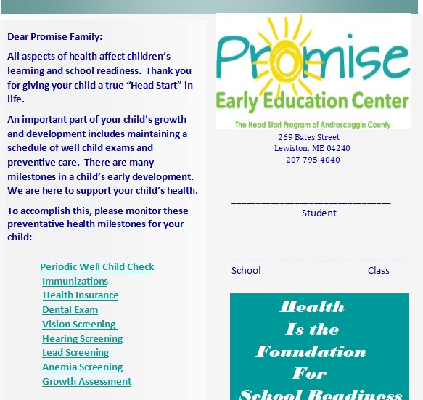

Title of Procedure or Process:. | ACCESS TO HEALTH INSURANCE PROTOCOL
Program Area(s): | Health, Family Services, ERSEA
Related Standards or  Regulations: | Head Start Performance Standard 45CFR Section 1302.42, 1302.46
Person Responsible for implementation: | Staff with Family Service Responsibility and Health Staff
Timeline for completion: | Periodically throughout the year i.e. initial home visit, first parent/teacher conference, parent meeting, second teacher/parent conference
Submitted to:
ChildPlus Documentation: | Health/Dental Coverage Notes Area on Health Info Tab
Uploaded to ChildPlus: | MaineCare Card
Specific Directions: | Document all conversations of status changes into CP+
Procedure | Promise staff is responsible for assuring we meet the Head Start standard for Family support services for health, nutrition, and mental health.

Purpose: Health is the foundation for school readiness. This is why Head Start programs help enrolled children access preventive screenings, health care, and health insurance coverage.

Research shows that children are more likely to be healthy when their parents and siblings have access to health care. For this reason, Promise plays a vital role in making sure that parents know how to navigate health systems and secure their own health insurance.

Procedure:
    - A program, within 30 calendar days after the child first attends the program must consult with parents to determine whether each child has health insurance coverage.
•
    - Use this resource on ECLKC to support families at https://eclkc.ohs.acf.hhs.gov/family-support-well- being/article/resources-programs-about-childrens-health-insurance-coverage

    - Ask families if they have health insurance for their child multiple times throughout the school year; at enrollment, health screening day, open house, initial home visit, first parent/teacher conference, parent meeting, second teacher/parent conference, through Remind, by phone, and unscheduled home visits.
    - Once a child has lost health insurance, the expectation is that staff with family service responsibility asks the family weekly if they have retained health insurance or needs support. Family service staff need to create a plan or goal to attain health insurance for their child and maintain the ongoing medical appointments required by Head Start to keep their child school ready.

    - Include health coverage messaging when talking with Head Start families about children’s health. Let families know how to get help applying for health coverage and plan to offer help through our Head Start program.

    - Use health coverage opportunities at parent meetings. Invite local Navigators or certified application counselors (CACs) to parent meetings to share news about health coverage opportunities and how to enroll. Ask for a speaker who can answer questions about eligibility, benefits, access to providers and other pressing concerns.

    - Child Plus-Document all work in this area in the Health Tab under Health/Dental Coverage Notes. If this becomes a family goal please document in the Family Services Tab under Event and copy and paste your work/conversation into the Health Tab also.

    - Health will run a Health Insurance report monthly and collaborate with Family Service Staff in assisting families’ to access Health coverage.

Resources: How to Apply for MaineCare or Affordable Health Coverage.
Encourage families to visit . Help is also available by phone (toll-free) at 800-318-2596 or (TTY) 855-889- 4325. Interpreters in 150 languages are available by phone. To speak with an interpreter, say “Agent” or press “0.” Once an agent is on the line, say the name of the language you need.
MaineCare Citizenship & Identity at

Maine’s Individual Affordable Health Insurance Market- https://www.healthinsurance.org/maine/

You can assist a family to access: Our state Medicaid office. If you don’t know how to reach them, call 1-877-KIDSNOW (1- 877-543-7669). The toll-free number belongs to a federal service called InsureKidsNow.gov or Healthcare.gov (1-800-318- 2596).
Connect with Maine specialists at 211 Maine via phone-dial 211, text-your zip code to 898-211, or email -211maine.org– it’s free and confidential.

MaineCare Rules – https://www1.maine.gov/benefits/account/login.html
    - Although Medicaid eligibility policy varies greatly by state, all states must cover children through age five up to 133 percent of the federal poverty level. Head Start and Medicaid both serve additional special populations of children, such as those receiving Supplemental Security Income (SSI) and those in foster care.
    - An adult may qualify, but must be between the ages of 19 and 64.
    - You must be a resident of Maine, under 19 years of age or be a primary care giver with a child under the age of 19, not covered by health insurance (including Medicaid), and
    - Must be U.S. national, citizen, legal alien or permanent resident.

Office of Head Start:
*1302.42 -Child health status and care.
a) Source of health care. (1) A program, within 30 calendar days after the child first attends the program or, for the home- based program option, receives a home visit, must consult with parents to determine whether each child has ongoing sources of continuous, accessible health care – provided by a health care professional that maintains the child’s ongoing health record and is not primarily a source of emergency or urgent care – and health insurance coverage.
(2) If the child does not have such a source of ongoing care and health insurance coverage or access to care through the Indian Health Service, the program must assist families in accessing a source of care and health insurance that will meet these criteria, as quickly as possible.
*1302.46 -Family support services for health, nutrition, and mental health.
2) A program must provide ongoing support to assist parents’ navigation through health systems to meet the general health and specifically identified needs of their children and must assist parents:
(i) In understanding how to access health insurance for themselves and their families, including information about private and public health insurance and designated enrollment periods
AW 5/2019

Title of Procedure or Process: | LEAD SCREENING PROTOCOL
Program Area(s): | Health, Nutrition
Related Standards or Regulations: | ☒Head Start Program Performance Standards  - Maine State Licensing  - Developmentally Appropriate Practice/NAEYC  ☒Caring for Children  - Other
Person Responsible for implementation: | Parent at WCC and Health Department Lead Screens
Timeline for completion: | 12 month & 24 month
Submitted to: | Screen Result to Parents and Lab Results to Health Depart.
ChildPlus Documentation: | Lab Results, WCC under Health Attachment
Uploaded to ChildPlus: | Medical Records, Permission Form or Lead Refusal Form
Specific Directions: | We are required to provide follow-up guidance and resources; along with PCP care
Why we screen children
Screening results for lead poisoning are required at ages 12 and 24 months and anemia (hemoglobin level) at 1 year of age, in accordance with Bright Futures guidelines, EPSDT MaineCare program, and Federal Head Start Child Health and Development performance standards as part of the Early Head Start health screenings. Head Start children from ages 3 to 5 are required to have one lead and anemia screening. If the child did not have a lead screening at age 2 or later, or if there are known environmental or dietary risks, Head Start requires a lead screening up to 72 months of age.

Written permission for screening tests
Every effort will be made by Promise staff to work collaboratively with the child’s primary health care provider and/or the State Lead Office to obtain blood lead test results.

Capillary blood screenings for lead will be offered to Early and Preschool Head Start children who have missed the preventive health screenings through their primary care providers. Blood sample collection will be done by registered nurses or certified phlebotomists in accordance with the attached procedures.

Written parental/guardian permission, and notification of the screening date(s), will be provided in advance of all center-based blood screening activities. Parents will be encouraged to attend the screenings.

Teacher/FA/FE will return lead permission slips to the Health Dept. for review and to complete State Lab Slips.

Test Results
Results of all blood testing will be given to the parents of the child, with copies also sent to the primary care provider’s office.

Children with elevated lead or low hemoglobin findings are referred promptly to their primary health care provider for appropriate follow-up. Sources of care will be found for any at-risk children without primary providers. Nutritional information will be forwarded to the family as support until medical provider appointments can be made.

Screening costs will be billed to third party payers, as available, or covered by Head Start funds as a “last dollar” resource. There will be no charge to Head Start/Early Head Start parents for the blood screening. Every effort will be made to link families with insurance sources to cover any further follow up and treatments recommended.

Title of Form: | LEAD SCREEN AUTHORIZATION FORM
Related Policy: | Lead Screening Protocol
Program Area(s): | Health
Related Standards or Regulations: | ☒Head Start Program Performance Standards  - Maine State Licensing  - Developmentally Appropriate Practice/NAEYC  ☒Caring for Children  - Other
Procedures | - Health Staff will identify through WCC who needs a lead screening.  - Health staff will outreach to staff with Family Service responsibility with a list of who will need to be screened.  - Staff with Family Service responsibility will present form and discuss the Importance of lead screening. Parent must agree or decline in writing with signature.  - Staff must return completed form to Health Department
Form Completed By: | Responsible staff
Timeline for completion: | Within 45-90 days of Enrollment
Specific Directions: | Inform parent its happenings
Submitted to: | Health Coordinator
ChildPlus Documentation: | Yes, under Health Tab-- Health Event—Lead Event.  - Documenting parent consent or decline decision and that form was completed.  - Lead Results will be documented under lead event
Uploaded to ChildPlus: | Yes, Health Tab—Attachments (completed form)
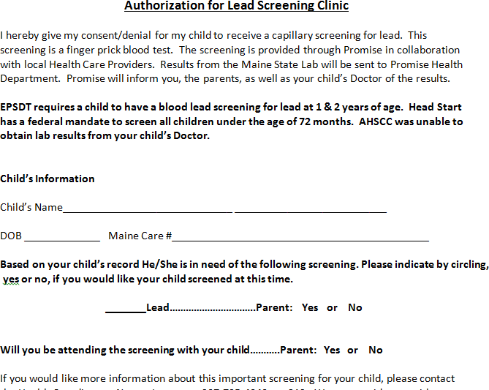

Title of Procedure or Process: | ORAL HEALTH/HYGIENE FOR PRE-SCHOOL CHILDREN
Program Area(s): | Health, Nutrition, Education, Special Services
Related Standards or Regulations: | ☒Head Start Program Performance Standards  - Maine State Licensing  - Developmentally Appropriate Practice/NAEYC  ☒Caring for Children  - Other
Person Responsible for implementation: | Teachers and FE
Timeline for completion: | Once daily
Submitted to: | N/A
ChildPlus Documentation: | N/A
Uploaded to ChildPlus: | N/A
Specific Directions: | Each classroom will have daily supervised tooth brushing that models and teaches good dental hygiene and prevents cross-contamination between children, toothbrushes, and toothpaste. Children with  disabilities will be supported with any needed adaptation.
Procedure:
To prevent cross-contamination group tooth brushing must be supervised by staff and/or volunteers who have been trained to monitor for activities that could result in cross contamination (spitting, playing with toothbrushes, etc.) Children should never perform tooth brushing or rinsing of toothbrushes without adequate supervision.
- Disposable gloves should be worn by staff if contact with a child’s oral fluids is anticipated.
- Classroom procedure must ensure that each child picks up only his or her own toothbrush.
- Classroom staff will insure that toothbrushes are rinsed and stored properly after use (only staff may place toothbrushes into the holder).
- Sitting at a table in a circle, children brush teeth as a group activity once every day.
- Give each child a small paper cup, a paper towel and tooth brush.
- Put a small (peas-sized) dab of fluoride toothpaste on the bottom of a small paper cup and have children us their toothbrushes to pick up the dabs of toothpaste.
- Brush together for two minutes, using an egg timer or a song that lasts for about two minutes.
- Brush your teeth with the children to set an example, and remind them to brush all their teeth, on all sides.
- When two minutes are up, have the children spit any extra toothpaste into their cups, wipe their mouths and put the paper towel inside of the cup and throw it away.
- Children may rinse their toothbrush individually but rinsing their mouths should be limited, or not take place. Rinsing washes away some of the benefits of the fluoride.
- Only staff can place toothbrushes in holders to dry.

Sanitization/Storage:
- Each child will have her/his own labeled toothbrush and never be shared.
- Following each use, toothbrushes should be rinsed in tap water, stored in an upright position and allowed to air dry in the tooth brush holder. Toothbrushes should be spaced so they do not touch one another.
- Only staff may place toothbrushes into the holder.
- Toothbrushes should be replaced every three months and as needed when the bristles are worn/bent.
- If a child is absent from the classroom due to illness, the contaminated toothbrush will be discarded and a new one issued upon return to the classroom.
- Each toothbrush holder will be sanitized 2X month or when a child is absent due to illness.
  - Wash with hot water and detergent and wiped dry with a paper towel.
- The tables must be sanitized before and after tooth brushing activities.
- The sink area must be sanitized before and after tooth brushing activities.

Dental Examinations: Every HS child is required to have a dental home.
Staff will encourage and support parents in scheduling oral health care appointments as part of the schedule of well child care (EPSDT). Staff will provide parents with applications and information for the B-Street Dental Clinic, Community Dental and other local community dental clinics.

Title of Procedure or Process: | AVAILABILITY OF DRINKING WATER
Program Area(s): | Health, Nutrition
Related Standards or Regulations: | ☒Head Start Program Performance Standards  ☒Maine State Licensing  - Developmentally Appropriate Practice/NAEYC  ☒Caring for Children  - Other
Person Responsible for implementation: | Classroom Staff and Site Supervisor
Timeline for completion: | Readily available every day, all day.
Submitted to: | N/A
ChildPlus Documentation: | N/A
Uploaded to ChildPlus: | N/A
Specific Directions: | Potable clean drinking water needs to be “offered” to children throughout the day and available to children upon their request and allow children to serve themselves.  When children are thirsty between meals and snacks, water is the best choice.

PROCEDURE:
HS Classrooms:
- Clean, sanitary drinking water needs to be readily available, in indoor and outdoor areas, at mealtimes and throughout the day (1). Drinking water helps maintain a child’s hydration and overall health.
  - Center for Disease Control and Prevention, Increasing Access to Drinking Water and Other Healthier Beverages in Early Care and Education Settings, https://www.cdc.gov/obesity/downloads/early-childhood-drinking-water-toolkit-final-508reduced.pdf
- Water should not be a substitute for milk at meals or snacks where milk is a required food component unless recommended by a child’s primary health care provider.
- Children need extra water to drink when they are physically active or when it is hot outside. Ensure that children know there is water available before and during periods of physical activity.

- Make a water break part of the routine before and during play time.
- Children should be allowed to use the disposable cups, placed in cup holders near sinks in the classroom, when they are requesting water and feeling thirsty.
- Clean and Sanitized water coolers should be accessible at every outside time with disposable drinking cups.

EHS Classrooms:
- Infants should not be given water, especially in the first six months of life.
- Infants receiving breast milk in a bottle may need additional breast milk on hot days-feed on demand always.
- Infants receiving formula mixed with water may be given additional formula mixed with water-feed on demand always.
- Children should be taught to drink water from a cup rather than a sippy cup or bottle. Permitting toddlers to suck continuously on a bottle or sippy cup filled with water, may cause nutritional or in rare instances, electrolyte imbalances.
Signs of Dehydration in Infants, may be dry lips or mouth, dark yellow or orange urine, no interest in taking the bottle, breastfeeding or no tears when crying.

Sanitizing water coolers/jugs:
- Clean and sanitize water pitchers, dispensers, and reusable drinking cups daily.
- Cleaning and sanitizing the jug and spigot is the only way to prevent the growth and spread of bacteria that could potentially make children sick.
- Discard any leftover beverage, and rinse out the drink dispenser with hot water.
- Fill the container with 1 quart hot water, 1 tsp. dish soap and 2 tsp. white vinegar to disinfect.
- Hold your hand over the spigot and gently shake the container so the cleaner hits all sides of the drink dispenser.
- Use a toothbrush to scrub inside and outside of the spigot weekly,
- Drain the cleaner through the spigot, and wipe the inside and outside of the container with a wet dish cloth.
- Rinse the dispenser with hot water and run hot water through the spigot and allow to air dry.

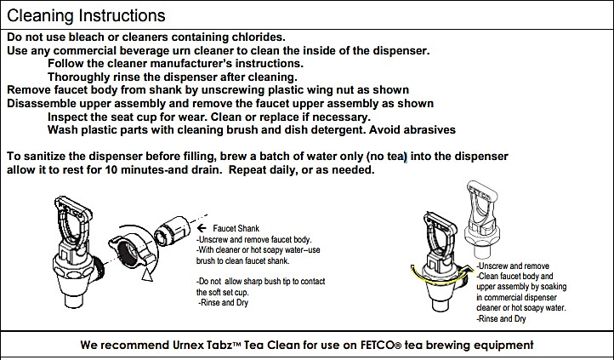
9.

Title of Procedure or Process: | SUN SAFETY PROTOCOL
Program Area(s): | Health, Education, Family Services.
Related Standards or Regulations: | - Head Start Program Performance Standards  - Maine State Licensing  - Developmentally Appropriate Practice/NAEYC  ☒Caring for Children  ☒ Other; American Academy of Pediatrics
Person Responsible for implementation: | All Classroom Staff and Site Supervisors
Timeline for completion: | Spring, Summer, Fall Playground Time
Submitted to:
ChildPlus Documentation: | Only if Parent refused Sunscreen application
Uploaded to ChildPlus: | Universal Permission Form
Specific Directions: | Use Child Care Weather Watch and use gloves if you or a child has an open  wound/rash while applying sun screen.
Procedure:
At Promise Early Education Center, we recognize that playing outdoors is an important part of a growing child’s physical, social and mental health. However, too much exposure to the sun’s harmful UV rays during early childhood can greatly increase a child’s risk of developing skin cancer later in life. While individuals of all ages benefit from protecting their skin from the sun, young children can learn early in life to develop healthy, life-long sun protection habits. The sun safety guidelines outlined below will be communicated and reinforced to center staff and parents through letters, notices, and above all, site practice. Working together, parents and staff members can ensure that children enjoy their time outdoors in the safest way possible.

Staff members will:
- Encourage children to wear wide-brimmed hats when playing outdoors, especially between the hours of 10a.m. and 4p.m.
- Encourage children to wear broad-spectrum sunglasses that reflect 100% of UV rays when playing outdoors, especially between the hours of 10 a.m. and 4 p.m.
- Encourage children to wear sun-protective clothing including long pants/long shorts and long-sleeved shirts when playing outdoors, especially between the hours of 10a.m. and 4p.m. (weather permitting).
- Identify shade in outdoor play areas and encourage children to play in shady areas, especially if a child is not wearing other forms of sun protection.
- Apply sunscreen, SPF 15 or greater, to all exposed skin of children, 6 months of age and older, thirty minutes prior to going outdoors. Staff must use gloves when they have an open wound on their hands or applying to a child’s open wound area.
- Parents must provide initial and signature on our Permission for Services Form
- Include lessons and/or activities on sun safety practices into the curriculum.
- Provide parents/guardians with sun safety information and materials.
- Staff serve as role models for children under their care by personally practicing sun protection recommendations.

Parents/guardians of children will:
- Be asked to provide a wide-brimmed hat for his or her child to keep at school and wear when participating in outdoor activities. Hats should protect the child’s ears, face, and neck. Hats should be clearly labeled with the child’s name and taken home once a week for cleaning.
- Be asked to provide broad-spectrum sunglasses for his or her child to keep at school and wear when participating in outdoor activities. UV-protective coating may also be applied to prescription glasses.
- Be asked to provide protective clothing for his or her child. Light-colored, tightly woven, loose fitting, lightweight clothing is best for sun protection.
- Be asked to sign Promise’s Sun Safety Policy and Consent Form allowing staff to apply sunscreen to his/ her child about 30 minutes before going outdoors. [Parents may supply their own sunscreen with signed permission].

Title of Procedure or Process: | HEAT STRESS PROTOCOL
Program Area(s): | Health
Related Standards or Regulations: | - Head Start Program Performance Standards  ☒Maine State Licensing  - Developmentally Appropriate Practice/NAEYC  ☒Caring for Children  - Other
Person Responsible for implementation: | Lead Teacher, Site Supervisor, Health staff
Timeline for completion: | Before letting children outside
Submitted to: | N/A
ChildPlus Documentation: | N/A
Uploaded to ChildPlus: | N/A
Specific Directions: | CFOC Standard 3.1.3.3, Supervising adult should check the air quality index each day and use information to determine whether it is safe for children to play
Children get heat-related illnesses more quickly than most adults. This is because:
- Children produce more body heat and are generally more active
- Children sweat less and this reduces the ability to cool the body
- Children are less likely to drink enough fluids to stay hydrated

The impact of heat and humidity is measured by the Heat Index (colored chart), which provides a measurement of what weather conditions feel like in the shade. Exposure to the full sun can increase the heat index by up to 15 degrees F. Check the daily Heat Index for your area at www.weather.gov.
Licensing regulations for child care centers require that measures be taken to cool children when the indoor temperature exceeds 82°F.
Tips for keeping children safe in hot weather:
  - Check the Heat Index Chart before children go out to play. If the Heat Index is 90 or above (the yellow and red zones on the Heat Index Chart), select indoor activities.
  - Stay indoors during the hottest time of day between 10am and 4pm.
  - Encourage children to drink plenty of fluids without sugar, especially water.
  - Watch for signs of dehydration (see chart below).
  - NEVER leave children, pets or anyone with special needs in a parked car, even briefly when the outside temperature is 80 degrees F or above.
  - Consider cancellation of outdoor events, field trips, recess, etc. based on the Heat Index.
  - When existing air conditioning systems are not sufficient to reduce the indoor temperature below 82 degrees F within the classroom locate an area within the building that is cooler or consider moving the children to another location.
Condition Symptoms First Aid
Dehydration Headache; heavy sweating; red, Move to a cooler location; remove flushed, warm skin; muscle cramps; excess clothing; give 4 ounces of stomach cramps or nausea; normal water every 15 minutes; discontinue body temperature. fluids if vomiting occurs.

Heat Exhaustion Heavy sweating; cool, pale, or flushed Lie down in a cool or air-conditioned

90 - 100 degrees F skin; weak pulse; dizziness or fainting; place; loosen or remove clothing; headache; nausea and/or vomiting; apply cool, wet cloths; give 4 ounces normal or rising body temperature. of cool water every 15 minutes.

SEEK medical attention if vomiting occurs.

Heat Stroke Body temperature 105 degrees F or Move to a cooler environment and

105 – 129 degrees F greater; hot, red, dry skin; rapid weak remove clothing; place in a cool bath, pulse; rapid shallow breathing, not sponge, or cover with a cool wet sheet
sweating; loss of consciousness. Do not give fluids; call 911 or transport to hospital immediately.

Title of Procedure or Process: | INSECT REPELLENT PROCEDURE
Program Area(s): | Health,
Related Standards or Regulations: | ☒Head Start Program Performance Standards  - Maine State Licensing  - Developmentally Appropriate Practice/NAEYC  ☒Caring for Children  - Other
Person Responsible for  implementation: | Classroom Staff i.e. Lead teacher, TA, Substitute, Health staff
Timeline for completion: | Upon parent request
Submitted to: | Lead Teacher
ChildPlus Documentation: | Permission OTC Product Form and create a CP+ flag
Uploaded to ChildPlus: | Under Health Attachment
Specific Directions: | Parent must provide the repellent; label the product with child’s name and teachers must keep up and out of reach of children. Can only be applied to children older than two months.
Procedure: Insect repellent will NOT be used on babies under two (2) months of age.

Babies two months of age to five years old:
- A repellent with 10% to 30% DEET may be used. DEET concentration should not exceed 30% (AAP).
- A parent must call their child’s physician for approval, if less than 6 months old before staff can apply any DEET product.
- Staff must read product label to ensure the product is EPA registered and labeled as approved for use in the child’s age range.
- Products with 10% DEET are effective for approximately two (2) hours and products with 24% DEET offers protection for about five (5) hours.
- If the child develops a skin rash or other localized adverse reaction, discontinue use and wash off the repellent with soap and water. Notify parent/guardian of the adverse reaction.
- Products containing oil of lemon and eucalyptus should NOT be used on children under three (3) years of age.
- Apply repellent (spray or lotion) to the hands of caregiver/teacher first than apply to the exposed skin of the child.
- Do not apply under clothing.
- Do NOT apply to children’s hands or areas around the mouth or eyes.
- Preschool children and toddlers should not apply repellent to themselves.
- If sunscreen is used, apply sunscreen first than the repellent.
- Caregivers/teachers should wash their hands before and after applying insect repellent to children or staff may choose to wear non-latex disposable gloves. If staff or child has open wound or rash, gloves must be worn; change gloves if it’s multiple children.
- After returning indoors, insect repellent should be washed off with soap and water.
OTC Form: Parent/guardian must sign Permission to administer OTC medication.
- Insect repellent used for preventative purposes does not require a written authorization from a primary care provider.
- Insect repellent must be in the original container and labeled with the child’s full name and stored out of the reach of children.
- Insect repellent will be applied in accordance with the label instructions and PROMISE procedure guidelines.
- Aerosol sprays are NOT recommended. Pump sprays are preferred.
- Notify parent/guardian at eh end of the day when insect repellent is applied to their child since it is recommended that treated skin be washed with soap and water.

Title of Procedure or Process: |  | HEAD LICE PROTOCOL
Program Area(s): |  | Health
Related Standards or Regulations: |  | - Head Start Program Performance Standards  ☒Maine State Licensing  ☒Developmentally Appropriate Practice/NAEYC  ☒Caring for Children  ☒Other-American Academy of Pediatrics, Health Advisory Committee
Person Responsible for implementation: |  | Lead Teacher, Site Supervisor and Health Staff
Timeline for completion: |  | Daily Health Check and Monday Lice Check
Submitted to: |  | Health Manager
ChildPlus Documentation: |  | Health Communication Log
Uploaded to ChildPlus: |  | Under Health Tab-Health Event-Health Comm. Log
 | Specific Directions: | Head Lice infestation in children attending the child education setting is common. Head lice infestations occur in all social-economic groups and are not a representation of poor hygiene. Head lice are not responsible for spreading any diseases, and is NOT  considered a health hazard. This protocol provides guidelines for education and support of staff and families with evidence based approach for treatment of head lice infestation  that will reduce unnecessary absences.
Procedure:
- Observing scalps for live head lice will be conducted weekly by staff on Monday morning. Children who are not present that day will be checked on the morning the child returns to the program.
To look for the signs and symptoms of head lice, the child may have one or more of these symptoms:
  - A tickling feeling on the scalp or a sensation that something is moving in the hair.
  - Itching caused by an allergic reaction to lice bites (kids may scratch or rub their scalp, especially around the back of the head or ears).
  - Sores on the head caused by scratching.
- Children will not be sent home early from our classrooms due to the presence of live head lice; unless:
- Live lice cannot be contained to the scalp i.e. eyebrows, crawling down the face or neck.
- If providing lice prevention support (combing, vacuuming, washing soft classroom items) to children/classroom from teachers result in a need for care that is greater than the staff can provide without compromising the safety of other children.
- If symptoms i.e. excessive itching, pain from head sores prevents the child from participating comfortably in school activities.
- Classroom staff will not perform lice vacuum comb treatment if it interrupts children’s education or jeopardizes the safety of children. If needed, support staff i.e. Site Supervisor or Health Department
- Verbal and written information will be given to the parent/guardian regarding the recommended procedures to treat a head lice infestation in a language the parent/guardian can understand.
- Communication to the parent/guardian at the end of the day should state “The child can return the next day after a lice preventative treatment has been applied to the child’s scalp and without the presence of live lice upon return to school.”
o *New Staff will inform parent for the next 8 days (egg cycle) that during the morning health screen a live lice check will be performed, and child cannot stay if live lice is still present.
If child arrives with live lice on their scalp the next morning, the person dropping off the child will have two options
  - Cannot do during COVID-19 Pandemic Stay at school and help support the staff in using the live lice vacuum comb that can remove live lice within 10-20 minutes please have parent arrive 15 minutes early) or
  - Return the child home to receive guidance from their physician on eliminating live lice and nits from child’s hair.

- All household members and other close family contacts of an infested child should be checked for head lice. Only infected (presence of live lice) persons should be treated and at the same time.

- Staff will notify via email/phone the Health Manager when an IC has brought live lice into the classroom by the end of the day. Teachers are expected to communicate to both there Site Supervisor and Health Manager if a family needs assistance with head lice treatment or eradicating a chronic head lice infestation.
- Treatment will need to be repeated within 8 to 10 days after the first treatment as new lice (nymphs) will hatch from live lice eggs (nits) that are still attached to the hair shaft.
- After 2 months (2 cycles of nit hatching) or sooner of chronic lice in the classroom a team meeting (involving FA, teacher, health staff and case manager) will be scheduled to provide support and resources to the family.
  - If a parent refuses team meeting, we will require the child to access preventative treatment from a medical provider and will need a doctor’s note that states “the parent received/was prescribed lice treatment and guidance was provided from a medical provider” that will allow the child to return to school.
- Classroom items such as headgear, pillows, blankets, dramatic play clothes, which have come into contact with the affected child within forty-eight hours can be laundered in hot water (130°F) or dried for 30 minutes to temperatures greater than 130°F, or placed in a plastic bag for no less than two days. Recognize you can put infested child’s outer wear and head wear into the dryer before the parent arrives, if needed.
o During outbreaks in winter months ensure all children store winter hats inside a coat sleeve and that no classroom should have a basket or bag to store “extra classroom hats” (store all items separately).

- Classroom staff and volunteers are expected to engage in the same protocols that we educate our parents about to prevent lice from spreading outside of the classrooms into homes and to family members. Please reach out to your Site Supervisor or the Health Coordinator if you need to have a lice kit for yourself and if you need support in checking your own head. Please remember to put your hair up when in a classroom when live lice are present. Put away any dramatic play clothes, stuffed animals, blankets, and pillows until the child(ren) has received a treatment and there are no signs of live lice.

AW 6/2021

Title of Procedure or Process: | TICK REMOVAL PROCEDURE
Program Area(s): | Health
Related Standards or Regulations: | - Head Start Program Performance Standards  - Maine State Licensing  - Developmentally Appropriate Practice/NAEYC  ☒Caring for Children  ☒ Other
Person Responsible for implementation: | Classroom staff who feel comfortable in performing this task and Health Staff
Timeline for completion: | Remove immediately or call parent to remove (parent should be advised to save tick and call child’s PCP for follow-up).
Submitted to: | Notify Health Manager that IR was completed.
ChildPlus Documentation: | Yes, under Health Event and in Health Communication Log
Uploaded to ChildPlus: | If received a PCP note
Specific Directions: | call the Health Department if you need support in removing the tick and washing the  bite area.
Procedure:
After children play outside, classroom staff will do a visual check for ticks. If a tick is found on a child, but is not attached, the tick will be removed and flushed down the toilet. If a tick has attached to a child’s/staff’s skin, the tick should be removed as soon
as possible according to the guidelines and instructions outlined below and recommended by the Maine Center for Disease Control and Prevention.

Ticks usually crawl upward from the ankles or drop from overhanging leaves and brush. Ticks need to attach to the skin and cannot bite through clothing. Preventing contact with ticks is encouraged by wearing long sleeved shirts and long pants tucked into socks or boots whenever children/staff are playing/walking in woodsy areas and/or tall grasses.

Parents will be encouraged by staff to check for ticks at home, paying close attention to the scalp, behind the ears, neck, back, and under the arms. Parent/guardian should notify their doctor if the child develops a rash of any kind, especially a red-ringed bull’s-eye type rash or if the child experiences flu-like symptoms such as fever, headache, chills, muscle or joint pain, and/or fatigue within a few days of having removed an attached tick.

Recent research indicates that deer ticks need to be attached to the skin for over 24 hours in order to transmit disease, so early detection and removal is important in preventing infection.

Tick Removal using a Tick Spoon:
- Place the wide part of the notch in the spoon on the skin as near as possible to the attached head of the tick.
- Applying slight pressure downward on the skin, slide the spoon forward (do not pry, lever, or lift up) so the notch in the spoon is framing the tick and the body of the tick lies in the spoon.
- Continue to apply a steady pressure while sliding the spoon forward until the tick detaches.
- After removing the tick, thoroughly clean the bite area, your hands, and the tick removal spoon with soap and water.
Tick Removal using Tweezers:
- Grasp the head of the tick as close to the skin where it is attached with the tweezers.
- Pull firmly and steady with the tweezers until the tick detaches.
- If the head of the tick remains attached and separates from the body of the tick, try grasping the remaining part of the tick with the tweezers and repeating the procedure.
- If the head is embedded in the skin and cannot be grasped with the tweezers or tick spoon, do not attempt to remove it and refer the family to their doctor for guidance.

The body of the tick contains the infectious agent(s) that transmits disease. Place the tick or part of the tick that has been removed in a sealed plastic bag. Write the child’s name and the date it was removed on the bag, give it to the parent and refer them to their doctor for guidance and recommendations for follow-up diagnosis and/or treatment.

Title of Procedure or Process: | PEST PROTOCOL
Program Area(s): | Health, Family Services
Related Standards or Regulations: | - Head Start Program Performance Standards  ☒Maine State Licensing  - Developmentally Appropriate Practice/NAEYC  - Caring for Children  - Other
Person Responsible for implementation: | Classroom Staff, Site Supervisor and Health staff
Timeline for completion: | Immediately
Submitted to: | Health Manager
ChildPlus Documentation: | Yes, Health Communication Log under Unhealthy Living Conditions & Family Services Event, Need Identified (include a description if the issue i.e. pest).
Uploaded to ChildPlus: | Pine Tree Legal Forms under Health Attachment.
Specific Directions: | Notify Health the day a pest is found in our facility and when parent divulges pest infestation in the home.
Purpose: To detect and treat for Pests in a proactive approach that focuses on preventing infestations and monitoring for pests when discovered in a center.
Philosophy: Because the health and safety of students and staff is our first Promise Early Education Center will approach pest management that:
- Protect the health and safety of students and employees;
- Protect the integrity of buildings and grounds;
- Maintain a productive learning environment.

Procedure:
Insect on a student:
If an insect is found on a student, it may indicate that the student has infestation at home. However, insects can crawl or jump onto or off of a person (or their belongings) at any time, so it is also possible that the insect(s) was brought to school by someone else.

- Capture it for proper ID
- Student should be discreetly removed from the classroom to examine the student’s clothing, hair and other belongings. If parent/guardian is present they should stay with the child for the inspection.
- Inspect any closets or cubbies used to store the person’s belongings (especially cracks and crevices).
- Students will not be excluded from school due to infestation unless repeated efforts have been made to remedy the infestation.
- Notify the school Nurse/Health Manager, even if only bites were seen and documented.
- Notify the parent/guardian to inform them of the insect(s) presence on their child.
- If fleas are found on a child, you are to follow the live lice procedure.

Pest in the Classroom:
- Capture it for proper ID, if possible
- Isolate the location in the room where it was found.
- Call your SS to come and inspect the area near where the bed bug was found.
- Notify the school Nurse/Health Manager (for procedure guidance)
- Staff will put on PPE and put all blankets and soft toys into a bag to carry to the laundry room. Place the items into the dryer (do not overstuff the heat must reach all items) for 30 minutes on high heat; this will kill most pests life stages. Please bag the used bag and tie tightly and discard immediately to prevent bed bugs from crawling out of the bag.
- Hard surfaces can be cleaned with standard cleaning products.
- A staff member will complete a pest work order and sent to Administrative Secretary to inform the pest control and the
cleaning company that a pest was captured in the classroom that day.

8. If pests have been found repeatedly in a particular classroom or on the same child you are to contact the Health Manager immediately and save the captured bed bug. The Health Manager will then determine if an inspection and monitoring of the classroom needs to take place and will provide further ongoing guidance.

If a child’s household has a Pest Infestation:
    - When families are dealing with an infestation at home, it is important to be sensitive to their problem.
    - We as an agency will work with the parent(s) of any student living in an infested home to develop strategies for preventing the further spread of bed bugs into the school environment.
    - Ask the parent if the infested home is being treated and if their landlord is assisting in the removal of pests.
If a parent that rents lacks the financial resources to assist the landlord in the process of getting rid of pests that are entering their apartment from unhealthy building conditions (moving furniture, laundering clothes, etc.) you may suggest and assist them contacting Pine Tree Legal Assistance at:
Phone: (207) 784-1558 or walking to 95 Park Street, 3rd Floor, Lewiston, ME 04243-0398.
    - If parent lacks resources to eradicate an infestation brought on by their own actions i.e. fleas due to untreated pets. Outreach to your Supervisor for guidance.
    - Also, outreach to the Health Manager for resources to assist the family.
    - It is an expectation that you will outreach to the Health Manager for information resources that you will provide to the family.
    - In an infested home, parents should store their child’s freshly laundered clothing in sealed plastic bags until they are put on in the morning or preferably at school. This prevents pests from hiding in the clothes and being carried to school.
    - Backpacks, car seats, strollers and other items that travel back and forth to school can also be inspected daily and stored in sealed plastic container/trash bags at home and school to prevent bed bugs from getting into them.
    - At school, staff and families need to inspect outside clothes brought into the classroom, including backpacks (outside items are restricted from being brought into the centers during this time).
    - It is expected that the child will have a second outfit at school to change into, if needed. Follow all safety protocols when these items are brought in (placing in the dryer) and then place in a plastic bag.
    - At school, the student will be provided with plastic bags or bin in which to store their belonging in order to prevent any bed bug from spreading to the classroom and other student’s belongings. During this time, we strongly urge items from home not be brought to school.
    - If temporary precautions are to be implemented, it will need to be approved by the IC parent, your SS and the Health Manager.
    - Continue to use these measures until successful treatment of the home has been verified. Only your supervisor can determine when these measures discontinue.
Visiting a home known or unknown to have bed bugs- Staff with Family Service Responsibility
    - Bring only what you need into the home. Leave (purses, bags, coats, etc.) locked in the trunk of the car.
    - Do not place belonging on the floor or upholstered furniture.
    - Choose furniture to sit on without pillows or upholstery, if possible.
    - Try not to sit still for long period of time (hours); pests stay hidden when they sense movement.
    - Select toys and materials that can withstand heat, toys should be bagged after the visit. Then put into dishwasher or clothes dryer on high for at least 30 minutes. Toys that cannot withstand heat/wetness; please clean with Hydrogen peroxide spray/wipes.
    - Change and launder your clothes after a visit to a known infested environment. If possible, change before entering your home. Place clothing into a bag to safely carry them to the dryer and place the bag in another bag sealing tightly to dispose of. Vacuum your car out; particularly in crevices and seams.

Title of Form: | PEST MANAGEMENT
Related Policy: | Pest Procedure
Program Area(s): | Health and Maintenance Dept.
Related Standards or Regulations: | - Head Start Program Performance Standards  ☒Maine State Licensing  - Developmentally Appropriate Practice/NAEYC  - Caring for Children  - Other
Procedures 1. Go to Promise website and complete Pest Management Form
2. Must be completed the day of the sighting
3. To complete, follow forms directions
Form Completed By: | Staff who observed the pest
Timeline for completion: | By the end of the day
Specific Directions: | We must be pest free at all times and requires immediately notification to appropriate personnel if sightings have occurred.
Submitted to: | Site Supervisor and Supervisor will forward to Agency personnel as appropriate, i.e. Maintenance, Health Manager, and Executive Director
ChildPlus  Documentation: | N/A
Uploaded to ChildPlus: | N/A

Title of Procedure or Process: | Family Services Monitoring Plan
Program Area(s): | Family Services Monitoring Plan
Related Standards or Regulations: | ☒Head Start Program Performance Standards  ☒Maine State Licensing  - Developmentally Appropriate Practice/NAEYC  - Caring for Children  ☒Other
Person Responsible for implementation: | Staff with family services responsibilities
Timeline for completion: | Ongoing
Submitted to: | N/A
ChildPlus Documentation: | N/A
Uploaded to ChildPlus: | N/A
Specific Directions: | To ensure the consistent delivery of Family Services please follow the time line  below

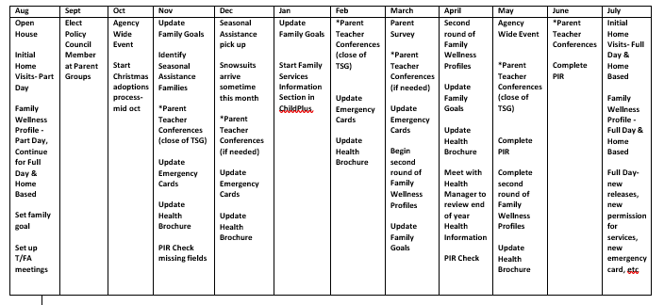
Title of Procedure or Process: | Family Advocate and Teacher Meetings
Program Area(s): | Family Services, Health, Education, Special Services
Related Standards or Regulations: | ☒Head Start Program Performance Standards  - Maine State Licensing  - Developmentally Appropriate Practice/NAEYC  - Caring for Children  ☒Other
Person Responsible for implementation: | Staff with family services responsibilities and teaching staff
Timeline for completion: | Full day- Meetings are to take place twice per month at a scheduled time (once with each lead). Part year- once per month
Submitted to: | Site Supervisor
ChildPlus Documentation: | N/A
Uploaded to ChildPlus: | N/A
Specific Directions: | See Below

Procedure:

What to cover in these Family Advocate and Teacher Meetings?

- High Needs Families- pick top 3 (cover the next 3 in line at the second session)
- High Needs Children- pick top 3 (cover the next 3 in line at the second session)
- DHHS
- Fees (extended day classrooms only)
- Medical Needs (includes follow up treatment if needed)
- Dental Needs (includes follow up treatment if needed)
- Hearing and Vision Follow Ups (if needed)
- Medications/Health Plans
- Parent Group Meetings
- Home Visits
- Parent Teacher Conferences (Center visits)
- Shared Families
- Special Education Needs/Referrals/Services
- Mental Health Referrals/Services
- Other

If a teacher receives information such as a date for a WCC and dental appointments please email the Family Advocate by the end of the business day the information is received, the Family Advocate will enter the information into ChildPlus and/or do follow up with the family.

The meeting is an opportunity to determine what needs to be done in the areas that are covered during the Family Advocate and Teacher Meeting, who will do the follow up and when the follow up will take place.

Please keep your site supervisor up to date on what took place during the meetings, what were the outcomes and what follow up happened or is needed. If these meetings are not happening with consistency please inform the site supervisor the second time a meeting is missed. Your site supervisor can make suggestions or recommendations on how to get those meetings scheduled.

Please use sheet such as the example below to document the conversations, the family advocate will email the notes to the teaching staff & site supervisor within 24 hours of each meeting.

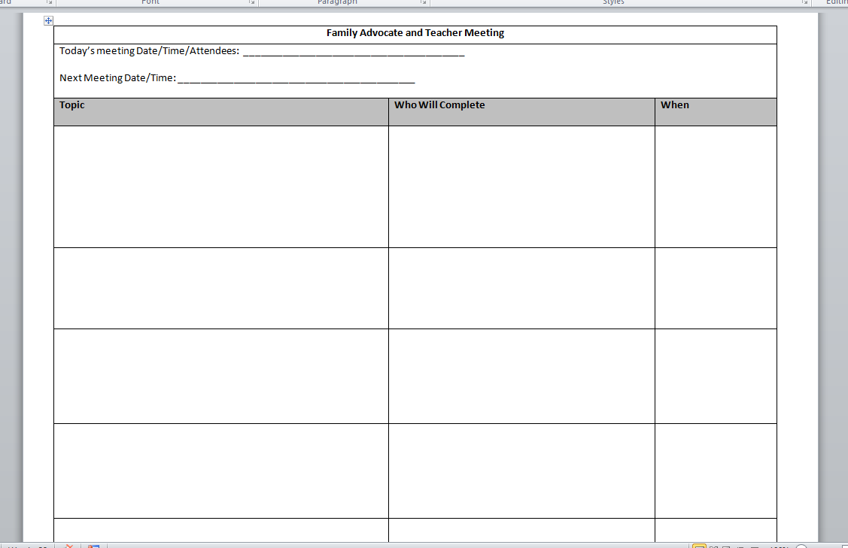

Title of Procedure or Process: | Documentation Shortcuts and Examples
Program Area(s): | Health, Nutrition, Education, Special Services, Family Services, ERSEA, etc.
Related Standards or Regulations: | - Head Start Program Performance Standards  - Maine State Licensing  - Developmentally Appropriate Practice/NAEYC  - Caring for Children  ☒Other
Person Responsible for implementation: | All staff
Timeline for completion: | Ongoing
Submitted to: | N/A
ChildPlus Documentation: | All Areas
Uploaded to ChildPlus: | N/A
Specific Directions: | See Below

Procedure:

Use clear and concise language; documentation should be no longer than 2 lines in most situations. Be factual and objective, there are to be no opinions or room for subjectivity. Remember educational records can be subpoenaed at any point in time, when writing and reviewing contact notes think “what would a judge or lawyer think of this statement, would he or she have an understanding of what happened on that day or in that moment?”

Documentation Shortcuts:

MOC | Mother of child
FOC | Father of child
IC | Identified child
PGM | Paternal Grandmother
PGF | Paternal Grandfather
MGM | Maternal Grandmother
MGF | Maternal Grandfather
SMOC | Stepmother of Child
SFOC | Stepfather of Child
FMOC | Foster Mother of Child
FFOC | Foster Father of Child
MH | Mental Health
DV | Domestic Violence
PA | Physical Abuse
SA | Sexual Abuse
EA | Emotional Abuse
CA | Child Abuse
PCP | Primary Care Physician
TSG | Teaching Strategies Gold
IHP | Individual Health Plan
IZ | Immunization
RX | Medication/Prescription
DX | Diagnosis
F/U | Follow Up

Some Documentation Examples:

Initial home visit and all necessary paperwork completed with MOC and FOC. Attendance Policy and subsidy/parent fee information reviewed. IC’s will visit classroom on… and is scheduled to start on Monday...

MOC slept through her alarm (works 3rd shift) and picked IC up around 2:00 today. MOC apologized, updated her emergency card

Teacher and I arrived for home visit at 9am, no one answered the door, but we could hear someone inside. Attempted to call, no answer. Letter to be mailed and dropped off requesting contact.

Spoke with FOC regarding IC's attendance as IC has missed several days this year. FOC shared that he did not think that Pre K was mandatory so he didn’t feel like he had to bring IC every day. Explained the importance of attending every day. FOC shared that when IC goes to K he will get him to school every day. The family currently only has one vehicle. In the end FOC said that he would try to get IC to school each day.

Title of Procedure or Process: | Family Referrals
Program Area(s): | Family Services
Related Standards or Regulations: | ☒Head Start Program Performance Standards  - Maine State Licensing  - Developmentally Appropriate Practice/NAEYC  - Caring for Children  ☒Other: Defined by Maine Head Start Agencies
Person Responsible for implementation: | Staff with Family Services Responsibilities
Timeline for completion: | Ongoing
Submitted to: | N/A
ChildPlus Documentation: | Family Services Events- All event topics- create an Action that indicates Referral, select the referral agency (if they are not there please let the Family Services  Manager know)
Uploaded to ChildPlus: | N/A
Specific Directions: | A referral is information that is shared with a family and the family acts upon that information on their own or with your support. Referral agencies can be  found by accessing 211 or visiting 211maine.org

Procedure:

Category
Emergency | Promise staff help connect a family to things like Alternative Aid, Emergency shelter assistance (Hope  Haven for example)
Crisis Assistance | Promise staff help the family to outreach to things like the Crisis Hotline 1-888-568-1112, Red Cross, 911, etc.
Food | Promise staff helped a family obtain food items through  food banks or pantries, Good Food Bus, etc.
Clothing | Promise staff helping a family to obtain clothing through clothing banks, Salvation Army (Coats for Kids)
Transportation | Promise staff helped a family get connected with transportation such as Logisticare and the family utilizing that ride, helping the family with getting a vehicle and them taking the steps to get that vehicle,  this includes a driver’s license, Purple Bus.
Housing Assistance | Promise staff helping the family to secure house or to obtain items to make their house safe (outlet covers, smoke detectors, etc), HEAP, Section 8, Community Concepts programs, legal assistance through Pine Tree  Legal
Mental Health Services | Promise staff helping the family get connected to Mental Health Services such as counseling, Tri County Mental Health, etc. and the family accessing those services.
Literacy or Education | Family attended agency events (math night/literacy night), Promise staff helped the family obtain books for  family literacy.
English as a Second Language | Promise staff helped the family get connected to ESL  classes and the family accessing the services.

Adult Education | Promise staff helped a family to sign up for adult education classes, which could include GED/HiSet classes, college courses, adult education program,  certificate programs, driver’s license.
Job Training | Promise staff helped a family get connected to job training programs within our community such as the  Career Center, FedCap
Substance Abuse Prevention | Promise staff helped a family get connected to a program or giving family information and then accessing that information before the “abuse” starts.  May include alcohol, illegal drugs, legal drugs.
Substance Abuse Treatment | Promise staff helping a family get connected to and accessing a substance abuse treatment program. May include alcohol, illegal drugs, and legal drugs. St. Mary’s Treatment Center, Tri-County Mental Health, The Comprehensive Substance Abuse Treatment and  Rehabilitation Program (CSTAR), Drug Court, Facing Change, AA Meetings- 800-737-6237
Child Abuse and Neglect Services | Promise staff making a DHHS referrals and/or  connections with DHHS Case Workers
Domestic Violence Services | Promise staff help connect a family to D.V. agency and the family accesses those services. Disclosure of DV is not enough. PFA’s included as a domestic violence  service. Safe Voices Hotline 1-800-559-2927.
Child Support Services | Promise staff helping a family to complete the paperwork and/or necessary steps to obtain child support. Support Enforcement
Health Education- Including Prenatal (All Families receive these services by being enrolled) | Every enrolled family receives health education. Health Education includes: hearing & vision, dental & medical,  hand washing, tooth brushing, etc.
Assistance of families of incarcerated individuals | Promise staff helping family access services and or resources around incarceration, help transitioning  individuals back into the family, Counseling services.
Parenting Education | All enrolled families receive parenting education. Parent Training topics: such as gun safety, pedestrian safety, nutrition, etc.
Marriage Education | Promise Staff helping a family get connected to marriage counseling services, healthy relationship information that the family implements into practice. Cornerstone Counseling, LLC in Auburn, Solid Roots  Counseling, LLC in Lewiston.
Asset Building Services | Promise staff helping a family with budgeting, connecting a family to a financial literacy course and  them attending that course or contact the provider to get more information.

Seasonal Adoption: Every year community partners and private individuals support our families by providing items during the winter holiday season. Information will be sent via email in October or November asking for staff to select families who have the greatest needs for assistance. We cannot guarantee that all families will receive assistance or the amount of assistance/items each family will receive during this process as we are honoring the requests of our donors. We ask that staff are gracious and professional when picking up items. Please remember donors wish to remain anonymous. Items are usually ready for pick up and distribution in mid to late December.

Winter Gear: We are approached by various organizations to provide winter jackets, ski pants, hats, mittens or gloves and winter boots to children. We do not receive enough winter gear to outfit all children. In November an email will be sent to gather information such as the name of a child and their sizes. Snowsuits do not arrive until mid-December, once they arrive they need to be counted and sorted, you will be emailed once the snowsuits are ready to be picked up and delivered. We will want to help families get connected to the Salvation Army for winter gear as they can outfit the entire family and as agency can only support the children who are enrolled in our program.

Title of Procedure or Process: | Shared Families
Program Area(s): | Family Services
Related Standards or Regulations: | - Head Start Program Performance Standards  - Maine State Licensing  - Developmentally Appropriate Practice/NAEYC  - Caring for Children  ☒Other: Best Practice
Person Responsible for implementation: | Staff with family services responsibilities
Timeline for completion: | Ongoing
Submitted to: | N/A
ChildPlus Documentation: | Teaching staff and staff with family services responsibilities document in the Family Services Events.  Identified point person enters in Family Wellness Profile aka Family Outcomes Assessment.
Uploaded to ChildPlus: | N/A
Specific Directions: | See Below

Procedure:

Working with a family who has children in multiple program options can be challenging as there are many individuals interfacing with that family on a regular basis.

Point Person:

Each shared family will have an assigned point person who will do the outreach and follow up about situations that impact the entire family (individual child information or situations will be shared at the classroom level). Examples include but are not limited to: unhealthy or unsafe living conditions, chronic head lice, DHHS involvement (reports will be made by all parties when and if needed), case management, subsidy, etc.

To determine who that point person will be please contact your site supervisor(s) who can provide some support to determine who will be that families point person. If the family is enrolled in Home Based or Early Home Based the Family Educator is automatically the point person for that family as they have weekly contact in the home.

Information that is to be shared on a regular basis consists of but is not limited to:

- Reviewing Goals- goal setting with each family should only be done once unless it is child specific
- Family strengths and concerns and coordination of any follow-up that may be needed
- DHHS Involvement and/or DHHS Reports
- Attendance concerns and attendance goals
- Transitions (EHS to HS, Home Based to Center Based, HS to K)
- Outside service providers (case management, daily living skills, etc)
- Subsidy- extended care classrooms only
- Custody/Protection Orders
- Other information that will help staff work effectively with the family as a team

If there is a change in the families situation or if a crisis arises staff need to immediately (before the end of day) contact the other site or classroom to inform them what is taking place, this contact should come via a phone call in an emergency and through an email for updates such as the family is moving. When sending an email please be sure to cc all site supervisors attached to the family, the Health and Nutrition Manager if there is a health related component and the Family Services Manager if there are things such as domestic violence, DHHS, subsidy, etc.

*If you are not the assigned point person to that family, please take the information from the family and outreach to the point person about how to best support the family and who will do follow up and outreach. If you need support to determine who does what please connect with your site supervisor (s).

Family Wellness Profile:

Only 1 Family Wellness Profile needs to be completed per family. The assigned point person is responsible for the data entry but should always include the other staff with family services responsibilities that are associated with this family to ensure accurate reporting and scoring.

Home Visits:

Home visits that impact the family (social services) should be scheduled together whenever possible to allow a family to get to know both staff with family services responsibilities and ensures that the family knows that we are all working together with the family’s best interest in mind. Anything child specific should only be discussed and reviewed by that individual child’s teacher.

ChildPlus:

Family information is accessible by locations, sites or classrooms for shared families; however information about the children remains site and/or classroom specific per our data management protocol.

Title of Procedure or Process: | Program Information Report (PIR)
Program Area(s): | Family Services, Health, Education, Special Services
Related Standards or Regulations: | ☒Head Start Program Performance Standards  - Maine State Licensing  - Developmentally Appropriate Practice/NAEYC  - Caring for Children  - Other
Person Responsible for implementation: | Staff with Family Services Responsibilities
Timeline for completion: | Ongoing but must be completed before a child leaves a classroom. All questions must be answered with a yes or no
Submitted to: | N/A
ChildPlus Documentation: | Click the PIR tab on the right hand side of ChildPlus
Uploaded to ChildPlus: | N/A
Specific Directions:

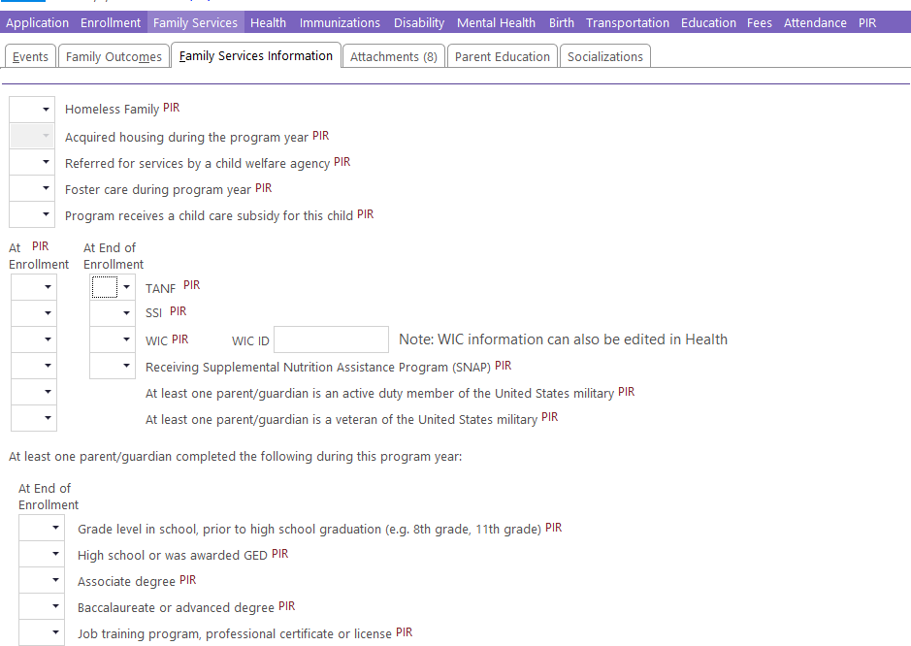
Procedure:
This question is related to what happened during the current school year.

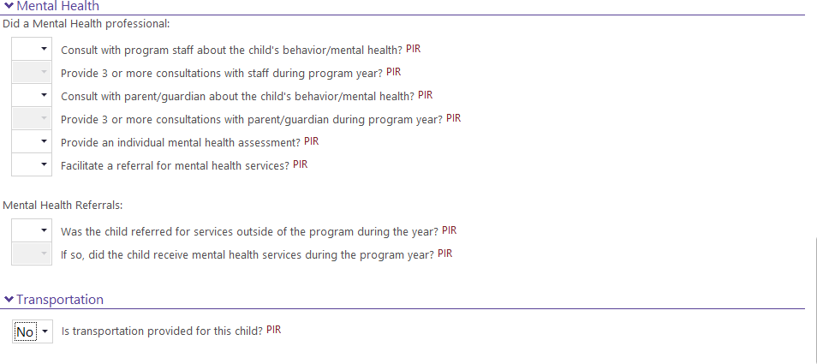
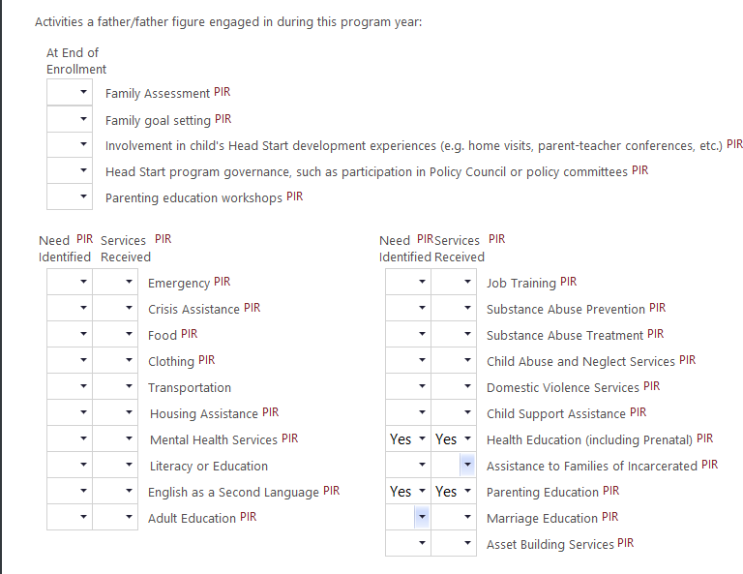
The mental health questions refer to outside mental health providers such as Tri County.
Health Education and Parenting Education are a Yes in both boxes; all other areas are based on services provided to the family.
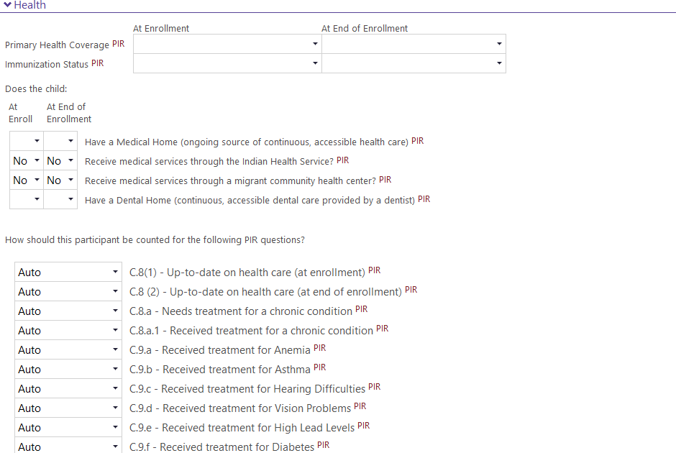
The Health Questions are completed by the Health Department

Check yes if outside transportation is provided for the child ( such as public school, Western Maine )

Under the parents name, you will find additional PIR questions. These are usually answered in enrollment at the time of enrollment but are occasionally missed and are worth checking. Note Pir fields in red, below.
These questions need to be answered for both parents.
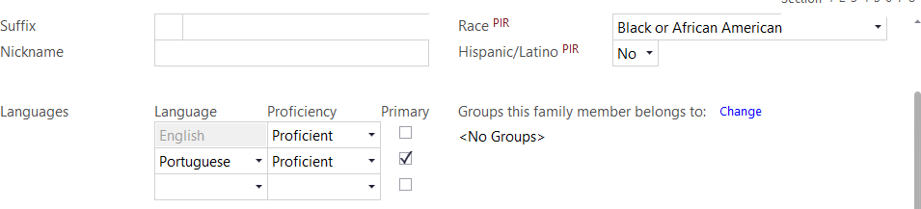

Work history / status is entered during enrollment and updated again at end of year. Note PIR fields in red, below.

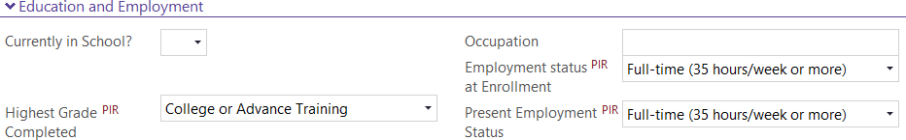

Title of Procedure or Process: | Family Engagement- Framework
Program Area(s): | Family Services
Related Standards or Regulations: | ☒Head Start Program Performance Standards  ☐Maine State Licensing  ☐Developmentally Appropriate Practice/NAEYC  ☐Caring for Children  ☐Other
Person Responsible for implementation: | Teachers, Teacher Assistants, Family Educators, Family Advocates
Timeline for completion: | Ongoing
Submitted to: | N/A
ChildPlus Documentation: | N/A
Uploaded to ChildPlus: | N/A
Specific Directions: | This is information about the PFCE framework that guides all the work that we do with families throughout all aspects of our agency.

Procedure:
Parent, Family, and Community Engagement (PFCE) Framework (2018)
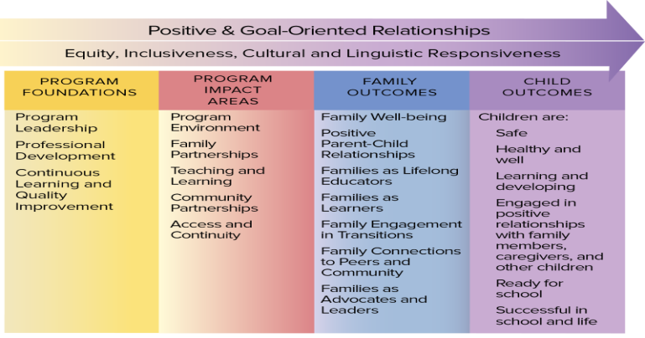
Positive & Goal Oriented Relationships | Positive, goal-oriented relationships improve wellness by reducing isolation and stress for both families and staff. When they focus on shared goals for children, staff and families can experience the support that comes from knowing they all are on the same team. These relationships support the aims of equity, inclusiveness, and cultural and linguistic responsiveness.
Equality, Inclusiveness, Cultural and Linguistic Responsiveness | The PFCE Framework identifies important drivers for positive and goal-oriented relationships across the entire early childhood field. Equity, inclusiveness, and cultural and linguistic responsiveness are important to integrate throughout the system.
Program Leadership | Leaders set a clear vision and goals and make sure that program policies, operational procedures, and practices (e.g., hiring) actively promote PFCE. They monitor activities in all of the Program Foundations and Program Impact Areas and make changes when needed to ensure that they are mutually reinforcing. Leaders also advocate for the inclusion of diverse family voices at all levels of the program, including in formal decision-making groups, such as parent committees and Policy Councils.
Professional Development | PFCE professional development is important for all staff, regardless of their role. Professional development plans can be aligned with continuous learning and improvement data, as well as family and community feedback. These plans include training, ongoing supports and information about career options.
Continuous Learning and Quality Improvement | Head Start and Early Head Start program leadership, staff, and families are committed to using data to improve family engagement practices on a continuous basis. Leaders and managers build support and capacity for this work among staff, families, and community partners. Together, they can work on selecting indicators of PFCE progress, planning for continuous improvement, and interpreting data, including community strengths and needs assessments.
Program Environment | "Program environment" refers to the features and physical setting of the program. High-quality program environments help protect the health and safety of children, families, and staff. They make families feel welcomed, valued, and respected. They also promote children's well-being, learning, and development. High-quality environments facilitate cultural and linguistic responsiveness, promote open and regular communication, and provide a sense of support to families. These environments create opportunities for families to build relationships with other Head Start parents and community organizations.
Family Partnerships | In family partnerships, program staff and families build ongoing, reciprocal, and respectful relationships. Program staff value families' unique expertise about their children. Staffs engage in regular communication with families to understand their goals for their children and themselves and work toward those goals together.
Teaching and Learning | Through teaching and learning, families and staff work together to promote children's learning, development, and school readiness. As children's first and most important teachers, families are engaged as partners in their children's learning and development. Families share their knowledge about their child. Teachers and home visitors share information about the child's progress. Head Start and Early Head Start programs build connections with community partners to offer children and families access to other learning opportunities.
Community Partnerships | Through community partnerships, Head Start, Early Head Start, and child care programs build collaborative relationships with community organizations that support positive child and family outcomes. These organizations may include libraries, health centers, schools and school districts, sources of economic support, the workforce, higher education, human services agencies, faith-based organizations, businesses, and others.
Access and Continuity | Eligibility, Recruitment, Selection, Enrollment, and Attendance (ERSEA) procedures are developed using community assessment data and engaging former and currently enrolled families, staff, and community members. These policies and procedures help Head Start and Early Head Start programs provide services for families most in need of them. The intention is to address specific challenges, such as family homelessness, that can interfere with consistent service access. Transitions practices can also ensure effective moves from Early Head Start to Head Start and on to other early childhood education programs or schools.
Family Well-Being | Families are safe and healthy. They also have opportunities for educational advancement and economic mobility. Programs also ensure families have access to physical and mental health services, housing and food assistance, and other support services.
Positive Parent-Child Relationships | Beginning with the transition to parenthood, parents and families develop warm relationships that nurture their child's health, development, and learning.
Families as Lifelong Educators | Parents and families observe, guide, promote, and participate in the everyday learning of their children at home, school, and in their communities.
Families as Learners | Parents and families learn about their child's personality, development, and learning style. They also advance their own learning interests through education, training, and other experiences that support their parenting, careers, and life goals.
Family Engagement in Transitions | Parents and families encourage and advocate for their child's learning and development as they transition to new learning environments within and between Early Head Start, Head Start, early childhood services, early elementary grades, and beyond.
Family Connections to Peers and Community | Parents and families form connections with peers, mentors, and other community members in formal and informal social networks. These networks are supportive and educational. They honor and are inclusive of families' home languages and cultures. They also enhance families' social well-being and community life.
Families as Advocates and Leaders | Parents and families advocate for their children and take on leadership roles in Head Start and Early Head Start. They participate in decision-making, policy development, and organizing activities in communities and states to improve children's safety, health, development, and learning experiences.

Title of Procedure or Process: | Confidentiality
Program Area(s): | Family Services, Health, Education, Special Services
Related Standards or Regulations: | ☒Head Start Program Performance Standards  - Maine State Licensing  - Developmentally Appropriate Practice/NAEYC  - Caring for Children  ☒Other
Person Responsible for implementation: | All staff
Timeline for completion: | Ongoing
Submitted to: | N/A
ChildPlus Documentation: | N/A
Uploaded to ChildPlus: | Confidentiality Agreements signed by parents are to be uploaded into Family  Services Attachments
Specific Directions: | Confidentiality is extremely important in the work that we do as we deal with a lot of sensitive information pertaining to families and children.

Procedure:

Staff: See Personnel Policies for more information

- All staff are required to sign a confidentiality agreement upon hire and annually thereafter.
- Information about families is only to be shared with staff that needs to know the information and no one else. Information may be shared within their teams and with their supervisor and/or manager. If staff is unsure whether or not information should be shared, they will consult with their supervisor or a manager.
- Information about children is only to be shared with staff that needs to know the information and no one else. Information may be shared within their teams and with their supervisor and/or manager. If staff is unsure whether or not information should be shared, they will consult with their supervisor or a manager.
- ChildPlus, TSG, ASQ and Brigance systems are is tailored to the amount of information each individual needs to know based on our data management procedures
- Health information follows HIPPA guidelines
- All records containing personal information about children and families are kept in locked file cabinets at the child’s center or main office
- At the end of the program year or when a child leaves the program, all records are sent to the main office. Records are retained for three to five years after the child has left the program. Records are then destroyed.
- Any information that is learned about a staff or potential staff member through participation in any classroom, program, function, committee, Policy Council or Board meeting is confidential information. This information will not be shared with other staff, parents, agencies, professionals, family or friends.

Parents:

- Sign a confidentiality agreement annually
- Records are only shared with other agencies with signed written permission
- All parents and legal guardians have a right to access information from their own child’s records. Staff has the right to access information from their own records. Copies of information are obtained through a request in writing. A copying fee may be assessed.
- Any information that is learned about a child or family through participation in any classroom, program, function, committee, Policy Council or Board meeting is confidential information. This information will not be shared with other staff, parents, agencies, professionals, family or friends.

Title of Procedure or Process: | Family Engagement- Parent Group, Nurturing Parenting Program, Agency Wide Family Events, End of year Celebration, Agency Committees, In-Kind
Program Area(s): | Health, Nutrition, Education, Special Services, Family Services, ERSEA
Related Standards or Regulations: | ☒Head Start Program Performance Standards  - Maine State Licensing  - Developmentally Appropriate Practice/NAEYC  - Caring for Children  - Other
Person Responsible for implementation: | Teachers, Family Advocates  Agency Wide Family Events- Everyone
Timeline for completion: | Parent Groups- Monthly (snack/food orders 2 weeks prior to group)  Agency Wide Family Events- twice per year
Submitted to: | N/A
ChildPlus Documentation: | Parent Groups: Entry Express- Parent Education  Agency Wide Family Events: Family Services Events- Parent Involvement- Description Literacy Night and Math & Science Night (Fall and Spring need their  own events)
Uploaded to ChildPlus: | N/A
Specific Directions: | See Below
Procedure:

Promise Early Education Center Staff:

- Recognize that parents/guardians/caregivers are their child’s first and best teacher and they ensure that parents/guardians/caregivers know this to be true
- Work to ensure that parents are engaged in their child’s learning and development and support positive parent- child relationships
- Develop relationships with parents/guardians/caregivers that are trusting, respectful, strengths based and foster ongoing communication
- Have an open door policy in all classrooms where families are feel welcome and are able to attend and participate in all aspects of a program day
  - If a parent/guardian/caregiver is interested in volunteering on a regular basis please connect them with Human Resources.
- Collaborate with families to identify strengths, interests and needs using the Family Wellness Profile and assisting families to set goals and getting connected to community resources as part of the Family Partnership Agreement Process
- Ensure the work we do with families is delivered in their Home Language through the use of Language Facilitators and when they are not available the use of the Language Line, Remind and/or Google Translate
- Teaching staff will complete no less than 2 Parent Teacher Conferences per program year to enhance the knowledge and understanding of both staff and parents of the child’s education and developmental progress and activities in the program

Monthly Parent Group (Parent Committee Meeting):

- Each classroom or center has a Parent Group that is made up of all enrolled parents/guardians/caregivers
  - August- Open House, at this Parent Group complete the Parent Education Survey to determine topics and schedule

- Parent Groups meet once a month at a mutually agreed upon time. Please keep the same time each month, if you are not able to maintain that schedule please communicate with your site supervisor for assistance
  - Once a day and time have been secured please use a calendar invite to notify staff in that classroom or center, site supervisor, Language Facilitator
- There is a small amount of funds available for each parent group throughout the year, additional information on how to utilize those funds will be forthcoming upon approval of Policy Council, the information will be emailed in September.
- During the Parent Group parents/guardians/caregivers are updated on what is taking place in the classroom and/or center. Parents/guardians/caregivers are also updated on what is taking place Agency wide with updates from the identified Policy Council Representative and/or by using the monthly dashboard report.
- Parent Groups are also required to have a Parent Training component (see topics below). Parents are asked to complete a survey to determine the level of interest in topics that will drive what month topics are offered.
  - If you are requesting the presence of someone from the leadership team to cover a topic for your Parent Group you must send them a request at least 1 month in advance via email, once you have received confirmation that the member of leadership is able to attend then please send a calendar invite.
- It is the responsibility of the teachers and the family services staff to encourage and motivate parents to participate in parent groups and activities. This encouragement should include personal contacts when parents drop off or pick up children, phone calls, and personal messages sent home with children, Remind messages.
- Snacks are provided for each Parent Group (Full Day Centers will receive a meal each month), the Nutrition Department will determine the snack for each month.
  - A Food Request Form must be completed two (2) weeks prior to the meeting in order to ensure you have snack for your meeting. Should there be a change in the date or time of the event, such as a snow day, the kitchen must be informed by center personal or the site supervisor, a new food request form with the corrected date must be submitted.
  - Each part day center or classroom is allotted 1 meal per year in accordance with the schedule below. Meals are to be requested in the same manner as a snack, 2 weeks prior to the meeting on the Food Request Form.

Month | Full Day Meals | Part Day Meals
September | Webster, B Street, Coburn Full Day | No meals
October | Webster, B Street, Coburn Full Day | Coburn 2 (6 hour day)
November | Webster, B Street, Coburn Full Day | Hillview
December | Webster, B Street, Coburn Full Day | Spruce Mountain Primary
January | Webster, B Street, Coburn Full Day | FDC
February | Webster, B Street, Coburn Full Day | Connors
March | Webster, B Street, Coburn Full Day | Coburn EHS
April | Webster, B Street, Coburn Full Day | Coburn 4 (4 hour day)
May | Webster, B Street, Coburn Full Day | No meals
June | Webster, B Street, Coburn Full Day | No meals
July | Webster, B Street, Coburn Full Day | No meals
August | Webster, B Street, Coburn Full Day | No meals
Who plans Parent Groups?

Teacher | Plan and execute all Parent Groups, including Open House Notify Kitchen via food request form of the meeting date Vote for Policy Council Representative  Document Attendance in ChildPlus-Entry Express- Parent Education
Family Advocate | Contact Community providers if you are requesting their presence Support Policy Council Representative as needed  Attend all Parent Groups

What should Parent Groups Look like? LEAVE IT UP TO THE PARENTS! ☺
- Complete the Promise Parent Education Survey (Promise website- staff forms) at the Open House to find out about what your families are interested in and when to host your Parent Groups. If parents are not present at your Open House please have surveys available for them to complete and a spot for them to leave the survey once completed.
- A language facilitator is required to be present if any family has limited English skills.
- Parent Group ideas:
  - Formal Meeting: Seated at a table where one person facilitates and the others listen and supply information when asked or as needed.
  - Morning Mingle: Can be done a couple times a month where one is facilitated by staff to deliver Policy Council information and delivering parent education opportunities via handout or guest speaker. The second mingle could just be parents connecting with each other.
  - Parent Café: 2 or 3 tables for parents to visit each with a different “topic”. For example, one table could be to deliver Policy Council information and the second table could be a place for a guest speaker to deliver the parent education portion of the meeting and the third table can be a place for parents to connect with each other.
  - Make-N-Take: Pair a parent/child activity with your parent committee, items can be obtained from the share center and can be used in connection with curriculum… do not forget about the Share Center!!

The following are topics for Parent Education:

Topic | Community Partners or Promise Staff | PFCE Framework
Child Development | Promise Education Manager Promise Special Services Manager  Promise Curriculum Coaches | Families as Lifelong Educators  Families as Learners
Nurturing Parenting | Advocates for Children- this program will be offered annually | Positive Parent Child Relationship
Budgeting/Financial Literacy and/or Career Development | New Ventures Maine Promise Financial Director  Career Center or FedCap | Family Well-Being
Family Nutrition | Promise Nutrition Staff Maine Cooperative Extension | Family Well-Being
Mental Health | Promise Special Services Manager Contracted Mental Health Consultant  Tri County Mental Health | Family Well-Being
Safety | Promise Teaching or Family Services Staff (use home safety checklist)  Pedestrian Safety, bike safety, etc. Law Enforcement  Car Seat Safety- Health Coordinator is a Car Seat  Technician | Family Well-Being
Stress Management | Contracted Mental Health Consultant  Tri County Mental Health | Families as Lifelong  Educators

 | EHS Curriculum Coach | Families as Learners Family Well Being
Family Crafting Activity | Promise Teaching or Family Services Staff (materials from the share center)- A crafting activity can be done as part of each parent  group, but should not be a stand-alone meeting | Positive Parent Child Relationships
Community Activities- | This should be a part of your newsletter and/or  Send through Remind | Family Connections to  Peers and the Community
Advocacy | Maine Equal Justice Partners Attend Head Start Goes to Augusta  Promise Teaching or Family Services Staff | Families as Advocates and Leaders
Fire Safety | Local Fire Department | Family Well-Being
Transitions (EHS to HS; HS to K; Home Based to Classroom) | Transitions to K- Access a Kindergarten Teacher Transition to Pre K- Access a Promise Pre K Teacher  Transition from EHS to HS- Access a Promise Head Start Teacher  Transition from Home Based to Classroom- Access  a Promise classroom teacher | Families Engaged in Transitions
Family Health | Promise Health and Nutrition Manager  Promise Health Coordinator | Family Well-Being
First Aid | Promise Health and Nutrition Manager Promise Health Coordinator | Family Well-Being
Family Violence &/or Healthy Relationships | Safe Voices- these topics can be done together | Family Well-Being
Mandated Reporting | Promise Teaching or Family Services Staff ( A deeper dive into our role as mandated  reporters and how DHHS is a resource for families  and not a punishment) | Family Well-Being Positive Parent Child Relationships
Substance Use, Abuse Treatment | Tri County Mental Health | Family Well-Being

Nurturing Parenting Program

The Community Based Nurturing Parenting Program (CBNPP) is offered at least once per year for parents to participate in the research-based parenting curriculum that builds on parents’ knowledge and offers opportunities to practice those skills to promote children’s learning and development. Information on session dates, times and locations will come out via email.

Agency Wide Family Events

Twice per year, once in the Fall and once in the Spring, the agency hosts Family Nights which are themed around Math and Science and Literacy at local libraries. Staffs from all classrooms are required to attend these events, part year and full year staff should speak with their supervisor about how to adjust hours to accommodate these events. (Spruce Mountain and Connors will follow a different event schedule based on the public school partnerships). The Family Nights are an opportunity for families to explore their local libraries, to have dinner and to engage with their child in different activities, most of which can be recreated at home. Staff are there to support and encourage children and families to work together to complete the activities. This event counts as a Socialization for Home Based. A Parent Group is still required during the months that the agency wide family events are scheduled.

End of Year Celebrations

Each classroom or center is responsible for planning their own End of the Year Celebration. Items will be purchased in bulk for all enrolled children and will be distributed to classrooms at the end of May. If you would like to have certificates for children please contact the Family Services Manager for printing, they will not be printed unless they are requested. Snacks for these events are already predetermined by Promise nutrition staff and need to be requested using the Food Request form, we will not supplement these events with additional food items. If you would like to bring in a guest speaker please consult with your site supervisor for approval prior to asking the individual to be present.

Agency Committees

Parents are welcome at all agency committee meetings; these committees include Health Advisory Committee (Health and Nutrition) and Program Advisory Committee (Education). Please contact Health and Nutrition manager for information on the Heath Advisory Committee and contact Educational Manager for Program Advisory Committee. Parent and staff attendance are strongly desired.

Volunteer In-Kind Information

We are required to document any time a parent, caregiver, or non-paid person volunteers their time to Head Start. Examples would include but are not limited to: volunteering in the center or for any function related to Head Start, attending a parent meeting and for any donation that someone may contribute to Head Start. In-Kind forms must be filled out and signed by parents. In-Kind forms are available on the agency website and must be turned in to our Fiscal Office monthly; an email reminder will go out.

Parent Meetings are considered in-kind but parent education is not in-kind. We as an agency blend parent meetings and parent education which can cause some confusion around in-kind.

So what does that mean…

- The time families are there and you are updating families on what is going on in the classroom, what is taking place with policy council, etc. are considered in-kind. If this takes 30 minutes to do the parent meeting portion you write 30 minutes in the # of hours.
- When a guest speaker is here talking about nutrition for example is not considered in-kind.

Title of Procedure or Process: | Family Engagement- Policy Council
Program Area(s): | Program Governance, Health, Nutrition, Education, Special Services, Family Services, ERSEA
Related Standards or Regulations: | ☒Head Start Program Performance Standards  ☐Maine State Licensing  ☐Developmentally Appropriate Practice/NAEYC  ☐Caring for Children  ☐Other
Person Responsible for implementation: | Teaching staff and Family Advocate staff
Timeline for completion: | Open House- families vote for their representative; monthly support is required to update families on what is happening at the center and to ensure they attend the meetings
Submitted to: | Inform Family Services Manager of identified representative and the date they were voted in via email within 24 hours of the Open House taking place
ChildPlus Documentation: | Family Services Events- Strength Identified with the description being Policy Council Representative. Open an Action to share that the parent/guardian/caretaker was voted in and on what date.
Uploaded to ChildPlus: | N/A
Specific Directions: | At August Open House teaching staff and/or family advocate staff are responsible for identifying interested individuals and taking votes from each family to identify the Policy Council member that will represent that center or classroom

Procedure:
Policy Council
Policy Council is a parent and community partner board that works in partnership with key management staff and the agency board of directions to develop, implement, review, approve or disapprove the following:
- Budgets and work plans of programs including any major changes.
- Criteria for selecting children within applicable guidelines (ERSEA).
- Method for setting the composition of Policy Council.
- Review and create Policy Council By-Laws.
- Plans to use available community resources, community organizations and parents to meet identified needs.
- Review areas in which the program operates to accommodate community needs.
- Review Personnel Policies and approval of selection of Head Start staff.
- To participate in a self-assessment of the Head Start programs.
- To provide information prior to any decision requested by a funding source.
- To present suggestions for program improvements and review those that is feasible for possible implementation.

**Policy Council Representatives must be voted in at the start of each program year, existing representatives are not guaranteed a spot in the coming year.
**Policy Council Representatives have an opportunity to take an additional leadership role within the Executive Committee and serve as a Chair, Vice-Chair, Secretary and Treasurer. If a parent is voted in for a role on the Executive Committee they remain the representative for their site and/or classroom. An existing Executive Committee Member is not guaranteed their role in the coming year.

Families are responsible for attending all meetings; if they are not able to attend please encourage them to call prior to the meeting (795-4040 X 0). If a family has 3 unexcused absences a center or classroom will be required to identify a different representative.
About the meetings
- Policy Council meetings take place once a month
- Dinner and Child Care are provided at each meeting
- Policy Council Members who are voted in receive a stipend of $15 ( For Spruce Mountain Families it is $15 and an additional $0.44 a mile for mileage as they are traveling a large distance)
- Policy Council members have the ability to participate in conferences during their time on Policy Council
- Policy Council Members are voted in each year and can participate for a total of 5 years as long as their child is enrolled in one of our programs
- Policy Council is a great way to meet other families and to grow leadership skills!
Policy Council Membership Policy Council must consist of 51% currently enrolled families as well as Community Representatives:
Coburn (EHS & HS) | 3
Family Development Center (FDC) | 1
Hillview | 1
Spruce Mountain | 1
Connors | 3
Webster | 1
Home Based | 1
B Street | 1
Community Representatives | 7 maximum

Policy Council members will report back at Parent Groups the discussions had at the Policy Council; a dashboard will be e-mailed to staff and the full minutes will be mailed to Policy Council members to prior to the next month’s meeting.
Staff Responsibility
- Remind families each month about the meetings
- If able, provide child care during the meetings (staff are eligible to receive overtime for Policy Council Child Care and a meal is provided)
- Remind representatives about monthly parent groups and highly recommended their attendance
- Assist a family using the dashboard report to recap what happened at the Policy Council meetings

Title of Procedure or Process: | Requesting a Language Facilitator and Use of Language Line
Program Area(s): | Family Services, Child Development and Education, Special Services, Health and Nutrition, ERSEA
Related Standards or Regulations: | ☒Head Start Program Performance Standards  - Maine State Licensing  - Developmentally Appropriate Practice/NAEYC  - Caring for Children  ☒Other: Best Practice
Person Responsible for implementation: | All Staff
Timeline for completion: | Ongoing
Submitted to: | Family Services Manager on the last business day of the month
ChildPlus Documentation: | N/A
Uploaded to ChildPlus: | N/A
Specific Directions: | See below for how to request.  Language Facilitator Logs MUST be emailed to the Family Services, if you have completed a handwritten log please scan and email on the last business day of each month. Please see below for an example of how a log should be  completed.

Procedure:

How to request an on staff Language Facilitator:

Email the Language Facilitator and CC the Family Services Manager. Within the email please include the family member’s name, their phone number and the language that they speak. The email also must include the reason for your outreach. Example: family’s name needs a home visit scheduled, child’s name is not in today can you please contact family member’s name at phone number.

The language facilitator will email you back within 24 hours with a response, information about the challenges and/or to get more information. If you do not hear within the next 24 hours please reply to the email asking for follow up.

Emergency communication with families will go through the Language Facilitators work cell phone (use the agency phone list to obtain that number), leave a message if she does not pick up or send a text.

How to request a Contracted Language Facilitator:

When using a contracted language facilitator please call, email or text them with the information that is needed along with the families contact information. When a contracted language facilitator is used a Language Facilitator Log (found on the Staff Forms Website under Family Services) must be completed and sent via email to the Family Services Manager on the last day of each month (handwritten logs must be scanned and emailed), the contracted language facilitator will not get compensated for their time without these logs.

How to access the Language Line:

Please contact the Family Services Manager prior to accessing the language line, if the Family Services Manager is not available please contact the Education and Child Development Manager. To access the language line call 1-888-808-

9008, you will be prompted to enter an 8 digit code and the code is 25273290. Speak the name of the desired language (example: French). If the language you requested is correct, press 1. You will wait on hold as they are connecting you will an interpreter. Tell the interpreter what you want to accomplish and give then any special instructions (remember these individuals do not have our forms or may not have an understanding of the services we provide so we will want to be specific). Provide the phone number if you need the interpreter to place an international or domestic call. Complete a Language Facilitator Log and email the log to the Family Services Manager.

Sample Contracted (not on staff) Language Facilitator Log for proper completion of a language facilitator log:
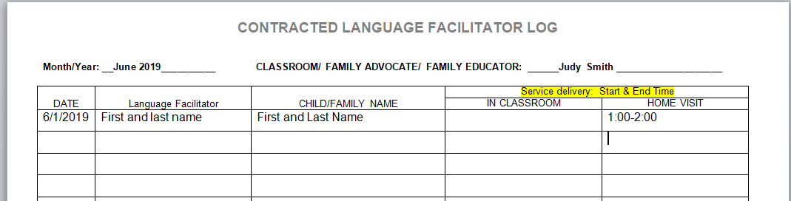

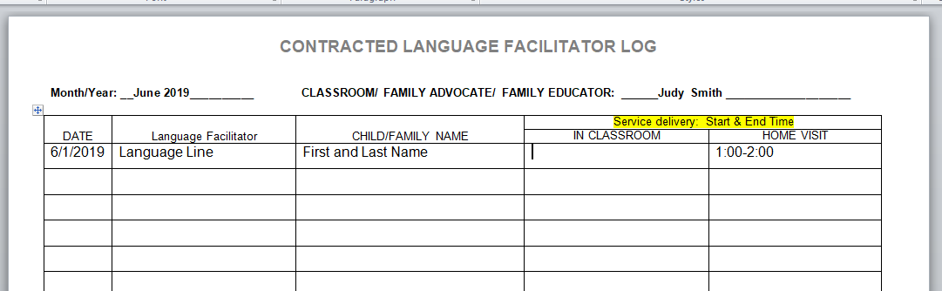

Contaracted Language Facilitator Log

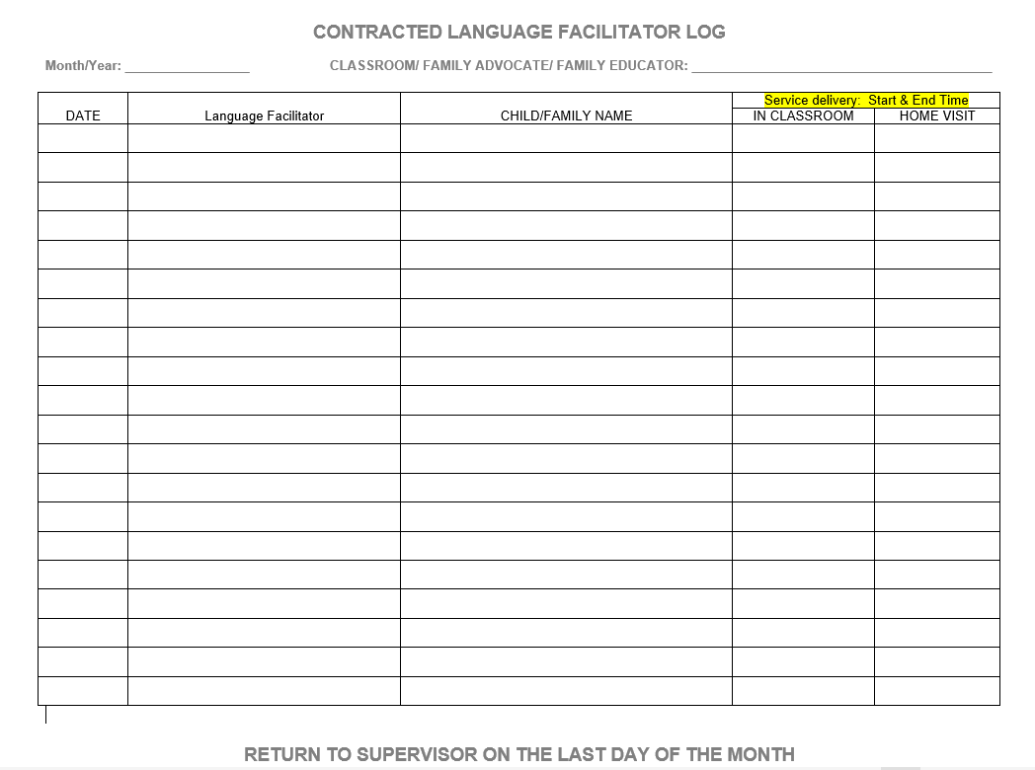

Roles and Responsibilities:
Home Visits
Parent Teacher Conferences
Policy Council
Parent Committee

Home Visits and Parent Teacher Conference Guidance

Teachers: Head Start and Early Head Start teachers are required to make, at minimum, two (2) visits in the home of each child. The first visit is the Initial Home Visit, which is completed prior to the child entering into any of our program options. The second Home Visit is considered a Parent Teacher Conference and is to be completed as part of Fall TSG completion or as part of Winter TSG.

Teachers: In addition, Parent Teacher Conferences happen two (2) times per year for each child and are to take place in a mutually agreed upon location (such as the classroom, the family’s home, the library, etc.) as part of TSG completion.

Advocates: Head Start and Early Head Start family advocates are required to make, at minimum, two (2) home visits per year for each child. The first visit is the Initial Home Visit, which is completed prior to the child entering into any of our program options. The second family services home visit can be completed at any point during the academic school year. Most families will require additional home visits throughout the program year based on the needs of the family and/or at the family’s request. Not all family services need to be provided in the family’s home, however if that is where the family feels the most comfortable and/or if there are complicated needs then additional home visits can take place if needed.

If there is a Teacher and a Family Advocate assigned to a classroom all efforts must be made to schedule Initial Home Visits and subsequent Home Visits at the same time. Please connect with the site supervisor to make arrangements for classroom coverage when needed.

Family Educators: Families who are enrolled in our Home Based program will receive once weekly home visits by a Family Educator. As part of those weekly home visits Family Conferences will take place in the Fall, Winter and Spring as part of TSG completion.

Home Visits and Family Conferences
Full Year
Visit Type/When | What to do
Initial Visits: July-Sept or whenever the child enrolls with the program- Family Advocate & Teachers  - Visits must be done in the family’s home before a child can start. If there is a barrier to doing the initial home visit please contact the Family Services Manager to review options. | Complete initial paperwork (see Initial Home Visit Checklist)- FA  E-cards-FA  Health Passport-FA  Complete Family Outcomes Assessment – FA  Review Parent Handbook- FA  Beginning goal setting (all families must have a goal to maintain subsidy and payment, then a second goal is to be set based on family need)-FA  Discuss the importance of attendance- FA  Review classroom schedule- Teacher  Discuss classroom expectations- Teacher
Family Conference (Parent Teacher Conference)- November- December- Done at center or in Family Home | Review TSG- Teacher  Set educational goal for child- Teacher  E-cards update-FA  Health Passport updates-FA  Kids going to K: Transition Discussion- FA
Family Conference (Parent Teacher Conference)-  February- March (teacher) | Review TSG- Teacher  Review, update and/or change educational goal set for child- Teacher  E-cards update-FA  Health Passport updates-FA
Update Family Goals- January and April  Done at center | Check in with families around goals or create new goals- FA  E-cards update-FA  Health Passport updates-FA
Second Round of Family Outcomes Assessments- FA Home Visit  Start in March and end in May | Complete second round of Family Outcomes Assessments- FA  E-cards update-FA  Health Passport updates-FA  Wrap up goals/help make a summer plan for families around goals- FA
Family Conference (Parent Teacher Conference)-  Teacher Home Visit | Review TSG- Teacher

Home Visits and Family Conferences
Part Day
Visit Type/When | What to do
Initial Visits: July-August or whenever the child enrolls with the program- Family Advocate & Teachers  - Visits must be done in the family’s home before a child can start. If there is a barrier to doing the enrollment visit please contact the Family Services Manager to review options. | Complete initial paperwork- FA  E-cards-FA  Health Passport-FA  Complete Family Outcomes Assessment – FA  Review Parent Handbook- FA  Beginning goal setting (goal is to be set based on family need)-FA  Discuss the importance of attendance- FA  Review classroom schedule- Teacher  Discuss classroom expectations- Teacher
Family Conference (Parent Teacher Conference)- November- December- Done at center or in Family Home | Review TSG- Teacher  Set educational goal for child- Teacher  Kids going to K: Transition Discussion- Teacher  E-cards update-FA  Health Passport updates-FA
Family Conference (Parent Teacher Conference)-  February- March (teacher) | Review TSG- Teacher  Review, update and/or change educational goal set for child- Teacher  E-cards update-FA  Health Passport updates-FA
Update Family Goals- January and April  Done at center | Check in with families around goals or create new goals- FA  E-cards update-FA  Health Passport updates-FA
Second Round of Family Outcomes Assessments- FA Home Visit  Start in March and end in May | Complete second round of Family Outcomes Assessments- FA  E-cards update-FA  Health Passport updates-FA  Wrap up goals/help make a summer plan for families around goals- FA
Family Conference (Parent Teacher Conference)-  Teacher Home Visit | Review TSG- Teacher

Home Visits and Family Conferences
Combo Classroom (these visits are to be documented in Family Services tab and education tab, see below)- Teacher Assistant Family Advocate
Visit Type/When | What to do
Initial Visits: July-August or whenever the child enrolls with the program- TAFA & Teacher  - Visits must be done in the family’s home before a child can start. If there is a barrier to doing the enrollment visit please contact the Family Services Manager to review options. | Complete initial paperwork- TAFA  E-cards-TFA  Health Passport-TFA  Complete Family Outcomes Assessment – TAFA  Review Parent Handbook- TAFA  Beginning goal setting (goal is to be set based on family need)-TAFA  Discuss the importance of attendance- TAFA  Review classroom schedule- Teacher  Discuss classroom expectations- Teacher
Family Conference (Parent Teacher Conference)- November- December- Done at center or in Family Home | Review TSG- Teacher  Set educational goal for child- Teacher  E-cards update-TFA  Health Passport updates-TFA  Kids going to K: Transition Discussion- TAFA
Family Conference (Parent Teacher Conference)-  February- March (teacher) | Review TSG- Teacher  Review, update and/or change educational goal set for child- Teacher  E-cards update-TFA  Health Passport updates-TFA
Update Family Goals- January and April  Done at center | Check in with families around goals or create new goals- TAFA  E-cards update-TFA  Health Passport updates-TFA
Second Round of Family Outcomes Assessments- TAFA Home Visit  Start in March and end in May | Complete second round of Family Outcomes Assessments- TAFA  E-cards update-TFA  Health Passport updates-TFA  Wrap up goals/help make a summer plan for families around goals- TAFA
Family Conference (Parent Teacher Conference)-  Teacher Center Visit | Review TSG- Teacher

Policy Council & Parent Committee Meetings - Part Year / Full Year
Activity | Who does what?
Policy Council  Monthly Policy Council meetings  Policy Council Rep- Center updates | Recruit families- FA & T  Vote for Policy Council Representative- T  Support Policy Council reps as needed- FA
Parent Committee Meetings  Monthly Parent Committee meetings  Policy Council Rep- Policy Council updates | Schedule/plan all committee meetings including open house-T  Create poll / survey for parent education topics-T  Select parent training topic-T  Notify kitchen of meeting date via food request T  Contact Community providers if needed- FA  Document attendance in Child Plus (entry xpress- parent education)- T  Attend all parent groups- T & FA

Title of Procedure or Process: | Scheduling Home Visits
Program Area(s): | Family Services, Health, Education, Special Services
Related Standards or Regulations: | ☒Head Start Program Performance Standards  ☐Maine State Licensing  ☐Developmentally Appropriate Practice/NAEYC  ☐Caring for Children  ☒Other: Best Practice
Person Responsible for implementation: | Family Advocate is the point on scheduling Home Visits, teaching staff are responsible for scheduling center Parent Teacher Conferences.  Please make all efforts to have the teaching staff present at all initial home visits, if that is not able to happen please consult with the site supervisor for approval to complete the teacher portion within 2 weeks of the child entering into the classroom.
Timeline for completion: | Initial Home Visit- Prior to a child attending a classroom or within 2 weeks of the child starting in a public pre k classroom setting with approval from the site supervisor.  2nd Home Visit- see the Family Services Monitoring Plan and the Education Monitoring Plan for a timeline.
Submitted to: | N/A
ChildPlus Documentation: | Initial Home Visits are documented in 2 areas.  Family Advocates document in Family Services Events and Teachers Document in Education Events.  2nd Home Visits are documented in the Education Events by the teacher, Family Services Events are documented by the Family Advocates
Uploaded to ChildPlus: | N/A
Specific Directions: | See Below
Procedure:
- Share Outlook Calendars (Teachers and Family Advocates and Site Supervisors)
  - Make sure that your calendar is consistently up to date; Request Sub Calendar
- Family Advocates are the point on scheduling home visits (Parent Teacher Conferences at the center are to be scheduled by teachers)
- All efforts should be made to have teaching staff be present at initial home visits as they are required to complete an initial home visit. If teaching staff are not able to be present please seek out approval from the site supervisor for the teacher to complete their home visit within 2 weeks of the child being enrolled in the classroom.
How to schedule home visits?
- Family Advocates will look at each calendar for those who are required to attend (including sub calendar)
- The Family Advocate will outreach to staff via email with a cc to the site supervisor to determine what days and times are the best for home visits. The Family Advocate will ask about what is happening on the week of scheduling (trainings, subbing, staffing coverage, etc.), if there are any trainings or subbing happening, please connect with the site supervisor to see if there is any way to free a teacher up to do a visit.
  - If there is an urgent need for a Home Visit, such as to maintain/obtain a subsidy or if there is a need from an enrollment perspective, please access the site supervisor to help with scheduling if there is a concern.
- The Family Advocate will use their schedule and teachers schedules to outreach to a Language Facilitator if needed to see their availability prior to contacting the family.
- The Family Advocate will contact the family with the schedule of open times, if the family is not able to participate in a visit during the open time frames the Family Advocate will relook at schedules with the parent’s availability.
- The Family Advocate will document the scheduling attempts in the Family Services Events and the Teachers will document the completion if the Home Visits in the Education Events. Scheduling attempts are logged under Family Services Events.

Title of Procedure or Process: | Home Visiting Safety
Program Area(s): | Health, Nutrition, Education, Special Services, Family Services, ERSEA, etc.
Related Standards or Regulations: | ☒Head Start Program Performance Standards  ☐Maine State Licensing  ☐Developmentally Appropriate Practice/NAEYC  ☐Caring for Children  ☒Other: Best Practice
Person Responsible for implementation: | All Staff
Timeline for completion: | Ongoing
Submitted to: | N/A
ChildPlus Documentation: | N/A
Uploaded to ChildPlus: | N/A
Specific Directions: | Your safety on a home visit is of the upmost importance, please follow the guidance below to ensure your continued safety while participating on home visits
Procedure:
Always wear your agency or public school issued badge
Use your Outlook Calendar to inform co-workers & supervisor of your scheduled home visit/start and end time; please use the format below:

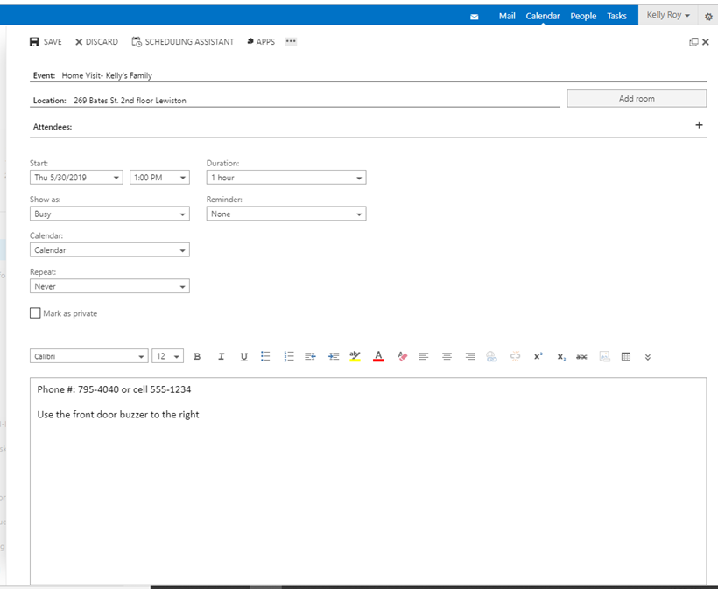

If your home visit takes place or ends after 4:30pm please notify your supervisor that you have safely completed the visit.

Limit the amount of items that you bring on home visits, for home based going bag-less (notebook or folder and a pen) and using what is in the home is the best way to go and if you are a teacher or a family advocate please bring only a notebook or folder and a pen. Please bring 2 blank releases.

If home visit presents significant safety risk consider have a co-worker call you 10-15 minutes into your visit on your agency cell phone, if you do not have an agency cell phone please work with your supervisor to create a plan. Another thing to consider is to work with your supervisor to identify an alternate location for visiting with the family or take along a coworker or arrange joint visits with staff from other agencies.
Be aware of the areas in the neighborhood where help could be obtained if an emergency arises.

Ensure that your vehicle is in good working order and has enough gas, park on the street whenever possible and if a driveway is the only option, consider backing in and asking the family where a good place to park would be so you are not blocked in (in the event of inclement weather or during mud season call ahead to ask the status of the driveway).

Take precaution around pets- ask the family in advance about pets by phone and ask them to secure the pets before arrival.

Do not enter the yard/home when there threats are present such as violence in progress, unsecured vicious animals, parent/others are intoxicated or under the influence of substances and there is no quick escape.

Limit valuables, credit cards or money on your person when visiting homes of the families. Leave valuables at home or place in the trunk of your car before leaving the office. Do not attempt to place valuable items in the trunk of your parked car for a visit.

Keep your vehicle locked at all times when you are on a home visit. Check around, inside and under your vehicle before entering it. Carry vehicle keys in your hand or close by for accessibility. Do not linger to make phone calls or notes, leave immediately.

Carefully consider your safety before entering a home, listen to your instincts and feelings. Be aware of smells associated with illegal substance use. While marijuana and tobacco are legal we will want to ensure families know the risk of smoking, second hand smoke and third hand smoke and how to properly store their smoking paraphernalia and marijuana edibles.

If you believe your safety is threatened, politely remove yourself immediately from the situation. Contact the main office and 911 if necessary.

If you anticipate crisis situations and practice sound listening and deescalating skills, you will be able to diffuse most crises and deliver services without jeopardizing your safety or that of the family.

Maintain appropriate appearance and grooming in order to project an image of a clean and neat professional. Keep jewelry to a minimum and wear comfortable shoes with low or no heels. Ask a family when you arrive if they would like you to take your shoes off, consider bringing socks if being barefoot is uncomfortable to you.

Know the physical layout of the place you are visiting, ask the family for a tour. Keep the door in sight during the visit. Identify locations where other people may be present, ask to be introduced to others who are in the home.
- Ask the family about weapons, if there are fire arms for example ask how they are secured

Set the tone for the professional relationship by clearly defining inter personal boundaries between you and family being visited. Limit how much personal information you share.
When you arrive at the home visit do not wait in your car, use a public parking lot or parking area.
Utilize the restroom in a public location, not in a family’s home.
Wash your hands at the end of each home visit as soon as you are able, but always before the next home visit.

Title of Procedure or Process: | Family Services Initial Home Visits (See Education Section for Educational Home Visits)
Program Area(s): | Family Services, Health, Education, Special Services
Related Standards or Regulations: | ☒Head Start Program Performance Standards  ☒Maine State Licensing  ☐Developmentally Appropriate Practice/NAEYC  ☐Caring for Children  ☐Other
Person Responsible for implementation: | Staff with family services responsibilities
Timeline for completion: | Prior to the child attending or at the latest within 2 weeks of attending
Submitted to: | N/A
ChildPlus Documentation: | Family Services Events- Initial Home Visit (this is the event that you document each attempt you made to connect with a family to schedule the IHV)
Uploaded to ChildPlus: | See below. All items should be uploaded within 24 hours of visit completion, if the visit takes place on a Friday afternoon please upload first thing Monday morning
Specific Directions: | See below
Procedure:
Prior to the initial home visit:
- Review the child’s files- paper and electronic
  - Pay careful attention to the Application Tab in ChildPlus, click on each Parent’s Name and scroll down to see if their Highest Level of Education and Employment Status at Enrollment are complete, if they are not you MUST ask them for that information and enter it in to ChildPlus.
- Create an Initial Home Visit Event in Family Services- document all contacts with the family in the action steps that are related to the Initial Home Visit
- After review of the file contact the family to schedule the visit
  - If a family refuses to participate in the initial home visit process please consult with your site supervisor to create a plan for the completion of this visit
- Please make all attempts to schedule the visits with classroom teaching staff
- Add center information to the Parent Handbook
- Print out Initial Home Visits Forms from the Staff Forms Website- Initial Home Visit Folder
- Extended Care Classrooms Only: Print off parent contract and CDBG forms
During the initial home visit (the order of completion does not matter):
- Review emergency card and permission for services with the family, make changes if needed
- Review and update all medical releases, dental releases, social service provider release, etc
  - Ask about what other service providers are working with the family, DHHS, Safe Voices, Case Manager, BHH, etc. obtain releases for these providers, upload all releases in the appropriate sections.
  - If the family is referred to us by a substance abuse program please ask the family about the types of supports they are receiving (medically assisted-Methadone, Suboxone, Subutex, Intensive Outpatient Program, Drug Court, etc.)
- Complete Health and Nutrition Questionnaire if not completed- enter the information into the Enrollment Section, this must be entered in to ChildPlus before a child attends any programming, if this is not able to happen please contact the Health Manger for guidance.
- If needed complete the dietary restriction form, please send to all at bottom of form and upload to health attachments
- Complete the CACFP enrollment form (Connors and Spruce Mountain complete public school paperwork), send the original to CACFP Coordinator and upload the form in the health attachments
- Review Parent Handbook, have family sign off that they have received the book, upload the signature page to the family services attachments
- Review Attendance Policies
- Have the families sign the Parent/Staff Agreement forms, upload to the family services attachments
- Review and have families sign the confidentiality agreement, upload to the family services attachments
- Complete the Family Wellness Profile using the Family Wellness Profile Discussion Guide, enter the information in the family outcomes assessment tab, upload discussion guide to family services attachments
- Use the Home Emergency and Safety Checklist as a conversational tool to obtain information not gathered throughout the Family Wellness Profile and Parent/Staff Agreements, complete the checklist after the Initial Home Visit and upload in the health attachments
- Complete Family Circles Activity, upload to family services attachments. If for some reason you are not able to complete the Family Circles Activity please schedule a time to complete with the family within 1 month of the child starting in one of our programs.
- Complete the Family Development Plan for goal setting with families (if this is an extended care family there should always be a goal to maintain their subsidy), upload completed plan sheet to family services attachments. If for some reason you are not able to complete the Family Development Plan please schedule a time to complete with the family within 1 month of the child starting in one of our programs.

Title of Procedure or Process: | Emergency Card
Program Area(s): | Health, Nutrition, Education, Special Services, Family Services, ERSEA
Related Standards or Regulations: | ☐Head Start Program Performance Standards  ☒Maine State Licensing  ☐Developmentally Appropriate Practice/NAEYC  ☐Caring for Children  ☐Other
Person Responsible for implementation: | Staff with family services responsibilities and/or teachers if family services staff are not available
Timeline for completion: | Ongoing
Submitted to: | N/A
ChildPlus Documentation: | Click the blue Family Information Tab to enter in Emergency Contacts, scroll down to the bottom of the Family Information screen until you see the colored line that says Emergency Contacts and Release Authorizations click Add Contact to enter in the information within 24 hours.  Updates are entered under Family Services Events; Emergency Card Update- document attempts made to update and that the card was update.
Uploaded to ChildPlus: | N/A
Specific Directions: | See Below for completion guidance.  As of July 1st 2021, we will be using CP report 1520 as our emergency card.  If an emergency card is on the old form, please transfer contacts to the new form when doing initial home visits.
Procedure:
The following must be included on a child’s emergency card as part of the child’s record:
A record must be completed at the time of admission and maintained by the Child Care Facility on each child in care and must include per Maine State Licensing:
- Name, birth date, street address and mailing address of the child;
- Name, street address, mailing address and telephone number of parent(s) or legal guardian(s);
- Places of employment of parent(s) or legal guardian(s), if employed;
- The telephone number and street address and mailing address of parent(s)’ or legal guardian(s)’ employers;
- A method of contacting the parent(s) or legal guardian(s) while the child is in care;
- The name, street address and telephone number of a person other than the parent(s) or legal guardian(s) to contact in case the parent(s) cannot be reached in an emergency;
- Names, addresses and telephone numbers of the child's physician and dentist, if available;
- Names of persons, street address and telephone number of those who are permitted by the parent(s) or legal guardian(s) to remove the child from the facility;
- Promise also asks that families share their home language and if an interpreter is needed to assist in accurate communication that can be done in a timely manner
- Medical Insurance Information must be obtained at the time of completion and must be reviewed at each check in (Parent Teacher Conferences, Family Services Goal Check Ins, with each ecard update, etc.)

Emergency cards are completed as part of the application process and are to be updated during the initial home visit and throughout the year. Enter in Emergency Contacts to ChildPlus in the Blue Family Information section within 24 hours of obtaining that information.
Should the emergency card not be completed during the application meeting, it MUST be completed on the initial home visit. All areas (PCP, Dentist, current medications, allergies, and MaineCare #) must be completed/reviewed.

Updating E- Cards

Emergency cards are to be updated minimally at each visit with the family (Home Visit, Parent Teacher Conferences); for Home Based, the emergency cards are to be updated at the Educational Visit (TSG) at a minimum. When updating emergency cards please cross out old information with 1 pen line and write in corrected information. New information / changes should be updated in CP within 24 hours and a new emergency card should be printed after any change.

- Parent (s) or legal guardian(s) can edit or amend emergency card at any point in time.

Emergency Contacts

- # of Contacts. The emergency card indicates 2 additional contacts beyond the parent(s) or legal guardian(s)., this is the absolute minimum (more is a strong preference); it is the expectation that we encourage families to think of additional individuals beyond the 2 additional contacts.
  - Ask questions such as:
                - Is there anyone else you can think of who could pick up your child if none of the names listed above are able to make it?
    - Do you have a friend, family (or extended family) member or neighbor who we could outreach to if we are not able to connect with the others mentioned above? Who cares your child when they are not with you, is that someone we could add to the emergency card?

- No Photo ID. If an authorized individual is too young to have a photo ID please take a photo of that individual with the classroom iPad and send to Administrative Assistant for printing, the photo is to be attached to the emergency card.

- Outside Transportation Provider. If parent has coordinated transportation for their child from a provider (i.e., Western Maine Transportation, Bill Gordons) please document in ChildPlus (Family Services - Emergency Card Update) and add provider to the Emergency Card. On sign-in/out sheet provider needs to be noted daily.

- If a family calls to send someone not on the emergency card to pick up a child, you must first ask if you can outreach to someone else on the emergency card on behalf of the family. Have the family give you the person’s name and contact information (phone number); remind the family that we will need photo identification, inform your site supervisor of the situation prior to pick up, they will outreach to leadership for guidance if needed. Inform the family that at the next drop off or pick up they will want to add this person to the emergency card (name, phone number, address). This conversation should be documented in Family Services Events Emergency Card Update. This documentation should include the name of the parent as well as the name / contact of the new individual picking up the child and if this is a onetime pick up or if this person is to be added to the emergency card.

- Unable to obtain addresses. If we have made 4 documented attempts in ChildPlus (Family Services Events- Emergency Card Update) to obtain addresses for emergency contacts, please put Unknown- See ChildPlus on that line. Unknowns MUST be supported with ChildPlus documentation.

- Custody / Court Orders. If there are any custody situations or court orders, please indicate on the emergency card, attach a copy to the emergency card, and scan the court document to ChildPlus then email the Family Services Manager that it has been uploaded.

- Unable to contact Emergency Contact. If there is an emergency and nobody on the emergency card can be reached please outreach to a member of the Leadership team (Family Services Manager, Education and Child Development Manager, Program Specialist, Operations and Special Services Manager, Health and Nutrition Manager) or the Executive Director if a member of the leadership team is not available for guidance.

Title of Procedure or Process: | Child Care Fees and Core Hours: Extended Care Classrooms ONLY
Program Area(s): | Family Services
Related Standards or Regulations: | ☐Head Start Program Performance Standards  ☐Maine State Licensing  ☐Developmentally Appropriate Practice/NAEYC  ☐Caring for Children  ☒Other: Subsidy Contracts
Person Responsible for implementation: | Staff with Family Services Responsibilities, Extended Care Classroom Teaching Staff, Fiscal Department, Family Services Manager
Timeline for completion:
Submitted to:
ChildPlus Documentation: | Family Services Events, choose the Subsidy Event type, create actions to document any conversations with families and/or subsidy providers (do not put monetary amounts
Uploaded to ChildPlus:
Specific Directions:
Procedure:
Promise provides extended care, before and after the Head Start/Early Head Start day, for children from low wage earning families who are employed or in school with subsidized support from the following:
- Child Care Voucher/DHHS or Transitional Child Care or ASPIRE/FedCap
- Private Payment- 2018 Maine Child Care Market Rates:
Age | Per Week | Per Month
Infant | $215 | $860 (4 weeks)
Toddler | $200 | $800 (4 weeks)
Preschool | $165 | $660 (4 weeks)
Extended Care Families will all have goals developed around maintaining CCSP Vouchers, ASPIRE/FEDCAP, Transitional, Vocational or Career Center, etc. subsidies and maintaining parent fees. Be sure to note the expiration and renewal date of subsidy and be sure to check in with families about a month before the expiration or renewal date. Also be sure to get the contact information of who is providing the subsidy for follow up if needed. Contact must be made with ASPIRE/Career Center workers for example to ensure that staff understand what is expected of families so they are not in danger at any time of losing their funding.

- Parents must review and sign Extended Care Parent Agreement and sign the Parent Contract generated by the Fiscal Office.

- Parent fees must be received by our fiscal office the week prior to extended care services.

- Payment drop boxes are located at Coburn in the front lobby and at Webster in the common area outside of the classrooms. Please contact the fiscal office if there are questions around fees or payments.

- Should a family become behind on fees, please refer to the Core Hours Procedure for more information.

Non-Disclosure of Financial Information: When developing written goals around payment of child care fees, no financial information should be disclosed. This is private, protected information and no one but the parent and Head Start staff have the right to view this information. When writing a goal around a payment plan for fees, the date that payments are due is the only information that should be included on the goal sheet. No monetary amounts should be noted in ChildPlus contact notes. Fiscal staff will provide training for all full day staff on ways to support families to pay child care fees

Voucher, Transitional and ASPIRE
The contract process is as follows:
- Finance Department sends contract to Family Service personnel for parent signature.
- Family Service personnel informs parent of fee, if indicated, and obtains parent signature. Payment is required prior to child’s starting. Contract with original signature is sent to Finance. Family Service staff keeps a copy for child’s file.
- At this time the termination date is known to Family Service personnel…the development of family goal with identified strategies and timeline for maintaining subsidy and ensuring continuation of HS/EHS services occurs at this time (i.e. one month prior to termination parent needs to connect with subsidy program).
- In child’s Child Plus Family Services section, please make an Event titled Subsidy and within that Event, Family Service Personnel will document case worker’s name and contact information in the event notes section
- Contact the Subsidy Provider to introduce yourself and ensure that you understand how to support this family based on their individual case
- Extended care fees are required to be paid before child starts and are due a week in advance (Friday for the following week). Payment made at Coburn 269 Bates Street, Lewiston, in cash, check or money order or at Webster 48 Webster St. Auburn. If weekly payments are not the best option for the family, an alternative payment schedule can be established by speaking with Finance.
- Family Service staff generates an Enrollment Activity Sheet with child’s actual start and sends to staff listed on form.
As the contract expiration date approaches for all subsidy programs, the following is expected:
- Voucher - one month prior to expiration Family Service personnel will meet with parent to support parent’s outreach regarding contract continuation. If documentation not received by State parent will receive termination letter…agency cc’d.
- ASPIRE – one month prior to expiration date family service personnel will work with parent to support meeting or paperwork with ASPIRE worker to continue services.
Contracts are all signed by parents and clearly state that fees are to be paid in full and in advance (one week prior to services being delivered).

All communication between Family Service personnel and parents regarding fee payments is to be documented under the Subsidy Event in the Family Services Tab in ChildPlus. When Extended Care Services are terminated for non-payment of fees, it is important for Family Service personnel to support children’s transition as availability allows into part-year options or home-based services.

Provider Agreement
Late pick-up policy:
- After 5 minutes past closing time (5:30pm), staff will call parent/guardian/caregiver. If unsuccessful and the parent/guardian/caregiver has not called, the identified emergency contacts will be called.
- After 30 minutes, if direct service staff has not heard from the parent/guardian/caregiver or anyone on the emergency card they will notify their site supervisor or a member of the leadership team if their site supervisor is not reachable. Law enforcement will be called to do a Wellness Check, they will ask for the family’s address and/or work address.
- In full day classrooms, a late pick up fee will be assessed: $10 for the first 10 minutes and $5 for each additional 5 minutes. Please notify the fiscal office of late pick-ups and they will generate a late fee letter.
- After 3 late pick-ups Family Services staff will meet with the family to create a goal around picking up on time.
Storm Days:
Full day classrooms rarely close due to inclement weather. Please follow agency guidance around where to access storm closure information, the guidance is sent out via a letter in the late Fall.
Extended Vacation Requests:
If a family plans to take a vacation that will be 2 weeks or longer, this request must be presented to the Family Services manager for approval. The Family Services Manager will review the request with the Selection Committee and will inform you of the decision via email
Maternity/Paternity Leave:
The agency will honor the current award letter for a child whose parent is on maternity or paternity leave for up to 8 weeks per DHHS child care subsidy rules, please contact the fiscal office for information on this matter
2 weeks’ notice:
If a family leaves our program and would like to access their subsidy at another child care they must give their subsidy provider a 2 week written notice in order for the subsidy to transfer to another child care (their balance must also be paid in full)
Returning to Promise after leaving:
If a family wants to return to Promise after leaving our program they must complete the enrollment process again and be placed on the waitlist. Their balance must be paid in full before they will be considered for re-enrollment.

Promise Early Education Center Core Hours Procedure
Loss of Subsidy
- Upon notification of lost subsidy either by parent or provider child will be moved child to core hours.
  - Classroom staff will immediately notify Finance AP/AR Coordinator who will inform Family Services Manager.
- Family Advocate or Teacher/Family Advocate will communicate and support family (complete steps for application if needed) in attempt to get reinstatement of subsidy or if possible another form of subsidy as appropriate.
- Should the family not be able to re-obtain a subsidy Teacher will complete transfer request to a Part Day or Home Based program option.
  - Transfer request to be put in place by teachers 1 week after notification of loss of subsidy.
Lack of Payment with regard to Parent Fees though Subsidy Maintained
- If the family maintains their subsidy however has fallen behind on their parent fees we will continue to keep the child/children here for full hours.
- Parents to be notified by Family Advocate (Teacher in the absence of FA) that the lack of payment of parent fees is reported to the subsidy provider and places them in jeopardy of losing subsidy and not being able to take their subsidy elsewhere or return to us until the balance is paid in full.
- Communication will be had with the family regarding payment agreements (Fiscal and/or Family Advocates can establish payment agreement).
  - Family Advocate (Teacher in absence of Family Advocate): payment agreements will be typed by Finance and e-mailed to staff for signature (original to be sent to Finance).
  - AR/AP Coordinator: will email payment agreement to staff for signature (original returned to Finance).
Lack of Parent Fee Payment for families (HS Eligible) with a Subsidy
- If the family accumulates $200.00 in past due fees, Finance AP/AR Coordinator will generate a “Core Hours” letter giving family 2 additional weeks to make a payment.
- Family Advocate will provide letter to family and explain core hours.
- A child on “core hours” may attend between the hours of 8:30-2:30. The parent does not accumulate new fees while on core hours and is expected to use this time to catch up on back fees during this time.
  - Discuss remaining balance and need for balance to be paid off prior to transitioning subsidy elsewhere.
- If after 2 weeks ( the end of core hours) the parents are not caught up on fees, the case will be referred to Family Services Manager. Information on next steps will be forward to classroom and family services personnel from Administration.
Parent Notification of Core Hours Procedure
- Parents are notified by Enrollment at application visit.
- Teacher/Family Service personnel will inform families at initial home visit.
- Parents receive letter from Finance when payment not received.

Title of Procedure or Process: | Parent Handbook
Program Area(s): | Family Services, Health, Education, Special Services
Related Standards or Regulations: | ☐Head Start Program Performance Standards  ☒Maine State Licensing  ☐Developmentally Appropriate Practice/NAEYC  ☐Caring for Children  ☒Other
Person Responsible for implementation: | Family Advocate and Teachers
Timeline for completion: | Initial Home Visit and/or Open House
Submitted to: | N/A
ChildPlus Documentation: | Family Services Events- Initial Home Visit- Action should read something like “completed initial home visit paperwork”
Uploaded to ChildPlus: | Upload the signed receipt of handbook to the family services attachments
Specific Directions: | See Below
Procedure:
The following are areas of the Parent Handbook that need to be covered at the initial home visit and/or open house. Please keep conversations brief; 1-2 minutes per topic, we can spend more times on areas as we get to know families.
Family Advocates:
- Attendance
- Mandated Reporting
- Confidentiality
- Health
  - When is too sick to come to school?; Doctor’s notes- when are they needed
  - Medical/Dental services that are tracked
- Extended Care Classrooms Only
  - Late Fees
  - Subsidy/Fees
- Transition Process
- Parent Code of Conduct (no weapons, no smoking on our property, etc.)
- Grievance Policy
- Child Release Policy

Teachers:
- Classroom Schedule
- Agency Calendar- make sure you have the correct one for the specific center/classroom
- Meals/Snacks- no outside food
- Inclement Weather
- Appropriate Clothing (cover again at Open House)
- Daily Sign in and Sign Out
- Rest time (if applicable)

Title of Procedure or Process: | Child found unattended on Home Visit
Program Area(s): | Family Services
Related Standards or Regulations: | ☐Head Start Program Performance Standards  ☐Maine State Licensing  ☐Developmentally Appropriate Practice/NAEYC  ☐Caring for Children  ☒Other- Mandated Reporting
Person Responsible for implementation: | All Staff
Timeline for completion: | Immediately
Submitted to: | N/A
ChildPlus Documentation: | Family Services Events, DHHS Referral, the Description is to say Unattended Child, open an Action to document the DHHS referral being made
Uploaded to ChildPlus: | DHHS Report Uploaded to Family Service Attachments
Specific Directions: | Please see below

Procedure:
When entering a family’s home and discovering a child to be unattended by his or her parent or guardian or care taker please adhere to the following procedure:
- Yell the adults name to see if they are in another room or sleeping
  - Stay in the apartment or home
- Attempt to call the family
  - If there is not interpreter attempt to call anyway
- Contact local law enforcement via 911
  - Explain to 911 the reason you are in the home and why you are calling them
  - They will ask for the address and apartment number, they will ask the name of the parents as well
  - 911 will typically ask if the family needs an interpreter, we can use agency Language Facilitator or Contracted Language Facilitator
- Call 795-4040 X 0 and ask for a member of the leadership team
  - If you need someone with you please give the address and how to enter the home if there are multiple doors or if it is a secure building
- Upon returning to the office a DHHS report is to be made following the mandated reporter procedures

Title of Procedure or Process: | Family Partnership Agreement (FPA)
Program Area(s): | Family Services
Related Standards or Regulations: | ☒Head Start Program Performance Standards  ☐Maine State Licensing  ☐Developmentally Appropriate Practice/NAEYC  ☐Caring for Children  ☒Other: Family Development Credential
Person Responsible for implementation: | Staff with family services responsibilities
Timeline for completion: | Ongoing
Submitted to: | N/A
ChildPlus Documentation: | Family Outcomes Assessment Tab, Family Goal Event
Uploaded to ChildPlus: | Family Development Plan forms uploaded to Family Services Attachments
Specific Directions: | Family Goals must impact a family’s self-sufficiency, such as but not limited to the following areas: Food Security, Housing, Employment & Income, Transportation, Financial Management, Education/Skill Development, Family Health & Physical Well-Being, Family Engagement in the community, Child Care
Procedure:
The purpose of the Family Partnership Agreement (FPA) is to assess the goals and needs of families enrolled in the program and reinforces Parent, Family and Community Engagement Framework. The FPA is family driven and designed to help families become more self-sufficient. Although voluntary, all enrolled families are strongly encouraged to participate (if a family does not want to participate please contact your site supervisor for assistance). This is a valuable way for families to engage in program activities, become more aware of community resources, achieve self-sufficiency and foster the need for families to become advocates for their children.
- The FPA starts with the completion of the Family Wellness Profile (Family Outcomes Assessment in ChildPlus) during the initial home visit process. The Family Wellness Profile is to be completed with the family by utilizing the Family Wellness Profile Discussion Guidance. By completing the tool at the initial home visit we will have a better idea of the strengths and needs of the families that we serve and how to best support them in the coming school year. At this visit you will also work to set family goals using the Family Success Plan (second step in the FPA process). A second Family Wellness Profile is to be completed prior to the family completing a program year.
- Goal setting is the second step in the FPA process and can be scary for a family and/or often families choose large goals to meet. It is helpful to talk with the family and to choose small steps towards big goals. For instance, if a family is interested in going to college, it might be helpful to start with a small goal of checking out schools. Goals can also be simple and should be what the family wants, in their own words. Some families want to spend more time with their children and others want to make more money. Goals can be developed from needs, wants or wishes, hopes or dreams identified during the completion of the Family Wellness Profile. If a family is struggling to identify a goal you may suggest, drawing on the information already provided. Please use the Family Success Plan that is found in the Family Services section on the Staff Forms Website
Goals will be reviewed and updated per the schedule on the Family Services Monitoring Plan and a second Family Wellness Profile will also be completed per the Family Services Monitoring Plan Schedule. Progress will be monitored via ChildPlus Family Goal Events and though the Actions within those events.
*When a family identifies an area of need or challenge you must provide the family with information, resources (see Family Referral section). Following up with the family in a week or two after the resource is given is a great way to track the family’s progress and/or offer support to the family in outreaching to the resource.
Title of Form: | Family Wellness Profile and Family Wellness Profile Discussion Guide
Related Policy: | Family Partnership Agreement
Program Area(s): | Health, Nutrition, Education, Special Services, Family Services, ERSEA, etc.
Related Standards or Regulations: | ☒Head Start Program Performance Standards  ☐Maine State Licensing  ☐Developmentally Appropriate Practice/NAEYC  ☐Caring for Children  ☐Other
Procedures
Form Completed By: | Staff with Family Services Responsibilities
Timeline for completion: | As part of Initial Home Visit Process and a second Wellness Profile that is to be completed starting in March and wrapping up at the end of the school year
Specific Directions: | Family Wellness Profile Discussion Guide can be found on the Staff Forms Website in the Family Services section. Use the Family Wellness Profile Discussion Guide as part of the Initial Home Visit process, the tool gives you questions and a place to jot down notes from the visits so you are better able to complete the Family Wellness Profile in ChildPlus.
Submitted to: | N/A
ChildPlus Documentation: | Family Services Section, Outcomes Assessment Tab- See ChildPlus section for more entry information.
Uploaded to ChildPlus: | N/A

What does the Family Wellness Profile look like in ChildPlus?
(Report # 4210- Family Outcomes- Assessment Worksheet)

Discussion guide used on home visits

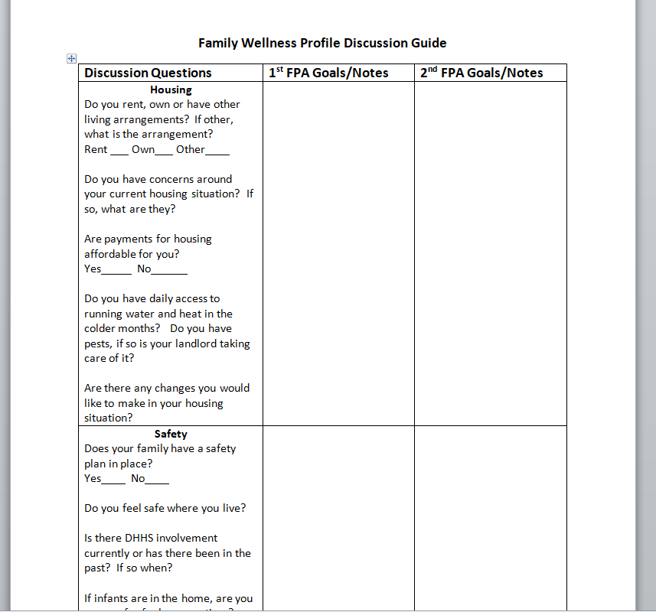

.
.

Title of Form: | Family Circles Activity
Related Policy: | Family Partnership Agreement Process
Program Area(s): | Health, Nutrition, Education, Special Services, Family Services, ERSEA, etc.
Related Standards or Regulations: | ☒Head Start Program Performance Standards  ☐Maine State Licensing  ☐Developmentally Appropriate Practice/NAEYC  ☐Caring for Children  ☒Other: Family Partnership Agreement Process
Procedures
Form Completed By: | Staff with Family Services Responsibilities
Timeline for completion: | Initial Home Visit and at the second Family Wellness Profile visit
Specific Directions: | The Family Circles Activity can be found on the Staff Forms Website, in the Family Services Section. The Family Circles Activity will help a family to identify their stressors and supports in their lives. Staff will support a family in completing the circles activity by reading or describing the description of each category and allowing the family to write names of people or words that apply to the strengths, stressors or supports that fit within each circle in their life at the current moment. Should a family not want to write staff can complete the circles with the words or people that are shared during this conversation. If a family struggles to fill in a circle please move on to another one or provide the family some examples.
Submitted to: | N/A
ChildPlus Documentation: | Document family services initial home visit as a Family Services Event, please reference the completion of paper work in the action notes (example, initial home visit paper work completed)
Uploaded to ChildPlus: | Family Services Attachments

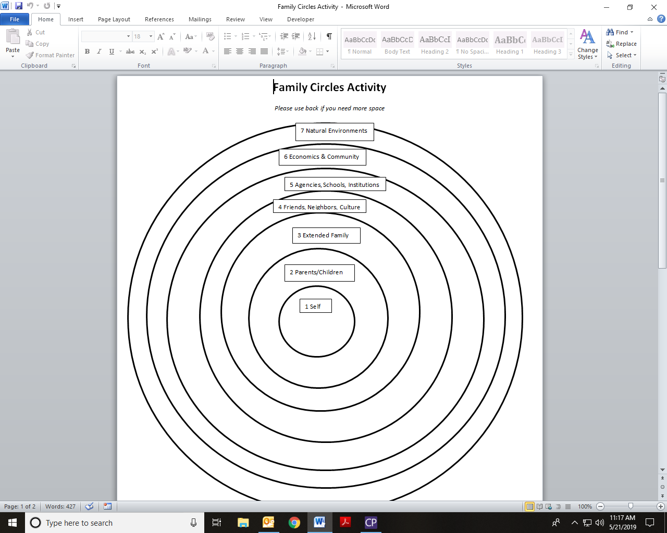

Title of Form: | Family Development Plan
Related Policy: | Family Partnership Agreement
Program Area(s): | Health, Nutrition, Education, Special Services, Family Services, ERSEA, etc.
Related Standards or Regulations: | ☒Head Start Program Performance Standards  ☐Maine State Licensing  ☐Developmentally Appropriate Practice/NAEYC  ☐Caring for Children  ☒Other: Family Partnership Agreement
Procedures
Form Completed By: | Staff with Family Services Responsibilities
Timeline for completion: | Completed as part of initial home visit process, reviewed and updated in November, January and April
Specific Directions: | Family Development Plan can be found on the Staff Forms Website, in the Family Services Section. Ask the family if they want to fill out the form or prefer you to complete. If you complete, be sure to use their words. If the family member wants you to do the writing, read out loud what you have written. Let the family define whom they consider family members, please note ages and gender. Ask them for any corrections, and make the corrections they request on all the sections except “in the worker’s words”. Give a copy to the family member, and keep a copy in your file. Each of you should review the form before your next meeting, to make sure you’ve each taken the steps you agreed on. Begin your next meeting by reviewing the last plan.  Goals should be focused around self-sufficiency: Food Security, Housing, Employment & Income, Transportation, Financial Management, Education/Skill Development, Family Health & Physical Well-Being, Family Engagement in the community, Child Care
Submitted to: | N/A
ChildPlus Documentation: | Family Services Section, Events, Family Goal (each goal is its own event), please utilize the Description section to indicate what the goal is… examples include housing, driver’s license, GED, Employment, etc.
Uploaded to ChildPlus: | Family Services Attachment- uploaded within 1 week of completion of document

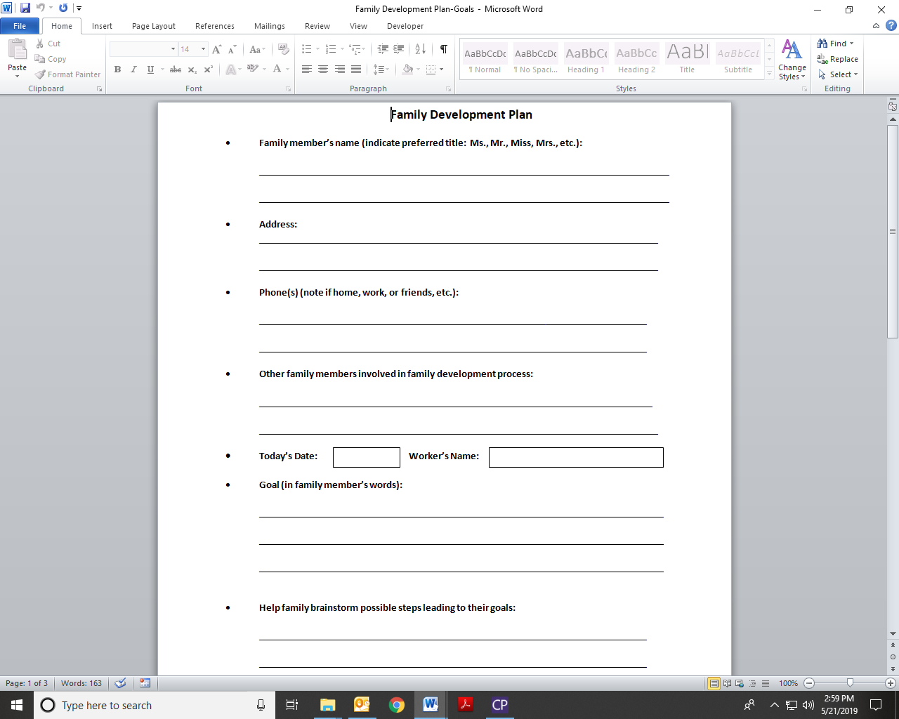
Title of Form: | Home Emergency and Safety Checklist
Related Policy: | Family Engagement- Parent Group
Program Area(s): | Family Services, Health
Related Standards or Regulations: | ☒Head Start Program Performance Standards  ☐Maine State Licensing  ☐Developmentally Appropriate Practice/NAEYC  ☐Caring for Children  ☒Other
Procedures
Form Completed By: | Staff with family services responsibilities
Timeline for completion: | As part of initial home visit process
Specific Directions: | This checklist is to be completed during the initial home visit or within 2 weeks of the child entering in to our program. The goal of this tool is to provide families with some home health and safety education; if there are things that the family needs to work on they can be addressed as goals. As an agency we will not be providing families with items that are missing but we can work with a family to identify ways to access the missing items. The checklist must be updated during your second home visit with a family. This form can be found in the Initial Home Visit folder on the staff forms website.
Submitted to: | N/A
ChildPlus Documentation: | Document completion in the Family Services Initial Home Visit event in an Action step and example of how to document is “completed Home Emergency and Safety Checklist”
Uploaded to ChildPlus: | Upload to Health Attachments

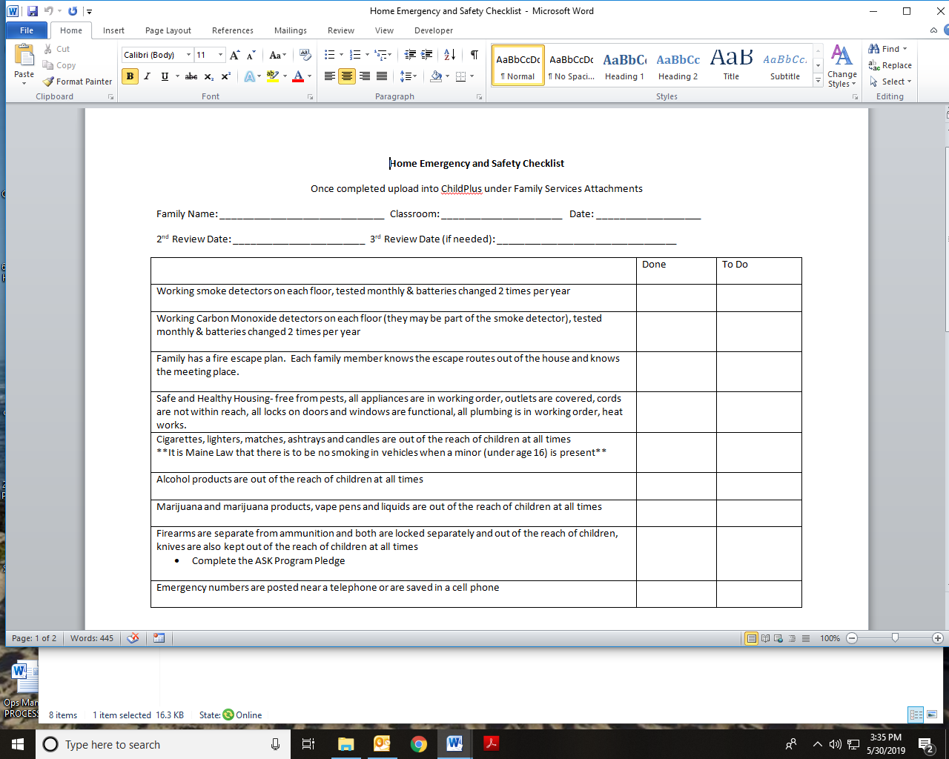

Title of Procedure or Process: | DHHS Involvement and Interviews
Program Area(s): | Family Services, Health, Education, Special Services
Related Standards or Regulations: | ☐Head Start Program Performance Standards  ☐Maine State Licensing  ☐Developmentally Appropriate Practice/NAEYC  ☐Caring for Children  ☐Other
Person Responsible for implementation: | Teachers, Family Advocates, Site Supervisors, Leadership
Timeline for completion: | Ongoing
Submitted to: | N/A
ChildPlus Documentation: | Family Services- DHHS Involvement Event, in Event Notes please put the name and phone number of the DHHS worker ONLY  Create an Action for each step that is
Uploaded to ChildPlus: | Releases- Family Services Attachments
Specific Directions: | See Below

Procedure:
If a family comes to us somehow involved with DHHS (Child Protective Services- CPS) we need to ensure that we are documenting each step that we take while working with a DHHS Involved family.
Review contact notes under the DHHS Involvement Event
Contact the DHHS worker to get an understanding of the goals the family is working on to ensure we are working on the same goals through our work with the family.
If the child is in DHHS Custody, the DHHS worker is required to sign all documents such as emergency cards, releases, etc.

What do you do if DHHS comes to interview a child or yourself?
All DHHS calls go to Lead Teacher
Before the interview:
- Ask when are they are coming?
- Ask DHHS what their plan is for the interview process?
- Ask if there is anything DHHS needs from staff?
- Tell DHHS worker what the family/child’s schedule is
- Ask what should we do if the family picks up early?
- Make sure the worker has the address/phone number of the center
- Contact site supervisor & management (dial 0 and the Administrative Assistant will find a manager who is on site) to let them know when the interview is taking place and ask for someone to be on site when that interview happens.
Interview:
- Properly identify the DHHS staff person by inspecting their badge
- Make a photocopy of the individual’s badge prior to them conducting an interview
- Ask if they have a business card so you have their contact information
- Ensure there is a quiet space for DHHS to conduct their interview
- Ask if there is any follow up needed from Promise
After Interview:
- Contact the worker within 24 hours of the interview to see if there is any follow up needed
- If the worker does not return your call within 48 hours contact the supervisor at DHHS listed on the workers voicemail
- If no return call from supervisor within 72 hours outreach to site supervisor for further follow up with management

Title of Procedure or Process: | DHHS: Mandated Reporting of Suspicion of Child Abuse or Neglect
Program Area(s): | Family Services
Related Standards or Regulations: | ☐Head Start Program Performance Standards  ☒Maine State Licensing  ☐Developmentally Appropriate Practice/NAEYC  ☐Caring for Children  ☒Other: Mandated Reporter
Person Responsible for implementation: | All Promise Early Education Center Staff
Timeline for completion: | Immediately
Submitted to: | Supervisor or Manager for review
ChildPlus Documentation: | Family Services Events, DHHS Referral, include a description of the event in the description line (examples: child disclosure, visible mark, etc). You must create an Action to indicate that the report was made.  If making a consultation call, please document under DHHS Consultation Call, you must create and Action to indicate the call was made and the response from DHHS.  If the consultation results in a report, please document in both events and create actions for tracking purposes.  Each time a report or consultation is made a new event and actions need to be created.
Uploaded to ChildPlus: | Reports must be uploaded to the Family Services Attachment section within 24 hours of making the report
Specific Directions: | See below

Procedure:
Promise employees are required to be mandated reporters in any case where there is reasonable cause to suspect child abuse, neglect or endangerment while working within their professional capacity. All Promise staff receives annual training on reporting mandates. Staff will follow the guidelines set forth in our agreement with DHHS for what constitutes abuse and neglect. If you have “Reasonable Suspicion” if what you’ve seen or heard leaves you with the nagging feeling that “abuse” is a genuine possibility, please keep the following in mind:
  - How sure are you about what you observed?
  - Did you observe it first hand?
  - How familiar are you with the child/family/situation?
  - Does the explanation you received “fit” what you know?
  - How vulnerable is the child?
  - Are you seeing a pattern that is concerning?
  - Do you have information and/or insight others don’t?
  - If you don’t report, could something bad happen?

- If a family is an open case or is in the assessment/evaluation processes please call the assigned worker and not the intake number if there are additional concerns. Leave a voicemail with relevant information along with the best way that they can reach you. If there is a true emergency please call the 1-800 number and follow the prompts to access a duty worker that can get the information to the appropriate case worker.
DHHS Consultation Calls:
If there is a question on whether a report should be made staff are able to call the intake phone number to ask questions about any concerns that they may be happening with a child and/or a family. The intake worker will take some basic information and will ask some questions that can help to determine if a report should be made or not. Consultation calls may be “documented” by DHHS to remain in a family’s file, or if they deem that a report needs to be made the call will move into a full report.
DHHS Referral Procedure:
1: Any staff member who, based on observation or disclosure from a child, has reasonable cause to suspect child abuse or neglect is required by law to make a report to the DHHS.

2: Staff report observations and concerns to Site Supervisor as soon as possible. Site Supervisor will alert Family Service Manager. Family Service Staff will discuss their concerns with the Head Teacher and Site Supervisor.

- If their Site Supervisor is not available, please notify a Program Manager, should a Program Manager not be available please contact the Executive Director.
- Be sure to share any prior concerns or DHHS reports with the Supervisor and management staff, this will help to determine if we inform the parent of the report or not.
- Public School Partnerships at a Public School
  - Please visit the school nurse if there is a visible mark
  - Please also notify the building principal that we will be making a DHHS Report

3: Complete the DHHS Referral Form found on the Agency forms website under Family Services before calling DHHS. This form follows the questions an Intake Worker will ask.
- Prior to calling DHHS please have the report reviewed by a Site Supervisor or the Family Services Manager, if a supervisor or the Family Services Manager are not available please outreach to the Executive Director.
- Once the report has been reviewed the supervisor, manager or director will remain with staff while the call is being made
  - If you must leave a message please give the contact information of the Site Supervisor or Program Manager and they can make the report on your behalf
    - Should a report be made on behalf of staff additional information can be added by teaching staff at a later date and time.

4: While on the phone with DHHS please read the report as written and if questions are asked make note of those questions and responses that can be added to the report.
- Ask DHHS if they have concerns about us informing the family and use the check boxes
  - If no, note the reasoning in the DHHS Response section
- Ask for the Intake Workers Name and if there is a Case Referral Number, note those on the report
- Please make sure to complete the DHHS Response section with any information they may have shared with you as part of the report making process.

5: Complete the bottom sections of the form and upload to the Family Services Attachment section. Once uploaded please inform the Family Services Manager via email. If you are in a public school partnerships please email Public School staff and Promise Executive Director. Promise Executive Director is informed of all DHHS Referrals by the Family Services Manager on a monthly basis.

Title of Procedure or  Process: | Behavior Incident Reports
Program Area(s): | Special Services, Education
Related Standards or Regulations: | ☒Head Start Program Performance Standards  - Maine State Licensing  ☒Developmentally Appropriate Practice/NAEYC  - Caring for Children  - Other
Person Responsible for  implementation: | Classroom Teachers, Early interventionist
Timeline for completion: | Behavior Incident Report (BIR) should be completed within 24 hours of  the incident.
Submitted to: | Alert the Early interventionist, Site Supervisor, Education & Child  Development Manager via email.
ChildPlus Documentation: | A behavior incident should be documented under the Education tab
Uploaded to ChildPlus: | BIR forms (located in Staff Forms) should be uploaded to ChildPlus within 48 hours from the incident
Specific Directions: | The Behavior Incident Report (BIR) is completed within 24 hours when a child’s behavior is atypical for the situation, development and/or rises to a level that persists beyond typical intervention, interfering with the child’s educational experience.

Procedure:

- When a child is engaging in atypical behavior (ex. physical aggression, verbal aggression, inappropriate language, bolting, property damage, self-injurious) which is disrupting the classroom and/or their ability to access the curriculum, the teacher will complete a BIR to establish the details and timeline of the behavior.
- The BIR Form should be completed within 24 hours of the incident and uploaded to ChildPlus by the classroom teacher. Alert the Early Interventionist, Site Supervisor, and Education & Child Development Manager that a BIR has been uploaded via email including child’s name and date of the incident.
- The classroom teacher should contact the parent the day of the incident, sharing the details of the incident and alerting them that the Early Interventionist and Education & Child Development Manager have been notified.
- When a BIR is submitted the following steps are taken. The Early Interventionist will connect with the classroom teacher within 2 business days to discuss the incident and debrief on next steps in coordination with the teacher.
- The Early Interventionist is committed to providing consultation and support to our classrooms in the timeliest manner possible. This person will triage requests based on the significance of the need and will work to actively communicate expectations for turnaround and action with classroom staff.

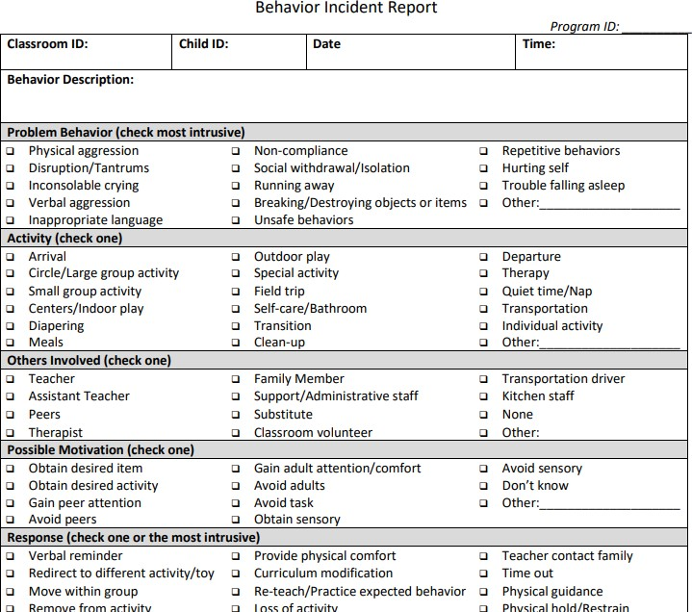
Form Sample:
Locate the Behavior Documentation tab under the Education section of Child Plus
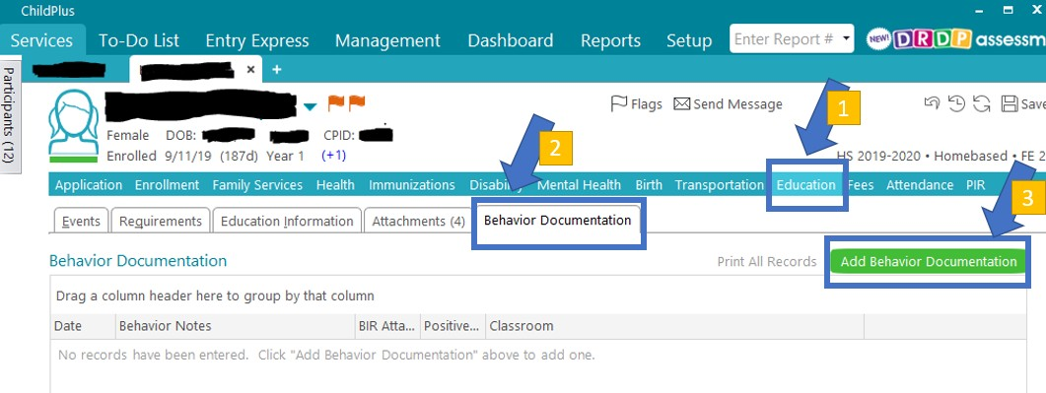

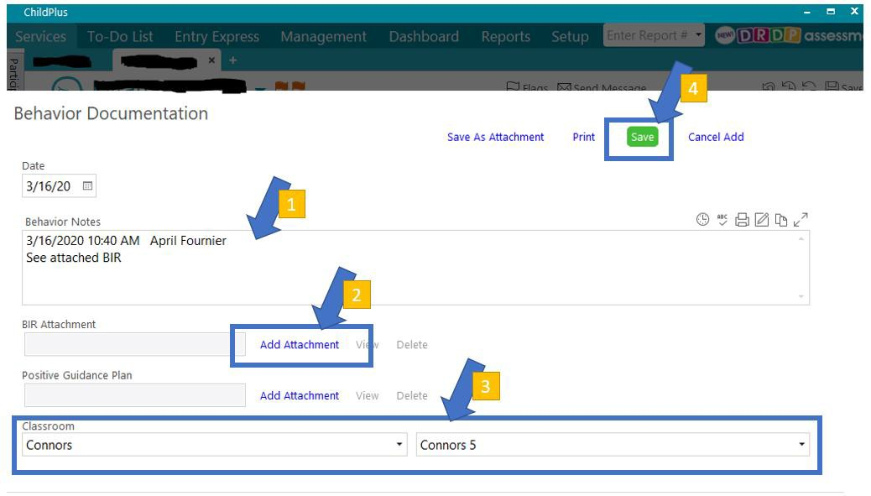
Fill out the fields for the Behavior Documentation screen and then download the BIR form found on the Special Services section of Staff Forms once completed:

Title of Procedure or Process: | Requesting an Observation
Program Area(s): | Special Services
Related Standards or Regulations: | ☒Head Start Program Performance Standards  ☒Developmentally Appropriate Practice/NAEYC
Person Responsible for implementation: | Lead Teacher, Site Supervisor, Early Interventionist
Timeline for completion: | Observation will be completed by Early Interventionist ASAP
Submitted to: | Special Services
ChildPlus Documentation: | https://docs.google.com/spreadsheets/d/1bjOU5fpATw-78sCrTfeR-uVx6EMqm7MYINRpZ9UomNI/edit#gid=243693850  Google Form to submit request
Uploaded to ChildPlus: | Early Interventionist will document observation in ChildPlus under Disability Tab.
Specific Directions: | Lead Teacher will submit an observation request via the Google Form, providing all information to support the need for the observation, then alert the Early Interventionist via email of the request. Early Interventionist will contact the Lead Teacher to discuss the concerns/request and schedule the observation. The Early Interventionist will follow up with the Lead Teacher to discuss further actions, such as, RTI, accommodations, discussions with parents and/or referrals.
Procedure

- Lead Teacher will submit an observation request via the Google Form, providing all information to support the need for the observation.
- Lead Teacher will alert the Early Interventionist via email of the request.
- Early Interventionist will contact the Lead Teacher to discuss the concerns/request and schedule the observation.
- The Early Interventionist will follow up with the Lead Teacher to discuss further actions, such as, RTI, accommodations, discussions with parents and/or referrals.

Title of Procedure or Process: | Referrals to Child Development Services
Program Area(s): | Education, Special Services
Related Standards or Regulations: | ☒Head Start Program Performance Standards  - Maine State Licensing  ☒Developmentally Appropriate Practice/NAEYC  - Caring for Children  - Other
Person Responsible for implementation: | Classroom Staff, Early Interventionist, Site Supervisors, FA’s
Timeline for completion: | Developmental screenings are conducted at Promise within 45 days of enrollment (30 days for Public Pre-K).  A child may be referred to CDS anytime during the year if concerns are present or a parent request is made.
Submitted to: | Special Services
ChildPlus Documentation: | Disability Tab  When a concern is identified the classroom staff will open the concern under the disabilities tab with the relevant information regarding the concern and alert the Early Interventionist via email.
Uploaded to ChildPlus: | CDS Authorization to Request and/or Share Information and Records, Brigance, Referral for Services. Possible additional documentation-TSG Report, Behavior Documentation, Relevant Medical Records, Classroom Observations, ELL Form for CDS.
Specific Directions: | Once a classroom has identified a concern for a child who is demonstrating delays in the domain(s) of; communication, adaptive skills, social emotional skills, motor skills, cognitive skills, and/or behavioral concerns the classroom will share the concerns with the child’s family and contact special services. The procedure to refer to CDS will be completed in coordination with the Early Interventionist.

Procedure:

Children may be identified through Developmental Screening, through Classroom Observation or through an outside source such as a parent, family physician or other treating provider. When there is information presented requiring a referral to Child Development Services the following steps should be completed.

- The classroom staff should discuss their concerns with their Site Supervisor and Early Interventionist.
- If child is DLL, it is preferrable to have a language facilitator involved in both the screening process and identification process. ELL form for CDS will be completed to accompany referral
- The classroom staff will contact the family of the child to discuss the concerns.
  - No referrals are made without informed consent of the parent(s).
- The CDS Authorization to Request and/or Share Information and Records form is filled out by the Teacher or FA and signed by the parent(s), giving consent to Child Development Services to contact the family regarding the area(s) of concern. The teacher will alert the parent(s) that CDS will be contacting them within 10 days to schedule an initial meeting once the referral is submitted.
  - Teacher/FA will upload the CDS Release to ChildPlus or submit it to the Early Interventionist. If uploading the form, alert the Early Interventionist via email.
- The Early Interventionist will complete and fax the Referral to CDS along with the CDS Authorization to Request and/or Share Information and Records and any additional supporting information.
- Early Interventionist will follow up with a phone call to CDS to ensure that referral was received.
- The Early Interventionist will be responsible for entering the referral and documenting into ChildPlus. This includes initial and follow up actions.

Title of Procedure or  Process: | Behavior Safety Plan for Challenging Behaviors
Program Area(s): | Special Services, Education
Related Standards or Regulations: | ☒Head Start Program Performance Standards  - Maine State Licensing  ☒Developmentally Appropriate Practice/NAEYC  - Caring for Children  - Other
Person Responsible for  implementation: | Classroom Teachers, Early interventionist, Education & Child  Development Manager
Timeline for completion: | Part 1- Behavior Incident Report (BIR) should be completed within 24 hours of the incident. Part 2- Meeting scheduled with parent, teacher and Early Interventionist after 3 BIR’s are collected for aggressive/ unsafe behaviors.
Submitted to: | Alert the Early interventionist, Site Supervisor, Education & Child  Development Manager via email.
ChildPlus Documentation: | Safety Plan will be documented under the Education tab/ BIR
Uploaded to ChildPlus: | Safety Plan forms (located in Staff Forms) should be uploaded to ChildPlus within 48 hours of the meeting.
Specific Directions: | The implementation of a safety plan will be determined necessary based on the behaviors displayed by a child within the educational setting. The safety plan is a contract between the individual’s child’s classroom teachers and the parent/guardian(s). The safety plan could result in a modified schedule and/or a referral for special education or mental health services in coordination with the parent/guardian(s).
Procedure:
- The Lead Teacher will alert the Early Interventionist when an individual child has 3 BIR’s uploaded into CP because of aggressive and/or unsafe behaviors.
- The Lead Teacher would have begun a conversation with parents/guardian(s) regarding aggressive and/or unsafe behaviors after the first BIR.
- After the 3rd BIR is recorded, the Early Interventionist will reach out to the parent/ guardian(s) to schedule a meeting to discuss the Safety Plan, review it and complete the action steps in coordination with the parent/guardian(s).
- The Lead Teacher will keep the Early Interventionist informed about further BIR’s and the Early Interventionist will be responsible for overseeing the agreement made within the Safety Plan and fulfilling the actions steps outlined in it.
- The action steps could include a modified schedule and/or a referral for special education or mental health services in coordination with the parent/guardian(s).

Title of Procedure or Process: | Referrals to Mental Health Provider for Community-Based Services
Program Area(s): | Health, Nutrition, Education, Special Services, Family Services, ERSEA, etc.
Related Standards or Regulations: | ☒Head Start Program Performance Standards  - Maine State Licensing  - Developmentally Appropriate Practice/NAEYC  - Caring for Children  - Other
Person Responsible for implementation: | Lead Teacher, Site Supervisor, Early Interventionist, FA
Timeline for completion:
Submitted to: | Early Interventionist
ChildPlus Documentation: | Mental Health tab add a transaction using Referral in the drop down.
Uploaded to ChildPlus: | Mental Health Referral Form, Mental Health Observation
Specific Directions: | If the parent or guardian indicates the need for additional community or  home-based services the team will provide support in completing the referral process.

Procedure:

- If the classroom staff or FA is notified by the parent or guardian or determines that the family could benefit from additional community based or home-based services (i.e. Counseling, Home-based Behavioral Health Professional, HCT, Targeted or Community Case Management, Adult Services);
  - Discuss and document the concerns with the Site Supervisor and Early Interventionist
  - If FA, Teacher or Early Interventionist determines that the family may benefit from mental health services, it will be discussed with the family and a determination made in coordination with the family.
  - Log under Transaction, then choose option (meeting, phone call, etc)
  - Early Interventionist will support the teacher to explain the referral process to the parent or guardian and secure informed consent of the parent
    - Authorization to Release Information Form (found in staff forms- Family Services)
  - Early Interventionist will complete the referral paperwork
  - Early Interventionist will fax the referral to the mental health provider and upload them into ChildPlus
  - The Early Interventions/FA will document the updates to the process in ChildPlus
- The mental health provider will contact the family directly to schedule consultation or intake.
- The Early Interventionist, FA or classroom staff will follow up with the family to check on the status of the referral. The Early Interventionist or FA will be the contact for the mental health provider.

Note: Children who are engaging in behaviors in the classroom may be eligible for Special Education Services. The Early Interventionist, in coordination with the classroom staff, will discuss the considerations for a referral for mental health services, special education services or both depending on the situation.

Title of Procedure or Process: | Referrals to Mental Health Provider for Classroom-Based Services (Play Therapy, Classroom Consultation, etc.
Program Area(s): | Health, Nutrition, Education, Special Services, Family Services, ERSEA, etc.
Related Standards or Regulations: | ☒Head Start Program Performance Standards  - Maine State Licensing  ☒Developmentally Appropriate Practice/NAEYC  - Caring for Children  - Other
Person Responsible for implementation: | Lead Teacher, Site Coordinator, Special Services Coordinator
Timeline for completion: | Staff is expected to secure mental health consultation services on a schedule of sufficient and consistent frequency to ensure a mental health consultant is  available to partner with staff and families in a timely and effective manner.
Submitted to: | Special Services Team
ChildPlus Documentation: | Under the Mental Health tab, add a transaction using Referral in the drop- down
Uploaded to ChildPlus: | Mental Health Referral Form, Mental Health Observation
Specific Directions: | If the classroom has identified that a child is requiring mental health services the classroom should follow this procedure for requesting support for the family and for completing a referral to a community mental health service  provider.

Procedure:

- If the classroom staff have identified that a child in their classroom is demonstrating concerning behaviors that may indicate a potential mental health concern or condition the classroom should;
  - Discuss and document the concerns with the child’s parent and discuss what observations and actions have been happening in the classroom. This should be as specific and objective as possible and include the frequency in which the behavior is being observed.
  - Discuss and document the concerns with the Site Supervisor
  - Add a transaction, choose drop down option (meeting, phone call, etc)
  - Send an Observation Request to the Special Services Coordinator
- The Special Services Coordinator will schedule an observation for the classroom within the next 10 business days. Once the observation is completed;
  - The Special Services Coordinator will complete an observation summary and contact the classroom teacher to discuss the observation and either recommend a formal mental health evaluation or recommend continued monitoring.
  - The classroom teacher will reach out to the family and discuss the results of the internal observation and discuss obtaining written consent from the parent for an external referral if that is recommended.
  - The classroom teacher will provide the signed consent forms and any referral/intake/questionnaire required for the mental health provider to the Special Services Coordinator.
- The Special Services Coordinator will receive the referral packet from the classroom teacher;
  - The Special Services Coordinator will fax the referral to the mental health provider
  - The referral forms will be uploaded into ChildPlus
  - The Special Services Coordinator will document the updates to the process in ChildPlus
- The mental health provider will contact parent to complete an assessment at the mental health
provider’s office.

Note: Children who are engaging in behaviors in the classroom may be eligible for Special Education Services. The Special Services Team will discuss the considerations for a referral for mental health services, special education services or both depending on the situation.

Title of Procedure or Process: | Help-Prompt-Wait: Using Behavior Management Techniques
Program Area(s): | Education, Early Interventionist
Related Standards or Regulations: | ☒Head Start Program Performance Standards  - Maine State Licensing  ☒Developmentally Appropriate Practice/NAEYC  - Caring for Children  - Other
Person Responsible for implementation: | Classroom Staff, Early Interventionist, Site Supervisors
Timeline for completion: | Ongoing
Submitted to: | Special Services
ChildPlus Documentation: | See BIR and IR Procedures
Uploaded to ChildPlus: | BIR and IR Forms
Specific Directions: | When a child is demonstrating signs of escalation staff should use approved and evidence-based behavior management techniques to support them in the de-escalation process. The following steps are a high-level reminder of how  to support a child in this process.

Procedure:
Steps to Follow As Outlined By Safety-Care™

HELP: When child is beginning to show signs of agitation. Avoid this strategy when the child’s behavior is highly
escalated
- Approach using safety stance
- Ask the person to state what he or she wants:
  - -Say “Tell me, ‘I want X.’ (if you think you know what the child wants
  - -Say “What do you want?” “Tell me what you want.” Or “How can I help you?” (if you are unsure what the child wants)
- Allow 5-10 seconds for the child to process request
- Repeat prompt if necessary
- If child makes appropriate request, then praise and comply.
- If child becomes more agitated, consider switching strategy.

PROMPT: When HELP strategy has not been effective or is not appropriate to use or when you think the person is likely to comply with your request
- Identify an incompatible or high probability behavior
- Approach using safety stance or elbow check
- Prompt the desired behavior in a calm, neutral tone
- Allow 5-10 seconds for the child to process request
- Repeat prompt if necessary
- Praise any compliance. Begin again with another incompatible or high probability behavior
- If non-compliant, then identify a different behavior and start over. If signs of agitation increase, then stop and consider switching to a different strategy.

WAIT: When HELPING or PROMPTING appear to make the situation worse, when you want to avoid all external reinforcement of crisis behaviors, when nothing else is working
- Remove other children and make sure that no one will accidently intrude
- Use safety stance. Position yourself to monitor the person without putting yourself at risk. Step back if necessary for safety
- Avoid reinforcing the person’s behavior (don’t talk, give eye contact, respond to provocations, etc.)
- When person behaves more calmly, switch to the HELP or PROMPT strategy.

Title of Procedure or Process: | Special Education Process and Timeline Does this one need to be in here? It is not our policy or procedure
Program Area(s): | Education, Early Interventionist
Related Standards or Regulations: | ☒Head Start Program Performance Standards  - Maine State Licensing  ☒Developmentally Appropriate Practice/NAEYC  - Caring for Children  - Other
Person Responsible for implementation: | Classroom Staff, Early Interventionist, Site Supervisors
Timeline for completion: | See Procedure for specifics
Submitted to: | Special Services Team
ChildPlus Documentation: | Disability Tab
Uploaded to ChildPlus: | Referral Documents, Release of Information, Behavior Documentation,  Observations, Relevant Medical Records
Specific Directions: | The Child Development Services (CDS) system is an Intermediate Educational Unit that provides both Early Intervention (birth through two years) and Free Appropriate Public Education (for ages three through five years) under the supervision of the Maine Department of Education. The CDS system ensures the provision of special education rules, federal and state regulations statewide, through a network of regional sites.  We partner with CDS to complete the Child Find Process and to facilitate implementation of the Individual Education Program or Individual Family Service Plan when appropriate.  More detailed information about Maine’s Special Education Regulations can  be found at https://www.maine.gov/doe/learning/cds/laws

Procedure:
Step 1 (Child Find)

- Child is identified as possibly needing special education and related services.
- Referral form submitted by Early Interventionist or request for evaluation made to CDS verbally or in writing by parent, physician, public Pre-K, and other professionals
- Information is gathered through observations, screenings, parent interviews, etc., and brought to the intake team to further guide decisions regarding suspected disability and evaluations that may be needed.

Step 2 (Evaluation)

- Parental consent is needed before CDS may refer a child to be evaluated.
- Evaluations need to be completed within 60 calendar days after parent gives consent.
- The purpose of the evaluations are;
  - Identify whether the child has a disability that requires the provision of special education and related services.
  - Identify the child’s specific educational needs.
- Evaluations must be individualized (focused on that child) and assess the child in all areas related to the child’s suspected disability. Evaluations completed will include standardized assessments and an observation. When a standardized assessment cannot be used a specific informal assessment will be used. The results from these evaluations will be used to determine eligibility for special education

services. If parents disagree with the evaluation they have the right to request an Independent Educational Evaluation (IEE) and request it be paid for by CDS.

STEP 3 (Meeting)

- Meeting must be scheduled within 60 calendar days of the date parent(s) gave written consent to evaluate.
- CDS schedules and conducts the Individual Education Plan (IEP) meeting. CDS must:
  - Contact the participants, including parents
  - Notify the parents early enough to make sure they have an opportunity to attend
  - Inform parents of the purpose, time, and location of the meeting
  - Inform parents who is attending
  - Inform parents that they may invite people who have knowledge or special expertise about the child.

Step 4. (Eligibility is decided)

- A group of qualified professionals and the parents look at the child’s evaluation results. Together, they decide if the child is a “child with a disability”, as defined by state and federal law. If the IEP team cannot reach consensus, the CDS IEP Administrator will make the final determination. If the parents do not agree with the eligibility decision, they may ask for a hearing to challenge the decision

Step 5 (Writing the Individual Education Plan- IEP)

- If the child is determined eligible for special education services then an IEP is written. The IEP team (parent and relevant professionals) has a discussion regarding development of the IEP. Parts of the IEP that will be discussed and determined during this discussion are:
  - Placement ( the type of program that the child will receive his/ her special education and related services)
  - Goals and services necessary to address the goals, including frequency (how often) and duration (how much)
  - Child’s strengths and needs and their present levels of educational performance.

Parents must provide signed written consent before the IEP can be implemented and services provided.
  - The IEP will be implemented as soon as possible after signed consent is received (within 30 calendar days) and all team members will receive a copy.

Step 6 (Progress is measured)

- The child’s progress towards the annual goal(s) is measured, as stated in the IEP. His/ her parent(s) are regularly informed of their child’s progress and whether that progress is enough for the child to achieve the goals by the end of the year. These progress notes must be given to parents at least as often as parents are informed of their nondisabled children’s progress, which is usually once per quarter of the academic year.

Step 7 (IEP is reviewed and Child is reevaluated)

- The child’s IEP is reviewed by the IEP team at least once a year, or more often if the parent(s) or school ask for a review. If necessary, the IEP is revised. Parents, as team members, must be invited to

participate in these meetings. Parents can make suggestions for changes can agree or disagree with the IEP, and agree or disagree with placement.
- At least every three years the child must be reevaluated. This reevaluation is sometimes called a
“triennial”. Its purpose is to find out if the child continues to be a child with a disability, as defined by
IDEA, and what the child’s educational needs are.

Step 8 ( What if parents disagree with the child’s placement, evaluations or a determination regarding the IEP)

If the parents do not agree with evaluations, the IEP and/or placement they may discuss their concerns with members of the IEP team and try to work out an agreement. There are several options available for consideration, including additional testing or an independent evaluation. If they still disagree, parents can ask for mediation, or the school may offer mediation. Parents may file a state complaint with the state education agency or a due process complaint, which is the first step in requesting a due process hearing, at which time mediation must be available.

Nutrition Starts

Title of Procedure or Process: | Age Eligibility
Program Area(s): | ERSEA
Related Standards or Regulations: | ☒Head Start Program Performance Standards  - Maine State Licensing  - Developmentally Appropriate Practice/NAEYC  - Caring for Children  - Other
Person Responsible for implementation: | Enrollment Coordinator
Timeline for completion: | Completed up on time of eligibility determination
Submitted to: | NA
ChildPlus Documentation: | Eligibility Records
Uploaded to ChildPlus: | NA
Specific Directions:

Procedure

Early Head Start Classroom (EHS):
Children are age eligible for Early Head Start at 6 weeks of age. Children are eligible to remain in EHS until they are PIR age 3 (birthday on or before October 15 of the current program year). Children enrolled in full day program who turn 3 within the program year may transition to full day Head Start before they are PIR age 3, pending with approval of Selection Committee. Children transitioning from EHS to HS must have income eligibility re verified prior to transfer minimally 4 months prior to transfer.
Children on the EHS waitlist will be transitioned to the HS waitlist at the age of 2.9 Head Start Classroom:
Children who are PIR age 3 and 4 are eligible for Head Start classrooms.

Home Based Head Start/Early Home Based / early/Head Start:
Pregnant mothers and children birth to PIR age 2 are age eligible for Early Home-Based Services. Children that are PIR age 3 are age eligible for Home Based services. Children enrolled in Early Home Based are age eligible to transition to Head Start services when they are PIR age 3. Home Based children
who have turned 3 within the program year may transition to Full Day Head Start before reaching PIR age 3. Income eligibility must be re – verified prior to a child transitioning from Early Home-Based Services to Head Start Services (six months prior to transfer).

Title of Procedure or Process: | Income Eligibility and Verification
Program Area(s): | ERSEA
Related Standards or Regulations: | ☒Head Start Program Performance Standards  - Maine State Licensing  - Developmentally Appropriate Practice/NAEYC  - Caring for Children  - Other
Person Responsible for implementation: | Enrollment Coordinator
Timeline for completion: | Completed up on time of eligibility determination
Submitted to: | NA
ChildPlus Documentation: | Eligibility Records
Uploaded to ChildPlus: | NA
Specific Directions: | Income eligibility is determined by Enrollment Coordinator at time of Enrollment based on the Head Start Family Income Guidelines. A child , or pregnant mother, is considered eligible if :  - The family’s income is equal to, or below poverty line; or  - The family is eligible for, in the absence of child care, would be potentially eligible for public assistance.

Income Verification
Income to be verified must include income for the previous 12 months preceding the month in which the application is submitted or income from the calendar year proceeding the calendar year in which the application is submitted; whichever more accurately reflects the needs of the family at the time of application.

Income documentation may include income tax forms, W-2 forms, pay stubs (for previous 12 months), written statements from employers, public assistance documentation. Copies of documents used to verify income will be uploaded into Child Plus and kept in the child’s physical file.

Income must be verified prior to considering the child eligible for a program. Income eligibility does not need to be re-verified for the following year if the child has been enrolled. A child in Head Start who is age eligible and re-enrolling for a third program year will need to have income verified. Income must be re verified when a child transitions from Early Head Start to Head Start. Income may also be re verified if an over income family has a drop in income that makes them income eligible.

If a family reports no income, Staff will document efforts made to verify the family’s income. This may include seeking information from third parties about the family’s eligibility, if the family gives written consent; or having by the family sign a written declaration of no income (No Income Statement)

Family Subsistence Allowance (FSSA) received by members of the armed forces should be disregarded as income.
Over Income
Over income children will be placed on the waiting list following any income-eligible children and considered only if no income-eligible children are already on the waiting list. If the family’s income is above the poverty line, a program may enroll a pregnant woman or a child who would benefit from services. These participants can only make up to 10 percent of a program’s total enrollment

A program may enroll an additional 35 percent of participants whose families are neither income nor categorically eligible and whose family incomes are below 130 percent of the poverty line, if the program:
- Establishes and implements outreach, and enrollment policies and procedures to ensure it is me eating the needs of income or categorically eligible pregnant women, children, and children with disabilities, before serving ineligible pregnant women or children; and establishes a criterion that ensures eligible pregnant women and children are served first.

Title of Procedure or Process: | Categorical Eligibility and Verification
Program Area(s): | ERSEA
Related Standards or Regulations: | ☒Head Start Program Performance Standards  - Maine State Licensing  - Developmentally Appropriate Practice/NAEYC  - Caring for Children  - Other
Person Responsible for implementation: | Enrollment Coordinator
Timeline for completion: | Completed up on time of eligibility determination
Submitted to: | NA
ChildPlus Documentation: | Eligibility Records
Uploaded to ChildPlus: | NA
Specific Directions: | Income eligibility is determined by Enrollment Coordinator at time of Enrollment based on the Head Start Family Income Guidelines. A child , or pregnant mother, is considered eligible if :  - The family’s income is equal to, or below poverty line; or  - The family is eligible for, in the absence of child care, would be potentially eligible for public assistance.

Procedure
Categorically Eligible Categories:
- Homeless. Children are considered categorically eligible for Head Start if they meet the definition of homeless. See Definition of terms.
- Foster Care. A child in Foster Care is considered categorically eligible, regardless of the family’s income
- Public Assistance. A family receiving SSI, SNAP Benefits, TANF are considered categorically eligible regardless of family’s income.

Verification Requirements:
Homeless Verification Terms: A written statement from a homeless services provider, school personnel, or other service agency attesting that the child is homeless or any other documentation that indicates homelessness, including documentation from a public or private agency, a declaration, information gathered on enrollment or application forms, or notes from an interview with staff to establish the child is homeless.
Process of Verification for Homelessness will be handled in such a way that it does not violate privacy or jeopardize housing arrangements. It is up to the local liaison, enrollment staff, and/or other school personnel to be sensitive and discreet. In summary, the program's attempt to verify a student's eligibility for McKinney-Vento services must be governed by respect, sensitivity, and reasonable limits. The McKinney Vento Act defines homelessness as lacking an adequate, fixed nighttime residence. Families who are “couch surfing” are considered homeless, as well as those living in cars, or adults who have left home and have returned to stay with parents.

Public Assistance Verification To verify whether a family is eligible for, or in the absence of child care, would be potentially eligible for public assistance, the program must have documentation from either the state, local, or tribal public assistance agency that shows the family either receives public assistance or that shows the family is potentially eligible to receive public assistance.
- SNAP Verification: To verify SNAP receipt or potential eligibility, a program would need to examine and maintain a copy of documentation from the state, local, or tribal public assistance agency within a relevant time period‘(within 12 months of application date)
- TANF Verification: To verify TANF receipt of TANF Award Letter from State, Local or tribal public assistance agency within; a relevant time period. (within 12 months of application date)
- SSI Verification: To Verify SSI Award Letter from State, Local or Tribal public assistance agency must be presented within a ‘relevant time period’ (within 12 months of application date)
Foster Verification To verify whether a child is in foster care, program staff must accept either a court order or other legal or government-issued document, a written statement from a government child welfare official that demonstrates the child is in foster care, or proof of a foster care payment.
Title of Procedure or Process: | Enrollment Activity Sheets
Program Area(s): | ERSEA
Related Standards or Regulations: | ☒Head Start Program Performance Standards  - Maine State Licensing  - Developmentally Appropriate Practice/NAEYC  - Caring for Children  - Other
Person Responsible for implementation: | Teachers, FA’s, FE’s
Timeline for completion: | Same day as Enrollment Activity occurs
Submitted to: | All staff listed at the top of the form
ChildPlus Documentation: | Enrollment Coordinator will make status changes in Child Plus
Uploaded to ChildPlus: | The EAS will be uploaded by Enrollment Coordinator
Specific Directions: | Staff will complete EAS to share changes in a child’s enrollment status

Procedure
Staff will complete an Enrollment Activity Sheet within 24 hours of change occurring. EAS Sheets are submitted to individuals at the Top of the Enrollment Activity Sheet, and Public Pre-K Programs with LPS require additional contacts to be added. EAS forms are required to be sent electronically and can be located on the Staff Forms Website under Enrollment.

When to complete an EAS:
- The first day that a child sits in seat. This is the child’s enrollment date.
- When a child transfers from one classroom to another. When a child transfers, the new classroom will send EAS dated first day child sits in the seat.
- If you receive a file for a new child and they never start an EAS is completed as this prompts the Enrollment Coordinator to remove the child from the accepted status and choose a replacement child.
- When a child drops out of the program or ages out and the end of the program year (June 30th) When a child drops, the day following child’s last day in seat is considered the child’s drop date.
- When an enrolled pregnant mother gives birth, an EAS prompts the Enrollment Coordinator to drop the mother as a participant and add the newborn as a participant.

Teacher Responsibilities:
Before an EAS Drop is completed, Teaching staff are required to complete the following prior to completion of EAS
- TSG Observations/ Assessments & Family Conference Forms uploaded to Child Plus
- ASQ / Brigance 45-day screening uploaded into Child Plus
- All PIR questions answered in Child Plus

Title of Procedure or Process: | Transfer Requests
Program Area(s): | ERSEA
Related Standards or Regulations: | ☒Head Start Program Performance Standards  - Maine State Licensing  - Developmentally Appropriate Practice/NAEYC  ☒Caring for Children  ☒Other
Person Responsible for implementation: | Teachers, FA’s, FE’s
Timeline for completion: | When a parent request a transfer
Submitted to: | Supervisor for signature, then to Enrollment Coordinator
ChildPlus Documentation:
Uploaded to ChildPlus: | The Transfer Request will be uploaded to Child Plus by Enrollment Coordinator
Specific Directions: | Staff will complete when parent requests a change in programming

Submitting a transfer request:

- Staff will complete a Transfer Request when a request is being made to change a child to another classroom or program option. EHS to HS requests must include updated income.
- The Transfer Request will be sent, electronically, to Site Supervisor for signature / approval.
- Site Supervisor will sign / approve and send to Enrollment Coordinator.
- Enrollment Coordinator will upload the Transfer Request into Child Plus.
Special considerations:
EHS to HS – Transfer requests from children from EHS to HS, need to have updated income attached
Part Day to Full Day: To be eligible for acceptance into a full day program, parents must have identified resources and/or confirmed subsidy.
After a transfer has been accepted:
  - When an opening arises for a HS / EHS spot, the EC will present the selection committee the next eligible Transfer Request(s)
  - Once a child’s transfer has been approved, the Enrollment Coordinator will send out an email notifying Site Supervisors, Teachers, and FA’s for both the present and new classroom. The email will include dates for the transfer to happen when applicable.
  - The Enrollment Coordinator will send the Transfer Request to the new Site Supervisor for review. The Site Supervisor will send the Transfer Request to the staff with family service responsibilities at the new site.
  - The receiving classroom will contact the current classroom to coordinate the transfer and discuss any child or family needs.
  - The current classroom will ensure all Teaching Strategies Gold observations are uploaded into Teaching Strategies and Assessments are complete, if applicable.
  - The receiving classroom will schedule a time for the parent to see the classroom, meet the staff and review the child’s emergency card and permission for services form
  - The receiving classroom will send an Enrollment Activity Sheet (EAS) on the child’s first day of attendance. This completes the transfer process.

Note: Over income slots are available in limited quantities and may not be available at time of transfer reques

Title of Procedure or Process: | Recruitment of Children and Families
Program Area(s): | ERSEA
Related Standards or Regulations: | ☒Head Start Program Performance Standards  - Maine State Licensing  - Developmentally Appropriate Practice/NAEYC  - Caring for Children  - Other
Person Responsible for implementation: | Teachers, FA’s, FE’s
Timeline for completion: | Ongoing
Submitted to: | NA
ChildPlus Documentation:
Uploaded to ChildPlus:
Specific Directions: | The agency must maintain full enrollment with an active waitlist

Procedure
Promise ensures the enrollment of programming through established annual recruitment plans, utilization of Social Media platforms, Signage, Community Partners, Community Events and Parent’s past and present.
Platforms for recruitment include but are not limited to:
Social Media- Instagram, Facebook, Promise Website
Signage: Banners located on Site in the Fall, Spring and Summer
Community Recruitment: Attending community events and partnering with community providers to provide recruitment on a drop basis as well as active community events.
Community Partner Recruitment: Attending Health Advisory, CPPC Meetings, Program Advisory Committee, Board Meetings and Policy Council and Community Based agencies IE: DHHS, Safe Voices, Fed cap, CCSP, to actively recruit through community partners.
Parent Recruitment: Promoting and supplying opportunities to encourage families currently enrolled, and previously enrolled to share upon there experiences with promise. Recruitment Materials: Postcards supplied to families in the Spring and Fall.
Documentation of Recruitment Hours*Staff*:
Enrollment Coordinator will confirm attendance after each recruitment event and input recruitment hours into childplus within 72 hours of the Recruitment Activity for Staff.
Title of Procedure or Process: | ERSEA Training
Program Area(s): | ERSEA
Related Standards or Regulations: | ☒Head Start Program Performance Standards  - Maine State Licensing  - Developmentally Appropriate Practice/NAEYC  - Caring for Children  - Other
Person Responsible for implementation: | Program Specialist, Enrollment Coordinator
Timeline for completion: | New staff receive ERSEA training within two weeks of hire ERSEA training is provided annually, for all, staff in August  Governing bodies receive training annually within 180 days of the new  term
Submitted to: | NA
ChildPlus Documentation: | NA
Uploaded to ChildPlus: | NA
Specific Directions: | A program must train all governing body, policy council, management, and staff who determine eligibility on applicable Federal regulations and program policies and procedures. ERSEA training is provided annually for staff in August. New staff receive ERSEA training within two weeks of hire. Governing bodies receive training annually within 180 days of the new term. ERSEA training must include;  - Methods on how to collect complete and accurate eligibility information from families and third  party sources;  - Strategies for treating families with dignity and respect and for dealing with possible issues of domestic violence, stigma, and privacy; and,  - Policies and procedures that describe actions taken against staff, families, or participants who intentionally attempt to provide or provide false information.

Procedure

Program Specialist will present ERSEA training ERSEA training to all staff at start up training in August

New staff will receive ERSEA training within two weeks of hire through the Onboarding process with the Enrollment Coordinator

The Program Specialist will provide ERSEA training for Board and Policy Council within 180 days of the new term during established Board and Policy Council Meetings

Title of Procedure or Process: | ERSEA Definitions
Program Area(s): | ERSEA
Related Standards or Regulations: | ☒Head Start Program Performance Standards  - Maine State Licensing  - Developmentally Appropriate Practice/NAEYC  - Caring for Children  - Other
Person Responsible for implementation: | Enrollment Manager

New: A child with a new status has an application that is not complete, and/or income that has not been verified
Waitlisted : A child that is has an application that has been completed and age and income have been verified.
Accepted: A child that is accepted has been assigned a classroom and is waiting for home visit
Enrolled: A child is enrolled the first day that they attend the classroom or for homebased, have their first home visit.
Colab: A colab child is a child that is enrolled in a public pre-K partnership classroom and has not had income verified. These children have an “*”next to their name in ChildPlus and do not receive Head Start funding
Completed: The child was enrolled through the end of the program year
Aged out: The child has is no longer age eligible for the program
Abandoned: This status is used when a child is not expected to enroll into a program or program year. A child may be “abandoned” from one waitlist or program to be put on another.
ERSEA: Eligibility, Recruitment, Selection, Enrollment & Attendance
Funded Enrollment: refers to the number of children which the Head Start grantee is expected to serve, as indicated on the grant award.
Homeless: The McKinney-Vento Homeless Assistance Act defines homelessness as:
    - children and youths who are sharing the housing of other persons due to loss of housing, economic hardship, or a similar reason and have no income that contributes to the benefit of that family; are living in hotels, motels, trailer parks, or camping grounds due to the lack of alternative accommodations; are living in emergency or transitional shelters, are abandoned in hospitals; or are awaiting foster care placement
    - children and youths who have a primary nighttime residence that is a public or private place not designed for or ordinarily used as a regular sleeping accommodation for human beings
    - children and youths who are living in cars, parks, public spaces, abandoned buildings, substandard housing
Income: includes earned income (gross), military income (including pay and allowances), veterans’ benefits, Social Security benefits, unemployment compensation, and public assistance benefits.
Selection: means the systematic process used to review all applications for Head Start services and to identify those children and families that are to be enrolled in the program.
Slots: The agency has a limited number of childcare slots available for private pay families. Although these children are offered the same services as HS or EHS children they have the option to opt out of any services that they do not wish to receive (Home Visits, family assessments etc. ). Slots are approved on a program year basis and are not guaranteed from year to year.
Transfer: Used when a family is interested in moving to another classroom/program option while continuing to receive services in the current classroom/program option.

Title of Form: | New Application Tracker *One Drive*
Related Policy:
Program Area(s): | Health, Nutrition, Education, Special Services, Family Services, ERSEA, etc.
Related Standards or Regulations: | ☐Head Start Program Performance Standards  ☐Maine State Licensing  ☐Developmentally Appropriate Practice/NAEYC  ☐Caring for Children  ☐Other
Procedures
Form Completed By: | Responsible staff
Timeline for completion:
Specific Directions:
Submitted to:
ChildPlus Documentation:
Uploaded to ChildPlus:
The enrollment coordinator and ERSEA Manager will oversee the New Application Tracker indicating the stage of outreach per ‘New Online Application submitted to Promise Early Education Center.
Process:
- Receives Application via Website, Community Partner, Phone Call or Walkin
- Inputs Date Application Received
- Inputs Parents and Childs Name
- Input 1st/2nd/3rd/4th contact type
- Input Date and Time of In-Person Interview
  - Update Outcome of In-Person Interview in Child plus
    - App Status: No Call No Show
    - App Status: Rescheduled In-Person Interview
    - App Status: Complete and Verified

Title of Form: | Application Status Definitions (Enrollment-Childplus)
Related Policy:
Program Area(s): | Health, Nutrition, Education, Special Services, Family Services, ERSEA, etc.
Related Standards or Regulations: | ☐Head Start Program Performance Standards  ☐Maine State Licensing  ☐Developmentally Appropriate Practice/NAEYC  ☐Caring for Children  ☐Other
Procedures
Form Completed By: | Responsible staff
Timeline for completion:
Specific Directions: | Application Status’s will be utilized by the Enrollment Coordinator and ERSEA Manager to ensure accurate Application Status’s are documented for children applying to Promise Early Education Center status’s will be updated as necessary to indicate accurate application status.
Application Status’s will be utilized by the Enrollment Coordinator and ERSEA Manager to ensure accurate Application Status’s are documented for children applying to Promise Early Education Center status’s will be updated as necessary to indicate accurate application status.
Application Status: New App- 1st Outreach/ 2nd Outreach / 3rd Outreach /4th Outreach-Letter Sent
  - 1st Outreach- Conducted via Phone, Voicemail, Email
  - 2nd Outreach- Conducted via Phone, Voicemail, Email
  - 3rd Outreach- Conducted via Phone, Voicemail, Email, Door Hanger
  - 4th Outreach- Conducted via Phone, Voicemail, Email, Unable to Reach you Letter.
Application Status: In Person Interview Scheduled
- Applicants have scheduled their Initial Enrollment Interview and have been sent confirmation email regarding documentation requirements.
Application Status: No Call No Show
- Applicants did not show for their Initial Enrollment Interview and Outreach is being conducted to Reschedule.
Application Status: Rescheduled in- person Interview
- Utilized for Applicants that have rescheduled their Initial Enrollment Interview due to No Call No Show or Outreach to Reschedule due to conflict. Updated Date and Time of Enrollment Interview should be updated in Enrollment Notes.
Application Status: Complete and Verified:
- Application contains all required documentation
  - Income and or Categorical Verification
  - Signed Releases
  - Immunization Records
Incomplete Application Missing Income, Release and Documentation:
- Indicates the participants has multiple missing documents from Application process.
Incomplete Application Missing Signed Documentation:
- Indicates applicant is missing one or more of the following documentations.
  - Permission for Services
  - Emergency Card
  - Pre-K Paperwork
  - Health History
  - PFA/Legal Documentation
Incomplete Application Missing Immunization Records:
- Indicates applicant is missing immunization records

