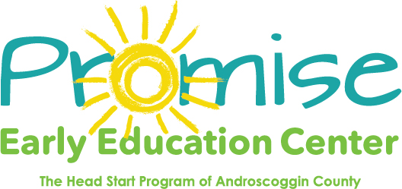

Our classrooms will be closed on

November 11th

Veteran’s Day

Thank you! 