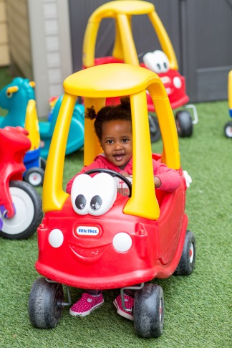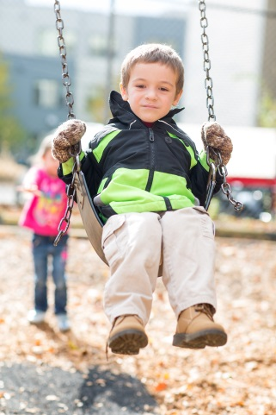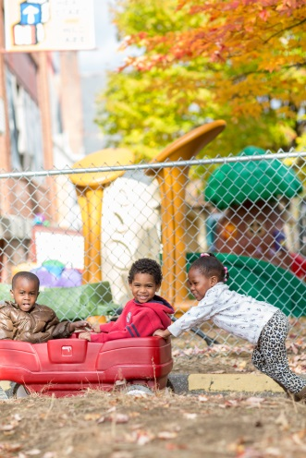
BE SAFE
  - Climbers are for climbing
  - Up the stairs, down the slide
  - Feet first down the slide
  - Bodies only on the climber (no toys)
  - Sticks and rocks are for building on the ground
  - Sand stays in the sandbox
  - Sit in wagons and on bikes
  - Keep wagons and bikes safe & pull/ride them in the same direction (no crashing or bashing)
BE RESPECTFUL
  - Share
  - Be kind to your friends (be kind or be quiet)
  - Listen to adults
BE RESPONSIBLE
  - Clean up your toys

