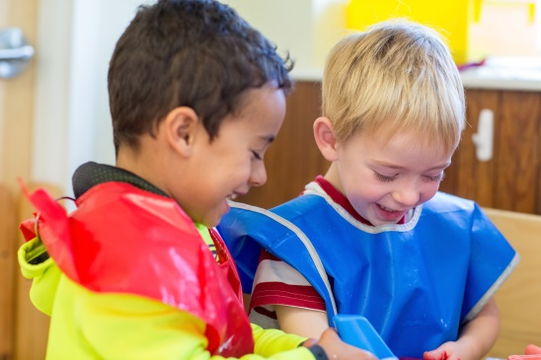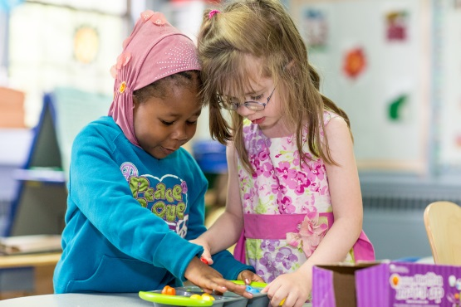
BE SAFE
  - Feet stay on the floor
  - Walking feet in the classroom
  - Inside voices in the classroom
  - Keep your hands to yourself
  - We only throw air
BE RESPECTFUL
  - Clean up your toys
  - Share
  - Be kind to your friends (be kind or be quiet)
  - Listen to adults
BE RESPONSIBLE
  - Wear a smock at water table/easel
  - Sit on your bottom in chairs/at circle

