Parent, Family, and Community Engagement (PFCE) Framework
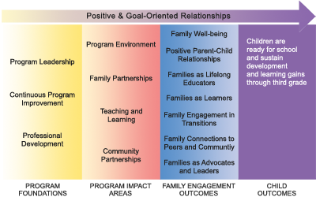
*bolded items below are the outcomes that we use in working with families

Program Leadership | The director, the governing board, policy council, parent committees and management teams determine the way that Head Start and Early Head Start programs engage parents, families, and the community.
Continuous Program Improvement | Leadership is committed to continuously improving systems and activities to engage and support parents and families.
Professional Development | PFCE training is important to all staff, but their professional development will focus uniquely around their roles in the program.
Program Environment | Families feel welcomed, valued, and respected by program staff.
Family Partnerships | Families work with staff to identify and achieve their goals and aspirations.
Teaching and Learning | Families are engaged as equal partners in their children’s learning and development.
Community Partnerships | Communities support families’ interests and needs and encourage parent and family engagement in children’s learning.
Family Well-Being | Parents and families are safe, healthy and have increased financial security.
Positive Parent-Child Relationships | Beginning with transitions to parenthood, parents and families develop warm relationships that nurture their child’s leaving and development.
Families as Lifelong Educators | Parents and Families observe, guide, promote, and participate in the everyday learning of their children at home, school and in their communities.
Families as Learners | Parents and families advance their own learning interests through education, training and other experiences that support their parenting, careers and life goals.
Family Engagement in Transitions | Parents and families support and advocate for their child’s learning and development as they transition to new learning environments.
Family Connections to Peers and Community | Parents and families form connections with peers and mentors in formal or informal social networks that are supportive and/or educational and that enhance social well-being and community life.
Families as Advocates and Leaders | Parents and families participate in leadership development, decision making, program policy development, or in community and state organizing activities to improve children’s development and learning experiences.

