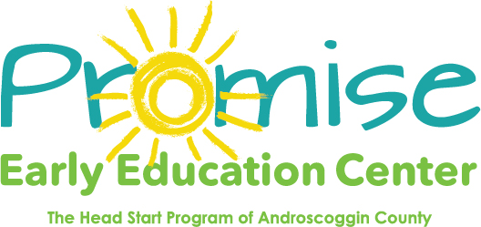

Our classrooms will be closed on
Monday October 12th
Indigenous Peoples Day
Thank you! 