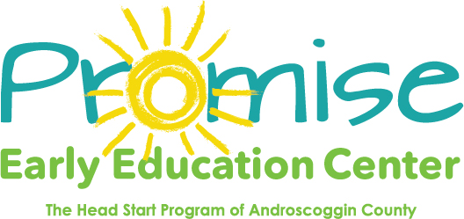

Our classrooms will be closed on
Thursday and Friday November 26th & 27th
For Thanksgiving Break
Thank you!

