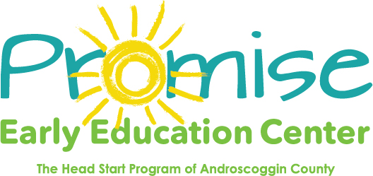

Our classrooms will be closed on
January 18th
Martin Luther King Jr. Day
Thank you! 