Lice Removal Kit

You have: 1 bottle of conditioner, 1 lice comb, hair clips and 1 trash bag.

The 10-day; hair conditioner nit-removal product.
Head lice can be removed by applying plenty of hair conditioner to dry hair and then combing to remove live lice and eggs. The conditioner makes it hard for the lice to move and traps them in the teeth of the comb. The conditioner also detangles hair, making combing easier.

Why does the treatment take 10 days?
Eggs generally hatch 7 to 10 days after being laid on the hair shaft (the part of your hair closest to the scalp). The 10-day treatment period helps break the reproductive cycle of the head lice. Even if only one or two adult lice are missed, they can lay about 6 eggs per day, and the cycle of outbreaks will continue.
Combing out new hatchlings every 1 to 2 days also means they cannot lay further eggs, which can happen about a week after hatching.
How to Remove Nits
- 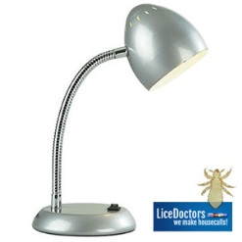 Work in a well lit room or under a bright lamp.

- 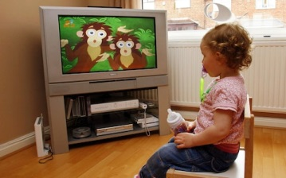 Have the person who is being combed watch TV, a video, or read a book.
- 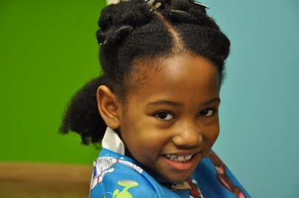 Drape a towel around the child’s shoulders or an old large shirt.
- 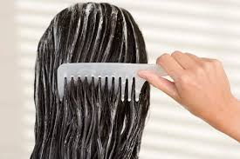 Comb through with an ordinary comb or brush to remove tangles.
- 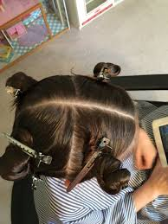 Divide the hair into 4 parts and divide each part into 1-inch sections.

- 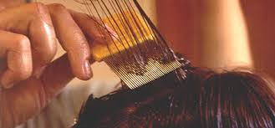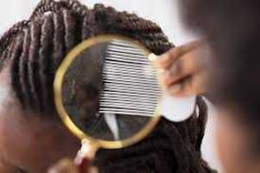
Starting at the scalp, use a metal nit comb, cat flea comb, or your fingernails to comb each hair section individually and comb the entire length of the hair strands

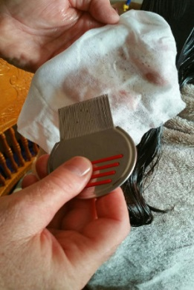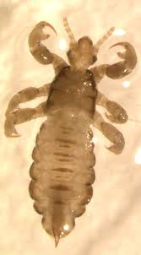
- Wipe the comb on a white paper towel to check that the dark adult lice or the paler hatchlings (young lice) are being removed.
- 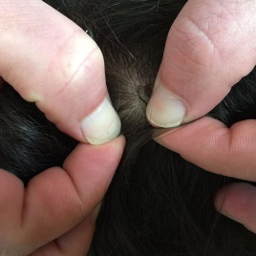 Use the comb or your fingernail to slide eggs off the hair shaft
or use scissors to cut hair shafts that have nits glued to them.
- Use bobby pins or hair clips, to pin back each section after you have combed through
it. Continue combing the hair in sections until the whole head has been checked
- When you have finished checking, rinse the
conditioner out and dry the hair.
- 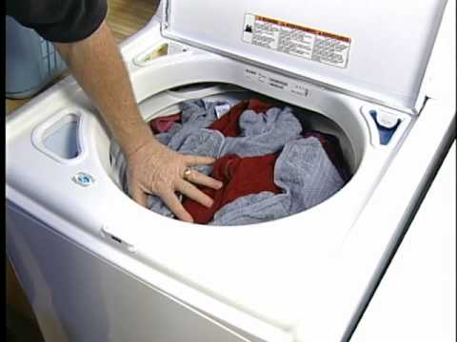 Then, change your clothes; put the towel that was draped
over the child and your clothes into the laundry.
- 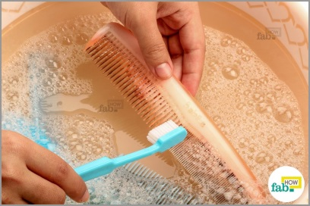 Wash the lice comb in warm soapy water; using an old
toothbrush can help clean between the teeth of the comb.
- Lastly, check the entire family daily during an infestation. Treat
only those who have evidence of active lice.
- REPEAT this process every 1 to 2 days over the 10-day treatment period. To save time during a school week, consider this combing schedule: Tuesday, Thursday, Saturday, Sunday, Tuesday, and Thursday.

- 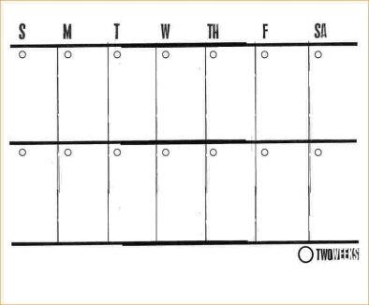 REMEMBER: it can take at least 2 weeks to get rid of lice.

Things to Know!

- No chemical treatment is effective in killing the eggs/nits. It is important to treat lice eggs when they hatch.
- Do not shave or cut a child’s hair because of lice. It will only cause more stigmas and not get rid of the lice.
- You do not have to treat your whole house or bag toys! Lice live only 24-48 hours away from food and warmth. You can throw items in a dryer on high hear for 30 minutes if it makes you feel better.
- You do not need to miss school or work.
- Talk to your child’s teacher or Promise’s health department… We are here for guidance/support.

