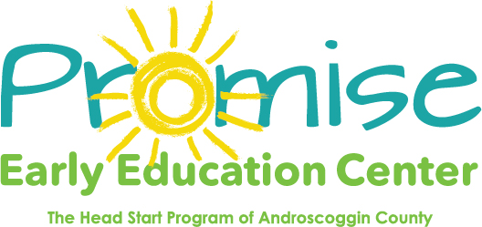

Our classrooms will be closed on

July 5th

Independence Day

Thank you! 