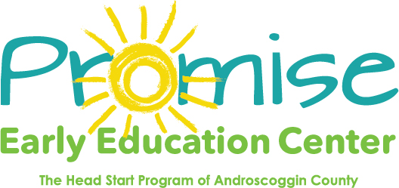

Our classrooms will be closed on

February 15th

Presidents Day

Thank you! 