The Head Start Program of Androscoggin County
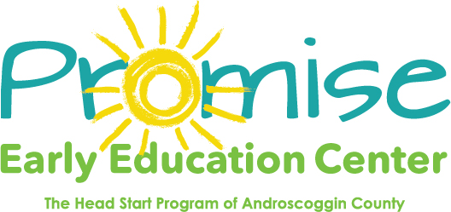

269 Bates Street, Lewiston, ME 04240
P: (207) 795-4040 F: (207) 795-4044

Fax

To: |  | From: | Promise Early Education Center
Fax: |  | Pages: | Including cover
Phone: |  | Date:
Re: |  | cc:

Urgent | For Review | Please Comment | Please Reply | Please Recycle

*Comment :

