The Head Start Program of Androscoggin County
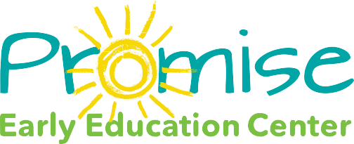

269 Bates Street, Lewiston, ME 04240
P: (207) 795-4040 F: (207) 795-4044

Parental Information
Child’s native language
Does parent have difficulty understanding child at home in native language?
Parental concerns?

Health
Health issues to be considered:
Lead level if concerning:

Classroom Information
Was a language facilitator used for screening?
Has language facilitator spent time with child?
How much time has language facilitator spent with child?

Behaviors observed by language facilitator
Does language facilitator have difficulty understanding child?
Does child respond to one step directions? 2 step directions?
Does child initiate interactions with peers appropriately?
Does child answer yes/no questions?
Does child attend to adult directed activities?
Does child follow classroom routine?
Does child interact with peers?
Does child display aggressive behaviors?

Engaged communities. Empowered families. School-ready kids. www.promiseearlyeducation.org

