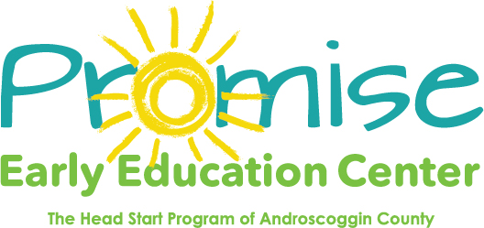
Our classrooms will be closed on December 25th
Thru January 1st
For Holiday Break
_______________________________________________

Closed January 1st for New Years Day

