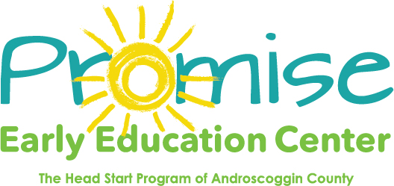

Our classrooms will be closed on
Monday April 19th
Patriots Day
Thank you!

